***Frameworx Specification***

**Service Ordering Management  
API REST Specification**

**TMF641**

**Release 16.5**

**October 2016**

|  |  |
| --- | --- |
| **Latest Update: Frameworx Release 16.5** | **Member Evaluation** |
| **Version 1.0.0** | **IPR Mode: RAND** |

# NOTICE

Copyright © TM Forum 2016. All Rights Reserved.

This document and translations of it may be copied and furnished to others, and derivative works that comment on or otherwise explain it or assist in its implementation may be prepared, copied, published, and distributed, in whole or in part, without restriction of any kind, provided that the above copyright notice and this section are included on all such copies and derivative works. However, this document itself may not be modified in any way, including by removing the copyright notice or references to TM FORUM, except as needed for the purpose of developing any document or deliverable produced by a TM FORUM Collaboration Project Team (in which case the rules applicable to copyrights, as set forth in the [TM FORUM IPR Policy](http://www.tmforum.org/IPRPolicy/11525/home.html), must be followed) or as required to translate it into languages other than English.

The limited permissions granted above are perpetual and will not be revoked by TM FORUM or its successors or assigns.

This document and the information contained herein is provided on an "AS IS" basis and TM FORUM DISCLAIMS ALL WARRANTIES, EXPRESS OR IMPLIED, INCLUDING BUT NOT LIMITED TO ANY WARRANTY THAT THE USE OF THE INFORMATION HEREIN WILL NOT INFRINGE ANY OWNERSHIP RIGHTS OR ANY IMPLIED WARRANTIES OF MERCHANTABILITY OR FITNESS FOR A PARTICULAR PURPOSE.

Direct inquiries to the TM Forum office:

240 Headquarters Plaza,

East Tower – 10th Floor,

Morristown, NJ  07960 USA

Tel No.  +1 973 944 5100

Fax No.  +1 973 944 5110

TM Forum Web Page: [www.tmforum.org](http://www.tmforum.org/)

# Table of Contents

NOTICE 2

Table of Contents 3

List of Tables 5

Introduction 6

SAMPLE USE CASES 7

RESOURCE MODEL 8

Managed Entity and Task Resource Models 8

Service Order resource 8

Notification Resource Models 18

Service Order Creation Notification 19

Service Order Attribute Value Change Notification 20

Service Order State Change Notification 20

Service Order Remove Notification 20

Service Order Information Required Notification 21

API OPERATIONS 23

Operations on Service Order 24

List service orders 24

Retrieve service order 27

Create service order 30

Patch service order 34

Delete service order 36

API NOTIFICATIONS 38

Register listener 38

Unregister listener 39

Publish Event to listener 39

Acknowledgements 41

Release History 41

**Service Order example** 42

BroadBand Service Example 42

# List of Tables

N/A

# Introduction

The following document is the specification of the REST API for Service Order Management. It includes the model definition as well as all available operations. Possible actions are creating, updating and retrieving Service Orders (including filtering).

The following Assumptions were considered in the development of this document :

* The Order Management system has access to a catalog system

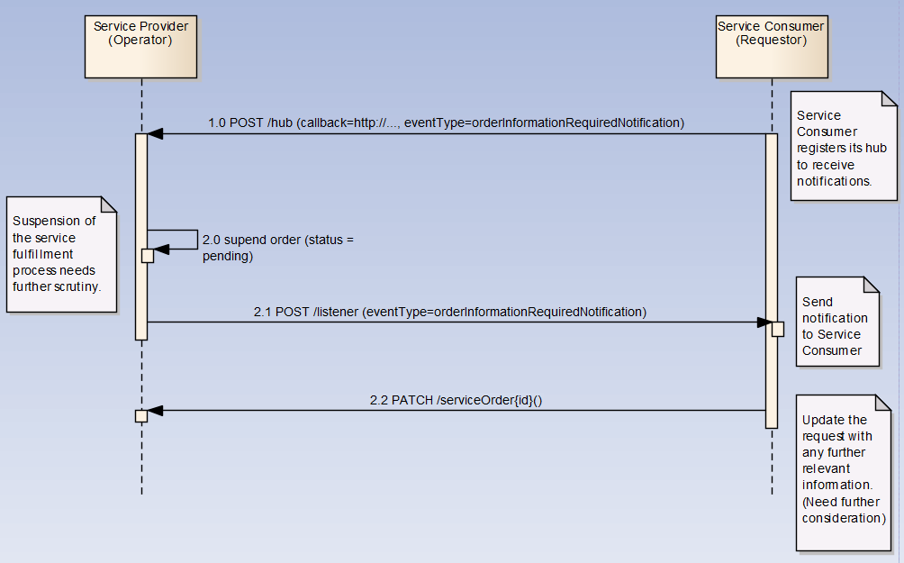

A service order will describe a list of service order items. A service order item references an action on an existing or future service. By service we designed Customer-Facing Service (CFS) as well as Resource Facing Service (RFS).

From a component perspective, a service order should be available

* from a Service Orchestration Component (and it could mix CFS and RFS)
* from an Infrastrucutre Control & Management component (and it would have only RFS)

# SAMPLE USE CASES

No use cases

# RESOURCE MODEL

## Managed Entity and Task Resource Models

### Service Order resource

A Service Order is a type of order which can be used to place an order between a customer and a service provider or between a service provider and a partner and vice versa,.

**Resource model**



**Lifecycle**

Here is the state machine diagram for a Service order. Each order state is described in the tabl below.

The order item states are the same as the order ones. Note that the order and order item states are tightly linked and need to be consistent (see table below):

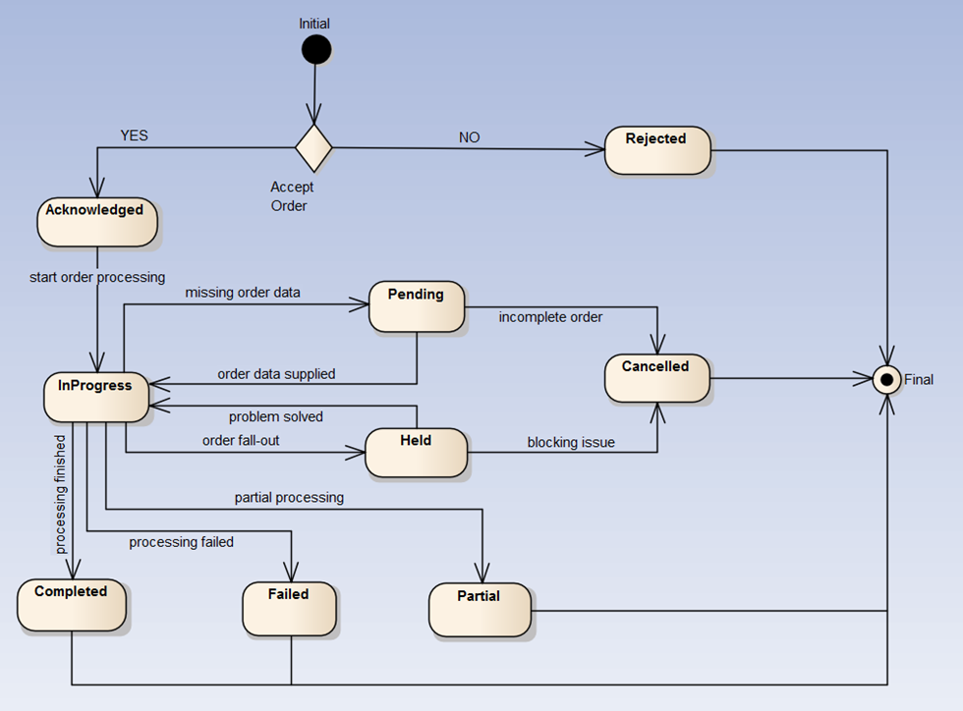

The following table provides service order state and service order item state description :

|  |  |
| --- | --- |
| Acknowledged | The Acknowledged state is where an order has been received and has passed message and basic business validations. |
| In Progress | The In Progress state is when service delivery has started. |
| Cancelled | The Cancelled state is where an In-Flight Order has been successfully cancelled. |
| Completed | The Completed state is where an order has complete provision and the service is now active. |
| Rejected | The Rejected state is where:   * An order failed the Order Feasibility check (but service technical eligibility is not done though service order API but with dedicated serviceQualification API (from preOrdering domain) * Invalid information is provided through the order request * The order request fails to meet business rules for ordering. |
| Pending | The Pending state is used when an order is currently in a waiting stage for an action/activity to be completed before the order can progress further, pending order amend or cancel assessment. In situations where Access Seeker action is required, an “information required” notification will be issued on transition into this state.  A pending stage can lead into auto cancellation of an order, if no action is taken within the defined timeframes to be described under the Agreement. |
| Held | The Held state is used when an order cannot be progressed due to an issue. SP has temporarily delayed completing an order to resolve an infrastructure shortfall to facilitate supply of order. Upon resolution of the issue, the order will continue to progress. |
| Failed | All Order items have failed which results in the entire Order has Failed. |
| Partial | Some Order items have failed and some have succeeded so the entire Order is in a Partial state. This provides support for partial Failure of an Order |

Consistency between Service Order state and Service Order Item state table:

|  |  |
| --- | --- |
| If service order state has state… | the service order items state should be… |
| Rejected | All ‘Rejected’ |
| Acknowledged | All ‘Acknowledged’  note: once delivery begins for at least an item the SO state shifts to ‘In Progress’ |
| in Progress | At least one SO item has ‘In Progress’ state  All items should be ‘Acknowledged’ |
| Pending | All ‘Pending state |
| Held | All ‘Held’ state |
| Cancelled | All ‘Cancelled’ |
| Partial | All Order item are either ‘Failed’ or ‘Completed’  At least one item has ‘Failed’ state  At least one item has ‘Completed’ state |
| Failed | All ‘Failed’ |
| Completed | All ‘Completed’ |

Service state model:

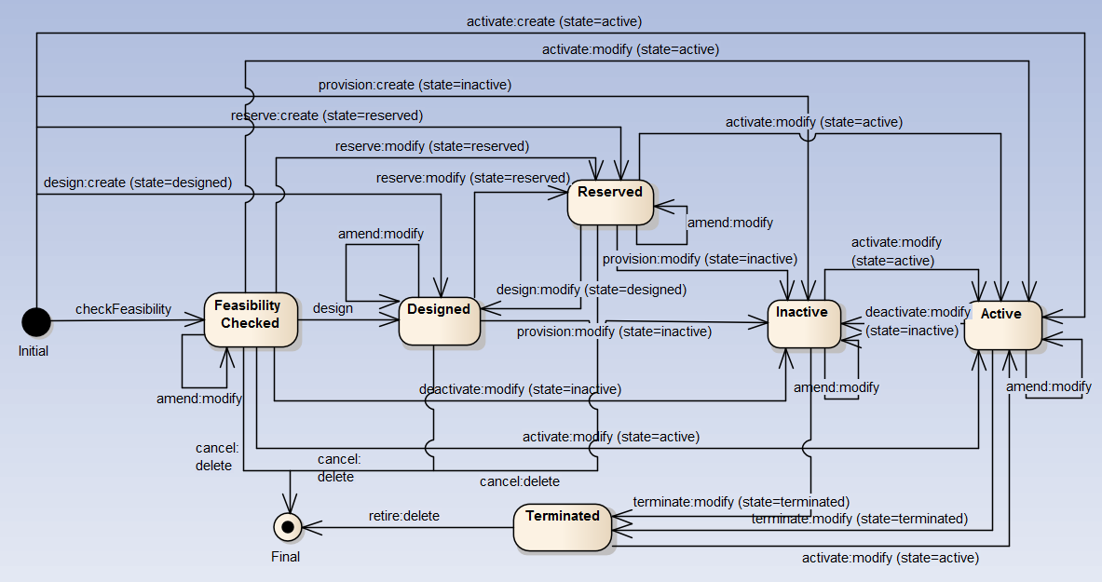

*Note*: ‘Feasability Checked’ should not be managed through service order. A dedicated API provides service qualification; This API is part of the pre-ordering domain.

Consistency between Service Order Item state and service state:

|  |  |  |
| --- | --- | --- |
| source service state | action | target service state |
| blank | add | Designed (valued in order item service state)  Reserved (valued in order item service state)  Inactive (valued in order item service state)  Active – by default |
| Designed | modify | Reserved (valued in order item service state)  Inactive (valued in order item service state)  Designed– by default |
| Designed | delete | *not relevant…service removed* |
| Reserved | delete | *not relevant…service removed* |
| Inactive | modify | Terminated (valued in order item service state)  Active (valued in order item service state)  Inactive– by default |
| Active |  | Active – by default  Terminated (valued in order item service state)  Inactive (valued in order item service state) |
| Terminated | delete | *not relevant…service removed* |

*Note*: when action ‘no change’ is used we did not expect any state change.

**Field descriptions**

*ServiceOrder*

|  |  |
| --- | --- |
| id | A string. ID created on repository side |
| href | A string. Hyperlink to access the order |
| externalId | A string. ID given by the consumer and only understandable by him (to facilitate his searches afterwards) |
| priority | A string. A way that can be used by consumers to prioritize orders in Service Order Management system (from 0 to 4 : 0 is the highest priority, and 4 the lowest) |
| description | A string. A free-text description of the service order. |
| category | A string. Used to categorize the order from a business perspective that can be useful for the Service Order Management system (e.g. "broadband", "TV option", ...). |
| state | A string. State of the order : described in the state-machine diagram. |
| orderDate | A date time (DateTime). Date when the order was created |
| completionDate | A date time (DateTime). Date when the order was completed. |
| requestedStartDate | A date (Date). Order start date wished by the requestor |
| requestedCompletionDate | A date (Date). Requested delivery date from the requestor perspective. |
| expectedCompletionDate | A date (Date). Expected delivery date amended by the provider |
| startDate | A date (Date). Order start date wished by the requestor |
| notificationContact | A string. Contact attached to the order to send back information regarding this order |
| note | A list of notes (Note [*]).Extra-information about the order (e.g. useful to add extra delivery information that could be useful for a human process) |
| orderItem | A list of order items (ServiceOrderItem [*]). Order items that have to be processed. |
| orderRelationship | A list of related order references (OrderRelationship [*]).Linked order to the one containing this attribute |
| relatedParty | A list of related party references (RelatedPartyRef [*]). Parties which are involved in this order and the role they are playing. |

*Note*

Extra-information about the order (e.g. useful to add extra delivery information that could be useful for a human process).

|  |  |
| --- | --- |
| author | A string. Author of the note. |
| date | A date time (DateTime). Date of the note. |
| text | A string. Text of the note. |

*OrderRelationship*

Linked order to the one containing this attribute.

|  |  |
| --- | --- |
| href | A string. An hyperlink to the related order. |
| id | A string. The id of the related order. |
| type | A string. The type of related order, can be:   * “dependency” if the order needs to be “not started” until another order item is complete (a service order in this case) * “cross-ref” to keep track of the source order (a productOrder) |

*OrderItem*

An identified part of the order. A service order is decomposed into one or more order items.

|  |  |  |
| --- | --- | --- |
| id | A string. Identifier of the line item (generally it is a sequence number 01, 02, 03, ...). | |
| action | A string. The action to be carried out on the Service. Can be:   * add * modify * delete * noChange   These align to the Service Activation operations POST, PATCH, DELETE and this shows how Service Activation request information can be included in service order items | |
| state | A string. State of the order item : described in the state machine diagram. | |
| appointment | An appointment references (AppointmentRef). Used to precise that an appointment was set up with a related party for this order item. | |
| serviceSpecification | A service specification (ServiceSpecificationRef). The service specification (default values, etc. are fetched from the catalogue). |
| orderItemRelationship | A list of order items relationships (ServiceOrderItemRelationship[*]). Linked order items to the one containing this attribute. | |
| service | A service references (Service). The Service to be acted on by the order item. | |

*OrderItemRelationship*

Linked order item to the one containing this attribute.

|  |  |
| --- | --- |
| type | A string. The type of related order item, can be:   * + “dependency” if the order item needs to be “not started” until another order item is complete |
| orderItem | A service order item references (ServiceOrderItemRef). An id and an hyperlink to the related order item. |

*Appointment*

Used to precise that an appointment was set-up with a related party for this order item.

|  |  |
| --- | --- |
| id | A string. The id of the appointment. |
| href | A string. An hyperlink to the appointment |

*Place*

Used to defined a place useful for the service (for example a delivery geographical place).

|  |  |
| --- | --- |
| href | A string. Reference of a place (for instance in google map). |
| role | A string. The role of the place (e.g. delivery address, install site etc). |

*Service*

Service attributes description (these are as per the Service ODE model as used in the Service Inventory specification).

|  |  |
| --- | --- |
| id | A string. Identifier of a service instance. Required to be unique. Used in URIs as the identifier of the service (for modify or delete use cases). |
| href | A string. Reference to the owned Service (useful for delete or modify command). |
| category | A string. The category of the service (e.g. CFS, RFS). |
| description | A string. A description of the service (what it provides). |
| name | A string. Name of the service. |
| serviceState | A string. The lifecycle state of the service (as per state diagram below). |
| place | A list of places (Place [*]). Used to defined places useful for the service (for example a delivery geographical place). | |
| serviceCharacteristic | A list of service characteristics (ServiceCharacteristic[*]).A name/value pair list used to store instance specific values of attributes. The behavior is equivalent to a MAP data structure where only one entry for any given value of "name" can exist. |
| serviceRelationship | A list or service relationships (ServiceRelationship[*]). Linked Services to the one instantiate, it can be :   * “reliesOn” if the Service needs another already owned Service to rely on (e.g. an option on an already owned mobile access Service) * “targets” or “isTargeted” (depending on the way of expressing the link) for any other kind of links that may be useful |
| relatedParty | A list of related party references (RelatedPartyRef[*]). Parties linked at the Service level (it may be a User for example). |

*RelatedPartyRef*

Related party references. A related party defines party which are involved in this order and the role they are playing.

|  |  |
| --- | --- |
| id | A string. Unique identifier of a related party. |
| href | A string. An hyperlink to the party. |
| role | A string. The role of the related party (e.g. Owner, requester, fullfiller etc). |
| name | A string. Name of the related party. |

**Json representation sample**

We provide below the json representation of a sample of a ServiceOrder resource composed of 3 order lines (orderItems) :

* Line “1” : Ordering of a new simple Service that needs a physical delivery place and an appointment to be delivered
* Line “2” : Modification of a characteristic value of an already owned Service, and change the user associated to this Service
* Line “3” : Ordering of a new simple Service that needs (is supported by) another already owned Service ()
* Line “4”: Modification of an already owned Service to switch its state to ‘inactive’.

|  |
| --- |
| {    "id":"42",    "href":"http://serverlocation:port/orderManagement/serviceOrder/42",    "externalId":"NiceNameForTheConsumer_42",    "priority":"1",    "description":"A wonderful 42 order for brand new Services",    "category":"Broadband",    "state":"InProgress",    "orderDate":"2013-04-12T16:42:23-04:00",    "completionDate":"2013-04-19T16:42:23-04:00",    "requestedStartDate":"2013-04-12",    "requestedCompletionDate":"2013-04-19",    "expectedCompletionDate":"2013-04-19",    "notificationContact":"emailAddr-myAddress@hotmail.com",    "note":[       {          "text":"A free text detailing the note",          "date":"2013-04-12T16:42:23-04:00",          "author":"name"       }    ],    "relatedParty":[       {          "role":"requester",          "id":"345231",          "name":"John Doe"       },       {          "role":"fulfiller",          "href":"http://serverlocation:port/provider/42"       }     ],    "orderItem":[       {          "id":"1",          "action":"add",          "state":"Acknowledged",           "appointment":{              "id":"89",             "href":"http://www.doodle.com/1WCV5647438"           },        "serviceSpecification": {              "id":"42",              "href":"http: //serverlocation: port/catalogManagement/serviceSpecification/42"           },  "service": {            "place": [  {              "href":"http://map.google.com/.../1234112GDE",              "role":"DeliveryPlace"           }  ],               "serviceCharacteristic":[                 {                    "name":"Colour",                    "value":"White"                 },                 {                    "name":"Memory",                    "value":"16"                 }              ]          }       },       {          "id":"2",          "action":"modify",          "state":"InProgress",           "serviceSpecification": {            "id":"43",             "href":"http: //serverlocation: port/catalogManagement/serviceSpecification/43"          },          "service":{             "id":"456",             "href":"http: //serverlocation: port/inventoryManagement/service/456",              "serviceCharacteristic":[                {                   "name":"anotherCharacteristic",                   "value":"itsNewValue"                }             ],             "relatedParty":[                {                   "role":"user",                   "id":"5667443",                   "name":"Jimmy Doe"                }             ]          }       },       {          "id":"3",          "action":"add",          "state":"InProgress",           "serviceSpecification": {            "id":"51",            "href":"http: //serverlocation: port/catalogManagement/serviceSpecification/51"          },           "service":{             "serviceRelationship":[                {                   "type":"reliesOn",                   "service":{                     "id":"511",                     "href":"http: //serverlocation: port/inventoryManagement/service/511"                   }                }  ]  }  },  {          "id":"4",          "action":"modify",          "state":"InProgress",         "serviceSpecification": {             "id":"89",           "href":"http: //serverlocation:port/catalogManagement/serviceSpecification/89"        },          "service":{             "id":"120",             "href":"http: //serverlocation: port/inventoryManagement/service/120",             "serviceState":"Inactive"  }       }    ]  } |

## Notification Resource Models

Five notifications are defined for this API.

Notifications related to ServiceOrder:  
 - ServiceOrderCreationNotification  
 - ServiceOrderAttributeValueChangeNotification  
 - ServiceOrderStateChangeNotification

- ServiceOrderInformationRequiredNotification  
 - ServiceOrderRemoveNotification

The notification structure for all notifications in this API follow the pattern depicted by the figure below.

A notification resource (depicted by "SpecificNotification" placeholder) is a sub class of a generic Notification structure containing an id of the event occurence (eventId), an event timestamp (eventTime), and the name of the notification resource (eventType).

This notification structure owns an event structure ("SpecificEvent" placeholder) linked to the resource concerned by the notification using the resource name as access field ("resourceName" placeholder).

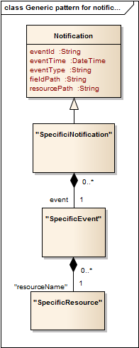

### Service Order Creation Notification

Notification sent when a new ServiceOrder resource is created.

**Json representation sample**

We provide below the json representation of an example of a 'ServiceOrderCreationNotification' notification object

|  |
| --- |
| {  "eventId":"00001",  "eventTime":"2016-11-16T16:42:25-04:00",  "eventType":"ServiceOrderCreationNotification",  "event": {  "ServiceOrder" :   {-- SEE ServiceOrder RESOURCE SAMPLE --}  } } |

### Service Order Attribute Value Change Notification

Notification sent when changing an attribute of a ServiceOrder resource.

**Json representation sample**

We provide below the json representation of an example of a 'ServiceOrderAttributeValueChangeNotification' notification object

|  |
| --- |
| {  "eventId":"00001",  "eventTime":"2016-11-16T16:42:25-04:00",  "eventType":"ServiceOrderAttributeValueChangeNotification",  "event": {  "ServiceOrder" :   {-- SEE ServiceOrder RESOURCE SAMPLE --}  } } |

### Service Order State Change Notification

Notification sent when changing the state of a ServiceOrder resource.

**Json representation sample**

We provide below the json representation of an example of a 'ServiceOrderStateChangeNotification' notification object

|  |
| --- |
| {  "eventId":"00001",  "eventTime":"2016-11-16T16:42:25-04:00",  "eventType":"ServiceOrderStateChangeNotification",  "event": {  "ServiceOrder" :   {-- SEE ServiceOrder RESOURCE SAMPLE --}  } } |

### Service Order Remove Notification

Notification sent when removing a ServiceOrder resource.

**Json representation sample**

We provide below the json representation of an example of a 'ServiceOrderRemoveNotification' notification object

|  |
| --- |
| {  "eventId":"00001",  "eventTime":"2016-11-16T16:42:25-04:00",  "eventType":"ServiceOrderRemoveNotification",  "event": {  "ServiceOrder" :   {-- SEE ServiceOrder RESOURCE SAMPLE --}  } } |

### Service Order Information Required Notification

Used to notify that some data in the order needs to be filled / is missing.

* “resourcePath” allows to precise if it is a data at order level or at orderItem level (and which one of them) that is missing
* “fieldPath” details which field is missing. Its structure is quite similar to GET filter criteria :
  + “missing=” points at the missing field
  + “&<criteria>” can be used to identify a specific element in lists

Simple example : notification contact is missing

|  |
| --- |
| {    "eventId":"00005",    "eventTime":"2013-04-19T16:42:25-30:00",    "eventType":"orderInformationRequiredNotification",    "resourcePath":"/order/42 ",    "fieldPath":"missing=notificationContact",    "serviceOrder":{       "id":" 42",       "href":"http://serverlocation:port/orderManagement/serviceOrder/42",       "externalId":"NiceNameForTheConsumer_42"    } } |

Complex example: in the order item “1”, the IMEI characteristic value is missing to instantiate the Service “465665”

|  |
| --- |
| {    "eventId":"00006",    "eventTime":"2013-04-19T16:42:25-30:00",    "eventType":"orderInformationRequiredNotification",    "resourcePath":"/order/42/orderItem/1",    "fieldPath":"missing=service.serviceCharacteristic.value&service.id=465665&service.serviceCharacteristic.name=IMEI",    "serviceOrder":{       "id":" 42",       "href":"http://serverlocation:port/serviceOrderingManagement/serviceOrder/42",       "externalId":"NiceNameForTheSubscriber_42"    } } |

# API OPERATIONS

Remember the following Uniform Contract:

|  |  |  |
| --- | --- | --- |
| Operation on Entities | Uniform API Operation | Description |
| Query Entities | GET Resource | GET must be used to retrieve a representation of a resource. |
| Create Entity | POST Resource | POST must be used to create a new resource |
| Partial Update of an Entity | PATCH Resource | PATCH must be used to partially update a resource |
| Complete Update of an Entity | PUT Resource | PUT must be used to completely update a resource identified by its resource URI |
| Remove an Entity | DELETE Resource | DELETE must be used to remove a resource |
| Execute an Action on an Entity | POST on TASK Resource | POST must be used to execute Task Resources |
| Other Request Methods | POST on TASK Resource | GET and POST must not be used to tunnel other request methods. |

Filtering and attribute selection rules are described in the TMF REST Design Guidelines.

Notifications are also described in a subsequent section.

## Operations on Service Order

### List service orders

**GET /serviceOrder?fields=...&{filtering}**

**Description**

This operation list service order entities.  
Attribute selection is enabled for all first level attributes.  
Filtering may be available depending on the compliance level supported by an implementation.

**Usage Samples**

Here's an example of a request for retrieving all the service orders for a given customer that were completed before a specified date.

|  |
| --- |
| **Request** |
| GET /serviceOrderingManagement/serviceOrder?relatedParty.role=subscriber&relatedParty.id=345221&completionDate.lt=2013-09-10 00:00:00ZGMT+1  Accept: application/json |
| **Response** |
| 200  Content-Type : application/json  [  {    "id":"42",    "href":"http://serverlocation:port/orderManagement/serviceOrder/42",    "externalId":"NiceNameForTheConsumer_42",    "priority":"1",    "description":"A wonderful 42 order for brand new Services",    "category":"Broadband",    "state":"InProgress",    "orderDate":"2013-04-12T16:42:23-04:00",    "completionDate":"2013-04-19T16:42:23-04:00",    "requestedStartDate":"2013-04-12",    "requestedCompletionDate":"2013-04-19",    "expectedCompletionDate":"2013-04-19",    "notificationContact":"emailAddr-myAddress@hotmail.com",    "note":[       {          "text":"A free text detailing the note",          "date":"2013-04-12T16:42:23-04:00",          "author":"name"       }    ],    "relatedParty":[       {          "role":"requester",          "id":"345231",          "name":"John Doe"       },       {          "role":"fulfiller",          "href":"http://serverlocation:port/provider/42"       }     ],    "orderItem":[       {          "id":"1",          "action":"add",          "state":"Acknowledged",           "appointment":{              "id":"89",             "href":"http://www.doodle.com/1WCV5647438"           },       "serviceSpecification": {           "id":"42",           "href":"http: //serverlocation: port/catalogManagement/serviceSpecification/42"      },  "service": {            "place": [  {              "href":"http://map.google.com/.../1234112GDE",              "role":"DeliveryPlace"           }  ],               "serviceCharacteristic":[                 {                    "name":"Colour",                    "value":"White"                 },                 {                    "name":"Memory",                    "value":"16"                 }              ]          }       },       {          "id":"2",          "action":"modify",          "state":"InProgress",           "serviceSpecification":{           "id":"43",           "href":"http: //serverlocation: port/catalogManagement/serviceSpecification/43"          },          "service":{             "id":"456",             "href":"http: //serverlocation: port/inventoryManagement/service/456",              "serviceCharacteristic":[                {                   "name":"anotherCharacteristic",                   "value":"itsNewValue"                }             ],             "relatedParty":[                {                   "role":"user",                   "id":"5667443",                   "name":"Jimmy Doe"                }             ]          }       },       {          "id":"3",          "action":"add",          "state":"InProgress",           "serviceSpecification":{            "id":"51",           "href":"http: //serverlocation: port/catalogManagement/serviceSpecification/51"          },          "service":{             "serviceRelationship":[                {                   "type":"reliesOn",                   "service":{                     "id":"511",                     "href":"http: //serverlocation: port/inventoryManagement/service/511"                   }                }  ]  }  },  {          "id":"4",          "action":"modify",          "state":"InProgress",        "serviceSpecification": {           "id":"89",           "href":"http: //serverlocation:port/catalogManagement/serviceSpecification/89"           },          "service":{             "id":"120",             "href":"http: //serverlocation: port/inventoryManagement/service/120",             "serviceState":"Inactive"  }       }    ]  } ] |

### Retrieve service order

**GET /serviceOrder/{id}?fields=...&{filtering}**

**Description**

This operation retrieves a service order entity.  
Attribute selection is enabled for all first level attributes.  
Filtering on sub-resources may be available depending on the compliance level supported by an implementation.

**Usage Samples**

Here's a sample of a request for retrieving a ServiceOrder resource based on its id.

|  |
| --- |
| **Request** |
| GET /serviceOrderingManagement/serviceOrder/42 Accept: application/json |
| **Response** |
| 200  Content-Type : application/json {    "id":"42",    "href":"http://serverlocation:port/orderManagement/serviceOrder/42",    "externalId":"NiceNameForTheConsumer_42",    "priority":"1",    "description":"A wonderful 42 order for brand new Services",    "category":"Broadband",    "state":"InProgress",    "orderDate":"2013-04-12T16:42:23-04:00",    "completionDate":"2013-04-19T16:42:23-04:00",    "requestedStartDate":"2013-04-12",    "requestedCompletionDate":"2013-04-19",    "expectedCompletionDate":"2013-04-19",    "notificationContact":"emailAddr-myAddress@hotmail.com",    "note":[       {          "text":"A free text detailing the note",          "date":"2013-04-12T16:42:23-04:00",          "author":"name"       }    ],    "relatedParty":[       {          "role":"requester",          "id":"345231",          "name":"John Doe"       },       {          "role":"fulfiller",          "href":"http://serverlocation:port/provider/42"       }     ],    "orderItem":[       {          "id":"1",          "action":"add",          "state":"Acknowledged",          "appointment":{              "id":"89",             "href":"http://www.doodle.com/1WCV5647438"           },           "serviceSpecification": {           "id":"42",           "href":"http: //serverlocation: port/catalogManagement/serviceSpecification/42"          },  "service": {            "place":[  {              "href":"http://map.google.com/.../1234112GDE",              "role":"DeliveryPlace"           }  ],               "serviceCharacteristic":[                 {                    "name":"Colour",                    "value":"White"                 },                 {                    "name":"Memory",                    "value":"16"                 }              ]          }       },       {          "id":"2",          "action":"modify",          "state":"InProgress",           "serviceSpecification":{           "id":"43",           "href":"http: //serverlocation: port/catalogManagement/serviceSpecification/43"          },          "service":{             "id":"456",             "href":"http: //serverlocation: port/inventoryManagement/service/456",              "serviceCharacteristic":[                {                   "name":"anotherCharacteristic",                   "value":"itsNewValue"                }             ],             "relatedParty":[                {                   "role":"user",                   "id":"5667443",                   "name":"Jimmy Doe"                }             ]          }       },       {          "id":"3",          "action":"add",          "state":"InProgress",           "serviceSpecification":{            "id":"51",            "href":"http: //serverlocation: port/catalogManagement/serviceSpecification/51"          },           "service":{             "serviceRelationship":[                {                   "type":"reliesOn",                   "service":{                     "id":"511",                     "href":"http: //serverlocation: port/inventoryManagement/service/511"                   }                }  ]  }  },  {          "id":"4",          "action":"modify",          "state":"InProgress",        "serviceSpecification": {            "id":"89",            "href":"http: //serverlocation:port/catalogManagement/serviceSpecification/89"          },          "service":{             "id":"120",             "href":"http: //serverlocation: port/inventoryManagement/service/120",             "serviceState":"Inactive"  }       }    ]  } |

### Create service order

**POST /serviceOrder**

**Description**

This operation creates a service order entity.

**Mandatory and Non Mandatory Attributes**

The following tables provides the list of mandatory and non mandatory attributes when creating a ServiceOrder, including any possible rule conditions and applicable default values.

POST should be used without specifying the id and the href, the Service Order Management system is in charge of generating the id + href for the ServiceOrder.

|  |  |
| --- | --- |
| Mandatory Attributes | Rule |
| relatedParty |  |
| orderItem.id |  |
| orderItem.action |  |
| orderItem.service |  |

|  |  |  |
| --- | --- | --- |
| Non Mandatory Attributes | Default Value | Rule |
| externalId | N/A |  |
| state | Acknowledged |  |
| priority | 4 (lowest) |  |
| description | N/A |  |
| category | “uncategorized” |  |
| requestedStartDate | No specified default value |  |
| requestedCompletionDate | No specified default value |  |
| notificationContact | No specified default value |  |
| note | No specified default value |  |
| relatedParty |  | They must be at least a defined party linked to the order (Customer, …)  Related party could have following role: owner, requester, fulfiller |
| orderItem.state | Acknowledged |  |
| orderItem.ServiceSpecification |  | The serviceSpecification may not be useful when doing a “modify” or “delete” on an owned Service |
| orderItem.place |  |  |
| orderItem.appointment |  |  |

**Additional Rules**

The following table provides additional rules indicating mandatory fields in sub-resources or relationships when creating a ServiceOrder resource.

|  |  |
| --- | --- |
| Context | Mandatory Sub-Attributes |
| POST Mandatory attributes within Service Order | * + Within “note”     - text   + Within “relatedParty”     - id AND/OR href AND/OR name     - role |
| POST Mandatory attributes within Service Order item | * + Within “place”     - role     - id AND/OR href   + Within “serviceSpecification”     - id AND/OR href   + Within “service”     - Depends on the order item “action”, cf. rule below |
| POST Mandatory attributes within Service (in each order item) | * + If orderItem.action = “add” :     - serviceCharacteristics   + If orderItem.action = “modify”     - id AND/OR href   + If orderItem.action = “delete”     - id AND/OR href |

**Default Values Summary**

When creating the resource, the following table summarizes the default values applicable to optional attributes of the resource (or sub-resources).

|  |  |
| --- | --- |
| Attributes | Default Value |
| state | Acknowledged |
| priority | 4 (lowest) |
| category | Uncategorized |
| orderItem.state | Acknowledged |

**Usage Samples**

Here's a sample of a request for creating a ServiceOrder resource.

|  |
| --- |
| **Request** |
| POST /serviceOrderingManagement/serviceOrder Content-Type: application/json  {       "note":[       {          "text":"A free text detailing the note",          "date":"2013-04-12T16:42:23-04:00",          "author":"name"       }    ],    "relatedParty":[       {          "role":"subscriber",          "id":"345231",          "name":"John Doe"       },       {          "role":"provider",          "href":"http://serverlocation:port/provider/4563"       }     ],    "orderItem":[       {          "id":"1",          "action":"add",        "serviceSpecification": {           "id":"42",           "href":"http: //serverlocation: port/catalogManagement/serviceSpecification/42"       },  "service": {               "serviceCharacteristic":[                 {                    "name":"Colour",                    "value":"White"                 },                 {                    "name":"Memory",                    "value":"16"                 }              ]          }       },       {          "id":"2",          "action":"modify",            "service":{             "id":"456",             "href":"http: //serverlocation: port/inventoryManagement/service/456",              "relatedParty":[                {                   "role":"user",                   "id":"5667443",                   "name":"Jimmy Doe"                }             ]          }       },       {          "id":"3",          "action":"delete",         "serviceSpecification":{            "id":"456",            "href":"http: //serverlocation: port/catalogManagement/serviceSpecification/456"       }  }     ]  } |
| **Response** |
| 201  Content-Type: application/json  {     "id":"42",    "href":"http://serverlocation:port/orderManagement/serviceOrder/42",    "priority":"4",    "description":"A wonderful 42 order for brand new Services",    "category":"Uncategorized",    "state":"Acknowledged",    "orderDate":"2013-04-12T16:42:23-04:00",     "expectedCompletionDate":"2013-04-19",    "note":[       {          "text":"A free text detailing the note",          "date":"2013-04-12T16:42:23-04:00",          "author":"name"       }    ],    "relatedParty":[       {          "role":"subscriber",          "id":"345231",          "name":"John Doe"       },       {          "role":"provider",          "href":"http://serverlocation:port/provider/4563"       }     ],    "orderItem":[       {          "id":"1",          "action":"add",           "state":"Acknowledged",       "serviceSpecification": {            "id":"42",            "href":"http: //serverlocation: port/catalogManagement/serviceSpecification/42"      },  "service": {               "serviceCharacteristic":[                 {                    "name":"Colour",                    "value":"White"                 },                 {                    "name":"Memory",                    "value":"16"                 }              ]          }       },       {          "id":"2",          "action":"modify",           "state":"Acknowledged",            "service":{             "id":"456",             "href":"http: //serverlocation: port/inventoryManagement/service/456",               "relatedParty":[                {                   "role":"user",                   "id":"5667443",                   "name":"Jimmy Doe"                }             ]          }       },       {          "id":"3",          "action":"delete",           "state":"Acknowledged",         "serviceSpecification":{            "id":"456",           "href":"http: //serverlocation: port/catalogManagement/serviceSpecification/456"       }  }     ]  } |

### Patch service order

**PATCH /serviceOrder/{id}**

**Description**

This operation allows partial updates of a service order entity. Support of json/merge (https://tools.ietf.org/html/rfc7386) is mandatory, support of json/patch (http://tools.ietf.org/html/rfc5789) is optional.  
  
Note: If the update operation yields to the creation of sub-resources or relationships, the same rules concerning mandatory sub-resource attributes and default value settings in the POST operation applies to the PATCH operation. Hence these tables are not repeated here.

**Patchable and Non Patchable Attributes**

The tables below provide the list of patchable and non patchable attributes, including constraint rules on their usage.

|  |  |
| --- | --- |
| Patchable Attributes | Rule |
| state | To manage the order delivery process : Acknowledged, InProgress (start process), Held / Pending (suspend process), Cancelled  Influence the orderItem states |
| priority |  |
| category |  |
| requestedStartDate | Only when order is in “Acknowledged” state – delivery process not started |
| requestedCompletionDate | Only when order is in “Acknowledged” state – delivery process not started |
| expectedCompletionDate |  |
| notificationContact |  |
| note |  |
| relatedParty | Only when order is in “Acknowledged” state – delivery process not started |
| orderItem.state | To manage the order delivery process : Acknowledged, InProgress (start process), Held / Pending (suspend process), Cancelled  Influence the orderItem states |
| orderItem.serviceSpecification | Only when order is in “Acknowledged” state – delivery process not started |
| orderItem.service | Only when order is in “Acknowledged” state – delivery process not started or suspended |
| orderItem.place | Only when order is in “Acknowledged” state – delivery process not started or suspended |
| orderItem.appointment | Only when order is in “Acknowledged” state – delivery process not started or suspended |

|  |  |
| --- | --- |
| Non Patchable Attributes | Rule |
| id |  |
| href |  |
| externalId |  |
| orderDate |  |
| completionDate |  |
| orderItem.id |  |
| orderItem.action |  |

**Additional Rules**

The following pre-conditions apply for this operation.

|  |
| --- |
| Pre-conditions |
| When patching an order state to :   * “Pending” / “Held” : all “InProgress” order items SHOULD be set to “Pending” / “Held” * “InProgress” :   + all “Acknowledged” order items MUST be set to “InProgress”   + all “Pending”/”Held” order items MAY be set to “InProgress”   When patching an order item state to :   * “Pending” / “Held” : the order state itself SHOULD be set to “Pending” / “Held” |

**Usage Samples**

Here's an example of a request for patching a ServiceOrder resource : resume order (Suspend would be the same request using the “Pending” state).

|  |
| --- |
| **Request** |
| PATCH /serviceOrderingManagement/serviceOrder/42  Content-Type: application/merge-patch+json {  "state": "InProgress" } |
| **Response** |
| 201  { Similar JSON as in GET response with state changed } |

### Delete service order

**DELETE /serviceOrder/{id}**

*Note: this operation is available only to ADMIN API users*

**Description**

This operation deletes a service order entity.

**Usage Samples**

Here's an example of a request for deleting a ServiceOrder resource.

|  |
| --- |
| **Request** |
| DELETE /serviceOrderingManagement/serviceOrder/42 |
| **Response** |
| 204 |

# API NOTIFICATIONS

For every single of operation on the entities use the following templates and provide sample REST notification POST calls.

It is assumed that the Pub/Sub uses the Register and UnRegister mechanisms described in the REST Guidelines reproduced below.

## Register listener

**POST /hub**

**Description**

Sets the communication endpoint address the service instance must use to deliver information about its health state, execution state, failures and metrics. Subsequent POST calls will be rejected by the service if it does not support multiple listeners. In this case DELETE /api/hub/{id} must be called before an endpoint can be created again.

**Behavior**

Returns HTTP/1.1 status code 204 if the request was successful.

Returns HTTP/1.1 status code 409 if request is not successful.

**Usage Samples**

Here's an example of a request for registering a listener.

|  |
| --- |
| **Request** |
| POST /api/hub  Accept: application/json  {"callback": "http://in.listener.com"} |
| **Response** |
| 201  Content-Type: application/json  Location: /api/hub/42  {"id":"42","callback":"http://in.listener.com","query":null} |

## Unregister listener

**DELETE /hub/{id}**

**Description**

Clears the communication endpoint address that was set by creating the Hub..

**Behavior**

Returns HTTP/1.1 status code 204 if the request was successful.

Returns HTTP/1.1 status code 404 if the resource is not found.

**Usage Samples**

Here's an example of a request for un-registering a listener.

|  |
| --- |
| **Request** |
| DELETE /api/hub/42  Accept: application/json |
| **Response** |
| 204 |

## Publish Event to listener

**POST /client/listener**

**Description**

Clears the communication endpoint address that was set by creating the Hub.

Provides to a registered listener the description of the event that was raised. The /client/listener url is the callback url passed when registering the listener.

**Behavior**

Returns HTTP/1.1 status code 201 if the service is able to set the configuration.

**Usage Samples**

Here's an example of a notification received by the listener. In this example “EVENT TYPE” should be replaced by one of the notification types supported by this API (see Notification resources Models section) and EVENT BODY refers to the data structure of the given notification type.

|  |
| --- |
| **Request** |
| POST /client/listener  Accept: application/json  {  "event": {  EVENT BODY  },  "eventType": "EVENT_TYPE"  } |
| **Response** |
| 201 |

For detailed examples on the general TM Forum notification mechanism, see the TMF REST Design Guidelines.

# Acknowledgements

## Release History

|  |  |  |  |
| --- | --- | --- | --- |
| **Release Number** | **Date** | **Release led by:** | **Description** |
| Release 1.0 | 24/10/2016 | Pierre Gauthier TM Forum [pgauthier@tmforum.org](mailto:pgauthier@tmforum.org)  Ludovic Robert Orange <ludovic.robert@orange.com>  Nicoleta Stoica  Vofadone [nicoleta.stoica@vodafone.com](mailto:nicoleta.stoica@vodafone.com)  Jean-Luc Tymen Orange [jeanluc.tymen@orange.com](mailto:jeanluc.tymen@orange.com) |  |
|  |  |  |  |
|  |  |  |  |
|  |  |  |  |

**Service Order example**

BroadBand Service Example

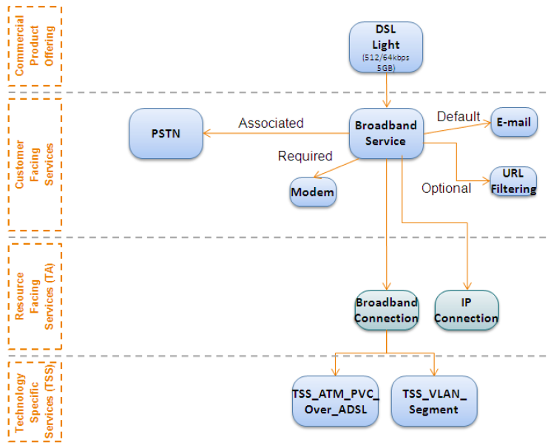

***Create Broadband Service (CFS)***

REQUEST - An example service order composed of 1 order line (orderItem).

This request would be used to for the subsequent creation of the following CFSs:

* PSTN
* EMAIL
* URL Filtering

|  |
| --- |
| POST /serviceOrderingManagement/serviceOrder  Content-type: application/json  {  "priority": "1",  "description": "An order for a Broadband service",  "category": "CFS",  "requestedStartDate": "2016-10-12",  "requestedCompletionDate": "2016-10-19",  "orderRelationship": [  {  "role": "cross-ref",  "id": "producOrderxx",  "href": "http://serverlocation:port/productOrderingManagement/productOrder/productOrderxx"  }  ],  "relatedParty": [  {  "role": "Service Provider",  "href": "http://serverlocation:port/partyManagement/party/42"  }  ],  "orderItem": [  {  "id": "1",  "action": "add",  "serviceSpecification": {  "id": "BBserviceSpecID",  "href": "[http://serverlocation:port/catalogManagement/serviceSpecification /BBServiceSpecID](http://serverlocation:port/catalogManagement/serviceSpecification%20/BBServiceSpecID)"  },  "service": {  "place": {  "role": "installation address",  "href": "http: //serverlocation:port/addressManagement/address/addressID"  },  "serviceCharacteristic": [{  "name": "bandwith",  "value": "10"  }]  }  }]  } |

RESPONSE

|  |
| --- |
| 201  Content-type: application/json  {  "id": "42",  "href": "http://serverlocation:port/serviceOrderingManagement/serviceOrder/42",  "state" :"Acknowledged",  "description": "An order for a Broadband service",  "category": "CFS",  "requestedStartDate": "2016-10-12T16:42:23-04:00",  "requestedCompletionDate": "2016-10-19T16:42:23-04:00",  "orderDate":"2016-10-19T16:42:23-04:10",  "orderRelationship": [  {  "role": "cross-ref",  "id": "producOrderxx",  "href": "http://serverlocation:port/productOrderingManagement/productOrder/productOrderxx"  }  ],  "relatedParty": [  {  "role": "Service Provider",  "href": "http://serverlocation:port/partyManagement/party/42"  }  ],  "orderItem": [  {  "id": "1",  "action": "add",  "state": "Acknowledged",  "serviceSpecification": {  "id": "BBserviceSpecID",  "href": "<http://serverlocation:port/catalogManagement/serviceSpecification/BBServiceSpecID>"  },  "service": {  "place": {  "role": "installation address",  "href": "http: //serverlocation:port/addressManagement/address/addressID"  },  "serviceCharacteristic": [{  "name": "bandwith",  "value": "10"  }]  }  }]  } |