***Frameworx Specification***

**Change Management   
API REST Specification**

**TMFXXX**

**Release XX.X**

**April 2016**

|  |  |
| --- | --- |
| **Latest Update: Frameworx Release \*\*\*** | **Member Evaluation** |
| **Version 1.0.0** | **IPR Mode: RAND** |

# NOTICE

Copyright © TM Forum 2016. All Rights Reserved.

This document and translations of it may be copied and furnished to others, and derivative works that comment on or otherwise explain it or assist in its implementation may be prepared, copied, published, and distributed, in whole or in part, without restriction of any kind, provided that the above copyright notice and this section are included on all such copies and derivative works. However, this document itself may not be modified in any way, including by removing the copyright notice or references to TM FORUM, except as needed for the purpose of developing any document or deliverable produced by a TM FORUM Collaboration Project Team (in which case the rules applicable to copyrights, as set forth in the [TM FORUM IPR Policy](http://www.tmforum.org/IPRPolicy/11525/home.html), must be followed) or as required to translate it into languages other than English.

The limited permissions granted above are perpetual and will not be revoked by TM FORUM or its successors or assigns.

This document and the information contained herein is provided on an "AS IS" basis and TM FORUM DISCLAIMS ALL WARRANTIES, EXPRESS OR IMPLIED, INCLUDING BUT NOT LIMITED TO ANY WARRANTY THAT THE USE OF THE INFORMATION HEREIN WILL NOT INFRINGE ANY OWNERSHIP RIGHTS OR ANY IMPLIED WARRANTIES OF MERCHANTABILITY OR FITNESS FOR A PARTICULAR PURPOSE.

Direct inquiries to the TM Forum office:

240 Headquarters Plaza,

East Tower – 10th Floor,

Morristown, NJ  07960 USA

Tel No.  +1 973 944 5100

Fax No.  +1 973 944 5110

TM Forum Web Page: [www.tmforum.org](http://www.tmforum.org/)

# Table of Contents

NOTICE 2

Table of Contents 3

List of Tables 5

Introduction 6

SAMPLE USE CASES 7

Change Request for Customer Experience Assurance 7

Planned Change Request for Importance Service 7

RESOURCE MODEL 8

Managed Entity and Task Resource Models 8

Change Request Specification Resource 8

Services Test Resource 12

Notification Resource Models 17

Change Request Specification Creat Notification 19

Change Request Specification Attribute Value Change Notification 20

Change Request Specification Remove Notification 20

Change Request Creation Notification 20

Change Request Attribute Value Change Notification 21

Change Request Remvoe Notification 21

API OPERATIONS 22

Operations on Change Request Specification 22

List Change Request specifications 22

Retrieve Change Request specification 24

Create Change Request specification 25

Patch Change Request specification 27

Delete Change Request specification 28

Operations on Change Request 29

Retrieve Change Request 30

Create Change Request 31

Patch Change Request 33

Delete Change Request 34

API NOTIFICATIONS 36

Register listener 36

Unregister listener 36

Publish Event to listener 37

Acknowledgements 39

Release History 39

Contributors to Document 39

# List of Tables

# Introduction

The following document is the specification of the REST API for Change Management. It includes the model definition as well as all available operations. Possible actions are creating, updating and retrieving Change Request.

Change Management process is to respond to the customer’s changing business requirements while maximizing value and reducing incidents, disruption and network. The Change Management API provides the standard integration capabilities between external applications and Change Management Application. The API consists of a simple set of operations that interact with Change Request in a consistent manner. A Change Request is an [IT service management](http://en.wikipedia.org/wiki/IT_service_management) discipline. The objective of change management in this context is to ensure that standardized methods and procedures are used for efficient and prompt handling of all changes to control IT infrastructure and Network, in order to minimize the number and impact of any related incidents upon service.

Change Request API performs the following operations on Change Request:

* Retrieval of a change request or a collection of change request s depending on filter criteria
* Partial update of a change request (including approve/reject, complete, abort and worklog exchange etc)
* Creation of a change request (including default values and creation rules)
* Deletion of change request (for administration purposes e.g. backup & archive)
* Notification of events on change request

# SAMPLE USE CASES

## CHANGE MANAGEMENT GOVERNANCE IN VIP ASSURANCE FOR PLANNED SERVICE OUTAGE

To decrease Customers impact at Construction work and Request for Changes (RFCs), NW Service Provider changes routes with planned service outage. The schedule is adjusted based on customer’s impact. Customer can query for checking the outage schedule and status.

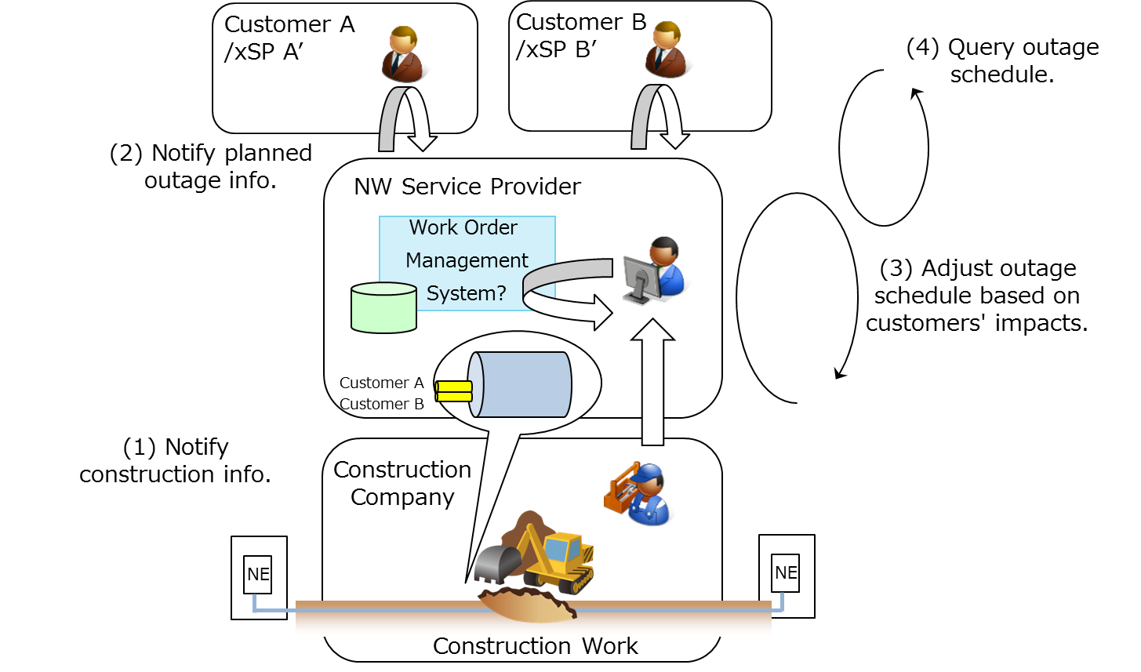

Fig.1. Example of planned service outage scenario

The Supplier has identified that the PR resolution will require disruption to common infrastructure /equipment serving other services owned by that Buyer. Other Buyers’ services are not affected. The Supplier requests permission to disrupt those services at a specified date/time, which the Buyer authorizes or rejects.

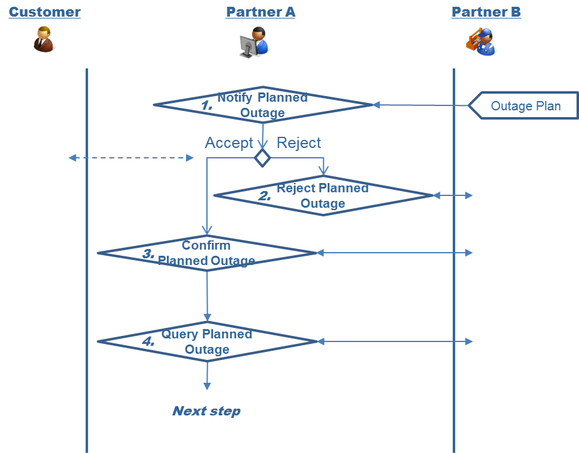

Fig.3. Example of planned service outage scenario

# RESOURCE MODEL

## Managed Entity and Task Resource Models

### Change request Resource

**Resource Model**



Fig.3. Change Request Resource

**Field descriptions**

*Attachment fields*

A document or other file attached to the information about a Change Request to help explain the change being implemented as part of this Change Request.

|  |  |
| --- | --- |
| dateTime | A String. Date and time of the attachment generated. |
| description | A String. The description of the attachment. |
| href | A String. Reference of the attachment. |
| id | A String. Identifier of the attachment. |
| relatedPartyRef | Defines parties which are involved in the change request and the role they are playing. It may be the customer, operator or 3rd party. |

*ChangeRequest fields*

Change Request is a type of request which can be used for the management and control of Change Management process between a customer and a service provider or between a service provider and a partner and vice versa.

|  |  |
| --- | --- |
| actualEndTime | A DateTime. Date and time when the change implementation is finished actually. |
| actualStartTime | A DateTime. Date and time when the change implementation is started actually. |
| budget | A string. The budget reserved for the change. |
| category | A String. The Category of change request |
| channel | A String. A channel represents the way the Change Request was created |
| completionDate | A DateTime. Date and time when the change request is confirmed to be completed |
| currency | A String. The used currency related with cost |
| description | A String. Description of the change request. |
| externalId | A String. ID given by the requestor to facilitate the relationship set up and searches afterwards) |
| href | A String. Hyperlink to access a change request |
| id | A String. Identifier of a Change Request, it is created on repository side (Change Management system). |
| impact | A String. Indicates how about the impact by this change |
| plannedEndTime | A DateTime. Date and time when the change implementation is planned to be finished. |
| plannedStartTime | A DateTime. Date and time when the change implementation is planned to be started. |
| priority | A String. A way that can be used by consumers to prioritize change request in Change Management system |
| requestDate | A DateTime. Date and time when the change request is raised |
| requestType | A String. Indicates the type of the change request. |
| risk | A String. The risk to implement this change request. |
| riskMitigationPlan | A String. The risk mitigation plan. |
| riskValue | A String. The additional cost if the risk will happen. |
| scheduledDate | A DateTime. Date and time that the schedule is made. |
| status | A String. Status of the change request and it’s a sub-state. |
| SLARef | A component that holds details of the SLA being applied to the change request. |
| changeRequestCharacteristic | Characteristics of the change request to instantiate or to modify |
| changeRequestSpecification | Defines a set of attributes related to Change Request. |
| workLog | A record of the work performed on the change request during the investigation and resolution process. |
| targetEntityRef | The entity which will be changed or configured while the change request is executed. |
| impactEntityRef | Defines the entities (product, service, resource, and other related objects) which will be impacted while the change request is executed. |
| relatedChangeRequestRef | An existing Change Request that has some form of correlation with the given Change Request. |
| location | The place at whcih the change request occurred. |
| note | Defines the additional information of the change request. |
| resolution | The way one or more change request has been implementation through a direct remedy or task. |
| relatedPartyRef | Defines parties which are involved in the change request and the role they are playing. It may be the customer, operator or 3rd party. |
| attachment | A document or other file attached to the information about a Change Request to help explain the change being implemented as part of this Change Request. |
| incident | An Incident is a record of an event that has altered the operational state of a entity (Resource, Service or Customer's Product). |

*ChangeRequestCharacteristic fields*

Characteristics of the change request to instantiate or to modify

|  |  |
| --- | --- |
| name | A String. Name of the characteristic. |
| value | A String. Value of the characteristic. |

*ChangeRequestSpecification fields*

Defines a set of attributes related to Change Request.

|  |  |
| --- | --- |
| description | A String. Description of the specification |
| href | A String. Hyperlink to access the specification. |
| id | A String. Identifier of the specification. |
| name | A String. Name of the specification. |
| validFor | A valid duration of a thing. |

*ImpactEntityRef fields*

Defines the entities (product, service, resource, and other related objects) which will be impacted while the change request is executed.

|  |  |
| --- | --- |
| description | A String. Description and analysis of the impact of the change request on the Product, Service or Resource. |
| href | A String. Hyperlink to access the impacted party, it could be a party reference or a party role reference. |
| id | A String. Identifier of impacted entity. |

*Incident fields*

An Incident is a record of an event that has altered the operational state of a entity (Resource, Service or Customer's Product).

|  |  |
| --- | --- |
| description | A String. The description of the incident. |
| name | A String. The name of the incident. |

*Location fields*

The place at whcih the change request occurred.

|  |  |
| --- | --- |
| address | A String. The detail address of the location. |
| postCode | A String. The post code of an address. |

*Note fields*

Defines the additional information of the change request.

|  |  |
| --- | --- |
| author | A String. Indicates who provides the description. |
| dateTime | A DateTime. Date and time when the description was inputted. |
| text | A String. The additional description. |

*Record fields*

A record in a worklog.

|  |  |
| --- | --- |
| dateTime | A String. The date time that a record is generated. |
| description | A String. The detail description in a record. |
| supportPerson | A String. The person who logged that record. |

*RelatedChangeRequestRef fields*

An existing Change Request that has some form of correlation with the given Change Request.

|  |  |
| --- | --- |
| correlation | A String. The correlation between two change requests |
| description | A String. Description of a change request. |
| href | A String. Hyper link to access a change request. |
| id | A String. Identifier of an Change Request |

*RelatedPartyRef fields*

Defines parties which are involved in the change request and the role they are playing. It may be the customer, operator or 3rd party.

|  |  |
| --- | --- |
| contactInfo | A String. Contact information of the party. |
| href | A String. Hyperlink to access a related party. |
| id | A String. Identifier of a related party. |
| name | A String. Name of related party. |
| role | A String. Role of related Party. |

*Resolution fields*

The way one or more change request has been implementation through a direct remedy or task.

|  |  |
| --- | --- |
| code | A String. The resolution's code, it can be configured as a multiple level hierarchy. |
| description | A String. The description of the resolution. |
| name | A String. The name of the resolution |
| task | A step or task along in the process of implementation a Change Request. |

*SLARef fields*

A component that holds details of the SLA being applied to the change request.

|  |  |
| --- | --- |
| description | A String. Description of a SLA |
| href | A String. Hyper link to a SLA |
| id | A String. Identifier of a SLA |
| name | A String. The name of a SLA |

*TargetEntityRef fields*

The entity which will be changed or configured while the change request is executed.

|  |  |
| --- | --- |
| description | A String. The description to the related party. |
| href | A String. Hyperlink to access the target entity. |
| id | A String. Identifier of target entity |

*Task fields*

A step or task along in the process of implementation a Change Request.

|  |  |
| --- | --- |
| description | A String. The description of the task. |
| name | A String. The name of the task. |
| state | A String. The state of the task. |

*ValidFor fields*

A valid duration of a thing.

|  |  |
| --- | --- |
| endDateTime | A DateTime. The end date and time. |
| startDateTime | A DateTime. The start date and time. |

*WorkLog fields*

A record of the work performed on the change request during the investigation and resolution process.

|  |  |
| --- | --- |
| creatDateTime | A DateTime. Date and time of worklog generated. |
| description | A String. The description of the worklog. |
| lastUpdateDateTime | A DateTime. Date and time when the worklog updated. |
| Record | A record in a worklog. |

**JSON representation sample**

We provide below the JSON representation of an example of Change Request Resource object:

|  |
| --- |
| {  "id": "20",  "href": "http://serverlocation:port/changeManagement/changeRequest/20",  "actualEndTime": "2013-04-19T16:42:23+0800",  "actualStartTime": "2013-04-19T16:42:23+0800",  "budget": "1000",  "category": "The Name",  "channel": "web",  "completionDateTime": "2013-04-19T16:42:23+0800",  "currency": "$",  "description": "the description of change request",  "externalId": "ChangeRequest_22",  "impact": "Non-service affecting",  "planedEndTime": "2013-04-19T16:42:23+0800",  "planedStartTime": "2013-04-12T16:42:23+0800",  "priority": "Critical ",  "requestDate": "2013-04-12T16:42:23+0800",  "requestType": "Normal",  "risk": "only 2 engineers have the knowledge to execute the task",  "riskMitigationPlan": "document encoding with base64",  "riskValue": "500",  "scheduledDateTime": "2013-04-12T16:42:23+0800",  "status": "Scheduled for Approval",  "SLARef":[  {  "id": "2",  "href": "http://serverlocation:port/SLAManagement/SLA/2",  "description": "SLA description",  "name": "name2"  },  {  "id": "3",  "href": "http://serverlocation:port/SLAManagement/SLA/3",  "description": "SLA description",  "name": "name3"  }  ],  "changeRequestCharacteristic": [  {  "name": "additionalRequest",  "value": "text"  },  {  "name": "test",  "value": "text"  }  ],  "changeRequestSpecification": {  "id": "20",  "href": "http://serverlocation:port/changeManagement/changerequestspecification/20",  "name": "ChangeRequestSpec_SiteMaintenance",  "description": "Change Request Specification for Site Maintenance",  "validFor":  {  "startDateTime": "2013-04-12T16:42:23+0800",  "endDateTime": "2018-04-12T16:42:23+0800"  }  },  "workLog": {  "description": "approved by email from Jack",  "creatDateTime": "2015-10-23T08:00:06+0800",  "creatDateTime": "2015-10-24T08:00:06+0800",  "record": [  {  "dateTime": "2015-10-23T08:00:06+0800",  "description": "receive the change request",  "supportPerson": "Bob"  },  {  "dateTime": "2015-10-24T08:00:06+0800",  "description": "Scheduled for Approval",  "supportPerson": "Bob"  },  ]  },  "targetEntity": [  {  "id": "11",  "href": "http://serverlocation:port/serviceInventory/11",  "description": "This is the target"  }  ],  "impactedEntity": [  {  "id": "12",  "href": "http://serverlocation:port/serviceInventory/12",  "description": "This is a related entity"  },  {  "id": "13",  "href": "http://serverlocation:port/serviceInventory/13",  "description": "This is a related entity"  }  ],  "relatedChangeRequestRef": [  {  "id": "19",  "href": "http://serverlocation:port/changeManagement/changeRequest/19",  "description": "the former change request",  "correlation": "former",  }  ],  "location": {  "address": "The address of the location",  "postCode": "the post code of the location"  },  "note": [  {  "text": "CreatedBy John at 2015-10-23T08: 00: 05+0800",  "dateTime": "2015-10-23T08: 00: 05+0800",  "author": "John"  },  {  "text": "Approved Smith at 2015-10-23T08: 00: 06+0800",  "dateTime": "2015-10-23T08: 00: 06+0800",  "author": "Smith"  }  ],  "relatedParty": [  {  "role": "requestor",  "id": "100",  "href": "http://serverlocation:port/partyManagement/customer/100",  "name": "John Doe",  "contactInfo":  {  "email": "myAddress@hotmail.com",  "phone": "+861088888889"  }  },  {  "role": "currentHandler",  "id": "101",  "href": "http://serverlocation:port/partyManagement/customer/101",  "name": "Pierre",  "contactInfo": {  "email": "myAddress@hotmail.com",  "phone": "+861088888888"  }  }  ],  "resolution": {  "code": "223-112-21-23",  "description": "need to pause the network",  "name": "pause network",  "task": [  {  "description": "pause the netwrok",  "name": "pause",  "state": "plan to do",  }  ]  },  "attachment": [  {  "id": "121",  "href": "http://serverlocation:port/contenetManagement/file/121",  "dateTime": " 2015-10-23T08: 00: 06+0800",  "type": "file",  "description": "Approval mail from Jack",  "relatedParty": {  "role": "requestor",  "id": "100",  "href": "http://serverlocation:port/partyManagement/operator/100",  "name": "John Doe"  }  },  {  "id": "122",  "href": "http://serverlocation:port/contenetManagement/file/122",  "dateTime": " 2015-10-23T08: 00: 06+0800",  "type": "file",  "description": "Impact estimation document",  "relatedParty": {  "role": "requestor",  "id": "100",  "href": "http://serverlocation:port/partyManagement/operator/100",  "name": "John Doe"  }  }  ],  "incident": {  "description": "prepare to pause a network",  "name": "preparation",  "impactEntity": [  {  "id": "11",  "href": "http://serverlocation:port/serviceInventory/11",  "description": "This is the target that need to be pause"  }  ]  }  } |

### Change Request lifecycle

Here is the state machine diagram for a change request. Each change request states are described in the tab below.



|  |  |
| --- | --- |
| New | The Change Request is submitted. |
| Request for Authorization | The Change Request is waiting authorization |
| Schduled for Approval | The Change Request is scheduled and waiting the approval for execution |
| Pending for Implementation | The Change Request is approved and waiting for execution according pre-defined schedule. |
| Post Implementation Review | The Change Request is executed and waiting the review for result |
| Fallback Execution | The result is not successful and needs to fallback |
| Cancelled | The Change Request is cancelled |
| Closed | The Change Request is closed after review. |

## Notification Resource Models

3 notifications are defined for this API

Notifications related to ChangeRequest:  
 - ChangeRequestCreationNotification  
 - ChangeRequestAttributeValueChangeNotification  
 - ChangeRequestRemoveNotification

The notification structure for all notifications in this API follow the pattern depicted by the figure below.  
A notification resource (depicted by "SpecificNotification" placeholder) is a sub class of a generic Notification structure containing an id of the event occurence (eventId), an event timestamp (eventTime), and the name of the notification resource (eventType).   
This notification structure owns an event structure ("SpecificEvent" placeholder) linked to the resource concerned by the notification using the resource name as access field ("resourceName" placeholder).

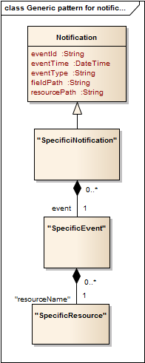

### Change Request Creation Notification

Notification sent when a new ChangeRequest resource is created.

**Json representation sample**

We provide below the json representation of an example of a 'ChangeRequestCreationNotification' notification object

|  |
| --- |
| {  "eventId":"00004",  "eventTime":"2016-03-01T16:42:25",  "eventType":"ChangeRequestCreationNotification",  "event": {  "ChangeRequest" :   {-- SEE ChangeRequest RESOURCE SAMPLE --}  } } |

### Change Request Attribute Value Change Notification

Notification sent when changing an attribute of a ChangeRequest resource.

**Json representation sample**

We provide below the json representation of an example of a 'ChangeRequest AttributeValueChangeNotification' notification object

|  |
| --- |
| {  "eventId":"00005",  "eventTime":"2016-03-02T16:42:25",  "eventType":" ChangeRequest AttributeValueChangeNotificationNotification",  "event": {  "ChangeRequest" :   {-- SEE ChangeRequest RESOURCE SAMPLE --}  } } |

### Change Request Remvoe Notification

Notification sent when changing an attribute of a ChangeRequest resource.

**Json representation sample**

We provide below the json representation of an example of a 'ChangeRequestRevmoveNotification' notification object

|  |
| --- |
| {  "eventId":"00005",  "eventTime":"2016-03-02T16:42:25",  "eventType":" ChangeRequestRevmoveNotification",  "event": {  "ChangeRequest" :   {-- SEE ChangeRequest RESOURCE SAMPLE --}  } } |

# API OPERATIONS

Remember the following Uniform Contract:

|  |  |  |
| --- | --- | --- |
| Operation on Entities | Uniform API Operation | Description |
| Query Entities | GET Resource | GET must be used to retrieve a representation of a resource. |
| Create Entity | POST Resource | POST must be used to create a new resource |
| Partial Update of an Entity | PATCH Resource | PATCH must be used to partially update a resource |
| Complete Update of an Entity | PUT Resource | PUT must be used to completely update a resource identified by its resource URI |
| Remove an Entity | DELETE Resource | DELETE must be used to remove a resource |
| Execute an Action on an Entity | POST on TASK Resource | POST must be used to execute Task Resources |
| Other Request Methods | POST on TASK Resource | GET and POST must not be used to tunnel other request methods. |

Filtering and attribute selection rules are described in the TMF REST Design Guidelines.

Notifications are also described in a subsequent section.

## Operations on Change Request

### List Change request

**GET /ChangeRequest?fields=...&{filtering}**

**Description**

This operation list Change Request entities.  
Attribute selection is enabled for all first level attributes.  
Filtering may be available depending on the compliance level supported by an implementation.

**Usage Samples**

Here's an example of a request for retrieving ChangeRequest resources.

|  |
| --- |
| **Request** |
| GET /ChangeManagement/ChangeRequest/fields=id,href,targetEntity,impactedEntity&id=20 Accept: application/json |
| **Response** |
| 200  [  {  "id": "20",  "href": "http://serverlocation:port/changeManagement/changeRequest/20",  "targetEntity": [  {  "id": "11",  "href": "http://serverlocation:port/serviceInventory/11",  "description": "This is the target"  }  ],  "impactedEntity": [  {  "id": "12",  "href": "http://serverlocation:port/serviceInventory/12",  "description": "This is a related entity"  },  {  "id": "13",  "href": "http://serverlocation:port/serviceInventory/13",  "description": "This is a related entity"  }  ]  } ] |

### Retrieve Change Request

**GET /ChangeRequest/{id}?fields=...&{filtering}**

**Description**

This operation retrieves a Change Request entity.  
Attribute selection is enabled for all first level attributes.  
Filtering on sub-resources may be available depending on the compliance level supported by an implementation.

**Usage Samples**

Here's an example of a request for retrieving a ChangeRequest resource.

|  |
| --- |
| **Request** |
| GET /ChangeManagement/ChangeRequest/19?fields=href,id,description Accept: application/json |
| **Response** |
| 200  {  "href": "https://host:port/ChangeManagement/ChangeRequest/19",  "id": "19",  "description:": " the description of change request"  } |

### Create Change Request

**POST /ChangeRequest**

**Description**

This operation creates a Change Request entity.

**Mandatory and Non Mandatory Attributes**

The following tables provides the list of mandatory and non mandatory attributes when creating a ChangeRequest, including any possible rule conditions and applicable default values.

|  |  |
| --- | --- |
| Mandatory Attributes | Rule |
| status |  |
| id | Automatically generated |
| href | Automatically generated |
| priority |  |
| targetEntityRef |  |
| changeRequestSpecification |  |

**Additional Rules**

The following table provides additional rules indicating mandatory attributes in sub-resources or relationships when creating a ChangeRequest resource.

|  |  |
| --- | --- |
| Object | Mandatory Attributes |
| Attachment | "href","id" |
| ChangeRequestCharacteristic | "name","value" |
| ChangeRequestSpecification | "href","id" |
| ImpactEntityRef | "href","id" |
| Record | "dateTime" |
| RelatedChangeRequestRef | "id","href" |
| RelatedPartyRef | "href", "id" |
| Resolution | "name","description" |
| SLARef | "id","href" |
| TargetEntityRef | "href","id" |
| ValidFor | "startDateTime","endDateTime" |
| Worklog | "creatDateTime" |

**Usage Samples**

Here's an example of a request for creating a ChangeRequest resource. In this example the request only passes mandatory attributes.

|  |
| --- |
| **Request** |
| POST /ChangeManagement/ChangeRequest Content-Type: application/json  {  "status": "New",  "priority": "Critical ",  "changeRequestSpecification": {  "id": "21",  "href": "http://serverlocation:port/changeManagement/changerequestspecification/21",  "name": "ChangeRequestSpec_SiteMaintenance",  "description": "Change Request Specification for Site Maintenance",  "validFor":  {  "startDateTime": "2013-04-12T16:42:23+0800",  "endDateTime": "2018-04-12T16:42:23+0800"  }  },  "targetEntity": [  {  "id": "12",  "href": "http://serverlocation:port/serviceInventory/12",  "description": "This is the target"  }  ],  } |
| **Response** |
| 201  {  "id": "21",  "href": "http://serverlocation:port/changeManagement/changeRequest/21",  "status": "New",  "priority": "Critical ",  "changeRequestSpecification": {  "id": "21",  "href": "http://serverlocation:port/changeManagement/changerequestspecification/21",  "name": "ChangeRequestSpec_SiteMaintenance",  "description": "Change Request Specification for Site Maintenance",  "validFor":  {  "startDateTime": "2013-04-12T16:42:23+0800",  "endDateTime": "2018-04-12T16:42:23+0800"  }  },  "targetEntity": [  {  "id": "12",  "href": "http://serverlocation:port/serviceInventory/12",  "description": "This is the target"  }  ],  } |

### Patch Change Request

**PATCH /ChangeRequest/{id}**

**Description**

This operation allows partial updates of a Change Request entity. Support of json/merge (https://tools.ietf.org/html/rfc7386) is mandatory, support of json/patch (http://tools.ietf.org/html/rfc5789) is optional.  
  
Note: If the update operation yields to the creation of sub-resources or relationships, the same rules concerning mandatory sub-resource attributes and default value settings in the POST operation applies to the PATCH operation. Hence these tables are not repeated here.

**Patchable and Non Patchable Attributes**

The tables below provide the list of patchable and non patchable attributes, including constraint rules on their usage.

|  |  |
| --- | --- |
| Non Patchable Attributes | Rule |
| id |  |
| href |  |

**Usage Samples**

Here's an example of requests for patching a ChangeRequest resource.

Changing the status to 'prospective' (using json-merge)

|  |
| --- |
| **Request** |
| PATCH /ChangeManagement/ChangeRequest/21 Content-Type: application/merge-patch+json  {  "status": "Request for Authorization" } |
| **Response** |
| 201  {  "id": "21",  "href": "http://serverlocation:port/changeManagement/changeRequest/21",  "status": "Request for Authorization",  "priority": "Critical ",  "changeRequestSpecification": {  "id": "21",  "href": "http://serverlocation:port/changeManagement/changerequestspecification/21",  "name": "ChangeRequestSpec_SiteMaintenance",  "description": "Change Request Specification for Site Maintenance",  "validFor":  {  "startDateTime": "2013-04-12T16:42:23+0800",  "endDateTime": "2018-04-12T16:42:23+0800"  }  },  "targetEntity": [  {  "id": "12",  "href": "http://serverlocation:port/serviceInventory/12",  "description": "This is the target"  }  ],  } |

### Delete Change Request

**DELETE /ChangeRequest/{id}**

*Note: this operation is available only to ADMIN API users*

**Description**

This operation deletes a Change Request entity.

**Usage Samples**

Here's an example of a request for deleting a ChangeRequest resource.

|  |
| --- |
| **Request** |
| DELETE /ChangeManagement/ChangeRequest/21 |
| **Response** |
| 204 |

# API NOTIFICATIONS

For every single of operation on the entities use the following templates and provide sample REST notification POST calls.

It is assumed that the Pub/Sub uses the Register and UnRegister mechanisms described in the REST Guidelines reproduced below.

## Register listener

**POST /hub**

**Description**

Sets the communication endpoint address the service instance must use to deliver information about its health state, execution state, failures and metrics. Subsequent POST calls will be rejected by the service if it does not support multiple listeners. In this case DELETE /api/hub/{id} must be called before an endpoint can be created again.

**Behavior**

Returns HTTP/1.1 status code 204 if the request was successful.

Returns HTTP/1.1 status code 409 if request is not successful.

**Usage Samples**

Here's an example of a request for registering a listener.

|  |
| --- |
| **Request** |
| POST /api/hub  Accept: application/json  {"callback": "http://in.listener.com"} |
| **Response** |
| 201  Content-Type: application/json  Location: /api/hub/42  {"id":"42","callback":"http://in.listener.com","query":null} |

## Unregister listener

**DELETE /hub/{id}**

**Description**

Clears the communication endpoint address that was set by creating the Hub..

**Behavior**

Returns HTTP/1.1 status code 204 if the request was successful.

Returns HTTP/1.1 status code 404 if the resource is not found.

**Usage Samples**

Here's an example of a request for un-registering a listener.

|  |
| --- |
| **Request** |
| DELETE /api/hub/42  Accept: application/json |
| **Response** |
| 204 |

## Publish Event to listener

**POST /client/listener**

**Description**

Clears the communication endpoint address that was set by creating the Hub.

Provides to a registered listener the description of the event that was raised. The /client/listener url is the callback url passed when registering the listener.

**Behavior**

Returns HTTP/1.1 status code 201 if the service is able to set the configuration.

**Usage Samples**

Here's an example of a notification received by the listener. In this example “EVENT TYPE” should be replaced by one of the notification types supported by this API (see Notification resources Models section) and EVENT BODY refers to the data structure of the given notification type.

|  |
| --- |
| **Request** |
| POST /client/listener  Accept: application/json  {  "event": {  EVENT BODY  },  "eventType": "EVENT_TYPE"  } |
| **Response** |
| 201 |

For detailed examples on the general TM Forum notification mechanism, see the TMF REST Design Guidelines.

# Acknowledgements

## Release History

|  |  |  |  |
| --- | --- | --- | --- |
| **Release Number** | **Date** | **Release led by:** | **Description** |
|  |  |  |  |

## Contributors to Document

|  |  |
| --- | --- |
| Nicoleta Stoica | Vodafone |
| Kuang Chunguang | Huawei |
| Jiang Yisong | Huawei |