**Communication  
API REST Specification**

**Document Number TMF681**

**November 2017**

|  |  |
| --- | --- |
| **Release: Frameworx Release 17.5** | **Status: Member Evaluation** |
| **Version: 1.1.0** | **IPR Mode: RAND** |

# NOTICE

Copyright © TM Forum 2017. All Rights Reserved.

This document and translations of it may be copied and furnished to others, and derivative works that comment on or otherwise explain it or assist in its implementation may be prepared, copied, published, and distributed, in whole or in part, without restriction of any kind, provided that the above copyright notice and this section are included on all such copies and derivative works. However, this document itself may not be modified in any way, including by removing the copyright notice or references to TM FORUM, except as needed for the purpose of developing any document or deliverable produced by a TM FORUM Collaboration Project Team (in which case the rules applicable to copyrights, as set forth in the [TM FORUM IPR Policy](http://www.tmforum.org/IPRPolicy/11525/home.html), must be followed) or as required to translate it into languages other than English.

The limited permissions granted above are perpetual and will not be revoked by TM FORUM or its successors or assigns.

This document and the information contained herein is provided on an "AS IS" basis and TM FORUM DISCLAIMS ALL WARRANTIES, EXPRESS OR IMPLIED, INCLUDING BUT NOT LIMITED TO ANY WARRANTY THAT THE USE OF THE INFORMATION HEREIN WILL NOT INFRINGE ANY OWNERSHIP RIGHTS OR ANY IMPLIED WARRANTIES OF MERCHANTABILITY OR FITNESS FOR A PARTICULAR PURPOSE.

Direct inquiries to the TM Forum office:

4 Century Drive  
Suite 100  
Parsippany, NJ 07054, USA

Tel No.  +1 973 944 5100

Fax No.  +1 973 944 5110

TM Forum Web Page: [www.tmforum.org](http://www.tmforum.org/)

# Table of Contents

NOTICE 2

Table of Contents 3

List of Tables 5

Introduction 6

Mapping with SID ABE 7

Mapping with eTOM Process 7

Distinction between this API and Event Management API 8

Distinction between this API and Change Request API 10

SAMPLE USE CASES 14

Case1: Communication with Customer 14

Case2: Communication with Agent (CSR) 15

RESOURCE MODEL 17

Managed Entity and Task Resource Models 17

Communication Message Resource Model 17

Field Descriptions 17

Example of the resource 20

Notification Resource Models 22

Communication Message Creation Notification 22

Communication Message Deletion Notification 22

Communication Message Update Notification 23

API OPERATION TEMPLATES 24

Communication Message Creation 24

Communication Message Sending (Send New Message) 27

Communication Message Sending (Send Pre-defined Message) 28

Communication Message Enquiry 29

Communication Message Deletion 30

Communication message Update 31

API NOTIFICATIOn TEMPLATES 33

REGISTER LISTENER POST /hub 33

UNREGISTER LISTENER DELETE hub/{id} 33

publish {EventTYPE} POST /listener 34

release history 35

Contributors to Document 36

# List of Tables

N/A

# Introduction

The following document is the specification of the REST API for Communication message. It includes the model definition as well as all available operations.

It provides a standardized mechanism for Communication management such as creation, update, retrieval, deletion and notification of the system communication events.

Communication API manages the following data resources:

* **Communication Message**
  + Communication message means a notification approach in the format of a message which can be dispatched (sent) to the certain user by the system with the content which can be felt and understood by the recipient. The user can be either a final customer or a customer service agent. The message can reach the customer in different interaction channels, including: email, short message, mobile app notification (push).

Normally the communication is implemented as a common shared service for all the IT applications. Whenever there is an application which needs to manage or send the message to the customer, this application can invoke the “communication” API to dispatch the notification.

To help clarify the concept of “communication API”, here all the possible “man-machine” contact approaches are listed as below.  The “tick” shows the interaction types for which the “communication API” is designed to support.

|  |  |
| --- | --- |
| **Business Interaction Method** | **Communication API Related** |
| SMS to customer | **√** |
| Email to customer | **√** |
| Mobile app push message to customer | **√** |
| Proactive calling to the customer  (human initiated, i.e. person-call-person) |  |
| Proactive calling to the customer  (system initiated, i.e. machine-call-person) |  |
| Face to face contact |  |
| Customer browsing web page, open mobile app, calling IVR etc |  |

Communication API performs the following operation on the resource of “Communication Message”. There are two types of operations provided in this API. One is the management of the request message body. Another is for sending the communication message to the customer.

*Operations for Communication Message body management*

* Retrieval of an existing Communication Message depending on filter criteria
* Creation of a new Communication Message
* Partial update of an existing Communication Message
* Deletion of an existing Communication Message
* Notification of events:
  + Creation of Communication Message
  + Updating Communication Message
  + Deletion of Communication Message

*Operations for sending Communication Message.*

* Send a message, including:
  + Send a new message with the whole communication message body (POST operation)
  + Send a message with the predefined communication message body (POST operation)

Mapping with SID ABE

Communication Message is mapped to “*Business Interaction ABE::* *Notification ABE*” in TMF Information Framework (SID).

The Business Interaction ABE is illustrated as the diagram below:



Mapping with eTOM Process

Communication API can be mapped to the “Customer Interaction Management” in TM Forum Process Framework (eTOM).

The relevant process is: **Notify Customer**.

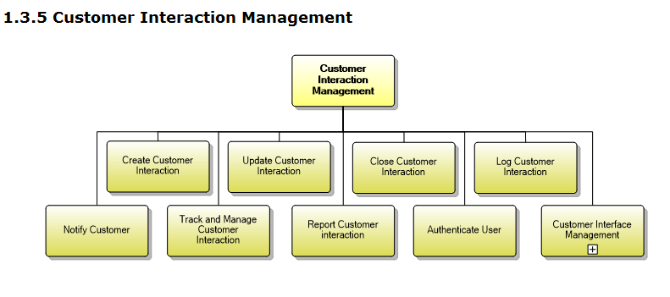

The definition of TM Forum Process Framework is:

**Category**: (3) eTOM Process Type

**Process Identifier**: 1.3.5.5

**Original Process Identifier**: 1.1.1.18.5

**Maturity Level**: 4

**Description**

Notify the customer when interesting events happen.

**Extended Description**

The purpose of this process is to notify the customer when events related to existing interactions or to significant customer experience happen. Some notifications can be sent immediately using interactive media (such as SMS, Push to applications, etc.) and other notifications can be sent later using asynchronous media such as mail

Distinction between this API and Event Management API

This API and Event Management API own some similarities.

The distinctions between them are explained in the table below:

|  |  |  |
| --- | --- | --- |
| **Comparison Points** | **Communication API** | **Event Management API** |
| **Definition** | Communication message means a message which can be dispatch (sent) to the certain user by the system in the format which can be felt and understood by the recipient | An Event represents a change in the state of a configuration item, service or business data entity |
| **User Role** | Sender: Enterprise (e.g. TelCo).  Receiver: Customer, agent, O&M staff | IT System.  No natural person (customer or agent) is involved. |
| **Business Scenario** | The enterprise needs to send the notification information to the customer or the agent.  Note: It is used to support the direct interaction with the users. | It can signal status changes or exceptions that allow the appropriate person or system to perform early response actions to ensure service performance and continuity or used as a trigger for automation run books.  Note: It is used to manage the intrinsic event inside the system. The event is always created in the EM backend referring to the internal Event Management system. |
| **Relevant IT System** | Interaction or contact module of the system | Any module inside the IT system |
| **Data Model** | Content of communication message. The content is visible to the user (customer, et al) | The description of how an event is triggered and handled.  It has no “content” to contain the concrete communication message information. The “related object” in this API does not distinctly express the meaning of content. The “related object” could be the “attachment” of the message.  It has no “sender” and “receiver” for the communication message information. The explanation of “related party” in this API has an example which is “assignee support group”. It shows this API parameter is used to depict who is the “event handler”. |
| **Information Framework (SID) Mapping** | Common Business Entities Domain  **Business Interaction ABE**  **Notification Entity**  A communication that informs about something that has or will happen. A Notification is typically one-sided, in that no Response is expected. A Notification can be created as the result of a Request. | Common Business Entities Domain  **Event ABE**  The Event ABE contains entities that are used to represent events, their occurrence and their recording within systems. |
| **Operation** | 1) CRUD of communication message in IT system, i.e., create, read, update and deletion.  2) Send the communication message to the user | Create event (i.e. trigger the event) in the system.  Query event  Update event |
| **Relationship** | In the widest conception, any system action can be an event, such as the creation of new offering, execution of order, adding one item into the shopping cart. On this level, the “communication message” is also an event.  In the narrow conception, event is for the technical terminology to describe the one-off change of the certain module, such as an event of “memory stack overflow” or “switch the web server”. Such event is collected by the Event Manager to monitor the status of whole running system.  According to the definition of Event Management API, this API focuses more on the second concept. “Communication” is also taking place in one-off mode, but it expresses the interactive human-machine contact instead of the pure system action. | |

Reference: Event Management API Data Model

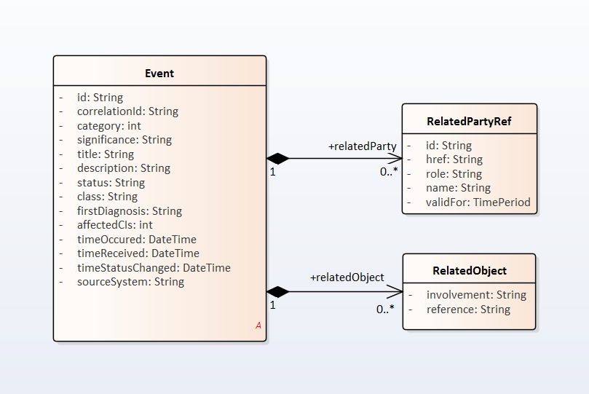

Distinction between this API and Change Request API

This API and Change Request API own some similarities.

The distinctions between them are explained in the table below:

|  |  |  |
| --- | --- | --- |
| **Comparison Points** | **Communication API** | **Event Management API** |
| **Definition** | Communication message means a message which can be dispatch (sent) to the certain user by the system in the format which can be felt and understood by the recipient | Change Management process is to respond to the customer’s changing business requirements.  The Change Management API provides the standard integration capabilities between external applications and Change Management Application |
| **User Role** | Sender: Enterprise (e.g. TelCo).  Receiver: Customer, agent, O&M staff | The involved roles of the API can be:   * Change Management Application * External application   No natural person (customer or agent) is involved. |
| **Business Scenario** | The enterprise needs to send the notification information to the customer or the agent.  Note: It is used to support the direct interaction with the users. | * Asset sharing * NFV MULTI-DIGITAL SERVICE PROVIDER offer the products * Manage Service of Network Operation or OSS |
| **Data Model** | Inherit from “Business Interaction”.  Content of communication message. The content is visible to the user (customer, et al). | Inherit from “Business Interaction”.  nota bene: The “Business Interaction” has a group of derivative objects. “Change Request” is mapped to “request” object, not “notification”.  Additionally, this API data model contains:   * Attachment: *This is also included in Communication API* * Related Party: The role which is involved. *This is also included in Communication API* * Target Entity, Impacted Entity: both are referred to “realted party”. * Work log * If the work log is a type of task for the staff to execute, it is not required in *Communication API* * If the work log is the pure log (record) of the system action, it is a default function of the system. *Communication API* has the “log flag” to indicate whether the log should be generated after invoking API. The detail of the log is not required to be explicitly expressed in *Communication API* * Note: It is an optional attribute. In *Communication API*, the “content” is used to describe the purpose of the communication message. |
| **Information Framework (SID) Mapping** | Common Business Entities Domain  **Business Interaction ABE**  **Notification Entity** | Common Business Entities Domain  **Business Interaction ABE** |
| **Operation** | 1) CRUD of communication message in IT system, i.e., create, read, update and deletion.  2) Send the communication message to the user | CRUD operations of the change request |

Reference: Change Request API Data Model



# SAMPLE USE CASES

Examples of use cases using Communication API is as following

Case1: Communication with Customer

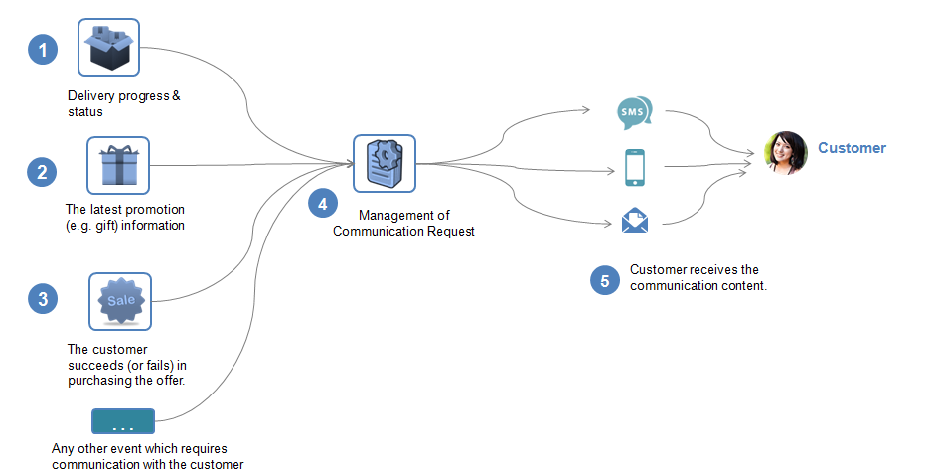

|  |  |
| --- | --- |
| Use Case Id | UC_TMF_CommunicationMessage_0001 |
| Use Case Name | Customer receives communication message. |
| Summary | This case describes the system manages the communication message and sends the communication message to the customer. |
| Actor(s) | Customer (person) |
| Pre-Conditions | NA |
| Begins When | When the sales/marketing/service or any other business activities requires notifying the customer, the application will initiates the communication message. |
| Description | 1. The system needs to notify the customer about the delivery progress & status. 2. The system needs to notify the customer about the latest promotion (e.g. gift) information. 3. The system needs to notify the customer about the result of purchasing the offer.   Or any other event happens which requires communication with the customer.   1. The system manages the Communication Message, such as the creation, modification, updating and deletion of the communication. 2. The system sends the communication and the customer receives the communication content. |
| Ends When | *In case of communication is done successfully:*  The customer will receive the message.  *In case of failure:*  The system records the failure and the customer cannot know the message. Normally the system will retry to send the message when the network or environment is available. |
| Post-Conditions |  |
| Exceptions |  |
| Traceability |  |

Case2: Communication with Agent (CSR)

|  |  |
| --- | --- |
| Use Case Id | UC_TMF_CommunicationMessage_0002 |
| Use Case Name | The agent (CSR staff) receives communication message. |
| Summary | This case describes the system manages the communication message and sends the communication message to the agent. |
| Actor(s) | Agent staff (person) |
| Pre-Conditions | NA |
| Begins When | When the sales/marketing/service or any other business activities requires notifying the agent, the application will initiates the communication message. |
| Description | The company needs to notify the agent that the latest SLA policy in the market has been published.  The agent needs to know such company rule (policy) and obey it when working. |
| Ends When | *In case of communication is done successfully:*  The agent will receive the message.  *In case of failure:*  The system records the failure and the customer cannot know the message. Normally the system will retry to send the message when the network or environment is available. |
| Post-Conditions |  |
| Exceptions |  |
| Traceability |  |

# RESOURCE MODEL

## Managed Entity and Task Resource Models

Communication Message Resource Model

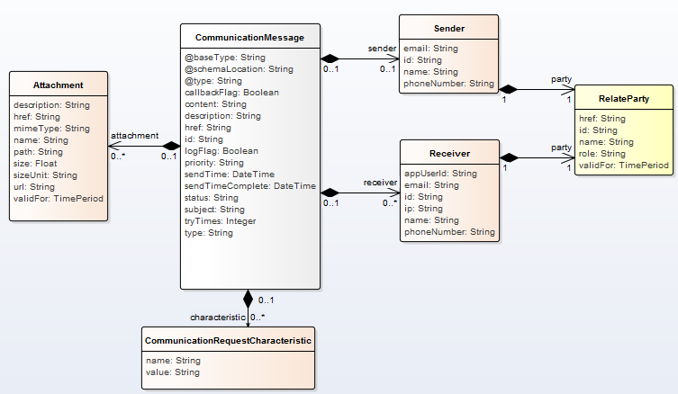

### Field Descriptions

“Business Interaction” is the inherited SID ABE of this API. So it is not shown in the API fields

| Parameter | Data Type | Description |
| --- | --- | --- |
| **@type** | String | It indicates the class type of the catalog. |
| **@schemaLocation** | String | It provides the link to the schema describing REST resource |
| **@baseType** | String | It indicates the base type of REST resource. |
| id | String | Unique identifier of Communication Message  (inherit from Business Interaction ABE) |
| href | String | Hypertext Reference of the Communication Message. |
| Priority | Integer | Priority level for applying this alteration among all the defined alterations . |
| Type | String | It could be  SMS, Email, “MobileApp” ( push notification) |
| Subject | String | The title of the message.  It is necessary for the email and mobile app push. |
| Content | String | The content of the communication message. |
| SendTime | DateTime | The time of sending communication message.  (inherit from Business Interaction ABE) |
| sendTimeComplete | DateTime | The time of completion of sending communication message.  (inherit from Business Interaction ABE) |
| status | String | Status of communication message  (inherit from Business Interaction ABE) |
| description | String | Description for the whole object  (inherit from Business Interaction ABE) |
| logFlag | Boolean | It is used to decide whether the contact log is need to be recorded. |
| callbackFlag | Boolean | It is used to decide whether the contact message needs to be replied. |
| tryTimes | Integer | If fail to send the communication message, how many times the system will retry. |
| ***CommunicationRequestCharacteristic*** | ***List of String*** | ***The values of parameters which are used in the content if the content contains them.*** |
| name | String | Content parameter identifier. |
| value | String | Content parameter value. |
| ***Sender*** | ***NA*** | ***Sender of the communication message.*** |
| email | String | Sender address of email, if the communication type is email |
| id | String | ID of the sender |
| name | String | Name of the sender |
| phoneNumber | String | Phone number of the sender, if the communication type is SMS. |
| ***Receiver*** | ***List of data objects*** | ***Receivers of the communication message.*** |
| appUserId | String | ID of the mobile app user |
| email | String | Receiver address of email, if the communication type is email |
| id | String | ID of the receiver |
| ip | String | IP address of the receiver |
| name | String | Name of the receiver |
| phoneNumber | String | Phone number of the receiver, if the communication type is SMS. |
| ***RelatedParty*** | ***NA*** | ***The party entity of the receiver (user)*** |
| id | String | Unique identifier of party  (inherit from Business Interaction ABE) |
| href | String | Hypertext Reference of the party |
| name | String | name of the party |
| role | String | role of the party (customer, partner, etc) |
| validFor | TimePeriod | Validity period of the party |
| ***Attachment*** | ***List of data objects*** | ***The attachments of the communication message (when it is email type).*** |
| name | String | The name of attached file in the communication message. |
| Path | String | The path of the attached file in the communication message. |
| description | String | Description of the attached file |
| Href | String | href of the attached file |
| mimeType | String | Multi-purpose Internet Mail Extensions Type |
| Size | Float | Size of the attached file |
| sizeUnit | String | Size Unit of the attached file |
| URL | String | URL of the attached file |
| validFor | TimePeriod | “Valid For” period of the attached file |

### Example of the resource

|  |
| --- |
| {  “id”:”1001”, “href”:"http://serverlocation:port/communicationMessage/v1/communicationMessage/564",  “type” : “1”,  “priority”: “1”,  “subject” : “News: the latest promotion for you”,  “sendTime”: “2016-12-19 T04:00:00.0Z”,  “sendTimeComplete”: “2016-12-19 T05:00:00.0Z”,  “status”: ‘Completed’,  “description”: “this is communication message for promotion”,  “content” : “Dear $Parameter1, Here is the information of the promotion $Parameter2”,  "@type": "communication",  "@schemaLocation":"http://serverlocation:port/ communication /schema/ communication.yml",  "@baseType": "",  “contactLogFlag”:”false”,  “callbackFlag” :”true”,  “tryTimes” :”3”  “CommunicationRequestCharacteristic”:[  {  {“name”: “$Parameter1”,  “value”: “Mr. Bush”  } ,  {  “Name”: “$Parameter2”,  “value”: “4G_LTE Discount 30%”  }  ],  “attachment” : [{  “path”: “/attachedfile/1, /attachedfile/”,  “name”: “File_XYZ_001”  }],    " sender": {  “id”:”10099”,  “name” :”ABC Company”,  “phoneNumber” :”10086”  },  "receiver":[ {  “id”:”10234”,  “name” :”Customer”,  “phoneNumber” :”008613811112222”  "relatedParty": {  "id": "991",  "href": "http://serverlocation:port/partyManagement/individual/1",  "role": "customer",  "name": "John Lock"  },  }]    } |
|  |

## Notification Resource Models

### Communication Message Creation Notification

It is used to notify that a Communication Message is created.

|  |
| --- |
| {  "eventType": " CommunicationMessageCreationNotification",  "eventTime": "2014-09-27T05:46:25.0Z",  "eventId": "8976",  "event":  {  "CommunicationMessage": [  {  "Id":"s1234",  *Following a whole representation of the Communication Message resource with all its attributes.*  *Refer to communication message Resource.*  }  ] }  } |

### Communication Message Deletion Notification

It is used to notify that a Communication Message is deleted.

|  |
| --- |
| {  "eventType": "CommunicationMessageDeletionNotification",  "eventTime": "2014-09-27T05:46:25.0Z",  "eventId": "8976",  "CommunicationMessage":{  "id":" s1234",  *Following a whole representation of the Communication Message resource with all its attributes.*  *Refer to Communication Message Resource.*  }  } |

### Communication Message Update Notification

|  |
| --- |
| {  "eventType": "CommunicationMessageUpdateNotification",  "eventTime": "2014-09-27T05:46:25.0Z",  "eventId": "8976",  "CommunicationMessage":{  "id":" s1234",  *Following a whole representation of the Communication Message resource with all its attributes.*  *Refer to Communication Message Resource.*  }  } |

# API OPERATION TEMPLATES

For every single of operation on the entities use the following templates and provide sample REST requests and responses.

Remember that the following Uniform Contract rules must be used:

|  |  |  |
| --- | --- | --- |
| Operation on Entities | Uniform API Operation | Description |
| Query Entities | GET Resource | GET must be used to retrieve a representation of a resource. |
| Create Entity | POST Resource | POST must be used to create a new resource |
| Partial Update of an Entity | PATCH Resource | PATCH must be used to partially update a resource  For reconciliation processes |
| Complete Update of an Entity | PUT Resource | PUT must be used to completely update a resource identified by its resource URI |
| Remove an Entity | DELETE Resource | DELETE must be used to remove a resource |

Filtering and attribute selection rules are described in the TMF REST Design Guidelines.

Notifications are also described in a subsequent section.

## Communication Message Creation

HTTP Verb + URI:

POST /communicationMessage

Description:

* This API is used to create a new Communication Message. The Communication Message is used to express the message itself. After the Communication Message has been created, it can be sent by the system to the “receiver” later.
* Condition:

There is no parameter in this POST verb URI

Behavior:

* Return Status Codes:

| Status Code | Description |
| --- | --- |
| 201 | The resource has been added successfully |
| 400 | Request Error |
| 500 | The server encountered an unexpected condition which prevented it from fulfilling the request |
| Other | The server may use other HTTP error status codes to reflect the error, the client must be processed in accordance with the error messages in other HTTP specification. |

Sample:

|  |
| --- |
| **REQUEST** |
| POST /communicationMessage  Content-type: application/json  {  “id”:”1001”,  “href”:"http://serverlocation:port/communicationMessage/v1/communicationMessage/56445633245",  “type” : “1”,  “priority”: “1”,  “subject” : “News: the latest promotion for you”,  “sendTime”: “2016-12-19 T04:00:00.0Z”,  “sendTimeComplete”: “2016-12-19 T05:00:00.0Z”,  “status”: ‘Completed’,  “description”: “this is communication message for promotion”,  “content” : “Dear $Parameter1, Here is the information of the promotion $Parameter2”,  “contactLogFlag”:”false”,  “callbackFlag” :”true”,  “tryTimes” :”3”,    “CommunicationRequestCharacteristic”:[  {  {“name”: “$Parameter1”,  “value”: “Mr. Bush”  } ,  {  “Name”: “$Parameter2”,  “value”: “4G_LTE Discount 30%”  }  ],  “attachment” : [{  “path”: “/attachedfile/1, /attachedfile/”,  “name”: “File_XYZ_001”  }],    " sender": {  “id”:”10099”,  “name” :”ABC Company”,  “phoneNumber” :”10086”  },  "receiver":[ {  “id”:”10234”,  “name” :”Customer”,  “phoneNumber” :”008613811112222”  "relatedParty": {  "id": "991",  "href": "http://serverlocation:port/partyManagement/individual/1",  "role": "customer",  "name": "John Lock"  },  }]    } |
| **RESPONSE** |
| 201  Content-Type: application/json  *Following a whole representation of the Communication Message resource with all its attributes.*  *Refer to Communication Message Resource.* |

## Communication Message Sending (Send New Message)

HTTP Verb + URI:

POST /communicationMessage/send

Description:

* This API is used to send a new Communication message from the “sender” to the “receiver”.

When executing this API, the message will be directly sent to the receiver, i.e., the final customer.

The full message body and attributes should be filled in this operation request.

* Condition:

The parameter of POST is “send” to indicate this operation is for the “sending message” action.

Behavior:

* Return Status Codes:

| Status Code | Description |
| --- | --- |
| 200 | The message of communication message has been sent. |
| 400 | Request Error |
| 500 | The server encountered an unexpected condition which prevented it from fulfilling the request |
| Other | The server may use other HTTP error status codes to reflect the error, the client must be processed in accordance with the error messages in other HTTP specification. |

Sample:

|  |
| --- |
| **REQUEST** |
| POST /communicationMessage/send  Content-type: application/json  *The following is a whole representation of the Communication Message resource with all its attributes.*  *Please refer to the Communication Message Creation” for the content of example.* |
| **RESPONSE** |
| 200 |

## Communication Message Sending (Send Pre-defined Message)

HTTP Verb + URI:

POST /communicationMessage/{id}/send

Description:

* This API is used to send a pre-defined Communication message from the “sender” to the “receiver”.

When executing this API, the message will be sent to the receiver, i.e., the final customer.

In this mode, the message body should be created in advance. The “Communication Message Creation” needs to be invoked firstly, so the system can send the pre-defined message.

* Condition:

The parameter of POST is “send” to indicate this operation is for the “sending message” action.

Behavior:

* Return Status Codes:

| Status Code | Description |
| --- | --- |
| 200 | The message of communication message has been sent. |
| 400 | Request Error |
| 500 | The server encountered an unexpected condition which prevented it from fulfilling the request |
| Other | The server may use other HTTP error status codes to reflect the error, the client must be processed in accordance with the error messages in other HTTP specification. |

Sample:

|  |
| --- |
| **REQUEST** |
| POST /communicationMessage/1001/send  Content-type: application/json |
| **RESPONSE** |
| 200 |

## Communication Message Enquiry

HTTP Verb + URI:

GET /communicationMessage /{id}

Description:

* This API is used to query an existing pre-defined message body by query conditions

Behavior:

* Return Status Codes:

| Status Code | Description |
| --- | --- |
| 200 | The resource has been retrieved |
| 404 | If no record was found |
| 500 | The server encountered an unexpected condition which prevented it from fulfilling the request |
| Others | The server may use other HTTP error status codes to reflect the error, the client must be processed in accordance with the error messages in other HTTP specification. |

|  |
| --- |
| **REQUEST** |
| GET /communicationMessage/11006  Content-type: application/json  Accept: application/json |
| **RESPONSE** |
| 200  Content-Type: application/json  *Following a whole representation of the Communication Message resource with all its attributes.*  *Refer to Communication Message Resource.* |

## Communication Message Deletion

HTTP Verb + URI:

DELETE /communicationMessage/{id}

Description:

* This API is used to delete an existing pre-defined message body.

Behavior:

* Return Status Codes：

| Status Code | Description |
| --- | --- |
| 204 | Delete the communication message successfully |
| 400 | Request Error |
| 404 | If no record was found |
| 500 | The server encountered an unexpected condition which prevented it from fulfilling the request |
| Others | The server may use other HTTP error status codes to reflect the error, the client must be processed in accordance with the error messages in other HTTP specification. |

|  |
| --- |
| **REQUEST** |
| DELETE / communicationMessage/1006  Content-type: application/json |
| **RESPONSE** |
| 204 |

## Communication message Update

HTTP Verb + URI:

PATCH /communicationMessage/{id}

Description:

* This API is used to partially update an existing pre-defined message body.

Behavior:

* Return Status Codes：

| Status Code | Description |
| --- | --- |
| 201 | Update the communication message successfully |
| 400 | Request Error |
| 404 | If no record was found |
| 500 | The server encountered an unexpected condition which prevented it from fulfilling the request |
| Others | The server may use other HTTP error status codes to reflect the error, the client must be processed in accordance with the error messages in other HTTP specification. |

|  |
| --- |
| **REQUEST** |
| PATCH / communicationMessage/1006  Content-type: application/json  {  “lifycycleStatus”: “Release”,  “name”: “Gift_On_Birthday”  } |
| **RESPONSE** |
| 201  Content-Type: application/json    *Following a whole representation of the communication message resource with all its attributes.*  *Refer to communication message Resource.* |

# API NOTIFICATIOn TEMPLATES

For every single of operation on the entities use the following templates and provide sample REST notification POST calls.

It is assumed that the Publish/Subscribe uses the Register and UnRegister mechanisms described in the REST Guidelines reproduced below.

## REGISTER LISTENER POST /hub

Description:

Sets the communication endpoint address the service instance must use to deliver information about its health state, execution state, failures and metrics. Subsequent POST calls will be rejected by the service if it does not support multiple listeners. In this case DELETE /api/hub/{id} must be called before an endpoint can be created again.

Behavior:

Returns HTTP/1.1 status code 204 if the request was successful.

Returns HTTP/1.1 status code 409 if request is not successful.

|  |
| --- |
| **REQUEST** |
| POST /api/hub  Accept: application/json  {"callback": "http://in.listener.com"} |
| **RESPONSE** |
| 201  Content-Type: application/json  Location: /api/hub/42  {"id":"42","callback":"http://in.listener.com","query":null} |

## UNREGISTER LISTENER DELETE hub/{id}

Description:

Clears the communication endpoint address that was set by creating the Hub.

Behavior:

Returns HTTP/1.1 status code 204 if the request was successful.

Returns HTTP/1.1 status code 404 if the resource is not found.

|  |
| --- |
| **REQUEST** |
| DELETE /api/hub/{id}  Accept: application/json |
| **RESPONSE** |
| 204 |

## publish {EventTYPE} POST /listener

Description:

Provide the Event description

Behavior:

Returns HTTP/1.1 status code 201 if the service is able to set the configuration.

|  |
| --- |
| **REQUEST** |
| POST /client/listener  Accept: application/json  {    "event": {  EVENT BODY   },  "eventType": "eventType" } |
| **RESPONSE** |
| 201  Content-Type: application/json |

Example see TMF REST Design Guidelines.

# release history

|  |  |  |  |
| --- | --- | --- | --- |
| **Release Number** | **Date** | **Release led by:** | **Description** |
| Release 1.0 | 13/11/2016 | Maxu  [maxu@huawei.com](mailto:maxu@huawei.com) | Initial Document. |
|  | 09/10/2017 | Maxu  [maxu@huawei.com](mailto:maxu@huawei.com)  Hongxia Hao  [haohongxia@huawei.com](mailto:haohongxia@huawei.com) | Addressed some comments from Orange & Vodafone & TMF . |

# Contributors to Document

|  |  |
| --- | --- |
| Name | Company |
| Ma Xu | Huawei |
| Hongxia Hao | Huawei |
| Sophie Bouleau | Orange |
| Pierre Gauthier | TM Forum |