**TM Forum Specification**

**Recommendation Management API User Guide**

**TMF680**

**Team Approved Date: 03-Apr-2020**

|  |  |
| --- | --- |
| **Release Status: Pre-production** | **Approval Status: Team Approved** |
| **Version 4.0.0** | **IPR Mode: RAND** |

NOTICE

Copyright © TM Forum 2020. All Rights Reserved.

This document and translations of it may be copied and furnished to others, and derivative works that comment on or otherwise explain it or assist in its implementation may be prepared, copied, published, and distributed, in whole or in part, without restriction of any kind, provided that the above copyright notice and this section are included on all such copies and derivative works. However, this document itself may not be modified in any way, including by removing the copyright notice or references to TM FORUM, except as needed for the purpose of developing any document or deliverable produced by a TM FORUM Collaboration Project Team (in which case the rules applicable to copyrights, as set forth in the [TM FORUM IPR Policy](http://www.tmforum.org/IPRPolicy/11525/home.html), must be followed) or as required to translate it into languages other than English.

The limited permissions granted above are perpetual and will not be revoked by TM FORUM or its successors or assigns.

This document and the information contained herein is provided on an "AS IS" basis and TM FORUM DISCLAIMS ALL WARRANTIES, EXPRESS OR IMPLIED, INCLUDING BUT NOT LIMITED TO ANY WARRANTY THAT THE USE OF THE INFORMATION HEREIN WILL NOT INFRINGE ANY OWNERSHIP RIGHTS OR ANY IMPLIED WARRANTIES OF MERCHANTABILITY OR FITNESS FOR A PARTICULAR PURPOSE.

Direct inquiries to the TM Forum office:

4 Century Drive, Suite 100

Parsippany, NJ 07054, USA

Tel No. +1 973 944 5100

Fax No. +1 973 998 7196

TM Forum Web Page: [www.tmforum.org](http://www.tmforum.org/)

Table of Contents

NOTICE 2

Table of Contents 3

List of Tables 4

Introduction 5

SAMPLE USE CASES 6

Support of polymorphism and extension patterns 8

RESOURCE MODEL 9

Managed Entity and Task Resource Models 9

Query Product Recommendation resource 9

Notification Resource Models 23

Query Product Recommendation Create Event 24

Query Product Recommendation State Change Event 25

API OPERATIONS 26

Operations on Query Product Recommendation 26

List query product recommendations 26

Retrieve query product recommendation 27

Create query product recommendation 29

API NOTIFICATIONS 34

Register listener 34

Unregister listener 35

Publish Event to listener 35

Acknowledgements 37

Version History 37

Release History 37

Contributors to Document 37

List of Tables

N/A

Introduction

The following document is the specification of the REST API for Recommendation Management. It includes the model definition as well as all available operations.

Recommendation API manages the following data resources:

- **Recommendation** is a type of automated (typically, conditional) system action to determine which products offerings to be presented as up-sells, cross-sells, and related products to each customer segment based on customer and session specific information. The design-time offers and product recommendations may come from Marketing and Catalog. The run-time evaluation and presentment will be executed with contextual/session information. Normally, it supports the recommendation of the offer which is proper for the customer, provides Up-sell and cross-sell based on contextual and catalog rules.

Recommendation API is used to recommend offering quickly based on the history and real-time context of customer. It is a real-time and personalized recommendation API. It is usually provided by e-commerce or BSS, CRM system in omni-channel.

The typical example of recommendation is on the online e-commerce site.



# SAMPLE USE CASES

Example 1: a recommendation can be based on a party and a channel. In this case, the user is logged on the website. A recommendation can be done, according to his actual product inventory.



Example 2: a recommendation can be based on a shopping cart’s content. In this case, the recommendation is based on the contents of the shopping cart.

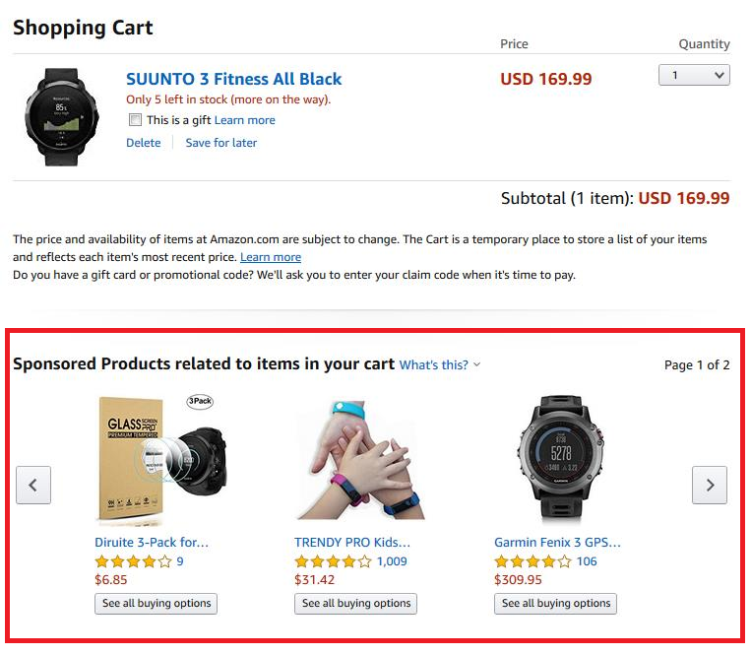

# Support of polymorphism and extension patterns

Support of polymorphic collections and types and schema based extension is provided by means of a list of generic meta-attributes that we describe below. Polymorphism in collections occurs when entities inherit from base entities, for instance a BillingAccount and SettlementAccount inheriting properties from the abstract Account entity.

Generic support of polymorphism and pattern extensions is described in the TMF API Guidelines v3.0 Part 2 document.

The @type attribute provides a way to represent the actual class type of an entity. For example, within a list of Account instances some may be instances of BillingAccount where other could be instances of SettlementAccount. The @type gives this information. All resources and sub-resources of this API have a @type attributes that can be provided when this is useful.

The @referredType can be used within reference entities (like for instance an AccountRef object) to explicitly denote the actual entity type of the referred class. Notice that in reference entities the @type, when used, denotes the class type of the reference itself, such as BillingAccountRef or SettlementAccountRef, and not the class type of the referred object. However, since reference classes are rarely sub-classed, @type is generally not useful in reference objects.

The @schemaLocation property can be used in resources to allow specifying user-defined properties of an Entity or to specify the expected *characteristics* of an entity.

The @baseType attribute gives a way to provide explicitly the base of class of a given resource that has been extended.

# RESOURCE MODEL

## Managed Entity and Task Resource Models

### Query Product Recommendation resource

Recommendation API is used to recommend offering quickly based on the history and real-time context of customer. It is a real-time and personalized recommendation API. It is usually provided by e-commerce or BSS, CRM system in omni-channel.

**Resource model**

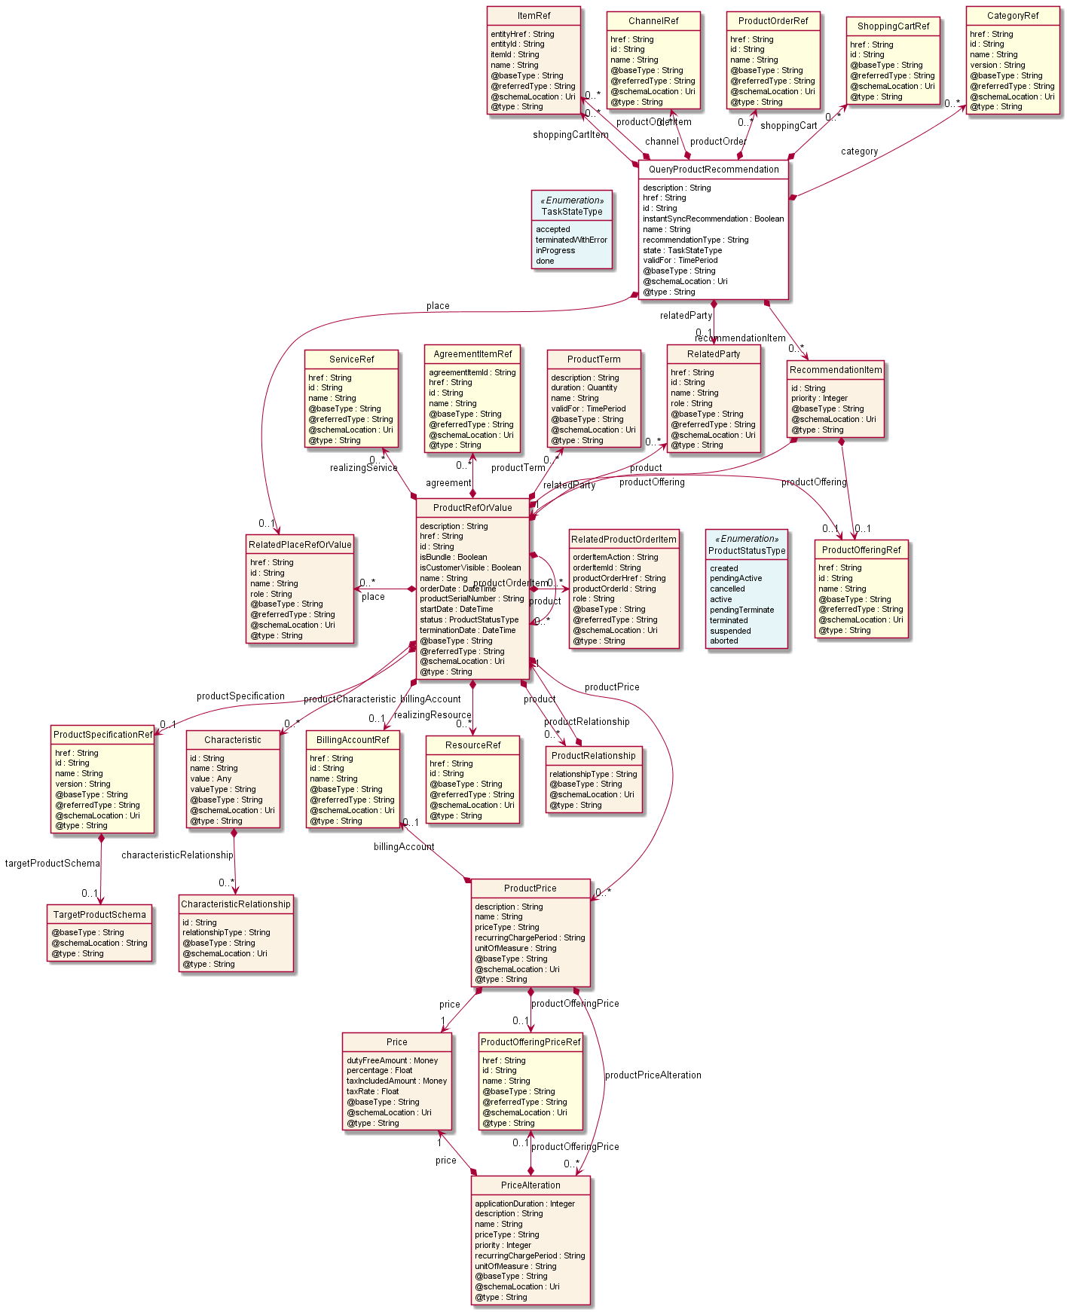

**Lifecycle**

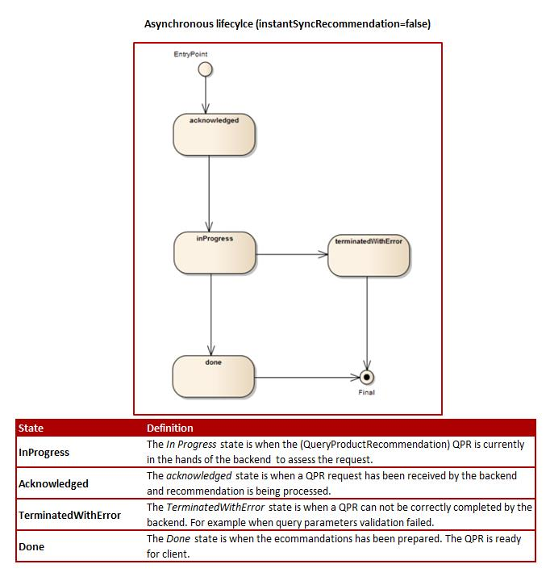

**Field descriptions**

*QueryProductRecommendation* fields

|  |  |
| --- | --- |
| category | A list of category references (CategoryRef [*]). The category for grouping recommendations. |
| channel | A list of channel references (ChannelRef [*]). The channel to which the resource reference to. e.g. channel for selling product offerings, channel for opening a trouble ticket etc.. |
| description | A string. |
| href | A string. Hypertext Reference of the queryProductRecommendation. |
| id | A string. Unique identifier of the queryProductRecommendation. |
| instantSyncRecommendation | A boolean. An indicator which when the value is "true" means that requester expects to get recommendation result in the response. |
| name | A string. Name of the queryProductRecommendation. |
| place | A related place ref or value (RelatedPlaceRefOrValue). The place which the queryProductRecommendation is related to. |
| productOrder | A list of product order references (ProductOrderRef [*]). ProductOrder (ProductOrder) .The product order which the recommendation is related with. |
| productOrderItem | A list of item references (ItemRef [*]). Describes a specific item contained in a parent element. |
| recommendationItem | A list of recommendation items (RecommendationItem [*]). Every item is a product offering and its rank. |
| recommendationType | A string. The type of the queryProductRecommendation. |
| relatedParty | A related party (RelatedParty). Related Entity reference. A related party defines party or party role linked to a specific entity. |
| shoppingCart | A list of shopping cart references (ShoppingCartRef [*]). ShoppingCart (ShoppingCartRef) . The shopping cart which the recommendation is related with. |
| shoppingCartItem | A list of item references (ItemRef [*]). Describes a specific item contained in a parent element. |
| state | A task state type (TaskStateType). State of the queryProductRecommendation defined in the state engine. |
| validFor | A time period. The period in which the queryProductRecommendation is valid. |

*Characteristic* sub-resource

Describes a given characteristic of an object or entity through a name/value pair.

|  |  |
| --- | --- |
| characteristicRelationship | A list of characteristic relationships (CharacteristicRelationship [*]). Another Characteristic that is related to the current Characteristic;. |
| id | A string. Unique identifier of the characteristic. |
| name | A string. Name of the characteristic. |
| value | An any (Any). The value of the characteristic. |
| valueType | A string. Data type of the value of the characteristic. |

*CharacteristicRelationship* sub-resource

Another Characteristic that is related to the current Characteristic.

|  |  |
| --- | --- |
| id | A string. Unique identifier of the characteristic. |
| relationshipType | A string. The type of relationship. |

*Money* sub-resource

A base / value business entity used to represent money.

|  |  |
| --- | --- |
| unit | A string. Currency (ISO4217 norm uses 3 letters to define the currency). |
| value | A float. A positive floating point number. |

*Price* sub-resource

Provides all amounts (tax included, duty free, tax rate), used currency and percentage to apply for Price Alteration.

|  |  |
| --- | --- |
| dutyFreeAmount | A money (Money). All taxes excluded amount (expressed in the given currency). |
| percentage | A float. Percentage to apply for ProdOfferPriceAlteration. |
| taxIncludedAmount | A money (Money). All taxes included amount (expressed in the given currency). |
| taxRate | A float. Tax rate. |

*PriceAlteration* sub-resource

Is an amount, usually of money, that modifies the price charged for an order item.

|  |  |
| --- | --- |
| applicationDuration | An integer. Duration during which the alteration applies on the order item price (for instance 2 months free of charge for the recurring charge). |
| description | A string. A narrative that explains in detail the semantics of this order item price alteration. |
| name | A string. Name of the order item price alteration. |
| price | A price (Price). Provides all amounts (tax included, duty free, tax rate), used currency and percentage to apply for Price Alteration. |
| priceType | A string. A category that describes the price such as recurring, one time and usage. |
| priority | An integer. Priority level for applying this alteration among all the defined alterations on the order item price. |
| productOfferingPrice | A product offering price reference (ProductOfferingPriceRef). ProductPriceOffering reference. An amount, usually of money, that is asked for or allowed when a ProductOffering is bought, rented, or leased. |
| recurringChargePeriod | A string. Could be month, week... |
| unitOfMeasure | A string. Could be minutes, GB... |

*ProductPrice* sub-resource

An amount, usually of money, that represents the actual price paid by a Customer for a purchase, a rent or a lease of a Product. The price is valid for a defined period of time.

|  |  |
| --- | --- |
| billingAccount | A billing account reference (BillingAccountRef). A BillingAccount is a detailed description of a bill structure. |
| description | A string. A narrative that explains in detail the semantics of this product price. |
| name | A string. A short descriptive name such as "Subscription price". |
| price | A price (Price). Provides all amounts (tax included, duty free, tax rate), used currency and percentage to apply for Price Alteration. |
| priceType | A string. A category that describes the price, such as recurring, discount, allowance, penalty, and so forth. |
| productOfferingPrice | A product offering price reference (ProductOfferingPriceRef). ProductPriceOffering reference. An amount, usually of money, that is asked for or allowed when a ProductOffering is bought, rented, or leased. |
| productPriceAlteration | A list of price alterations (PriceAlteration [*]). Is an amount, usually of money, that modifies the price charged for an order item. |
| recurringChargePeriod | A string. Could be month, week... |
| unitOfMeasure | A string. Could be minutes, GB... |

*ProductRefOrValue* sub-resource

A product to be created defined by value or existing defined by reference. The polymorphic attributes @type, @schemaLocation & @referredType are related to the product entity and not the RelatedProductRefOrValue class itself.

|  |  |
| --- | --- |
| @referredType | A string. The actual type of the target instance when needed for disambiguation. |
| href | A string. Reference of the product. |
| id | A string. Unique identifier of the product. |
| name | A string. Name of the product. It could be the same as the name of the product offering. |
| description | A string. Is the description of the product. It could be copied from the description of the Product Offering. |
| isBundle | A boolean. If true, the product is a ProductBundle which is an instantiation of a BundledProductOffering. If false, the product is a ProductComponent which is an instantiation of a SimpleProductOffering. |
| isCustomerVisible | A boolean. If true, the product is visible by the customer. |
| orderDate | A date time (DateTime). Is the date when the product was ordered. |
| productSerialNumber | A string. Is the serial number for the product. This is typically applicable to tangible products e.g. Broadband Router. |
| startDate | A date time (DateTime). Is the date from which the product starts. |
| terminationDate | A date time (DateTime). Is the date when the product was terminated. |
| agreement | A list of agreement item references (AgreementItemRef [*]). Agreement reference. An agreement represents a contract or arrangement, either written or verbal and sometimes enforceable by law, such as a service level agreement or a customer price agreement. An agreement involves a number of other business entities, such as products, services, and resources and/or their specifications. |
| billingAccount | A billing account reference (BillingAccountRef). A BillingAccount is a detailed description of a bill structure. |
| place | A list of related place ref or values (RelatedPlaceRefOrValue [*]). Related Entity reference. A related place defines a place described by reference or by value linked to a specific entity. The polymorphic attributes @type, @schemaLocation & @referredType are related to the place entity and not the RelatedPlaceRefOrValue class itself. |
| product | A list of product ref or values (ProductRefOrValue [*]). A product to be created defined by value or existing defined by reference. The polymorphic attributes @type, @schemaLocation & @referredType are related to the product entity and not the RelatedProductRefOrValue class itself. |
| productCharacteristic | A list of characteristics (Characteristic [*]). Describes a given characteristic of an object or entity through a name/value pair. |
| productOffering | A product offering reference (ProductOfferingRef). A product offering represents entities that are orderable from the provider of the catalog, this resource includes pricing information. |
| productOrderItem | A list of related product order items (RelatedProductOrderItem [*]). RelatedProductOrderItem (ProductOrder item) .The product order item which triggered product creation/change/termination. |
| productPrice | A list of product prices (ProductPrice [*]). An amount, usually of money, that represents the actual price paid by a Customer for a purchase, a rent or a lease of a Product. The price is valid for a defined period of time. |
| productRelationship | A list of product relationships (ProductRelationship [*]). Linked products to the one instantiate, such as [bundled] if the product is a bundle and you want to describe the bundled products inside this bundle; [reliesOn] if the product needs another already owned product to rely on (e.g. an option on an already owned mobile access product) [targets] or [isTargeted] (depending on the way of expressing the link) for any other kind of links that may be useful. |
| productSpecification | A product specification reference (ProductSpecificationRef). A ProductSpecification is a detailed description of a tangible or intangible object made available externally in the form of a ProductOffering to customers or other parties playing a party role. |
| productTerm | A list of product terms (ProductTerm [*]). Description of a productTerm linked to this product. This represent a commitment with a duration. |
| realizingResource | A list of resource references (ResourceRef [*]). |
| realizingService | A list of service references (ServiceRef [*]). for when Service is used by other entities. |
| relatedParty | A list of related parties (RelatedParty [*]). Related Entity reference. A related party defines party or party role linked to a specific entity. |
| status | A product status type (ProductStatusType). Is the lifecycle status of the product. |

*ProductRelationship* sub-resource

Linked products to the one instantiate, such as [bundled] if the product is a bundle and you want to describe the bundled products inside this bundle; [reliesOn] if the product needs another already owned product to rely on (e.g. an option on an already owned mobile access product) [targets] or [isTargeted] (depending on the way of expressing the link) for any other kind of links that may be useful.

|  |  |
| --- | --- |
| product | A product ref or value (ProductRefOrValue). A product to be created defined by value or existing defined by reference. The polymorphic attributes @type, @schemaLocation & @referredType are related to the product entity and not the RelatedProductRefOrValue class itself. |
| relationshipType | A string. Type of the product relationship, such as [bundled] if the product is a bundle and you want to describe the bundled products inside this bundle; [reliesOn] if the product needs another already owned product to rely on (e.g. an option on an already owned mobile access product) [targets] or [isTargeted] (depending on the way of expressing the link) for any other kind of links that may be useful. |

*ProductTerm* sub-resource

Description of a productTerm linked to this product. This represent a commitment with a duration.

|  |  |
| --- | --- |
| description | A string. Description of the productTerm. |
| duration | A quantity (Quantity). Duration of the productTerm. |
| name | A string. Name of the productTerm. |
| validFor | A time period. productTerm validity period. |

*Quantity* sub-resource

An amount in a given unit.

|  |  |
| --- | --- |
| amount | A float. Numeric value in a given unit. |
| units | A string. Unit. |

*RecommendationItem* sub-resource

A list of recommendation items. Every item is a product offering and its rank.

|  |  |
| --- | --- |
| id | A string. Unique identifier of the product. |
| priority | An integer. The rank of the list of recommended offering. |
| product | A product ref or value (ProductRefOrValue). A recommended product. |
| productOffering | A product offering reference (ProductOfferingRef). A product offering represents entities that are orderable from the provider of the catalog, this resource includes pricing information. |

*RelatedParty* sub-resource

Related Entity reference. A related party defines party or party role linked to a specific entity.

|  |  |
| --- | --- |
| @referredType | A string. The actual type of the target instance when needed for disambiguation. |
| href | A string. Reference of the related entity. |
| id | A string. Unique identifier of a related entity. |
| name | A string. Name of the related entity. |
| role | A string. Role played by the related party. |

*RelatedPlaceRefOrValue* sub-resource

Related Entity reference. A related place defines a place described by reference or by value linked to a specific entity. The polymorphic attributes @type, @schemaLocation & @referredType are related to the place entity and not the RelatedPlaceRefOrValue class itself.

|  |  |
| --- | --- |
| @referredType | A string. The actual type of the target instance when needed for disambiguation. |
| href | A string. Unique reference of the place. |
| id | A string. Unique identifier of the place. |
| name | A string. A user-friendly name for the place, such as [Paris Store], [London Store], [Main Home]. |
| role | A string. |

*RelatedProductOrderItem* sub-resource

RelatedProductOrderItem (ProductOrder item) .The product order item which triggered product creation/change/termination.

|  |  |
| --- | --- |
| @referredType | A string. The actual type of the target instance when needed for disambiguation. |
| orderItemAction | A string. Action of the order item for this product. |
| orderItemId | A string. Identifier of the order item where the product was managed. |
| productOrderHref | A string. Reference of the related entity. |
| productOrderId | A string. Unique identifier of a related entity. |
| role | A string. role of the product order item for this product. |

*TargetProductSchema* sub-resource

The reference object to the schema and type of target product which is described by product specification.

|  |  |
| --- | --- |
| @schemaLocation | A string. This field provides a link to the schema describing the target product. |
| @type | A string. Class type of the target product. |

*AgreementItemRef* relationship

Agreement reference. An agreement represents a contract or arrangement, either written or verbal and sometimes enforceable by law, such as a service level agreement or a customer price agreement. An agreement involves a number of other business entities, such as products, services, and resources and/or their specifications.

|  |  |
| --- | --- |
| @referredType | A string. The actual type of the target instance when needed for disambiguation. |
| href | A string. Reference of the related entity. |
| id | A string. Unique identifier of a related entity. |
| name | A string. Name of the related entity. |
| agreementItemId | A string. Identifier of the agreement. |

*BillingAccountRef* relationship

BillingAccount reference. A BillingAccount is a detailed description of a bill structure.

|  |  |
| --- | --- |
| @referredType | A string. The actual type of the target instance when needed for disambiguation. |
| href | A string. Reference of the billing account. |
| id | A string. Unique identifier of the billing account. |
| name | A string. Name of the billing account. |

*CategoryRef* relationship

The category for grouping recommendations.

|  |  |
| --- | --- |
| @referredType | A string. The actual type of the target instance when needed for disambiguation. |
| href | A string. Reference of the related entity. |
| id | A string. Unique identifier of a related entity. |
| name | A string. Name of the related entity. |
| version | A string. Category version. |

*ChannelRef* relationship

The channel to which the resource reference to. e.g. channel for selling product offerings, channel for opening a trouble ticket etc.

|  |  |
| --- | --- |
| @referredType | A string. The actual type of the target instance when needed for disambiguation. |
| href | A string. Reference of the related entity. |
| id | A string. Unique identifier of a related entity. |
| name | A string. Name of the channel. |

*ItemRef* relationship

Describes a specific item contained in a parent element.

|  |  |
| --- | --- |
| @referredType | A string. The actual type of the target instance when needed for disambiguation. |
| entityHref | A string. Hypertext Reference of the parent element. |
| entityId | A string. Unique identifier of the parent element. |
| itemId | A string. Unique identifier of the considered item. |
| name | A string. Name of the related entity. |

*ProductOfferingPriceRef* relationship

ProductPriceOffering reference. An amount, usually of money, that is asked for or allowed when a ProductOffering is bought, rented, or leased.

|  |  |
| --- | --- |
| @referredType | A string. The actual type of the target instance when needed for disambiguation. |
| href | A string. Reference of the related entity. |
| id | A string. Unique identifier of a related entity. |
| name | A string. Name of the related entity. |

*ProductOfferingRef* relationship

ProductOffering reference. A product offering represents entities that are orderable from the provider of the catalog, this resource includes pricing information.

|  |  |
| --- | --- |
| @referredType | A string. The actual type of the target instance when needed for disambiguation. |
| href | A string. Reference of the related entity. |
| id | A string. Unique identifier of a related entity. |
| name | A string. Name of the related entity. |

*ProductOrderRef* relationship

ProductOrder (ProductOrder) .The product order which the recommendation is related with.

|  |  |
| --- | --- |
| @referredType | A string. The actual type of the target instance when needed for disambiguation. |
| href | A string. Reference of the related entity. |
| id | A string. Unique identifier of a related entity. |
| name | A string. Name of the related entity. |

*ProductSpecificationRef* relationship

Product specification reference: A ProductSpecification is a detailed description of a tangible or intangible object made available externally in the form of a ProductOffering to customers or other parties playing a party role.

|  |  |
| --- | --- |
| @referredType | A string. The actual type of the target instance when needed for disambiguation. |
| href | A string. Reference of the related entity. |
| id | A string. Unique identifier of a related entity. |
| name | A string. Name of the related entity. |
| targetProductSchema | A target product schema (TargetProductSchema). A target product schema reference. The reference object to the schema and type of target product which is described by product specification. |
| version | A string. Version of the product specification. |

*ResourceRef* relationship

|  |  |
| --- | --- |
| @referredType | A string. The actual type of the target instance when needed for disambiguation. |
| href | A string. |
| id | A string. |

*ServiceRef* relationship

Service reference, for when Service is used by other entities.

|  |  |
| --- | --- |
| @referredType | A string. The actual type of the target instance when needed for disambiguation. |
| href | A string. Reference of the related entity. |
| id | A string. Unique identifier of a related entity. |
| name | A string. Name of the related entity. |

*ShoppingCartRef* relationship

ShoppingCart (ShoppingCartRef) . The shopping cart which the recommendation is related with.

|  |  |
| --- | --- |
| @referredType | A string. The actual type of the target instance when needed for disambiguation. |
| href | A string. Hypertext Reference of the shopping cart. |
| id | A string. Unique identifier of shopping cart. |

**Json representation sample**

We provide below the json representation of an example of a 'QueryProductRecommendation' resource object

|  |
| --- |
| {  "id": "1001",  "href": "http://serverlocation:port/recommendation/v1/queryProductRecommendation/1001",  "name": " recommendation of the latest TMFone",  "description": "Recommendation of the latest TMFone, for the customers with a high level of requirements",  "instantSyncRecommendation": "false",  "recommendationType": "offer",  "@type": "recommendation",  "@schemaLocation": "http://serverlocation:port/recommendation/schema/recommendation.schema.json",  "state": "done",  "validFor": {  "startDateTime": "2019-07-03 T04:00:00.0Z",  "endDateTime": "2019-07-05 T20:42:23.0Z"  },  "channel": {  "id": "21",  "href": "http://serverlocation:port/recommendation/v1/channel/21",  "name": "mobile app channel"  },  "shoppingCart": {  "id": "65484jyuty57655",  "href": "http://serverlocation:port/shoppingCart/v4/shoppingCart/65484jyuty57655"  },  "relatedParty": {  "id": "34",  "href": "http: //serverlocation:port/partyManagement/v1/individual/34",  "name": "John Smith",  "role": "customer"  },  "recommendationItem": [  {  "id": "1",  "priority": 1,  "product": {  "productOffering": {  "id": "6547",  "href": "https://host:port/productOffering/v1/productOffering/6547",  "name": "TMFone "  },  "productCharacteristic": [  {  "name": "capacity",  "valueType": "string",  "value": "128 Gb"  }  ]  }  },  {  "id": "2",  "priority": 2,  "product": {  "productOffering": {  "id": "6542",  "href": "https://host:port/productOffering/v1/productOffering/6542",  "name": " TMFone Case"  },  "productCharacteristic": [  {  "name": "material",  "valueType": "string",  "value": "plastic"  },  {  "name": "material",  "valueType": "string",  "value": "leather"  }  ]  }  }  ] } |

## Notification Resource Models

2 notifications are defined for this API

Notifications related to QueryProductRecommendation:  
 - QueryProductRecommendationCreateEvent  
 - QueryProductRecommendationStateChangeEvent

The notification structure for all notifications in this API follow the pattern depicted by the figure below.  
A notification event resource (depicted by "SpecificEvent" placeholder) is a sub class of a generic Event structure containing at least an id of the event occurrence (eventId), an event timestamp (eventTime), and the name of the resource (eventType).   
This notification structure owns an event payload structure ("SpecificEventPayload" placeholder) linked to the resource concerned by the notification using the resource name as access field ("resourceName" placeholder).

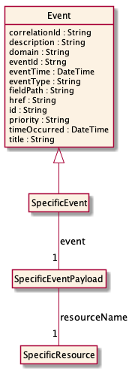

### Query Product Recommendation Create Event

Notification QueryProductRecommendationCreateEvent case for resource QueryProductRecommendation

**Json representation sample**

We provide below the json representation of an example of a 'QueryProductRecommendationCreateEvent' notification event object

|  |
| --- |
| {  "eventId":"00001",  "eventTime":"2015-11-16T16:42:25-04:00",  "eventType":"QueryProductRecommendationCreateEvent",  "event": {  "queryProductRecommendation" :   {-- SEE QueryProductRecommendation RESOURCE SAMPLE --}  } } |

### Query Product Recommendation State Change Event

Notification QueryProductRecommendationStateChangeEvent case for resource QueryProductRecommendation

**Json representation sample**

We provide below the json representation of an example of a 'QueryProductRecommendationStateChangeEvent' notification event object

|  |
| --- |
| {  "eventId":"00001",  "eventTime":"2015-11-16T16:42:25-04:00",  "eventType":"QueryProductRecommendationStateChangeEvent",  "event": {  "queryProductRecommendation" :   {-- SEE QueryProductRecommendation RESOURCE SAMPLE --}  } } |

# API OPERATIONS

Remember the following Uniform Contract:

|  |  |  |
| --- | --- | --- |
| Operation on Entities | Uniform API Operation | Description |
| Query Entities | GET Resource | GET must be used to retrieve a representation of a resource. |
| Create Entity | POST Resource | POST must be used to create a new resource |

Filtering and attribute selection rules are described in the TMF REST Design Guidelines.

Notifications are also described in a subsequent section.

## Operations on Query Product Recommendation

### List query product recommendations

**GET /queryProductRecommendation?fields=...&{filtering}**

**Description**

This operation list query product recommendation entities.  
Attribute selection is enabled for all first level attributes.  
Filtering may be available depending on the compliance level supported by an implementation.

**Usage Samples**

Here is an example of a request for retrieving a list of QueryProductRecommendation(s). The given criteria is the id of the customer.

|  |
| --- |
| **Request** |
| GET serverRoot/customer/v4/queryProductRecommendation?fields=id,href,name,description,state&relatedParty.id=34 Accept: application/json |
| **Response** |
| 200  [  {  "id": "1001",  "href": "http://serverlocation:port/recommendation/v1/queryProductRecommendation/1001",  "name": "Recommendation of the latest TMFone",  "description": "Recommendation of the latest TMFone, for the customers with a high level of requirements",  "state": "done"  },  {  "id": "7325",  "href": "http://serverlocation:port/recommendation/v1/queryProductRecommendation/7325",  "name": "Recommendation related to the customer's current offer",  "description": "Recommendations related to the customer's current offer",  "state": "done"  } ] |

### Retrieve query product recommendation

**GET /queryProductRecommendation/{id}?fields=...&{filtering}**

**Description**

This operation retrieves a query product recommendation entity.  
Attribute selection is enabled for all first level attributes.  
Filtering on sub-resources may be available depending on the compliance level supported by an implementation.

**Usage Samples**

Here is an example of a request for QueryProductRecommendation.

|  |
| --- |
| **Request** |
| GET serverRoot/customer/v4/queryProductRecommendation/1001 Accept: application/json |
| **Response** |
| 200  {  "id": "1001",  "href": "http://serverlocation:port/recommendation/v1/queryProductRecommendation/1001",  "name": " recommendation of the latest TMFone",  "description": "Recommendation of the latest TMFone, for the customers with a high level of requirements",  "instantSyncRecommendation": "false",  "recommendationType": "offer",  "@type": "recommendation",  "@schemaLocation": "http://serverlocation:port/recommendation/schema/recommendation.schema.json",  "state": "done",  "validFor": {  "startDateTime": "2019-07-03 T04:00:00.0Z",  "endDateTime": "2019-07-05 T20:42:23.0Z"  },  "channel": {  "id": "21",  "href": "http://serverlocation:port/recommendation/v1/channel/21",  "name": "mobile app channel"  },  "shoppingCart": {  "id": "65484jyuty57655",  "href": "http://serverlocation:port/shoppingCart/v4/shoppingCart/65484jyuty57655"  },  "relatedParty": {  "id": "34",  "href": "http: //serverlocation:port/partyManagement/v1/individual/34",  "name": "John Smith",  "role": "customer"  },  "recommendationItem": [  {  "id": "1",  "priority": 1,  "product": {  "productOffering": {  "id": "6547",  "href": "https://host:port/productOffering/v1/productOffering/6547",  "name": "TMFone "  },  "productCharacteristic": [  {  "name": "capacity",  "valueType": "string",  "value": "128 Gb"  }  ]  }  },  {  "id": "2",  "priority": 2,  "product": {  "productOffering": {  "id": "6542",  "href": "https://host:port/productOffering/v1/productOffering/6542",  "name": " TMFone Case"  },  "productCharacteristic": [  {  "name": "material",  "valueType": "string",  "value": "plastic"  },  {  "name": "material",  "valueType": "string",  "value": "leather"  }  ]  }  }  ] } |

### Create query product recommendation

**POST /queryProductRecommendation**

**Description**

This operation creates a query product recommendation entity.

**Mandatory and Non Mandatory Attributes**

The following tables provide the list of mandatory and non mandatory attributes when creating a QueryProductRecommendation, including any possible rule conditions and applicable default values. Notice that it is up to an implementer to add additional mandatory attributes.

|  |  |
| --- | --- |
| Mandatory Attributes | Rule |

| Non Mandatory Attributes | Rule |
| --- | --- |
| category |  |
| channel |  |
| description |  |
| instantSyncRecommendation |  |
| name |  |
| place |  |
| productOrder |  |
| productOrderItem |  |
| recommendationItem | Must not be present in the request |
| recommendationType |  |
| relatedParty |  |
| shoppingCart |  |
| shoppingCartItem |  |
| state |  |
| validFor |  |

**Usage Samples**

Here is an example of a request for a recommandation calculation, with instantSyncRecommendation set to false. A QueryProductRecommendation resource is created and the recommendationItem might be provided later.

|  |
| --- |
| **Request** |
| POST serverRoot/customer/v4/queryProductRecommendation Content-Type: application/json  {  "name": "Recommendation of the latest TMFone",  "description": "Recommendation of the latest TMFone, for the customers with a high level of requirements",  "instantSyncRecommendation": "false",  "@type": "queryProductRecommendation",  "validFor": {  "startDateTime": "2019-07-03 T04:00:00.0Z",  "endDateTime": "2019-07-05 T20:42:23.0Z"  },  "channel": {  "id": "21",  "href": "http://serverlocation:port/recommendation/v4/channel/21",  "name": "mobile app channel"  },  "shoppingCart": {  "id": "65484jyuty57655",  "href": "http://serverlocation:port/shoppingCart/v4/shoppingCart/65484jyuty57655"  },  "relatedParty": {  "id": "34",  "href": "http: //serverlocation:port/partyManagement/v4/individual/34",  "name": "John Smith",  "role": "customer"  } } |
| **Response** |
| 202  {  "id": "1001",  "href": "http://serverlocation:port/recommendation/v1/queryProductRecommendation/1001",  "name": "Recommendation of the latest TMFone",  "description": "Recommendation of the latest TMFone, for the customers with a high level of requirements",  "instantSyncRecommendation": "false",  "@type": "queryProductRecommendation",  "@schemaLocation": "http://serverlocation:port/recommendation/schema/recommendation.schema.json",  "state": "accepted",  "validFor": {  "startDateTime": "2019-07-03 T04:00:00.0Z",  "endDateTime": "2019-07-05 T20:42:23.0Z"  },  "channel": {  "id": "21",  "href": "http://serverlocation:port/recommendation/v4/channel/21",  "name": "mobile app channel"  },  "shoppingCart": {  "id": "65484jyuty57655",  "href": "http://serverlocation:port/shoppingCart/v4/shoppingCart/65484jyuty57655"  },  "relatedParty": {  "id": "34",  "href": "http: //serverlocation:port/partyManagement/v1/individual/34",  "name": "John Smith",  "role": "customer"  } } |

Here is an example of a request for creating a recommendations calculation with instantSyncRecommendation set to true. The result is directly provided in response and no QueryProductRecommendation resource is created.

|  |
| --- |
| **Request** |
| POST serverRoot/customer/v4/queryProductRecommendation Content-Type: application/json  {  "name": "Recommendation of the latest TMFone",  "description": "Recommendation of the latest TMFone, for the customers with a high level of requirements",  "instantSyncRecommendation": "true",  "@type": "queryProductRecommendation",  "validFor": {  "startDateTime": "2019-07-03 T04:00:00.0Z",  "endDateTime": "2019-07-05 T20:42:23.0Z"  },  "channel": {  "id": "21",  "href": "http://serverlocation:port/recommendation/v4/channel/21",  "name": "mobile app channel"  },  "shoppingCart": {  "id": "65484jyuty57655",  "href": "http://serverlocation:port/shoppingCart/v4/shoppingCart/65484jyuty57655"  },  "relatedParty": {  "id": "34",  "href": "http: //serverlocation:port/partyManagement/v4/individual/34",  "name": "John Smith",  "role": "customer"  } } |
| **Response** |
| 200  {  "name": "Recommendation of the latest TMFone",  "description": "Recommendation of the latest TMFone, for the customers with a high level of requirements",  "instantSyncRecommendation": "true",  "@type": "queryProductRecommendation",  "@schemaLocation": "http://serverlocation:port/recommendation/schema/recommendation.schema.json",  "state": "done",  "validFor": {  "startDateTime": "2019-07-03 T04:00:00.0Z",  "endDateTime": "2019-07-05 T20:42:23.0Z"  },  "recommendationType": "offer",  "channel": {  "id": "21",  "href": "http://serverlocation:port/recommendation/v4/channel/21",  "name": "mobile app channel"  },  "shoppingCart": {  "id": "65484jyuty57655",  "href": "http://serverlocation:port/shoppingCart/v4/shoppingCart/65484jyuty57655"  },  "relatedParty": {  "id": "34",  "href": "http://serverlocation:port/partyManagement/v4/individual/34",  "name": "John Smith",  "role": "customer"  },  "recommendationItem": [  {  "id": "1",  "priority": 1,  "product": {  "productOffering": {  "id": "6547",  "href": "https://host:port/productOffering/v4/productOffering/6547",  "name": "TMFone "  },  "productCharacteristic": [  {  "name": "capacity",  "valueType": "string",  "value": "128 Gb"  }  ]  }  },  {  "id": "2",  "priority": 2,  "product": {  "productOffering": {  "id": "6542",  "href": "https://host:port/productOffering/v1/productOffering/6542",  "name": " TMFone Case"  },  "productCharacteristic": [  {  "name": "material",  "valueType": "string",  "value": "plastic"  },  {  "name": "material",  "valueType": "string",  "value": "leather"  }  ]  }  }  ]  } |

# API NOTIFICATIONS

For every single of operation on the entities use the following templates and provide sample REST notification POST calls.

It is assumed that the Pub/Sub uses the Register and UnRegister mechanisms described in the REST Guidelines reproduced below.

## Register listener

**POST /hub**

**Description**

Sets the communication endpoint address the service instance must use to deliver information about its health state, execution state, failures and metrics. Subsequent POST calls will be rejected by the service if it does not support multiple listeners. In this case DELETE /api/hub/{id} must be called before an endpoint can be created again.

**Behavior**

Returns HTTP/1.1 status code 204 if the request was successful.

Returns HTTP/1.1 status code 409 if request is not successful.

**Usage Samples**

Here's an example of a request for registering a listener.

|  |
| --- |
| **Request** |
| POST /api/hub  Accept: application/json  {"callback": "http://in.listener.com"} |
| **Response** |
| 201  Content-Type: application/json  Location: /api/hub/42  {"id":"42","callback":"http://in.listener.com","query":null} |

## Unregister listener

**DELETE /hub/{id}**

**Description**

Clears the communication endpoint address that was set by creating the Hub.

**Behavior**

Returns HTTP/1.1 status code 204 if the request was successful.

Returns HTTP/1.1 status code 404 if the resource is not found.

**Usage Samples**

Here's an example of a request for un-registering a listener.

|  |
| --- |
| **Request** |
| DELETE /api/hub/42  Accept: application/json |
| **Response** |
| 204 |

## Publish Event to listener

**POST /client/listener**

**Description**

Clears the communication endpoint address that was set by creating the Hub.

Provides to a registered listener the description of the event that was raised. The /client/listener url is the callback url passed when registering the listener.

**Behavior**

Returns HTTP/1.1 status code 201 if the service is able to set the configuration.

**Usage Samples**

Here's an example of a notification received by the listener. In this example “EVENT TYPE” should be replaced by one of the notification types supported by this API (see Notification resources Models section) and EVENT BODY refers to the data structure of the given notification type.

|  |
| --- |
| **Request** |
| POST /client/listener  Accept: application/json  {  "event": {  EVENT BODY  },  "eventType": "EVENT_TYPE"  } |
| **Response** |
| 201 |

For detailed examples on the general TM Forum notification mechanism, see the TMF REST Design Guidelines.

# Acknowledgements

## Version History

|  |  |  |  |
| --- | --- | --- | --- |
| **Release Number** | **Date** | **Release led by:** | **Description** |
| Release 1.0 | 04/15/2017 | Pierre Gauthier TM Forum [pgauthier@tmforum.org](mailto:pgauthier@tmforum.org)  Mariano Belaunde Orange Labs | First Release of the Document. |
| Release 2.0 | 11/06/2018 | Mariano Belaunde  Orange Labs | Alignment with Guidelines 3.0 |
| Version 4.0.0 | 03-Apr-2020 | Pierre Gauthier -TM Forum [pgauthier@tmforum.org](mailto:pgauthier@tmforum.org)  Grégoire Laurent - Orange  [gregoire.laurent@orange.com](mailto:gregoire.laurent@orange.com)  Javed Syed - Oracle  [syed.javed@oracle.com](mailto:syed.javed@oracle.com) | Version 4.0 of the API REST  Note: the version 4.0 is assigned to all the APIs delivered in the release 19.0 |

## Release History

|  |  |  |  |
| --- | --- | --- | --- |
| **Release Number** | **Date** | **Release led by:** | **Description** |
| Pre-production | 03-Apr-2020 | Pierre Gauthier -TM Forum [pgauthier@tmforum.org](mailto:pgauthier@tmforum.org)  Grégoire Laurent - Orange  [gregoire.laurent@orange.com](mailto:gregoire.laurent@orange.com)  Javed Syed - Oracle  [syed.javed@oracle.com](mailto:syed.javed@oracle.com) | Version 4.0 of the API REST  Note: the version 4.0 is assigned to all the APIs delivered in the release 19.0 |

## Contributors to Document

|  |  |
| --- | --- |
| Ludovic Robert | Orange |