**TM Forum Specification**

**Communication API User Guide**

**TMF681**

**Team Approved Date: 28-May-2020**

|  |  |
| --- | --- |
| **Release Status: Pre-production** | **Approval Status: Team Approved** |
| **Version 4.0.0** | **IPR Mode: RAND** |

NOTICE

Copyright © TM Forum 2020. All Rights Reserved.

This document and translations of it may be copied and furnished to others, and derivative works that comment on or otherwise explain it or assist in its implementation may be prepared, copied, published, and distributed, in whole or in part, without restriction of any kind, provided that the above copyright notice and this section are included on all such copies and derivative works. However, this document itself may not be modified in any way, including by removing the copyright notice or references to TM FORUM, except as needed for the purpose of developing any document or deliverable produced by a TM FORUM Collaboration Project Team (in which case the rules applicable to copyrights, as set forth in the [TM FORUM IPR Policy](http://www.tmforum.org/IPRPolicy/11525/home.html), must be followed) or as required to translate it into languages other than English.

The limited permissions granted above are perpetual and will not be revoked by TM FORUM or its successors or assigns.

This document and the information contained herein is provided on an "AS IS" basis and TM FORUM DISCLAIMS ALL WARRANTIES, EXPRESS OR IMPLIED, INCLUDING BUT NOT LIMITED TO ANY WARRANTY THAT THE USE OF THE INFORMATION HEREIN WILL NOT INFRINGE ANY OWNERSHIP RIGHTS OR ANY IMPLIED WARRANTIES OF MERCHANTABILITY OR FITNESS FOR A PARTICULAR PURPOSE.

Direct inquiries to the TM Forum office:

4 Century Drive, Suite 100

Parsippany, NJ 07054, USA

Tel No. +1 973 944 5100

Fax No. +1 973 998 7196

TM Forum Web Page: [www.tmforum.org](http://www.tmforum.org/)

Table of Contents

NOTICE 2

Table of Contents 3

List of Tables 4

Introduction 5

Mapping with SID ABE 6

Mapping with eTOM Process 7

Distinction between this API and Event Management API 7

Distinction between this API and Change Request API 10

SAMPLE USE CASES 13

Case1: Communication with Customer 13

Case2: Communication with Agent (CSR) 14

Support of polymorphism and extension patterns 16

RESOURCE MODEL 17

Managed Entity and Task Resource Models 17

Communication Message resource 17

Notification Resource Models 22

Communication Message Attribute Value Change Event 23

Communication Message State Change Event 24

API OPERATIONS 25

Operations on Communication Message 25

List communication messages 25

Retrieve communication message 28

Create communication message 29

Patch communication message 34

Delete communication message 36

API NOTIFICATIONS 37

Register listener 37

Unregister listener 38

Publish Event to listener 38

Acknowledgements 40

Version History 40

Release History 40

Contributors to Document 41

List of Tables

N/A

Introduction

The following document is the specification of the REST API for Communication management. It includes the model definition as well as all available operations.

It provides a standardized mechanism for Communication management such as creation, update, retrieval, deletion and notification of the system communication events.

Communication API manages the following data resources:

* **Communication Message**
  + Communication message means a notification approach in the format of a message which can be dispatched (sent) to the certain user by the system with the content which can be felt and understood by the recipient. The user can be either a final customer or a customer service agent. The message can reach the customer in different interaction channels, including: email, short message, mobile app notification (push).

Normally the communication is implemented as a common shared service for all the IT applications. Whenever there is an application which needs to manage or send the message to the customer, this application can invoke the “communication” API to dispatch the notification.

To help clarify the concept of “communication API”, here all the possible “man-machine” contact approaches are listed as below. The “tick” shows the interaction types for which the “communication API” is designed to support.

| **Business Interaction Method** | **Communication API Related** |
| --- | --- |
| SMS to customer | **√** |
| Email to customer | **√** |
| Mobile app push message to customer | **√** |
| Proactive calling to the customer  (human initiated, i.e. person-call-person) |  |
| Proactive calling to the customer  (system initiated, i.e. machine-call-person) |  |
| Face to face contact |  |
| Customer browsing web page, open mobile app, calling IVR etc. |  |

Communication API performs the following operation on the resource of “Communication Message”. There are two types of operations provided in this API. One is the management of the request message body. Another is for sending the communication message to the customer.

*Operations for Communication Message body management*

* Retrieval of an existing Communication Message depending on filter criteria
* Creation of a new Communication Message
* Partial update of an existing Communication Message
* Deletion of an existing Communication Message
* Notification of events:
  + Creation of Communication Message
  + Updating Communication Message
  + Deletion of Communication Message

*Operations for sending Communication Message.*

* Send a message, including:
  + Send a new message with the whole communication message body (POST operation)
  + Send a message with the predefined communication message body (PATCH operation)

Mapping with SID ABE

Communication Message is mapped to “*Business Interaction ABE::* *Notification ABE*” in TMF Information Framework (SID).

The Business Interaction ABE is illustrated as the diagram below:



Mapping with eTOM Process

Communication API can be mapped to the “Customer Interaction Management” in TM Forum Process Framework (eTOM).

The relevant process is: **Notify Customer**.

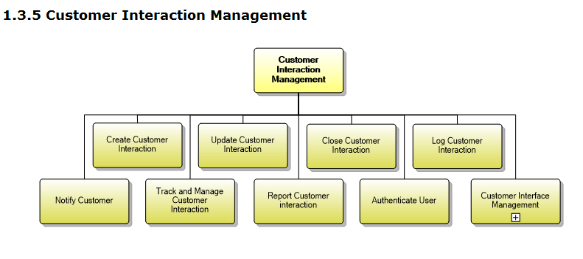

The definition of TM Forum Process Framework is:

**Category**: (3) eTOM Process Type

**Process Identifier**: 1.3.5.5

**Original Process Identifier**: 1.1.1.18.5

**Maturity Level**: 4

**Description**

Notify the customer when interesting events happen.

**Extended Description**

The purpose of this process is to notify the customer when events related to existing interactions or to significant customer experience happen. Some notifications can be sent immediately using interactive media (such as SMS, Push to applications, etc.) and other notifications can be sent later using asynchronous media such as mail.

Distinction between this API and Event Management API

This API and Event Management API own some similarities.

The distinctions between them are explained in the table below:

| **Comparison Points** | **Communication API** | **Event Management API** |
| --- | --- | --- |
| **Definition** | Communication message means a message which can be dispatch (sent) to the certain user by the system in the format which can be felt and understood by the recipient | An Event represents a change in the state of a configuration item, service or business data entity |
| **User Role** | Sender: Enterprise (e.g. TelCo).  Receiver: Customer, agent, O&M staff | IT System.  No natural person (customer or agent) is involved. |
| **Business Scenario** | The enterprise needs to send the notification information to the customer or the agent.  Note: It is used to support the direct interaction with the users. | It can signal status changes or exceptions that allow the appropriate person or system to perform early response actions to ensure service performance and continuity or used as a trigger for automation run books.  Note: It is used to manage the intrinsic event inside the system. The event is always created in the EM backend referring to the internal Event Management system. |
| **Relevant IT System** | Interaction or contact module of the system | Any module inside the IT system |
| **Data Model** | Content of communication message. The content is visible to the user (customer, et al) | The description of how an event is triggered and handled.  It has no “content” to contain the concrete communication message information. The “related object” in this API does not distinctly express the meaning of content. The “related object” could be the “attachment” of the message.  It has no “sender” and “receiver” for the communication message information. The explanation of “related party” in this API has an example which is “assignee support group”. It shows this API parameter is used to depict who is the “event handler”. |
| **Information Framework (SID) Mapping** | Common Business Entities Domain  **Business Interaction ABE**  **Notification Entity**  A communication that informs about something that has or will happen. A Notification is typically one-sided, in that no Response is expected. A Notification can be created as the result of a Request. | Common Business Entities Domain  **Event ABE**  The Event ABE contains entities that are used to represent events, their occurrence and their recording within systems. |
| **Operation** | 1) CRUD of communication message in IT system, i.e., create, read, update and deletion.  2) Send the communication message to the user | Create event (i.e. trigger the event) in the system.  Query event  Update event |
| **Relationship** | In the widest conception, any system action can be an event, such as the creation of new offering, execution of order, adding one item into the shopping cart. On this level, the “communication message” is also an event.  In the narrow conception, event is for the technical terminology to describe the one-off change of the certain module, such as an event of “memory stack overflow” or “switch the web server”. Such event is collected by the Event Manager to monitor the status of whole running system.  According to the definition of Event Management API, this API focuses more on the second concept. “Communication” is also taking place in one-off mode, but it expresses the interactive human-machine contact instead of the pure system action. | |

Distinction between this API and Change Request API

This API and Change Request API own some similarities.

The distinctions between them are explained in the table below:

| **Comparison Points** | **Communication API** | **Change Management API** |
| --- | --- | --- |
| **Definition** | Communication message means a message which can be dispatch (sent) to the certain user by the system in the format which can be felt and understood by the recipient | Change Management process is to respond to the customer’s changing business requirements.  The Change Management API provides the standard integration capabilities between external applications and Change Management Application |
| **User Role** | Sender: Enterprise (e.g. TelCo).  Receiver: Customer, agent, O&M staff | The involved roles of the API can be:   * Change Management Application * External application   No natural person (customer or agent) is involved. |
| **Business Scenario** | The enterprise needs to send the notification information to the customer or the agent.  Note: It is used to support the direct interaction with the users. | * Asset sharing * NFV MULTI-DIGITAL SERVICE PROVIDER offer the products * Manage Service of Network Operation or OSS |
| **Data Model** | Inherit from “Business Interaction”.  Content of communication message. The content is visible to the user (customer, et al). | Inherit from “Business Interaction”.  nota bene: The “Business Interaction” has a group of derivative objects. “Change Request” is mapped to “request” object, not “notification”.  Additionally, this API data model contains:   * Attachment: *This is also included in Communication API* * Related Party: The role which is involved. *This is also included in Communication API* * Target Entity, Impacted Entity: both are referred to “realted party”. * Work log * If the work log is a type of task for the staff to execute, it is not required in *Communication API* * If the work log is the pure log (record) of the system action, it is a default function of the system. *Communication API* has the “log flag” to indicate whether the log should be generated after invoking API. The detail of the log is not required to be explicitly expressed in *Communication API* * Note: It is an optional attribute. In *Communication API*, the “content” is used to describe the purpose of the communication message. |
| **Information Framework (SID) Mapping** | Common Business Entities Domain  **Business Interaction ABE**  **Notification Entity** | Common Business Entities Domain  **Business Interaction ABE** |
| **Operation** | 1) CRUD of communication message in IT system, i.e., create, read, update and deletion.  2) Send the communication message to the user | CRUD operations of the change request |

# SAMPLE USE CASES

Examples of use cases using Communication API is as following

Case1: Communication with Customer

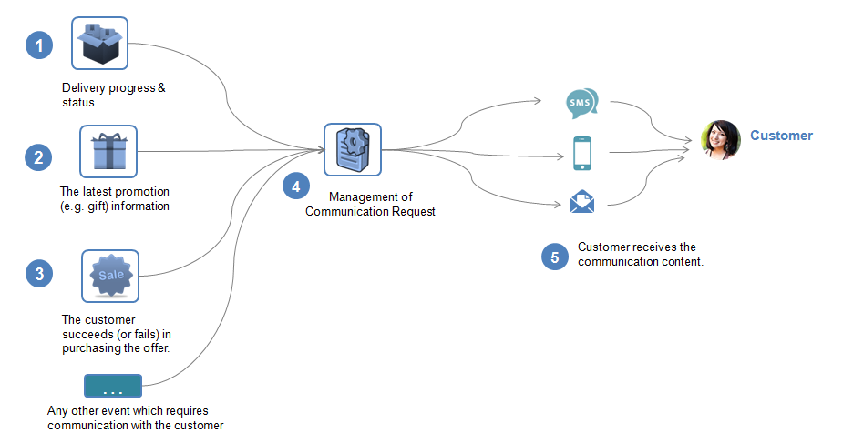

| Use Case Id | UC_TMF_CommunicationMessage_0001 |
| --- | --- |
| Use Case Name | Customer receives communication message. |
| Summary | This case describes the system manages the communication message and sends the communication message to the customer. |
| Actor(s) | Customer (person) |
| Pre-Conditions | NA |
| Begins When | When the sales/marketing/service or any other business activities requires notifying the customer, the application will initiate the communication message. |
| Description | 1. The system needs to notify the customer about the delivery progress & status. 2. The system needs to notify the customer about the latest promotion (e.g. gift) information. 3. The system needs to notify the customer about the result of purchasing the offer.   Or any other event happens which requires communication with the customer.   1. The system manages the Communication Message, such as the creation, modification, updating and deletion of the communication. 2. The system sends the communication and the customer receives the communication content. |
| Ends When | *In case of communication is done successfully:*  The customer will receive the message.  *In case of failure:*  The system records the failure and the customer cannot know the message. Normally the system will retry to send the message when the network or environment is available. |
| Post-Conditions |  |
| Exceptions |  |
| Traceability |  |

Case2: Communication with Agent (CSR)

|  |  |
| --- | --- |
| Use Case Id | UC_TMF_CommunicationMessage_0002 |
| Use Case Name | The agent (CSR staff) receives communication message. |
| Summary | This case describes the system manages the communication message and sends the communication message to the agent. |
| Actor(s) | Agent staff (person) |
| Pre-Conditions | NA |
| Begins When | When the sales/marketing/service or any other business activities requires notifying the agent, the application will initiate the communication message. |
| Description | The company needs to notify the agent that the latest SLA policy in the market has been published.  The agent needs to know such company rule (policy) and obey it when working. |
| Ends When | *In case of communication is done successfully:*  The agent will receive the message.  *In case of failure:*  The system records the failure and the customer cannot know the message. Normally the system will retry to send the message when the network or environment is available. |
| Post-Conditions |  |
| Exceptions |  |
| Traceability |  |

# Support of polymorphism and extension patterns

Support of polymorphic collections and types and schema based extension is provided by means of a list of generic meta-attributes that we describe below. Polymorphism in collections occurs when entities inherit from base entities, for instance an EnhancedCommunicationMessage inheriting properties from the CommunicationMessage entity.

Generic support of polymorphism and pattern extensions is described in the TMF API Design Guidelines.

The @type attribute provides a way to represent the actual class type of an entity. All resources and sub-resources of this API have a @type attributes that can be provided when this is useful.

The @referredType can be used within reference entities to explicitly denote the actual entity type of the referred class. Notice that in reference entities the @type, when used, denotes the class type of the reference itself and not the class type of the referred object. However since reference classes are rarely sub-classed, @type is generally not useful in reference objects.

The @schemaLocation property can be used in resources to allow specifying user-defined properties of an Entity or to specify the expected *characteristics* of an entity.

The @baseType attribute gives a way to provide explicitly the base of class of a given resource that has been extended.

# RESOURCE MODEL

## Managed Entity and Task Resource Models

### Communication Message resource

Communication message means a notification approach in the format of a message which can be dispatched (sent) to the certain user by the system with the content which can be felt and understood by the recipient. The user can be either a final customer or a customer service agent. The message can reach the customer in different interaction channels, including: email, short message, mobile app notification (push).

**Resource model**

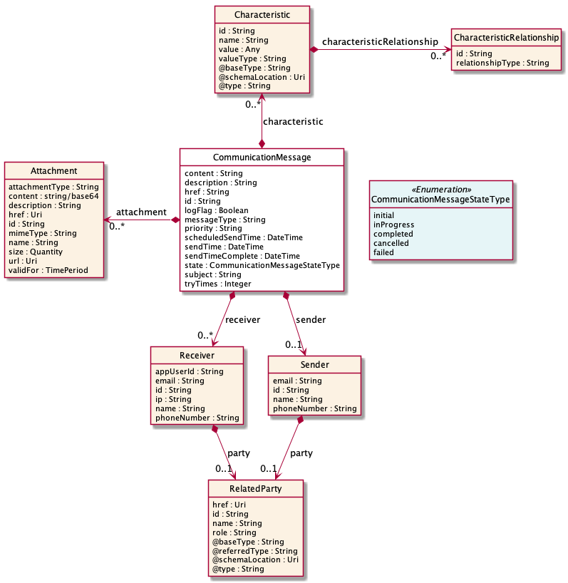

**Field descriptions**

*CommunicationMessage* fields

|  |  |
| --- | --- |
| attachment | A list of attachments (Attachment [*]). Any attachment associated with this message. |
| characteristic | A list of characteristics (Characteristic [*]). Any additional characteristic(s) of this message. |
| content | A string. The content of the communication message. |
| description | A string. Description for the whole object. |
| href | A string. Hypertext Reference of the Communication Message. |
| id | A string. Unique identifier of Communication Message. |
| logFlag | A boolean. |
| messageType | A string. The type of message, such as: SMS, Email, Mobile app push notification. |
| priority | A string. The priority of the communication message. Small number means higher priority. |
| receiver | A list of receivers (Receiver [*]). The receiver(s) of this message. |
| scheduledSendTime | A date time (DateTime). The scheduled time for sending the communication message. |
| sendTime | A date time (DateTime). The time of sending communication message. |
| sendTimeComplete | A date time (DateTime). The time of completion of sending communication message. |
| sender | A sender (Sender). The sender of this message. |
| state | A communication message state type (CommunicationMessageStateType). Status of communication message. |
| subject | A string. The title of the message, necessary for the email and mobile app push. |
| tryTimes | An integer. How many times do you want to retry the delivery of this message?. |

*Attachment* sub-resource

Complements the description of an element (for instance a product) through video, pictures...

|  |  |
| --- | --- |
| attachmentType | A string. Attachment type such as video, picture. |
| content | A base 6 4 (Base64). The actual contents of the attachment object, if embedded, encoded as base64. |
| description | A string. A narrative text describing the content of the attachment. |
| href | An uri (Uri). URI for this Attachment. |
| id | A string. Unique identifier for this particular attachment. |
| mimeType | A string. Attachment mime type such as extension file for video, picture and document. |
| name | A string. The name of the attachment. |
| size | A quantity (Quantity). The size of the attachment. |
| url | An uri (Uri). Uniform Resource Locator, is a web page address (a subset of URI). |
| validFor | A time period. The period of time for which the attachment is valid. |

*Characteristic* sub-resource

Describes a given characteristic of an object or entity through a name/value pair.

|  |  |
| --- | --- |
| @baseType | A string. When sub-classing, this defines the super-class. |
| @schemaLocation | An uri (Uri). A URI to a JSON-Schema file that defines additional attributes and relationships. |
| @type | A string. When sub-classing, this defines the sub-class Extensible name. |
| characteristicRelationship | A list of characteristic relationships (CharacteristicRelationship [*]). Another Characteristic that is related to the current Characteristic;. |
| id | A string. Unique identifier of the characteristic. |
| name | A string. Name of the characteristic. |
| value | An any (Any). The value of the characteristic. |
| valueType | A string. Data type of the value of the characteristic. |

*CharacteristicRelationship* sub-resource

Another Characteristic that is related to the current Characteristic;.

|  |  |
| --- | --- |
| id | A string. Unique identifier of the characteristic. |
| relationshipType | A string. The type of relationship. |

*Quantity* sub-resource

An amount in a given unit.

|  |  |
| --- | --- |
| amount | A float. Numeric value in a given unit. |
| units | A string. Unit. |

*Receiver* sub-resource

Receivers of the communication message.

|  |  |
| --- | --- |
| appUserId | A string. ID of the mobile app user. |
| email | A string. Receiver address of email, if the communication type is email. |
| id | A string. ID of the receiver. |
| ip | A string. IP address of the receiver. |
| name | A string. Name of the receiver. |
| party | A related party (RelatedParty). Related Entity reference. A related party defines party or party role linked to a specific entity. |
| phoneNumber | A string. Phone number of the receiver, if the communication type is SMS. |

*RelatedParty* sub-resource

Related Entity reference. A related party defines party or party role linked to a specific entity.

|  |  |
| --- | --- |
| @referredType | A string. The actual type of the target instance when needed for disambiguation. |
| name | A string. Name of the related entity. |
| href | An uri (Uri). Hyperlink reference. |
| id | A string. unique identifier. |
| @baseType | A string. When sub-classing, this defines the super-class. |
| @schemaLocation | An uri (Uri). A URI to a JSON-Schema file that defines additional attributes and relationships. |
| @type | A string. When sub-classing, this defines the sub-class Extensible name. |
| role | A string. Role played by the related party. |

*Sender* sub-resource

Sender of the communication message.

|  |  |
| --- | --- |
| email | A string. Sender address of email, if the communication type is email. |
| id | A string. ID of the sender. |
| name | A string. Name of the sender. |
| party | A related party (RelatedParty). Related Entity reference. A related party defines party or party role linked to a specific entity. |
| phoneNumber | A string. Phone number of the sender, if the communication type is SMS. |

**Json representation sample**

We provide below the json representation of an example of a 'CommunicationMessage' resource object

|  |
| --- |
| {  "id": "1708",  "href": "https://serverlocation/tmf-api/communicationManagement/v4/communicationMessage/1708",  "subject": "News: the latest promotion for you",  "scheduledSendTime": "2020-02-10T00:00:00+01:00",  "state": "initial",  "description": "this is communication message for promotion",  "content": "Dear $Parameter1, Here is the information of the promotion $Parameter2",  "messageType": "SMS",  "characteristic": [  {  "name": "$Parameter1",  "value": "Mr. Jones",  "valueType": "string"  },  {  "name": "$Parameter2",  "value": "4G_LTE Discount 30%",  "valueType": "string"  }  ],  "attachment": [  {  "url": "https://serverlocation/files/1",  "name": "File_XYZ_001"  }  ],  "sender": {  "id": "10099",  "name": "ABC Company",  "phoneNumber": "10086"  },  "receiver": [  {  "id": "10234",  "name": "Customer",  "phoneNumber": "008613811112222",  "party": {  "id": "991",  "href": "https://serverlocation/tmf-api/partyManagement/v4/individual/1",  "role": "customer",  "name": "John White",  "@referredType": "Individual"  }  }  ] } |

## Notification Resource Models

2 notifications are defined for this API

Notifications related to CommunicationMessage:  
 - CommunicationMessageAttributeValueChangeEvent  
 - CommunicationMessageStateChangeEvent

The notification structure for all notifications in this API follow the pattern depicted by the figure below.  
A notification event resource (depicted by "SpecificEvent" placeholder) is a sub class of a generic Event structure containing at least an id of the event occurrence (eventId), an event timestamp (eventTime), and the name of the resource (eventType).   
This notification structure owns an event payload structure ("SpecificEventPayload" placeholder) linked to the resource concerned by the notification using the resource name as access field ("resourceName" placeholder).

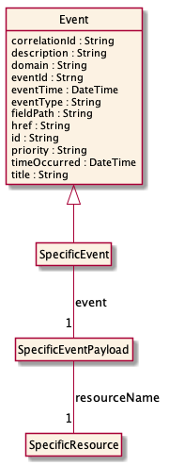

### Communication Message Attribute Value Change Event

Notification CommunicationMessageAttributeValueChangeEvent case for resource CommunicationMessage

**Json representation sample**

We provide below the json representation of an example of a 'CommunicationMessageAttributeValueChangeEvent' notification event object

|  |
| --- |
| {  "eventId":"00001",  "eventTime":"2015-11-16T16:42:25-04:00",  "eventType":"CommunicationMessageAttributeValueChangeEvent",  "event": {  "communicationMessage" :   {-- SEE CommunicationMessage RESOURCE SAMPLE --}  } } |

### Communication Message State Change Event

Notification CommunicationMessageStateChangeEvent case for resource CommunicationMessage

**Json representation sample**

We provide below the json representation of an example of a 'CommunicationMessageStateChangeEvent' notification event object

|  |
| --- |
| {  "eventId":"00001",  "eventTime":"2015-11-16T16:42:25-04:00",  "eventType":"CommunicationMessageStateChangeEvent",  "event": {  "communicationMessage" :   {-- SEE CommunicationMessage RESOURCE SAMPLE --}  } } |

# API OPERATIONS

Remember the following Uniform Contract:

|  |  |  |
| --- | --- | --- |
| Operation on Entities | Uniform API Operation | Description |
| Query Entities | GET Resource | GET must be used to retrieve a representation of a resource. |
| Create Entity | POST Resource | POST must be used to create a new resource |
| Partial Update of an Entity | PATCH Resource | PATCH must be used to partially update a resource |
| Remove an Entity | DELETE Resource | DELETE must be used to remove a resource |
| Execute an Action on an Entity | POST on TASK Resource | POST must be used to execute Task Resources |
| Other Request Methods | POST on TASK Resource | GET and POST must not be used to tunnel other request methods. |

Filtering and attribute selection rules are described in the TMF REST Design Guidelines.

Notifications are also described in a subsequent section.

## Operations on Communication Message

### List communication messages

**GET /communicationMessage?fields=...&{filtering}**

**Description**

This operation list communication message entities.  
Attribute selection is enabled for all first level attributes.  
Filtering may be available depending on the compliance level supported by an implementation.

**Usage Samples**

Here's an example of a request for retrieving multiple communication messages.

|  |
| --- |
| **Request** |
| GET /tmf-api/communicationManagement/v4/communicationMessage?status=inprogress Accept: application/json |
| **Response** |
| 200  [  {  "id": "2708",  "href": "https://serverlocation/tmf-api/communicationManagement/v4/communicationMessage/2708",  "subject": "News: the latest promotion for you",  "scheduledSendTime": "2020-02-10T00:00:00+01:00",  "sendTime": "2020-02-10T05:00:00+01:00",  "sendTimeComplete": "2020-02-10T05:05:00+01:00",  "state": "completed",  "description": "this is communication message for promotion",  "content": "Dear $Parameter1, Here is the information of the promotion $Parameter2",  "messageType": "SMS",  "characteristic": [  {  "name": "$Parameter1",  "value": "Mrs. Jones",  "valueType": "string"  },  {  "name": "$Parameter2",  "value": "4G_LTE Discount 30%",  "valueType": "string"  }  ],  "attachment": [  {  "url": "https://serverlocation/files/1",  "name": "File_XYZ_001"  }  ],  "sender": {  "id": "10099",  "name": "ABC Company",  "phoneNumber": "10086"  },  "receiver": [  {  "id": "10234",  "name": "Customer",  "phoneNumber": "008613222211111",  "party": {  "id": "1091",  "href": "https://serverlocation/tmf-api/partyManagement/v4/individual/1",  "role": "customer",  "name": "Sara White",  "@referredType": "Individual"  }  }  ]  },  {  "id": "2708",  "href": "https://serverlocation/tmf-api/communicationManagement/v4/communicationMessage/2708",  "subject": "News: the latest promotion for you",  "scheduledSendTime": "2020-02-10T00:00:00+01:00",  "state": "initial",  "description": "this is communication message for promotion",  "content": "Dear $Parameter1, Here is the information of the promotion $Parameter2",  "messageType": "Email",  "characteristic": [  {  "name": "$Parameter1",  "value": "Mrs. Jones",  "valueType": "string"  },  {  "name": "$Parameter2",  "value": "4G_LTE Discount 30%",  "valueType": "string"  }  ],  "attachment": [  {  "url": "https://serverlocation/files/2",  "name": "File_XYZ_002"  }  ],  "sender": {  "id": "10099",  "name": "ABC Company",  "phoneNumber": "10086"  },  "receiver": [  {  "id": "10234",  "name": "Customer",  "phoneNumber": "008613222211111",  "party": {  "id": "1091",  "href": "https://serverlocation/tmf-api/partyManagement/v4/individual/1",  "role": "customer",  "name": "Sara White",  "@referredType": "Individual"  }  }  ]  } ] |

### Retrieve communication message

**GET /communicationMessage/{id}?fields=...&{filtering}**

**Description**

This operation retrieves a communication message entity.  
Attribute selection is enabled for all first level attributes.  
Filtering on sub-resources may be available depending on the compliance level supported by an implementation.

**Usage Samples**

Here's an example of a request for retrieving a specific communication message.

|  |
| --- |
| **Request** |
| GET /tmf-api/communicationManagement/v4/communicationMessage/3830 Accept: application/json |
| **Response** |
| 200  {  "id": "1708",  "href": "https://serverlocation/tmf-api/communicationManagement/v4/communicationMessage/1708",  "subject": "News: the latest promotion for you",  "scheduledSendTime": "2020-02-10T00:00:00+01:00",  "sendTime": "2020-02-10T00:00:00+01:00",  "sendTimeComplete": "2020-02-10T00:10:00+01:00",  "state": "completed",  "description": "this is communication message for promotion",  "content": "Dear $Parameter1, Here is the information of the promotion $Parameter2",  "characteristic": [  {  "name": "$Parameter1",  "value": "Mr. Jones",  "valueType": "string"  },  {  "name": "$Parameter2",  "value": "4G_LTE Discount 30%",  "valueType": "string"  }  ],  "attachment": [  {  "url": "https://serverlocation/files/1",  "name": "File_XYZ_001"  }  ],  "sender": {  "id": "10099",  "name": "ABC Company",  "phoneNumber": "10086"  },  "receiver": [  {  "id": "10234",  "name": "Customer",  "phoneNumber": "008613811112222",  "party": {  "id": "991",  "href": "https://serverlocation//tmf-api/partyManagement/v4/individual/1",  "role": "customer",  "name": "John White",  "@referredType": "Individual"  }  }  ] } |

### Create communication message

**POST /communicationMessage**

**Description**

This operation creates a communication message entity.

**Mandatory and Non Mandatory Attributes**

The following tables provide the list of mandatory and non mandatory attributes when creating a CommunicationMessage, including any possible rule conditions and applicable default values. Notice that it is up to an implementer to add additional mandatory attributes.

| Mandatory Attributes | Rule |
| --- | --- |
| content |  |
| receiver |  |
| sender |  |
| messageType |  |

|  |  |
| --- | --- |
| Non Mandatory Attributes | Rule |
| attachment |  |
| characteristic |  |
| description |  |
| logFlag |  |
| priority |  |
| scheduledSendTime |  |
| sendTime |  |
| sendTimeComplete |  |
| state |  |
| subject |  |
| tryTimes |  |

**Usage Samples**

Here's an example of a request for creating a communication message. In this example the request is created in the initial state. The message will be available for sending by later setting the status to inProgress.

|  |
| --- |
| **Request** |
| POST /tmf-api/communicationManagement/v4/communicationMessage Content-Type: application/json  {  "subject": "News: the latest promotion for you",  "scheduledSendTime": "2020-02-10T00:00:00+01:00",  "state": "initial",  "description": "this is communication message for promotion",  "content": "Dear $Parameter1, Here is the information of the promotion $Parameter2",  "messageType": "SMS",  "characteristic": [  {  "name": "$Parameter1",  "value": "Mr. Jones",  "valueType": "string"  },  {  "name": "$Parameter2",  "value": "4G_LTE Discount 30%",  "valueType": "string"  }  ],  "attachment": [  {  "url": "https://serverlocation/files/1",  "name": "File_XYZ_001"  }  ],  "sender": {  "id": "10099",  "name": "ABC Company",  "phoneNumber": "10086"  },  "receiver": [  {  "id": "10234",  "name": "Customer",  "phoneNumber": "008613811112222",  "party": {  "id": "991",  "href": "https://serverlocation/tmf-api/partyManagement/v4/individual/1",  "role": "customer",  "name": "John White",  "@referredType": "Individual"  }  }  ] } |
| **Response** |
| 201  {  "id": "1708",  "href": "https://serverlocation/tmf-api/communicationManagement/v4/communicationMessage/1708",  "subject": "News: the latest promotion for you",  "scheduledSendTime": "2020-02-10T00:00:00+01:00",  "state": "initial",  "description": "this is communication message for promotion",  "content": "Dear $Parameter1, Here is the information of the promotion $Parameter2",  "messageType": "SMS",  "characteristic": [  {  "name": "$Parameter1",  "value": "Mr. Jones",  "valueType": "string"  },  {  "name": "$Parameter2",  "value": "4G_LTE Discount 30%",  "valueType": "string"  }  ],  "attachment": [  {  "url": "https://serverlocation/files/2",  "name": "File_XYZ_002"  }  ],  "sender": {  "id": "10099",  "name": "ABC Company",  "phoneNumber": "10086"  },  "receiver": [  {  "id": "10234",  "name": "Customer",  "phoneNumber": "008613811112222",  "party": {  "id": "991",  "href": "https://serverlocation/tmf-api/partyManagement/v4/individual/1",  "role": "customer",  "name": "John White",  "@referredType": "Individual"  }  }  ] } |

Here's an example of a request for creating a communication message. In this example the request is created in the inProgress state and will be sent at the scheduled send time.

|  |
| --- |
| **Request** |
| POST /tmf-api/communicationManagement/v4/communicationMessage Content-Type: application/json  {  "subject": "News: the latest promotion for you",  "scheduledSendTime": "2020-02-10T00:00:00+01:00",  "state": "inProgress",  "description": "this is communication message for promotion",  "content": "Dear $Parameter1, Here is the information of the promotion $Parameter2",  "messageType": "Email",  "characteristic": [  {  "name": "$Parameter1",  "value": "Mrs. Jones",  "valueType": "string"  },  {  "name": "$Parameter2",  "value": "4G_LTE Discount 30%",  "valueType": "string"  }  ],  "attachment": [  {  "url": "https://serverlocation/files/1",  "name": "File_XYZ_001"  }  ],  "sender": {  "id": "10099",  "name": "ABC Company",  "phoneNumber": "10086"  },  "receiver": [  {  "id": "10234",  "name": "Customer",  "phoneNumber": "008613811112222",  "party": {  "id": "991",  "href": "http://serverlocation/tmf-api/partyManagement/v4/individual/1",  "role": "customer",  "name": "John White",  "@referredType": "Individual"  }  }  ] } |
| **Response** |
| 201  {  "id": "2708",  "href": "https://serverlocation/tmf-api/communicationManagement/v4/communicationMessage/2708",  "subject": "News: the latest promotion for you",  "scheduledSendTime": "2020-02-10T00:00:00+01:00",  "state": "initial",  "description": "this is communication message for promotion",  "content": "Dear $Parameter1, Here is the information of the promotion $Parameter2",  "messageType": "Email",  "characteristic": [  {  "name": "$Parameter1",  "value": "Mrs. Jones",  "valueType": "string"  },  {  "name": "$Parameter2",  "value": "4G_LTE Discount 30%",  "valueType": "string"  }  ],  "attachment": [  {  "url": "https://serverlocation/files/1",  "name": "File_XYZ_001"  }  ],  "sender": {  "id": "10099",  "name": "ABC Company",  "phoneNumber": "10086"  },  "receiver": [  {  "id": "10234",  "name": "Customer",  "phoneNumber": "008613222211111",  "party": {  "id": "1091",  "href": "https://serverlocation/tmf-api/partyManagement/v4/individual/1",  "role": "customer",  "name": "Sara White",  "@referredType": "Individual"  }  }  ] } |

### Patch communication message

**PATCH /communicationMessage/{id}**

**Description**

This operation allows partial updates of a communication message entity. Support of json/merge (https://tools.ietf.org/html/rfc7386) is mandatory, support of json/patch (http://tools.ietf.org/html/rfc5789) is optional.  
  
Note: If the update operation yields to the creation of sub-resources or relationships, the same rules concerning mandatory sub-resource attributes and default value settings in the POST operation applies to the PATCH operation. Hence these tables are not repeated here.

**Patchable and Non Patchable Attributes**

The tables below provide the list of patchable and non patchable attributes, including constraint rules on their usage.

| Patchable Attributes | Rule |
| --- | --- |
| attachment |  |
| characteristic |  |
| content |  |
| description |  |
| logFlag |  |
| messageType |  |
| priority |  |
| receiver |  |
| scheduledSendTime |  |
| sendTime |  |
| sendTimeComplete |  |
| sender |  |
| state |  |
| subject |  |
| tryTimes |  |

|  |  |
| --- | --- |
| Non Patchable Attributes | Rule |
| href |  |
| id |  |

**Usage Samples**

Here's an example of a request for updating a communication message. In this example, the message status is set to inProgress, together with a new scheduled send time.

|  |
| --- |
| **Request** |
| PATCH /tmf-api/communicationManagement/v4/communicationMessage/3830 Content-Type: application/merge-patch+json  {  "scheduledSendTime": "2020-02-15T00:00:00+01:00",  "state": "inProgress" } |
| **Response** |
| 200  {  "scheduledSendTime": "2020-02-15T00:00:00+01:00",  "state": "inProgress",  "attachment": [  {  "url": "https://serverlocation/files/2",  "name": "File_XYZ_002"  }  ] } |

### Delete communication message

**DELETE /communicationMessage/{id}**

**Description**

This operation deletes a communication message entity.

**Usage Samples**

Here's an example of a request for deleting a communication message.

|  |
| --- |
| **Request** |
| DELETE /tmf-api/communicationManagement/v4/communicationMessage/3830 |
| **Response** |
| 204 |

# API NOTIFICATIONS

For every single of operation on the entities use the following templates and provide sample REST notification POST calls.

It is assumed that the Pub/Sub uses the Register and UnRegister mechanisms described in the REST Guidelines reproduced below.

## Register listener

**POST /hub**

**Description**

Sets the communication endpoint address the service instance must use to deliver information about its health state, execution state, failures and metrics. Subsequent POST calls will be rejected by the service if it does not support multiple listeners. In this case DELETE /api/hub/{id} must be called before an endpoint can be created again.

**Behavior**

Returns HTTP/1.1 status code 204 if the request was successful.

Returns HTTP/1.1 status code 409 if request is not successful.

**Usage Samples**

Here's an example of a request for registering a listener.

|  |
| --- |
| **Request** |
| POST /api/hub  Accept: application/json  {"callback": "http://in.listener.com"} |
| **Response** |
| 201  Content-Type: application/json  Location: /api/hub/42  {"id":"42","callback":"http://in.listener.com","query":null} |

## Unregister listener

**DELETE /hub/{id}**

**Description**

Clears the communication endpoint address that was set by creating the Hub.

**Behavior**

Returns HTTP/1.1 status code 204 if the request was successful.

Returns HTTP/1.1 status code 404 if the resource is not found.

**Usage Samples**

Here's an example of a request for un-registering a listener.

|  |
| --- |
| **Request** |
| DELETE /api/hub/42  Accept: application/json |
| **Response** |
| 204 |

## Publish Event to listener

**POST /client/listener**

**Description**

Clears the communication endpoint address that was set by creating the Hub.

Provides to a registered listener the description of the event that was raised. The /client/listener url is the callback url passed when registering the listener.

**Behavior**

Returns HTTP/1.1 status code 201 if the service is able to set the configuration.

**Usage Samples**

Here's an example of a notification received by the listener. In this example “EVENT TYPE” should be replaced by one of the notification types supported by this API (see Notification resources Models section) and EVENT BODY refers to the data structure of the given notification type.

|  |
| --- |
| **Request** |
| POST /client/listener  Accept: application/json  {  "event": {  EVENT BODY  },  "eventType": "EVENT_TYPE"  } |
| **Response** |
| 201 |

For detailed examples on the general TM Forum notification mechanism, see the TMF REST Design Guidelines.

# Acknowledgements

## Version History

| **Version Number** | **Date** | **Modified by:** | **Description** |
| --- | --- | --- | --- |
| 1.0.0 | 13-Nov-2016 | Maxu | Initial Document. |
| 1.1.0 | 09-Oct-2017 | Maxu  Hongxia Hao | Addressed some comments from Orange & Vodafone & TMF. |
| 1.1.1 | 23-Jan-2018 | Adrienne Walcott | Formatting/style edits prior to publishing |
| 2.0.0 | 12-Jun-2018 | Hongxia Hao | Modify some typos.  Change the table format of fields descriptions.  Align with DG3.0  Updated to TM Forum new brand guidelines |
| 2.0.1 | 29-Jun-2018 | Adrienne Walcott | Formatting/style edits prior to R18 publishing |
| 2.0.2 | 10-Sep-2018 | Adrienne Walcott | Updated to reflect TM Forum Approved Status |
| 4.0.0 | 28-May-2020 | Knut Johannessen | Updated to reflect new schema based approach. |

## Release History

| **Release Number** | **Date** | **Release led by:** | **Description** |
| --- | --- | --- | --- |
| Release 1.0 | 04/15/2017 | Pierre Gauthier TM Forum [pgauthier@tmforum.org](mailto:pgauthier@tmforum.org)  Mariano Belaunde Orange Labs | First Release of the Document. |
| Release 2.0 | 11/06/2018 | Mariano Belaunde  Orange Labs | Alignment with Guidelines 3.0 |
| Pre-production | 28-May-2020 | Knut Johannessen | Updated to reflect new schema based approach. |

## 

## Contributors to Document

|  |  |
| --- | --- |
| Hongxia Hao | Huawei |
| Maxu | Huawei |
| Mariano Belaunde | Orange |
| Nicoleta Stoica | Vodafone |
| Kuang Chunguang | Huawei |
| Jiang Yisong | Huawei |
| Pierre Gauthier | TM Forum |
| Knut Johannessen | Telenor |