TM Forum Specification

TMF908 IoT Device Management API REST Specification v1.0

TMF908
Team Approved Date: 17/Oct/2019

Release Status: Pre-Production | Approval Status: Team Approved
Version 1.0 | IPR Mode: RAND

NOTICE
Copyright © TM Forum 2020. All Rights Reserved.

This document and translations of it may be copied and furnished to others, and derivative works that comment on or otherwise explain it or assist in its implementation may be prepared, copied, published, and distributed, in whole or in part, without restriction of any kind, provided that the above copyright notice and this section are included on all such copies and derivative works. However, this document itself may not be modified in any way, including by removing the copyright notice or references to TM FORUM, except as needed for the purpose of developing any document or deliverable produced by a TM FORUM Collaboration Project Team (in which case the rules applicable to copyrights, as set forth in the TM FORUM IPR Policy, must be followed) or as required to translate it into languages other than English.

The limited permissions granted above are perpetual and will not be revoked by TM FORUM or its successors or assigns.

This document and the information contained herein is provided on an "AS IS" basis and TM FORUM DISCLAIMS ALL WARRANTIES, EXPRESS OR IMPLIED, INCLUDING BUT NOT LIMITED TO ANY WARRANTY THAT THE USE OF THE INFORMATION HEREIN WILL NOT INFRINGE ANY OWNERSHIP RIGHTS OR ANY IMPLIED WARRANTIES OF MERCHANTABILITY OR FITNESS FOR A PARTICULAR PURPOSE.

Direct inquiries to the TM Forum office:

4 Century Drive, Suite 100
Parsippany, NJ 07054, USA
Tel No. +1 973 944 5100
Fax No. +1 973 998 7196
TM Forum Web Page: www.tmforum.org

Table of Contents

NOTICE 2
Table of Contents 3
List of Tables 6
Introduction 7
SAMPLE USE CASES 8
Support of polymorphism and extension patterns 9
RESOURCE MODEL 10
Managed Entity and Task Resource Models 10
Iot Device resource 10
Data Access Endpoint resource 22
Iot Device Specification resource 25
Iot Data Event resource 32
Iot Management Event resource 33
Resource Specification resource 34
Alarm resource 40
Notification Resource Models 46
Iot Device Create Event 48
Iot Device Change Event 48
Iot Device Batch Event 48
Iot Device Delete Event 49
Iot Device Heart Beat Event 49
Iot Device State Change Event 49
Iot Device Specification Create Event 50
Iot Device Specification Change Event 50
Iot Device Specification Batch Event 51
Iot Device Specification Delete Event 51
Alarm Create Event 51
Alarm Change Event 52
Alarm Delete Event 52
API OPERATIONS 53
Operations on Iot Device 54
List iot devices 54
Retrieve iot device 57
Create iot device 60
Patch iot device 62
Delete iot device 67
Operations on Data Access Endpoint 67
List data access endpoints 67
Retrieve data access endpoint 68
Operations on Iot Device Specification 69
List iot device specifications 69
Retrieve iot device specification 70
Create iot device specification 71
Patch iot device specification 72
Delete iot device specification 74
Operations on Iot Data Event 75
List iot data events 75
Retrieve iot data event 76
Operations on Iot Management Event 77
List iot management events 77
Retrieve iot management event 78
Operations on Resource Specification 78
Operations on Alarm 78
List alarms 78
Retrieve alarm 80
Create alarm 81
Patch alarm 83
API NOTIFICATIONS 86
Register listener 86
Unregister listener 87
Publish Event to listener 87
Acknowledgements 89
Document History 89
Version History 89
Release History 89
Contributors to Document 89

List of Tables
N/A

Introduction

The following document is the specification of the REST API for Any management. It includes the model definition as well as all available operations.

SAMPLE USE CASES
Reader will find an example of use cases using Usage API in “Open Digital Business Scenarios and Use Cases” document.

Support of polymorphism and extension patterns

Support of polymorphic collections and types and schema-based extension is provided by means of a list of generic meta-attributes that we describe below. Polymorphism in collections occurs when entities inherit from base entities, for instance a BillingAccount and SettlementAccount inheriting properties from the abstract Account entity.
Generic support of polymorphism and pattern extensions is described in the TMF API Guidelines v3.0 Part 2 document.
The @type attribute provides a way to represent the actual class type of an entity. For example, within a list of Account instances some may be instances of BillingAccount where other could be instances of SettlementAccount. The @type gives this information. All resources and sub-resources of this API have a @type attributes that can be provided when this is useful.
The @referredType can be used within reference entities (like for instance an AccountRef object) to explicitly denote the actual entity type of the referred class. Notice that in reference entities the @type, when used, denotes the class type of the reference itself, such as BillingAccountRef or SettlementAccountRef, and not the class type of the referred object. However, since reference classes are rarely sub-classed, @type is generally not useful in reference objects.
The @schemaLocation property can be used in resources to allow specifying user-defined properties of an Entity or to specify the expected characteristics of an entity.
The @baseType attribute gives a way to provide explicitly the base of class of a given resource that has been extended.

RESOURCE MODEL

This API uses the GeoLocation Datamodel defined as follows: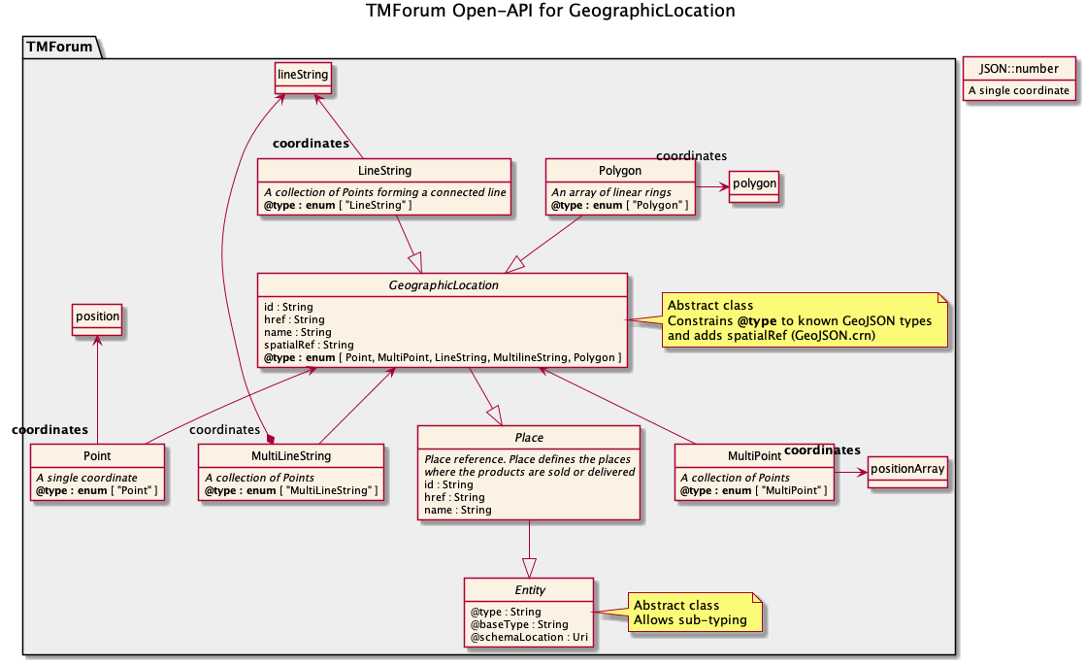

Managed Entity and Task Resource Models

Iot Device resource
#TODO.
Resource model
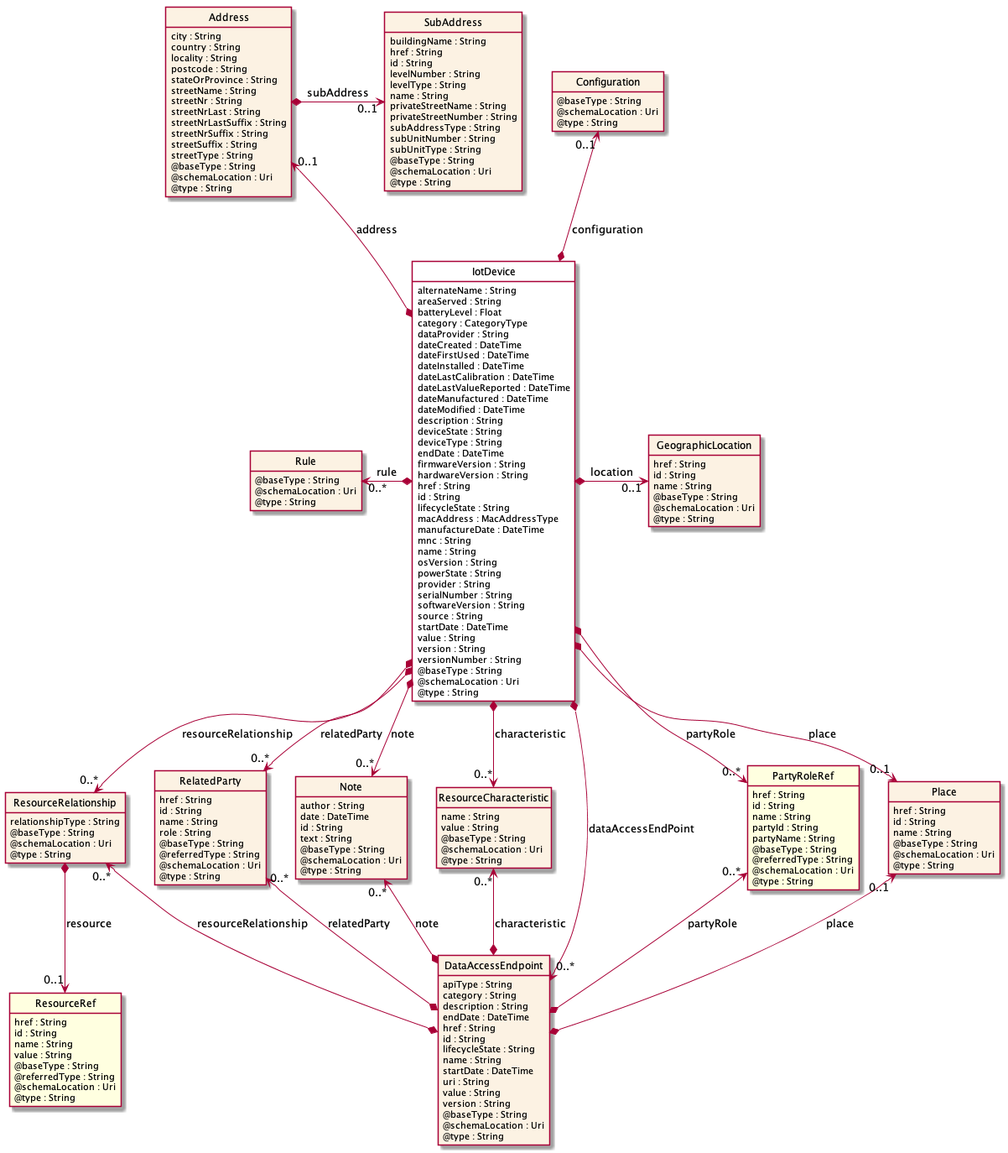

Field descriptions
IotDevice fields
batteryLevel | A float.
dateFirstUsed | A date time (DateTime).
dateInstalled | A date time (DateTime).
dateLastCalibration | A date time (DateTime).
dateLastValueReported | A date time (DateTime).
dateManufactured | A date time (DateTime).
deviceState | A string.
deviceType | A string. NGSI Entity type.
firmwareVersion | A string.
hardwareVersion | A string.
mnc | A string.
osVersion | A string.
provider | A string.
serialNumber | A string. This is a string that represents a manufacturer-allocated number used to identify different instances of the same hardware item. The ModelNumber and PartNumber attributes are used to identify different types of hardware items. This is a REQUIRED attribute.
softwareVersion | A string.
value | A string.
alternateName | A string.
dataProvider | A string.
dateCreated | A date time (DateTime).
dateModified | A date time (DateTime).
description | A string. free-text description of the resource.
name | A string. A string used to give a name to the resource.
source | A string.
areaServed | A string.
category | A list of category types (CategoryType [1..*]).
description | A string. free-text description of the resource.
endDate | A date time (DateTime). A date time( DateTime). The date till the resource is effective.
href | A string. The URI for the object itself.
id | A string. Identifier of an instance of the resource. Required to be unique within the resource type. Used in URIs as the identifier for specific instances of a type.
lifecycleState | A string. The life cycle state of the resource.
manufactureDate | A date time (DateTime). This is a string attribute that defines the date of manufacture of this item in the fixed format "dd/mm/yyyy". This is an optional attribute.
name | A string. A string used to give a name to the resource.
powerState | A string. This defines the current power status of the hardware item. Values include:  0: Unknown  1: Not Applicable  2: No Power Applied  3: Full Power Applied  4: Power Save - Normal  5: Power Save - Degraded  6: Power Save - Standby  7: Power Save - Critical  8: Power Save - Low Power Mode  9: Power Save - Unknown  10: Power Cycle  11: Power Warning  12: Power Off.
serialNumber | A string. This is a string that represents a manufacturer-allocated number used to identify different instances of the same hardware item. The ModelNumber and PartNumber attributes are used to identify different types of hardware items. This is a REQUIRED attribute.
startDate | A date time (DateTime). A date time ( DateTime). The date from which the resource is effective.
version | A string. A field that identifies the specific version of an instance of a resource.
versionNumber | A string. This is a string that identifies the version of this object. This is an optional attribute.
category | A list of category types (CategoryType [1..*]).
dataAccessEndPoint | A list of data access endpoints (DataAccessEndpoint [*]). This is the endpoint exposed by the IoT Device to authorized users.
location | A geographic location (GeographicLocation). A GeographicLocation is a pure-virtual super-class to the GeoJSON-aligned geometries of Point (addresses and locations), MultiPoint, LineString (streets, highways and boundaries), MultiLineString and Polygon (countries, provinces, tracts of land). Use the @type attribute to specify which of these is being specified by the geometry attribute.
configuration | A configuration (Configuration). #TODO.
macAddress | A list of mac address types (MacAddressType [*]). #TODO.
rule | A list of rules (Rule [*]).
address | An address (Address). Structured textual way of describing how to find a Property in an urban area (country properties are often  defined differently).  Note: Address corresponds to SID UrbanPropertyAddress.
location | A geographic location (GeographicLocation). A GeographicLocation is a pure-virtual super-class to the GeoJSON-aligned geometries of Point (addresses and locations), MultiPoint, LineString (streets, highways and boundaries), MultiLineString and Polygon (countries, provinces, tracts of land). Use the @type attribute to specify which of these is being specified by the geometry attribute.
characteristic | A list of resource characteristics (ResourceCharacteristic [*]).
note | A list of notes (Note [*]). Extra information about a given entity.
partyRole | A list of party role references (PartyRoleRef [*]). A party role represents the part played by a party in a given context.
place | A place (Place). Place reference. Place defines the places where the products are sold or delivered.
relatedParty | A list of related parties (RelatedParty [*]). Related Entity reference. A related party defines party or party role linked to a specific entity.
resourceRelationship | A list of resource relationships (ResourceRelationship [*]). Describes links between resources.

Address sub-resource
Structured textual way of describing how to find a Property in an urban area (country properties are often
defined differently).
Note: Address corresponds to SID UrbanPropertyAddress.
city | A string. City that the address is in.
country | A string. Country that the address is in.
locality | A string. "An area of defined or undefined boundaries within a local authority or other legislatively defined area, usually rural or semi-rural in nature." [ANZLIC-STREET], or a suburb "a bounded locality within a city, town or shire principally of urban character " [ANZLICSTREET].
postcode | A string. descriptor for a postal delivery area, used to speed and simplify the delivery of mail (also known as zipcode).
stateOrProvince | A string. the State or Province that the address is in.
streetName | A string. Name of the street or other street type.
streetNr | A string. Number identifying a specific property on a public street. It may be combined with streetNrLast for ranged addresses.
streetNrLast | A string. Last number in a range of street numbers allocated to a property.
streetNrLastSuffix | A string. Last street number suffix for a ranged address.
streetNrSuffix | A string. the first street number suffix.
streetSuffix | A string. A modifier denoting a relative direction.
streetType | A string. alley, avenue, boulevard, brae, crescent, drive, highway, lane, terrace, parade, place, tarn, way, wharf.
subAddress | A sub address (SubAddress). Within a property in an urban area, may refer to a building, building cluster, or a floor of a multistory building.
DataAccessEndpoint sub-resource
This is the endpoint exposed by the IoT Device to authorized users.
category | A string. Category of the concrete resource, such as: Gold, Silver for MSISDN concrete resource.
description | A string. Free-text description of the resource.
endDate | A date time (DateTime). The date till the resource is effective.
href | A string. The URI for the object itself.
id | A string. Identifier of an instance of the resource. Required to be unique within the resource type. Used in URIs as the identifier for specific instances of a type.
lifecycleState | A string. The life cycle state of the resource.
name | A string. A string used to give a name to the resource.
startDate | A date time (DateTime). A date time (DateTime). The date from which the resource is effective.
value | A string. The value of the logical resource, such as: 0044746712345 for an MSISDN.
version | A string. A field that identifies the specific version of an instance of a resource.
apiType | A string.
uri | A string. URI for using the data access API.
characteristic | A list of resource characteristics (ResourceCharacteristic [*]).
note | A list of notes (Note [*]). Extra information about a given entity.
partyRole | A list of party role references (PartyRoleRef [*]). A party role represents the part played by a party in a given context.
place | A place (Place). Place reference. Place defines the places where the products are sold or delivered.
relatedParty | A list of related parties (RelatedParty [*]). Related Entity reference. A related party defines party or party role linked to a specific entity.
resourceRelationship | A list of resource relationships (ResourceRelationship [*]). Describes links between resources.
GeographicLocation sub-resource
A GeographicLocation is a pure-virtual super-class to the GeoJSON-aligned geometries of Point (addresses and locations), MultiPoint, LineString (streets, highways and boundaries), MultiLineString and Polygon (countries, provinces, tracts of land). Use the @type attribute to specify which of these is being specified by the geometry attribute.
href | A string. An URI used to access to the geographic location resource.
id | A string. Unique identifier of the geographic location.
name | A string. A user-friendly name for the place, such as [Paris Store], [London Store], [Main Home].
MacAddressType sub-resource
#TODO.
MacAddressType | A string.
Note sub-resource
Extra information about a given entity.
author | A string. Author of the note.
date | A date time (DateTime). Date of the note.
id | A string. Identifier of the note within its containing entity (may or may not be globally unique, depending on provider implementation).
text | A string. Text of the note.
Place sub-resource
Place reference. Place defines the places where the products are sold or delivered.
href | A string. Unique reference of the place.
id | A string. Unique identifier of the place.
name | A string. A user-friendly name for the place, such as [Paris Store], [London Store], [Main Home].
RelatedParty sub-resource
Related Entity reference. A related party defines party or party role linked to a specific entity.
@referredType | A string. The actual type of the target instance when needed for disambiguation.
href | A string. Reference of the related entity.
id | A string. Unique identifier of a related entity.
name | A string. Name of the related entity.
role | A string. Role played by the related party.
ResourceCharacteristic sub-resource

name | A string. name of the characteristic.
value | A string. value of the characteristic.
ResourceRelationship sub-resource
Describes links between resources.
relationshipType | A string. Semantic of the relationship.
resource | A resource reference (ResourceRef). A reference to the resource.
SubAddress sub-resource
Representation of a SubAddress
It is used for addressing within a property in an urban area (country properties are often defined differently). It may refer to a building, a building cluster, or a floor of a multistory building.
buildingName | A string. Allows for buildings that have well-known names.
href | A string.
id | A string. Unique ID for this SubAddress.
levelNumber | A string. Used where a level type may be repeated e.g. BASEMENT 1, BASEMENT 2.
levelType | A string. Describes level types within a building.
name | A string. Name of the subAddress to identify it with a meaningful identification.
privateStreetName | A string. Private streets internal to a property (e.g. a university) may have internal names that are not recorded by the land title office.
privateStreetNumber | A string. Private streets numbers internal to a private street.
subAddressType | A string. The type of subaddress: it can be a subunit or a private street.
subUnitNumber | A string. The discriminator of the subunit, often just a simple number e.g. FLAT 5, may also be a range.
subUnitType | A string. The type of subunit, such as BERTH, FLAT, PIER, SUITE, SHOP, TOWER, UNIT, WHARF.
PartyRoleRef relationship
Party role reference. A party role represents the part played by a party in a given context.
@referredType | A string. The actual type of the target instance when needed for disambiguation.
href | A string. Reference of the product.
id | A string. Unique identifier of the product.
name | A string. The name of the referred party role.
partyId | A string. The identifier of the engaged party that is linked to the PartyRole object.
partyName | A string. The name of the engaged party that is linked to the PartyRole object.
ResourceRef relationship

@referredType | A string. The actual type of the target instance when needed for disambiguation.
href | A string. Reference of the related entity.
id | A string. Unique identifier of a related entity.
name | A string. Name of the resource.
value | A string. The resource value that can be used to identify a resource with a public key (e.g.: a tel nr, an msisdn).
Json representation sample
We provide below the json representation of an example of an 'IotDevice' resource object
{
"dateFirstUsed": "2019-05-13T00:00",
"dateInstalled": "2019-05-13T00:00",
"dateLastCalibration": "2019-05-13T00:00",
"dateLastValueReported": "2019-05-13T00:00",
"dateManufactured": "2019-05-13T00:00",
"deviceState": "ok",
"deviceType": "Temperature",
"firmwareVersion": "1.0.0",
"hardwareVersion": "1.0.0",
"mnc": "01",
"osVersion": "1.0.0",
"provider": "Mandat International",
"serialNumber": "12345",
"softwareVersion": "1.0.0",
"value": "0041227744222",
"alternateName": "CoAP temperature sensor 3",
"dataProvider": "https://www.mandint.org",
"dateCreated": "2019-05-13T00:00",
"dateModified": "2019-05-13T00:00",
"description": "This is a temperature sensor using CoAP and 6LoWPAN.",
"name": "temp_3",
"source": "coap://[2001:41e0:6002:1800:0:0:0:3]:61616/temp ",
"areaServed": "Switzerland ",
"category": "Gold ",
"endDate ": "2019-05-13T00:00",
"href ": "https//host:port/tmf-api/iotDevice/v1/iotDevice/temp_3",
"lifecycleState": "InService",
"manufactureDate": "2019-05-13T00:00",
"powerState": "3",
"startDate": "2019-05-13T00:00",
"version": "1.0",
"versionNumber": "1.0.0",
"dataAccessEndPoint": {
"category": "Gold",
"description": "This is a temperature sensor using CoAP and 6LoWPAN.",
"endDate": "2019-05-13T00:00",
"href": "https://host:port/tmf-api/iotDevice/v1/iotDevice/temp_3",
"id": "3",
"lifecycleState": "InService",
"name": "temp_3",
"startDate": "2019-05-03T00:00",
"value": "0041227744222",
"version": "1.0",
"apiType": "NGSI",
"uri": "https://host:port/tmf-api/iotDevice/v1/iotDevice/temp_3/dataAccessEndpoint/3"
},
"batteryLevel": 1.0,
"configuration": {
"timeout": 5,
"reportingPeriod ": 300
},
"macAddress": [
"02:00:00:00:00:03"
],
"$id": "Device.schema.json",
"address": {
"addressLocality": "Geneva",
"postalCode": "1209",
"streetAddress": "Chemin du Champ-Baron 3"
},
"location": {
" attrName": "position",
"coords": {
"type": "Point",
"coordinates": [
46.223064,
6.1305982
]
}
},
"characteristic": [
{
"name": "accuracy",
"value": "1.0"
}
],
"note": [
{
"author": "Cedric Crettaz",
"date": "2019-05-13T00:00",
"id": "txt001",
"text": "This is a CoAP temperature sensor."
}
],
"partyRole": [
{
"@referredType": "temperatureSensor",
"href": "https://www.mandint.org/temperatureSensor",
"id": "CoapTempSensor",
"name": "Mandat International",
"partyId": "MI",
"partyName": "Mandat International"
}
],
"place": {
"href": "Chemin du Champ-Baron 3",
"id": "1209",
"name": "Geneva Office"
},
"relatedParty": [
{
"@referredType": "temperatureSensor",
"href": "https://www.mandint.org/temperatureSensor",
"id": "CoapTempSensor",
"name": "Mandat International",
"role": "vendor"
}
],
"resourceRelationship": [
{
"@Type": "IotAgent",
"href": "https://www.mandint.org/iotAgent",
"id": "MI",
"name": "UDG",
"value": "0041227744222"
}
],
"iotAgent": [
{
"name": "UDG",
"objectId": "udgmi",
"href": "https://www.mandint.org/iotAgent",
"@referredType": "IotAgent",
"dataAccessEndPoint": {
"category": "Gold",
"description": "This is a temperature sensor using CoAP and 6LoWPAN.",
"endDate": "2019-05-13T00:00",
"href": "https://host:port/tmf-api/iotDevice/v1/iotDevice/temp_3",
"id": "3",
"lifecycleState": "InService",
"name": "temp_3",
"startDate": "2019-05-03T00:00",
"value": "0041227744222",
"version": "1.0",
"apiType": "NGSI",
"uri": "https://host:port/tmf-api/iotDevice/v1/iotDevice/temp_3/dataAccessEndpoint/3"
}
}
]
}

Data Access Endpoint resource
This is the endpoint exposed by the IoT Device to authorized users.
Resource model
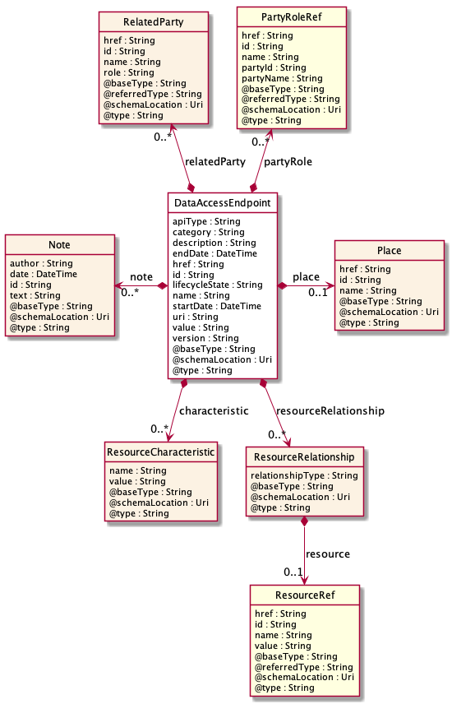

Field descriptions
DataAccessEndpoint fields
category | A string. Category of the concrete resource, such as: Gold, Silver for MSISDN concrete resource.
description | A string. Free-text description of the resource.
endDate | A date time (DateTime). The date till the resource is effective.
href | A string. The URI for the object itself.
id | A string. Identifier of an instance of the resource. Required to be unique within the resource type. Used in URIs as the identifier for specific instances of a type.
lifecycleState | A string. The life cycle state of the resource.
name | A string. A string used to give a name to the resource.
startDate | A date time (DateTime). A date time (DateTime). The date from which the resource is effective.
value | A string. The value of the logical resource, such as: 0044746712345 for an MSISDN.
version | A string. A field that identifies the specific version of an instance of a resource.
apiType | A string.
uri | A string. URI for using the data access API.
characteristic | A list of resource characteristics (ResourceCharacteristic [*]).
note | A list of notes (Note [*]). Extra information about a given entity.
partyRole | A list of party role references (PartyRoleRef [*]). A party role represents the part played by a party in a given context.
place | A place (Place). Place reference. Place defines the places where the products are sold or delivered.
relatedParty | A list of related parties (RelatedParty [*]). Related Entity reference. A related party defines party or party role linked to a specific entity.
resourceRelationship | A list of resource relationships (ResourceRelationship [*]). Describes links between resources.
Note sub-resource
Extra information about a given entity.
author | A string. Author of the note.
date | A date time (DateTime). Date of the note.
id | A string. Identifier of the note within its containing entity (may or may not be globally unique, depending on provider implementation).
text | A string. Text of the note.
Place sub-resource
Place reference. Place defines the places where the products are sold or delivered.
href | A string. Unique reference of the place.
id | A string. Unique identifier of the place.
name | A string. A user-friendly name for the place, such as [Paris Store], [London Store], [Main Home].
RelatedParty sub-resource
Related Entity reference. A related party defines party or party role linked to a specific entity.
@referredType | A string. The actual type of the target instance when needed for disambiguation.
href | A string. Reference of the related entity.
id | A string. Unique identifier of a related entity.
name | A string. Name of the related entity.
role | A string. Role played by the related party.
ResourceCharacteristic sub-resource

name | A string. name of the characteristic.
value | A string. value of the characteristic.
ResourceRelationship sub-resource
Describes links between resources.
relationshipType | A string. Semantic of the relationship.
resource | A resource reference (ResourceRef). A reference to the resource.
PartyRoleRef relationship
Party role reference. A party role represents the part played by a party in a given context.
@referredType | A string. The actual type of the target instance when needed for disambiguation.
href | A string. Reference of the product.
id | A string. Unique identifier of the product.
name | A string. The name of the referred party role.
partyId | A string. The identifier of the engaged party that is linked to the PartyRole object.
partyName | A string. The name of the engaged party that is linked to the PartyRole object.
ResourceRef relationship

@referredType | A string. The actual type of the target instance when needed for disambiguation.
href | A string. Reference of the related entity.
id | A string. Unique identifier of a related entity.
name | A string. Name of the resource.
value | A string. The resource value that can be used to identify a resource with a public key (e.g.: a tel nr, an msisdn).
Json representation sample
We provide below the json representation of an example of a 'DataAccessEndpoint' resource object
{
"category": "Gold",
"description": "This is a temperature sensor using CoAP and 6LoWPAN.",
"endDate": "2019-05-13T00:00",
"href": "https://host:port/tmf-api/iotDevice/v1/iotDevice/temp_3",
"id": "3",
"lifecycleState": "InService",
"name": "temp_3",
"startDate": "2019-05-03T00:00",
"value": "0041227744222",
"version": "1.0",
"apiType": "NGSI",
"uri": "https://host:port/tmf-api/iotDevice/v1/iotDevice/temp_3/dataAccessEndpoint/3"
}

Iot Device Specification resource
#TODO.

Resource model
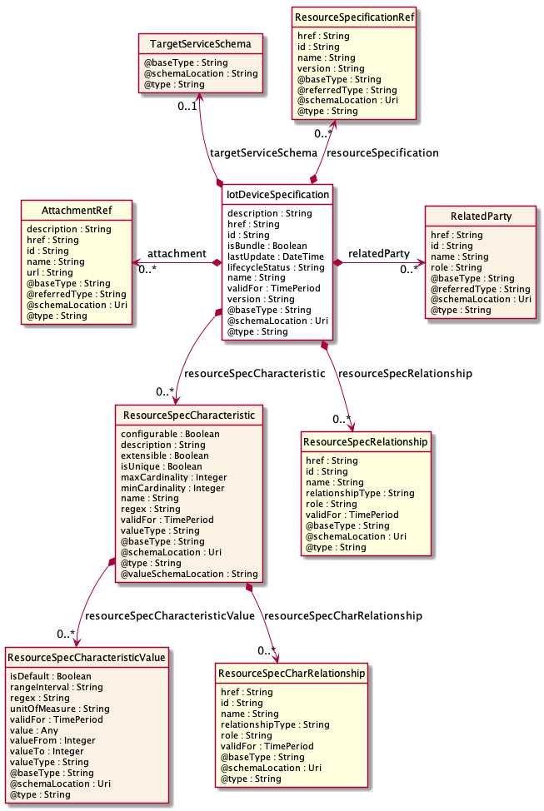

Field descriptions
IotDeviceSpecification fields
description | A string. A narrative that explains in detail what the service specification is.
href | A string. Reference of the service specification.
id | A string. Unique identifier of the service specification.
isBundle | A boolean. isBundle determines whether a ServiceSpecification represents a single ServiceSpecification (false), or a bundle of ServiceSpecification (true).
lastUpdate | A date time (DateTime). Date and time of the last update of the service specification.
lifecycleStatus | A string. Used to indicate the current lifecycle status of the service specification.
name | A string. Name of the service specification.
version | A string. Service specification version.
attachment | A list of attachment references (AttachmentRef [*]). A list of attachments (Attachment [*]). Complements the description of the specification through video, pictures...
relatedParty | A list of related parties (RelatedParty [*]). A list of related party references (RelatedParty [*]). A related party defines party or party role linked to a specific entity.
resourceSpecCharacteristic | A list of resource spec characteristics (ResourceSpecCharacteristic [*]). A list of service spec characteristics (ServiceSpecCharacteristic [*]). This class represents the key features of this service specification.
resourceSpecRelationship | A list of resource spec relationships (ResourceSpecRelationship [*]). A list of resource specifications related to this specification, e.g. migration, substitution, dependency or exclusivity relationship.
resourceSpecification | A list of resource specification references (ResourceSpecificationRef [*]). A list of resource specification references (ResourceSpecificationRef [*]). The ResourceSpecification is required for a service specification with type ResourceFacingServiceSpecification (RFSS).
targetServiceSchema | A target service schema (TargetServiceSchema). A target service schema reference (TargetServiceSchemaRef). The reference object to the schema and type of target service which is described by service specification.
validFor | A time period. The period for which the service specification is valid.
RelatedParty sub-resource
Related Entity reference. A related party defines party or party role linked to a specific entity.
@referredType | A string. The actual type of the target instance when needed for disambiguation.
href | A string. Reference of the related entity.
id | A string. Unique identifier of a related entity.
name | A string. Name of the related entity.
role | A string. Role played by the related party.
ResourceSpecCharRelationship sub-resource
An aggregation, migration, substitution, dependency or exclusivity relationship between/among resourceSpecCharacteristics.
href | A string. Hyperlink reference to the target specification.
id | A string. Unique identifier of the target specification.
name | A string. Name of the target characteristic.
relationshipType | A string. Type of relationship such as aggregation, migration, substitution, dependency, exclusivity.
role | A string. The association role for this service specification.
validFor | A time period. The period for which the serviceSpecCharRelationship is valid.
ResourceSpecCharacteristic sub-resource
This class represents the key features of this service specification. For example, bandwidth is a characteristic of many different types of services; if bandwidth is a relevant characteristic (e.g., from the point-of-view of a Customer obtaining this Service via a Product) then bandwidth would be a ServiceSpecCharacteristic for that particular Service.
@valueSchemaLocation | A string. This (optional) field provides a link to the schema describing the value type.
configurable | A boolean. If true, the Boolean indicates that the serviceSpecCharacteristic is configurable.
description | A string. A narrative that explains in detail what the serviceSpecCharacteristic is.
extensible | A boolean. An indicator that specifies that the values for the characteristic can be extended by adding new values when instantiating a characteristic for an Entity.
isUnique | A boolean. An indicator that specifies if a value is unique for the specification. Possible values are; "unique while value is in effect" and "unique whether value is in effect or not".
maxCardinality | An integer. The maximum number of instances a CharacteristicValue can take on. For example, zero to five phone numbers in a group calling plan, where five is the value for the maxCardinality.
minCardinality | An integer. The minimum number of instances a CharacteristicValue can take on. For example, zero to five phone numbers in a group calling plan, where zero is the value for the minCardinality.
name | A string. A word, term, or phrase by which this characteristic specification is known and distinguished from other characteristic specifications.
regex | A string. A rule or principle represented in regular expression used to derive the value of a characteristic value.
resourceSpecCharRelationship | A list of resource spec char relationships (ResourceSpecCharRelationship [*]). A list of resource spec char relationships (ResourceSpecCharRelationship [*]). An aggregation, migration, substitution, dependency or exclusivity relationship between/among Specification Characteristics.
resourceSpecCharacteristicValue | A list of resource spec characteristic values (ResourceSpecCharacteristicValue [*]). A list of resource spec characteristic values (ResourceSpecCharacteristicValue [*]). A ResourceSpecCharacteristicValue object is used to define a set of attributes, each of which can be assigned to a corresponding set of attributes in a ResourceSpecCharacteristic object. The values of the attributes in the ResourceSpecCharacteristicValue object describe the values of the attributes that a corresponding ResourceSpecCharacteristic object can take on.
validFor | A time period. The period for which the serviceSpecCharacteristic is valid.
valueType | A string. A kind of value that the characteristic can take on, such as numeric, text and so forth.
ResourceSpecCharacteristicValue sub-resource
A ResourceSpecCharacteristicValue object is used to define a set of attributes, each of which can be assigned to a corresponding set of attributes in a ResourceSpecCharacteristic object. The values of the attributes in the ResourceSpecCharacteristicValue object describe the values of the attributes that a corresponding ResourceSpecCharacteristic object can take on.
isDefault | A boolean. Indicates if the value is the default value for a characteristic.
rangeInterval | A string. An indicator that specifies the inclusion or exclusion of the valueFrom and valueTo attributes. If applicable, possible values are "open", "closed", "closedBottom" and "closedTop".
regex | A string. A regular expression constraint for given value.
unitOfMeasure | A string. A length, surface, volume, dry measure, liquid measure, money, weight, time, and the like. In general, a determinate quantity or magnitude of the kind designated, taken as a standard of comparison for others of the same kind, in assigning to them numerical values, as 1 foot, 1 yard, 1 mile, 1 square foot.
validFor | A time period. The period of time for which a value is applicable.
value | An any (Any). A discrete value that the characteristic can take on, or the actual value of the characteristic.
valueFrom | An integer. The low range value that a characteristic can take on.
valueTo | An integer. The upper range value that a characteristic can take on.
valueType | A string. A kind of value that the characteristic can take on, such as numeric, text, and so forth.
ResourceSpecRelationship sub-resource
A migration, substitution, dependency or exclusivity relationship between/among Resource specifications.
href | A string. Reference of the target ResourceSpecification.
id | A string. Unique identifier of the target ResourceSpecification.
name | A string. The name given to the target Resource specification instance.
relationshipType | A string. Type of relationship such as migration, substitution, dependency, exclusivity.
role | A string. The association role for this Resource specification.
validFor | A time period. The period for which the ResourceSpecRelationship is valid.
TargetServiceSchema sub-resource
The reference object to the schema and type of target service which is described by service specification.
@schemaLocation | A string. This field provides a link to the schema describing the target service.
@type | A string. Class type of the target service.
AttachmentRef relationship
Attachment reference. An attachment complements the description of an element (for instance a product) through video, pictures.
@referredType | A string. The actual type of the target instance when needed for disambiguation.
href | A string. URL serving as reference for the attachment resource.
id | A string. Unique-Identifier for this attachment.
name | A string. Name of the related entity.
description | A string. A narrative text describing the content of the attachment.
url | A string. Link to the attachment media/content.
ResourceSpecificationRef relationship
Resource Specification reference: The ResourceSpecification is required to realize a ProductSpecification.
@referredType | A string. The actual type of the target instance when needed for disambiguation.
href | A string. Reference of the resource specification.
id | A string. Unique identifier of the resource specification.
name | A string. Name of the requiredResourceSpecification.
version | A string. Resource specification version.
Json representation sample
We provide below the json representation of an example of an 'IotDeviceSpecification' resource object
{
"description": "This iot device specification ...",
"href": "https:/host:port/tmf-api/iotDeviceSpecification/v1/iotDeviceSpecification/4976",
"id": "4976",
"isBundle": true,
"lastUpdate": "2019-10-03T00:00",
"lifecycleStatus": "a string ...",
"name": "a string ...",
"version": "a string ...",
"attachment": [
{}
],
"relatedParty": [
{}
],
"resourceSpecRelationship": [
{}
],
"resourceSpecCharacteristic": [
{}
],
"resourceSpecification": [
{}
],
"targetServiceSchema": {},
"validFor": {}
}

Iot Data Event resource
#TODO.
Resource model
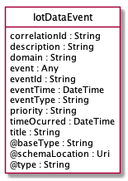
Field descriptions
IotDataEvent fields
correlationId | A string. The correlation id for this event.
description | A string. An explnatory of the event.
domain | A string. The domain of the event.
eventId | A string. The identifier of the notification.
eventTime | A date time (DateTime). Time of the event occurrence.
eventType | A string. The type of the notification.
priority | A string. A priority.
timeOcurred | A date time (DateTime). The time the event occured.
title | A string. The title of the event.
event | An any (Any).
Json representation sample
We provide below the json representation of an example of an 'IotDataEvent' resource object
{
"correlationId": "413",
"description": "This iot data event ...",
"domain": "a string ...",
"eventId": "374",
"eventTime": "2019-10-03T00:00",
"eventType": "a string ...",
"priority": "a string ...",
"timeOcurred": "2019-10-03T00:00",
"title": "a string ...",
"event": {}
}

Iot Management Event resource
Generic IotManagementEvent structure used to define commonalities between sub concepts of PartyIotManagementEvent and Financial IotManagementEvent.
Resource model
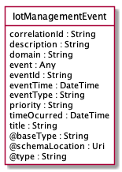

Field descriptions
IotManagementEvent fields
correlationId | A string. The correlation id for this event.
description | A string.
domain | A string. The domain of the event.
eventId | A string. The identifier of the notification.
eventTime | A date time (DateTime). Time of the event occurrence.
eventType | A string. The type of the notification.
priority | A string. A priority.
timeOcurred | A date time (DateTime). The time the event occurred.
title | A string. The title of the event.
description | A string.
event | An any (Any).
Json representation sample
We provide below the json representation of an example of an 'IotManagementEvent' resource object
{
"correlationId": "423",
"description": "This iot management event ...",
"domain": "a string ...",
"eventId": "536",
"eventTime": "2019-10-03T00:00",
"eventType": "a string ...",
"priority": "a string ...",
"timeOcurred": "2019-10-03T00:00",
"title": "a string ...",
"event": {}
}

Resource Specification resource
ResourceSpecification is a class that offers characteristics to describe a type of service.
Functionally, it acts as a template by which Services may be instantiated. By sharing the same specification, these services would therefore share the same set of characteristics.

Resource model
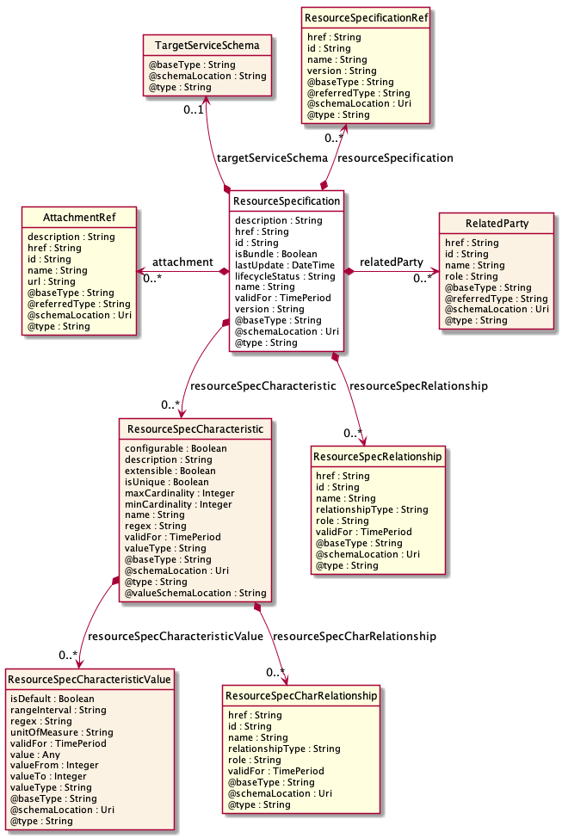
Field descriptions
ResourceSpecification fields
attachment | A list of attachment references (AttachmentRef [*]). A list of attachments (Attachment [*]). Complements the description of the specification through video, pictures...
description | A string. A narrative that explains in detail what the service specification is.
href | A string. Reference of the service specification.
id | A string. Unique identifier of the service specification.
isBundle | A boolean. isBundle determines whether a ServiceSpecification represents a single ServiceSpecification (false), or a bundle of ServiceSpecification (true).
lastUpdate | A date time (DateTime). Date and time of the last update of the service specification.
lifecycleStatus | A string. Used to indicate the current lifecycle status of the service specification.
name | A string. Name of the service specification.
relatedParty | A list of related parties (RelatedParty [*]). A list of related party references (RelatedParty [*]). A related party defines party or party role linked to a specific entity.
resourceSpecCharacteristic | A list of resource spec characteristics (ResourceSpecCharacteristic [*]). A list of service spec characteristics (ServiceSpecCharacteristic [*]). This class represents the key features of this service specification.
resourceSpecRelationship | A list of resource spec relationships (ResourceSpecRelationship [*]). A list of resource specifications related to this specification, e.g. migration, substitution, dependency or exclusivity relationship.
resourceSpecification | A list of resource specification references (ResourceSpecificationRef [*]). A list of resource specification references (ResourceSpecificationRef [*]). The ResourceSpecification is required for a service specification with type ResourceFacingServiceSpecification (RFSS).
targetServiceSchema | A target service schema (TargetServiceSchema). A target service schema reference (TargetServiceSchemaRef). The reference object to the schema and type of target service which is described by service specification.
validFor | A time period. The period for which the service specification is valid.
version | A string. Service specification version.
RelatedParty sub-resource
Related Entity reference. A related party defines party or party role linked to a specific entity.
@referredType | A string. The actual type of the target instance when needed for disambiguation.
href | A string. Reference of the related entity.
id | A string. Unique identifier of a related entity.
name | A string. Name of the related entity.
role | A string. Role played by the related party.
ResourceSpecCharRelationship sub-resource
An aggregation, migration, substitution, dependency or exclusivity relationship between/among resourceSpecCharacteristics.
href | A string. Hyperlink reference to the target specification.
id | A string. Unique identifier of the target specification.
name | A string. Name of the target characteristic.
relationshipType | A string. Type of relationship such as aggregation, migration, substitution, dependency, exclusivity.
role | A string. The association role for this service specification.
validFor | A time period. The period for which the serviceSpecCharRelationship is valid.
ResourceSpecCharacteristic sub-resource
This class represents the key features of this service specification. For example, bandwidth is a characteristic of many different types of services; if bandwidth is a relevant characteristic (e.g., from the point-of-view of a Customer obtaining this Service via a Product) then bandwidth would be a ServiceSpecCharacteristic for that particular Service.
@valueSchemaLocation | A string. This (optional) field provides a link to the schema describing the value type.
configurable | A boolean. If true, the Boolean indicates that the serviceSpecCharacteristic is configurable.
description | A string. A narrative that explains in detail what the serviceSpecCharacteristic is.
extensible | A boolean. An indicator that specifies that the values for the characteristic can be extended by adding new values when instantiating a characteristic for an Entity.
isUnique | A boolean. An indicator that specifies if a value is unique for the specification. Possible values are; "unique while value is in effect" and "unique whether value is in effect or not".
maxCardinality | An integer. The maximum number of instances a CharacteristicValue can take on. For example, zero to five phone numbers in a group calling plan, where five is the value for the maxCardinality.
minCardinality | An integer. The minimum number of instances a CharacteristicValue can take on. For example, zero to five phone numbers in a group calling plan, where zero is the value for the minCardinality.
name | A string. A word, term, or phrase by which this characteristic specification is known and distinguished from other characteristic specifications.
regex | A string. A rule or principle represented in regular expression used to derive the value of a characteristic value.
resourceSpecCharRelationship | A list of resource spec char relationships (ResourceSpecCharRelationship [*]). A list of resource spec char relationships (ResourceSpecCharRelationship [*]). An aggregation, migration, substitution, dependency or exclusivity relationship between/among Specification Characteristics.
resourceSpecCharacteristicValue | A list of resource spec characteristic values (ResourceSpecCharacteristicValue [*]). A list of resource spec characteristic values (ResourceSpecCharacteristicValue [*]). A ResourceSpecCharacteristicValue object is used to define a set of attributes, each of which can be assigned to a corresponding set of attributes in a ResourceSpecCharacteristic object. The values of the attributes in the ResourceSpecCharacteristicValue object describe the values of the attributes that a corresponding ResourceSpecCharacteristic object can take on.
validFor | A time period. The period for which the serviceSpecCharacteristic is valid.
valueType | A string. A kind of value that the characteristic can take on, such as numeric, text and so forth.
ResourceSpecCharacteristicValue sub-resource
A ResourceSpecCharacteristicValue object is used to define a set of attributes, each of which can be assigned to a corresponding set of attributes in a ResourceSpecCharacteristic object. The values of the attributes in the ResourceSpecCharacteristicValue object describe the values of the attributes that a corresponding ResourceSpecCharacteristic object can take on.
isDefault | A boolean. Indicates if the value is the default value for a characteristic.
rangeInterval | A string. An indicator that specifies the inclusion or exclusion of the valueFrom and valueTo attributes. If applicable, possible values are "open", "closed", "closedBottom" and "closedTop".
regex | A string. A regular expression constraint for given value.
unitOfMeasure | A string. A length, surface, volume, dry measure, liquid measure, money, weight, time, and the like. In general, a determinate quantity or magnitude of the kind designated, taken as a standard of comparison for others of the same kind, in assigning to them numerical values, as 1 foot, 1 yard, 1 mile, 1 square foot.
validFor | A time period. The period of time for which a value is applicable.
value | An any (Any). A discrete value that the characteristic can take on, or the actual value of the characteristic.
valueFrom | An integer. The low range value that a characteristic can take on.
valueTo | An integer. The upper range value that a characteristic can take on.
valueType | A string. A kind of value that the characteristic can take on, such as numeric, text, and so forth.
ResourceSpecRelationship sub-resource
A migration, substitution, dependency or exclusivity relationship between/among Resource specifications.
href | A string. Reference of the target ResourceSpecification.
id | A string. Unique identifier of the target ResourceSpecification.
name | A string. The name given to the target Resource specification instance.
relationshipType | A string. Type of relationship such as migration, substitution, dependency, exclusivity.
role | A string. The association role for this Resource specification.
validFor | A time period. The period for which the ResourceSpecRelationship is valid.
TargetServiceSchema sub-resource
The reference object to the schema and type of target service which is described by service specification.
@schemaLocation | A string. This field provides a link to the schema describing the target service.
@type | A string. Class type of the target service.

AttachmentRef relationship
Attachment reference. An attachment complements the description of an element (for instance a product) through video, pictures.
@referredType | A string. The actual type of the target instance when needed for disambiguation.
href | A string. URL serving as reference for the attachment resource.
id | A string. Unique-Identifier for this attachment.
name | A string. Name of the related entity.
description | A string. A narrative text describing the content of the attachment.
url | A string. Link to the attachment media/content.
ResourceSpecificationRef relationship
Resource Specification reference: The ResourceSpecification is required to realize a ProductSpecification.
@referredType | A string. The actual type of the target instance when needed for disambiguation.
href | A string. Reference of the resource specification.
id | A string. Unique identifier of the resource specification.
name | A string. Name of the requiredResourceSpecification.
version | A string. Resource specification version.
Json representation sample
We provide below the json representation of an example of a 'ResourceSpecification' resource object
{
"href": "https://mycsp.com:8080/tmf-api/resourceCatalogManagement/v3/resourceSpecification/42",
"id": "42",
"name": "Firewall",
"version": "1.0",
"@referredType": "ResourceFunctionSpec"
}

Alarm resource
This resource represents an alarm supporting the information model defined in ITU-T X.733.

Resource model
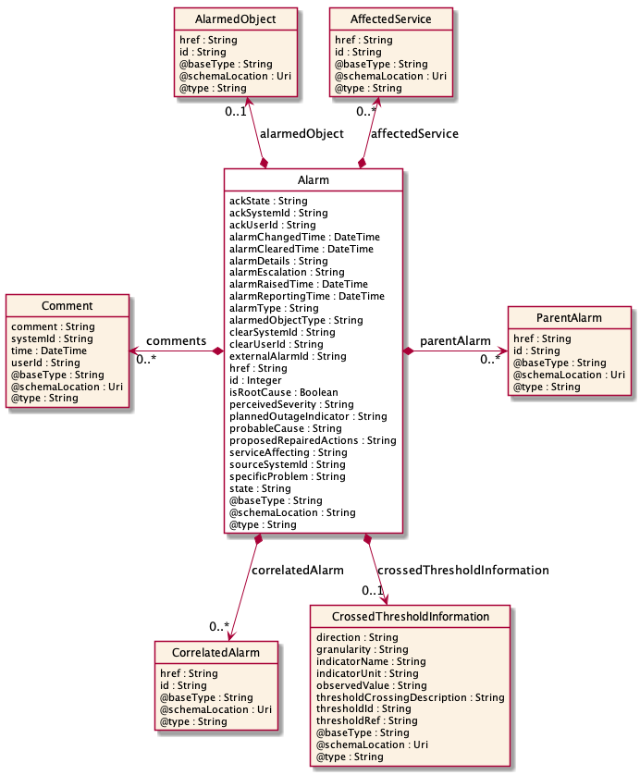
Field descriptions
Alarm fields
@baseType | A string. The base type of this alarm.
@schemaLocation | A string. A reference to the schema describing this alarm.
@type | A string. The type for this alarm.
ackState | A string. Provides the Acknowledgement State of the alarm ACKNOWLEDGED, UNACKNOWLEDGED.
ackSystemId | A string. Provides the name of the system that last changed the ackState of an alarm, i.e. acknowledged or unacknowledged the alarm.
ackUserId | A string. Provides the id of the user who has last changed the ack state of the alarm, i.e. acknowledged or unacknowledged the alarm.
affectedService | A list of affected services (AffectedService [*]).
alarmChangedTime | A date time (DateTime). Indicates the last date and time when the alarm is changed on the alarm-owning system. Any change to the alarm whether coming from the alarmed resource or triggered by a change from the client is changing this time.
alarmClearedTime | A date time (DateTime). Indicates the time (as a date + time) at which the alarm is cleared at the source.
alarmDetails | A string. Contains further information on the alarm.
alarmEscalation | A string. Indicates if this alarm has been escalated or not.
alarmRaisedTime | A date time (DateTime). Indicates the time (as a date + time) at which the alarm occurred at its source.
alarmReportingTime | A date time (DateTime). Indicates the time (as a date + time) at which the alarm was reported by the owning OSS. It might be different from the alarmRaisedTime. For instance, if the alarm list is maintained by an EMS, the alarmRaisedtime would be the time the alarm  was detected by the NE, while the alarmReportingTime would be the time this alarm was stored in the alarm list of the EMS.
alarmType | A string. Categorize the alarm. Should be one of the values defined in X.733 8.1.1 or 3GPP TS 32.111-2 Annex A:  Communications Alarm  Processing Error Alarm  Environmental Alarm  Quality of Service Alarm  Equipment Alarm  Integrity Violation  Operational Violation  Physical Violation  Security Service or Mechanism Violation  Time Domain Violation.
alarmedObject | An alarmed object (AlarmedObject). Identifies the managed object instance associated with the alarm.
alarmedObjectType | A string. The type (class) of the managed object associated with the event.
clearSystemId | A string. Provides the id of the system where the user who invoked the alarmCleared operation is located.
clearUserId | A string. Provides the id of the user who invoked the alarmCleared operation.
comments | A list of comments (Comment [*]). Indicates the comments entered on the alarm.
correlatedAlarm | A list of correlated alarms (CorrelatedAlarm [*]). Indicates the alarms attached to this alarm as correlated alarms from a correlation point of view. An alarm can be correlated to one or more underlying alarms. There might be multiple levels of alarm correlation and an underlying alarm in one relation can be itself a parent alarm for other underlying alarms.
crossedThresholdInformation | A crossed threshold information (CrossedThresholdInformation). Identifies the details of the threshold that has been crossed.
externalAlarmId | A string. An identifier of the alarm in the source system.
href | A string. A reference to the alarm.
id | An integer. Identifier of the alarm, determined by the alarm owning system.
isRootCause | A boolean. Indicates whether the alarm is a root cause alarm.
parentAlarm | A list of parent alarms (ParentAlarm [*]). Indicates the alarms attached to this alarm as parent alarms from a correlation point of view.
perceivedSeverity | A string. Lists the possible severities that can be allocated to an Alarm. The values are consistent with ITU-T Recommendation X.733:  CRITICAL  MAJOR  MINOR  WARNING  INDETERMINATE  CLEARED  Once an alarm has been cleared, its perceived severity is set to CLEARED and can no longer be set.
plannedOutageIndicator | A string. Indicates that the Managed Object (related to this alarm) is in planned outage (in planned maintenance, or out-of-service).
probableCause | A string. Provides the probable cause of the alarm. The values are consistent with ITU-T Recommendation X.733 or 3GPP TS 32.111-2 Annex B.
proposedRepairedActions | A string. Indicates proposed repair actions, if known to the system emitting the alarm.
serviceAffecting | A string. Indicates whether the alarm affects service or not.
sourceSystemId | A string.
specificProblem | A string. Provides more specific information about the alarm.
state | A string. Defines the alarm state during its life cycle RAISED, UPDATED or CLEARED.
AffectedService sub-resource

href | A string. Provides the identifier of the service affected by the alarm.
id | A string.
AlarmedObject sub-resource
Identifies the managed object instance associated with the alarm.
href | A string. A reference to the managed object associated with the event.
id | A string. The identifier of the managed object associated with the event.
Comment sub-resource
Indicates the comments entered on the alarm.
comment | A string. Indicates the text of the comment.
systemId | A string. Indicates the system identifier on which the client set the comment.
time | A date time (DateTime). Indicates the time commenting the alarm.
userId | A string. Indicates the user commenting the alarm.

CorrelatedAlarm sub-resource
Indicates the alarms attached to this alarm as correlated alarms from a correlation point of view. An alarm can be correlated to one or more underlying alarms. There might be multiple levels of alarm correlation and an underlying alarm in one relation can be itself a parent alarm for other underlying alarms.
href | A string.
id | A string.
CrossedThresholdInformation sub-resource
Identifies the details of the threshold that has been crossed.
direction | A string. Indicates the threshold crossing direction: up or down.
granularity | A string. Indicates the granularity at which the indicator is evaluated for threshold crossing.
indicatorName | A string. Indicates the name of indicator which crossed the threshold.
indicatorUnit | A string. Indicates the unit of the measurement of the indicator corresponding to the threshold that has been crossed.
observedValue | A string. Indicates the value of the indicator which crossed the threshold.
thresholdCrossingDescription | A string. Indicates further information on the threshold crossing alarm.
thresholdId | A string. Indicates the threshold id that caused the alarm.
thresholdRef | A string.
ParentAlarm sub-resource
Indicates the alarms attached to this alarm as parent alarms from a correlation point of view.
href | A string.
id | A string.
Json representation sample
We provide below the json representation of an example of an 'Alarm' resource object
{
"id": "8675309",
"href": "https://host:port/alarmManagement/v4/alarm/8675309",
"@baseType": "Alarm",
"@type": "Alarm",
"@schemaLocation": "https:://host:port/Alarm.schema.json",
"externalAlarmId": "5551212",
"state": "UPDATED",
"alarmType": "Environmental Alarm",
"perceivedSeverity": "MAJOR",
"probableCause": "Rectifier Low voltage",
"specificProblem": "ps=3,sl=1,in=8",
"alarmedObjectType": "Rectifier",
"alarmedObject": {
"id": "93051825",
"href": "https://host:port/resourceInventoryManagement/v4/resource/93051825"
},
"sourceSystemId": "ems-1",
"alarmDetails": "voltage=95",
"alarmRaisedTime": "2019-07-03T03:32:17.235Z",
"alarmReportingTime": "2019-07-03T03:32:17.552Z",
"alarmChangedTime": "2019-07-03T03:32:52.744Z",
"ackSystemId": "ems-1",
"ackUserId": "bob@example.net",
"ackTime": "2019-07-03T03:33:12.623Z",
"ackState": "ACKNOWLEDGED",
"isRoot": false,
"parentAlarm": {
"id": "8675300"
},
"correlatedAlarm": [
{
"id": "8675399",
"href": "https://host:port/alarmManagement/v4/alarm/868675399"
}
],
"comments": [
{
"userId": "bob@example.net",
"systemId": "ems-1",
"time": "2019-07-03T03:37:33.827Z",
"comment": "Dispatched"
}
]
}

Notification Resource Models
13 notifications are defined for this API
Notifications related to IotDevice:
- IotDeviceCreateEvent
- IotDeviceChangeEvent
- IotDeviceBatchEvent
- IotDeviceDeleteEvent
- IotDeviceHeartBeatEvent
- IotDeviceStateChangeEvent
Notifications related to IotDeviceSpecification:
- IotDeviceSpecificationCreateEvent
- IotDeviceSpecificationChangeEvent
- IotDeviceSpecificationBatchEvent
- IotDeviceSpecificationDeleteEvent
Notifications related to Alarm:
- AlarmCreateEvent
- AlarmChangeEvent
- AlarmDeleteEvent
The notification structure for all notifications in this API follow the pattern depicted by the figure below.
A notification event resource (depicted by "SpecificEvent" placeholder) is a sub class of a generic Event structure containing at least an id of the event occurrence (eventId), an event timestamp (eventTime), and the name of the resource (eventType).
This notification structure owns an event payload structure ("SpecificEventPayload" placeholder) linked to the resource concerned by the notification using the resource name as access field ("resourceName" placeholder).

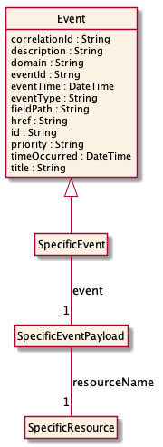

Iot Device Create Event
Notification IotDeviceCreateEvent case for resource IotDevice
Json representation sample
We provide below the json representation of an example of an 'IotDeviceCreateEvent' notification event object
{
"eventId":"00001",
"eventTime":"2015-11-16T16:42:25-04:00",
"eventType":"IotDeviceCreateEvent",
"event": {
"iotDevice" :
{-- SEE IotDevice RESOURCE SAMPLE --}
}
}

Iot Device Change Event
Notification IotDeviceChangeEvent case for resource IotDevice
Json representation sample
We provide below the json representation of an example of an 'IotDeviceChangeEvent' notification event object
{
"eventId":"00001",
"eventTime":"2015-11-16T16:42:25-04:00",
"eventType":"IotDeviceChangeEvent",
"event": {
"iotDevice" :
{-- SEE IotDevice RESOURCE SAMPLE --}
}
}

Iot Device Batch Event
Notification IotDeviceBatchEvent case for resource IotDevice
Json representation sample
We provide below the json representation of an example of an 'IotDeviceBatchEvent' notification event object
{
"eventId":"00001",
"eventTime":"2015-11-16T16:42:25-04:00",
"eventType":"IotDeviceBatchEvent",
"event": {
"iotDevice" :
{-- SEE IotDevice RESOURCE SAMPLE --}
}
}

Iot Device Delete Event
Notification IotDeviceDeleteEvent case for resource IotDevice
Json representation sample
We provide below the json representation of an example of an 'IotDeviceDeleteEvent' notification event object
{
"eventId":"00001",
"eventTime":"2015-11-16T16:42:25-04:00",
"eventType":"IotDeviceDeleteEvent",
"event": {
"iotDevice" :
{-- SEE IotDevice RESOURCE SAMPLE --}
}
}

Iot Device Heart Beat Event
Notification IotDeviceHeartBeatEvent case for resource IotDevice
Json representation sample
We provide below the json representation of an example of an 'IotDeviceHeartBeatEvent' notification event object
{
"eventId":"00001",
"eventTime":"2015-11-16T16:42:25-04:00",
"eventType":"IotDeviceHeartBeatEvent",
"event": {
"iotDevice" :
{-- SEE IotDevice RESOURCE SAMPLE --}
}
}

Iot Device State Change Event
Notification IotDeviceStateChangeEvent case for resource IotDevice
Json representation sample
We provide below the json representation of an example of an 'IotDeviceStateChangeEvent' notification event object
{
"eventId":"00001",
"eventTime":"2015-11-16T16:42:25-04:00",
"eventType":"IotDeviceStateChangeEvent",
"event": {
"iotDevice" :
{-- SEE IotDevice RESOURCE SAMPLE --}
}
}

Iot Device Specification Create Event
Notification IotDeviceSpecificationCreateEvent case for resource IotDeviceSpecification
Json representation sample
We provide below the json representation of an example of an 'IotDeviceSpecificationCreateEvent' notification event object
{
"eventId":"00001",
"eventTime":"2015-11-16T16:42:25-04:00",
"eventType":"IotDeviceSpecificationCreateEvent",
"event": {
"iotDeviceSpecification" :
{-- SEE IotDeviceSpecification RESOURCE SAMPLE --}
}
}

Iot Device Specification Change Event
Notification IotDeviceSpecificationChangeEvent case for resource IotDeviceSpecification
Json representation sample
We provide below the json representation of an example of an 'IotDeviceSpecificationChangeEvent' notification event object
{
"eventId":"00001",
"eventTime":"2015-11-16T16:42:25-04:00",
"eventType":"IotDeviceSpecificationChangeEvent",
"event": {
"iotDeviceSpecification" :
{-- SEE IotDeviceSpecification RESOURCE SAMPLE --}
}
}

Iot Device Specification Batch Event
Notification IotDeviceSpecificationBatchEvent case for resource IotDeviceSpecification
Json representation sample
We provide below the json representation of an example of an 'IotDeviceSpecificationBatchEvent' notification event object
{
"eventId":"00001",
"eventTime":"2015-11-16T16:42:25-04:00",
"eventType":"IotDeviceSpecificationBatchEvent",
"event": {
"iotDeviceSpecification" :
{-- SEE IotDeviceSpecification RESOURCE SAMPLE --}
}
}

Iot Device Specification Delete Event
Notification IotDeviceSpecificationDeleteEvent case for resource IotDeviceSpecification
Json representation sample
We provide below the json representation of an example of an 'IotDeviceSpecificationDeleteEvent' notification event object
{
"eventId":"00001",
"eventTime":"2015-11-16T16:42:25-04:00",
"eventType":"IotDeviceSpecificationDeleteEvent",
"event": {
"iotDeviceSpecification" :
{-- SEE IotDeviceSpecification RESOURCE SAMPLE --}
}
}

Alarm Create Event
Notification AlarmCreateEvent case for resource Alarm
Json representation sample
We provide below the json representation of an example of an 'AlarmCreateEvent' notification event object
{
"eventId":"00001",
"eventTime":"2015-11-16T16:42:25-04:00",
"eventType":"AlarmCreateEvent",
"event": {
"alarm" :
{-- SEE Alarm RESOURCE SAMPLE --}
}
}

Alarm Change Event
Notification AlarmChangeEvent case for resource Alarm
Json representation sample
We provide below the json representation of an example of an 'AlarmChangeEvent' notification event object
{
"eventId":"00001",
"eventTime":"2015-11-16T16:42:25-04:00",
"eventType":"AlarmChangeEvent",
"event": {
"alarm" :
{-- SEE Alarm RESOURCE SAMPLE --}
}
}

Alarm Delete Event
Notification AlarmDeleteEvent case for resource Alarm
Json representation sample
We provide below the json representation of an example of an 'AlarmDeleteEvent' notification event object
{
"eventId":"00001",
"eventTime":"2015-11-16T16:42:25-04:00",
"eventType":"AlarmDeleteEvent",
"event": {
"alarm" :
{-- SEE Alarm RESOURCE SAMPLE --}
}
}

API OPERATIONS
Remember the following Uniform Contract:
Operation on Entities | Uniform API Operation | Description
Query Entities | GET Resource | GET must be used to retrieve a representation of a resource.
Create Entity | POST Resource | POST must be used to create a new resource
Partial Update of an Entity | PATCH Resource | PATCH must be used to partially update a resource
Complete Update of an Entity | PUT Resource | PUT must be used to completely update a resource identified by its resource URI
Remove an Entity | DELETE Resource | DELETE must be used to remove a resource
Execute an Action on an Entity | POST on TASK Resource | POST must be used to execute Task Resources
Other Request Methods | POST on TASK Resource | GET and POST must not be used to tunnel other request methods.

Filtering and attribute selection rules are described in the TMF REST Design Guidelines.
Notifications are also described in a subsequent section.

Operations on Iot Device

List iot devices
GET /iotDevice?fields=...&{filtering}
Description
This operation list iot device entities.
Attribute selection is enabled for all first level attributes.
Filtering may be available depending on the compliance level supported by an implementation.

Usage Samples
Here's an example of a request for retrieving IotDevice resources.
Request
GET /tmf-api/iotdevicemanagement/v4/iotDevice
Accept: application/json
Response
200
[
{
"dateFirstUsed": "2019-05-13T00:00",
"dateInstalled": "2019-05-13T00:00",
"dateLastCalibration": "2019-05-13T00:00",
"dateLastValueReported": "2019-05-13T00:00",
"dateManufactured": "2019-05-13T00:00",
"deviceState": "ok",
"deviceType": "Temperature",
"firmwareVersion": "1.0.0",
"hardwareVersion": "1.0.0",
"mnc": "01",
"osVersion": "1.0.0",
"provider": "Mandat International",
"serialNumber": "12345",
"softwareVersion": "1.0.0",
"value": "0041227744222",
"alternateName": "CoAP temperature sensor 3",
"dataProvider": "https://www.mandint.org",
"dateCreated": "2019-05-13T00:00",
"dateModified": "2019-05-13T00:00",
"description": "This is a temperature sensor using CoAP and 6LoWPAN.",
"name": "temp_3",
"source": "coap://[2001:41e0:6002:1800:0:0:0:3]:61616/temp ",
"areaServed": "Switzerland ",
"category": "Gold ",
"endDate ": "2019-05-13T00:00",
"href ": "https//host:port/tmf-api/iotDevice/v1/iotDevice/temp_3",
"lifecycleState": "InService",
"manufactureDate": "2019-05-13T00:00",
"powerState": "3",
"startDate": "2019-05-13T00:00",
"version": "1.0",
"versionNumber": "1.0.0",
"dataAccessEndPoint": {
"category": "Gold",
"description": "This is a temperature sensor using CoAP and 6LoWPAN.",
"endDate": "2019-05-13T00:00",
"href": "https://host:port/tmf-api/iotDevice/v1/iotDevice/temp_3",
"id": "3",
"lifecycleState": "InService",
"name": "temp_3",
"startDate": "2019-05-03T00:00",
"value": "0041227744222",
"version": "1.0",
"apiType": "NGSI",
"uri": "https://host:port/tmf-api/iotDevice/v1/iotDevice/temp_3/dataAccessEndpoint/3"
},
"batteryLevel": 1.0,
"configuration": {
"timeout": 5,
"reportingPeriod ": 300
},
"macAddress": [
"02:00:00:00:00:03"
],
"$id": "Device.schema.json",
"address": {
"addressLocality": "Geneva",
"postalCode": "1209",
"streetAddress": "Chemin du Champ-Baron 3"
},
"location": {
" attrName": "position",
"coords": {
"type": "Point",
"coordinates": [
46.223064,
6.1305982
]
}
},
"characteristic": [
{
"name": "accuracy",
"value": "1.0"
}
],
"note": [
{
"author": "Cedric Crettaz",
"date": "2019-05-13T00:00",
"id": "txt001",
"text": "This is a CoAP temperature sensor."
}
],
"partyRole": [
{
"@referredType": "temperatureSensor",
"href": "https://www.mandint.org/temperatureSensor",
"id": "CoapTempSensor",
"name": "Mandat International",
"partyId": "MI",
"partyName": "Mandat International"
}
],
"place": {
"href": "Chemin du Champ-Baron 3",
"id": "1209",
"name": "Geneva Office"
},
"relatedParty": [
{
"@referredType": "temperatureSensor",
"href": "https://www.mandint.org/temperatureSensor",
"id": "CoapTempSensor",
"name": "Mandat International",
"role": "vendor"
}
],
"resourceRelationship": [
{
"@Type": "IotAgent",
"href": "https://www.mandint.org/iotAgent",
"id": "MI",
"name": "UDG",
"value": "0041227744222"
}
],
"iotAgent": [
{
"name": "UDG",
"objectId": "udgmi",
"href": "https://www.mandint.org/iotAgent",
"@referredType": "IotAgent",
"dataAccessEndPoint": {
"category": "Gold",
"description": "This is a temperature sensor using CoAP and 6LoWPAN.",
"endDate": "2019-05-13T00:00",
"href": "https://host:port/tmf-api/iotDevice/v1/iotDevice/temp_3",
"id": "3",
"lifecycleState": "InService",
"name": "temp_3",
"startDate": "2019-05-03T00:00",
"value": "0041227744222",
"version": "1.0",
"apiType": "NGSI",
"uri": "https://host:port/tmf-api/iotDevice/v1/iotDevice/temp_3/dataAccessEndpoint/3"
}
}
]
}
]

Retrieve iot device
GET /iotDevice/{id}?fields=...&{filtering}
Description
This operation retrieves an iot device entity.
Attribute selection is enabled for all first level attributes.
Filtering on sub-resources may be available depending on the compliance level supported by an implementation.
Usage Samples
Here's an example of a request for retrieving an IotDevice resource.
Request
GET /tmf-api/iotdevicemanagement/v4/iotDevice/42
Accept: application/json
Response
200
{
"dateFirstUsed": "2019-05-13T00:00",
"dateInstalled": "2019-05-13T00:00",
"dateLastCalibration": "2019-05-13T00:00",
"dateLastValueReported": "2019-05-13T00:00",
"dateManufactured": "2019-05-13T00:00",
"deviceState": "ok",
"deviceType": "Temperature",
"firmwareVersion": "1.0.0",
"hardwareVersion": "1.0.0",
"mnc": "01",
"osVersion": "1.0.0",
"provider": "Mandat International",
"serialNumber": "12345",
"softwareVersion": "1.0.0",
"value": "0041227744222",
"alternateName": "CoAP temperature sensor 3",
"dataProvider": "https://www.mandint.org",
"dateCreated": "2019-05-13T00:00",
"dateModified": "2019-05-13T00:00",
"description": "This is a temperature sensor using CoAP and 6LoWPAN.",
"name": "temp_3",
"source": "coap://[2001:41e0:6002:1800:0:0:0:3]:61616/temp ",
"areaServed": "Switzerland ",
"category": "Gold ",
"endDate ": "2019-05-13T00:00",
"href ": "https//host:port/tmf-api/iotDevice/v1/iotDevice/temp_3",
"lifecycleState": "InService",
"manufactureDate": "2019-05-13T00:00",
"powerState": "3",
"startDate": "2019-05-13T00:00",
"version": "1.0",
"versionNumber": "1.0.0",
"dataAccessEndPoint": {
"category": "Gold",
"description": "This is a temperature sensor using CoAP and 6LoWPAN.",
"endDate": "2019-05-13T00:00",
"href": "https://host:port/tmf-api/iotDevice/v1/iotDevice/temp_3",
"id": "3",
"lifecycleState": "InService",
"name": "temp_3",
"startDate": "2019-05-03T00:00",
"value": "0041227744222",
"version": "1.0",
"apiType": "NGSI",
"uri": "https://host:port/tmf-api/iotDevice/v1/iotDevice/temp_3/dataAccessEndpoint/3"
},
"batteryLevel": 1.0,
"configuration": {
"timeout": 5,
"reportingPeriod ": 300
},
"macAddress": [
"02:00:00:00:00:03"
],
"$id": "Device.schema.json",
"address": {
"addressLocality": "Geneva",
"postalCode": "1209",
"streetAddress": "Chemin du Champ-Baron 3"
},
"location": {
" attrName": "position",
"coords": {
"type": "Point",
"coordinates": [
46.223064,
6.1305982
]
}
},
"characteristic": [
{
"name": "accuracy",
"value": "1.0"
}
],
"note": [
{
"author": "Cedric Crettaz",
"date": "2019-05-13T00:00",
"id": "txt001",
"text": "This is a CoAP temperature sensor."
}
],
"partyRole": [
{
"@referredType": "temperatureSensor",
"href": "https://www.mandint.org/temperatureSensor",
"id": "CoapTempSensor",
"name": "Mandat International",
"partyId": "MI",
"partyName": "Mandat International"
}
],
"place": {
"href": "Chemin du Champ-Baron 3",
"id": "1209",
"name": "Geneva Office"
},
"relatedParty": [
{
"@referredType": "temperatureSensor",
"href": "https://www.mandint.org/temperatureSensor",
"id": "CoapTempSensor",
"name": "Mandat International",
"role": "vendor"
}
],
"resourceRelationship": [
{
"@Type": "IotAgent",
"href": "https://www.mandint.org/iotAgent",
"id": "MI",
"name": "UDG",
"value": "0041227744222"
}
],
"iotAgent": [
{
"name": "UDG",
"objectId": "udgmi",
"href": "https://www.mandint.org/iotAgent",
"@referredType": "IotAgent",
"dataAccessEndPoint": {
"category": "Gold",
"description": "This is a temperature sensor using CoAP and 6LoWPAN.",
"endDate": "2019-05-13T00:00",
"href": "https://host:port/tmf-api/iotDevice/v1/iotDevice/temp_3",
"id": "3",
"lifecycleState": "InService",
"name": "temp_3",
"startDate": "2019-05-03T00:00",
"value": "0041227744222",
"version": "1.0",
"apiType": "NGSI",
"uri": "https://host:port/tmf-api/iotDevice/v1/iotDevice/temp_3/dataAccessEndpoint/3"
}
}
]
}

Create iot device
POST /iotDevice
Description
This operation creates an iot device entity.
Mandatory and Non Mandatory Attributes
The following tables provide the list of mandatory and non mandatory attributes when creating an IotDevice, including any possible rule conditions and applicable default values. Notice that it is up to an implementer to add additional mandatory attributes.
Mandatory Attributes | Rule
category

Non Mandatory Attributes | Rule
batteryLevel
dateFirstUsed
dateInstalled
dateLastCalibration
dateLastValueReported
dateManufactured
deviceState
deviceType
firmwareVersion
hardwareVersion
mnc
osVersion
provider
serialNumber
softwareVersion
value
alternateName
dataProvider
dateCreated
dateModified
description
name
source
areaServed
description
endDate
lifecycleState
manufactureDate
name
powerState
serialNumber
startDate
version
versionNumber
dataAccessEndPoint
location
configuration
macAddress
rule
address
location
characteristic
note
partyRole
place
relatedParty
resourceRelationship

Usage Samples
Here's an example of a request for creating an IotDevice resource. In this example the request only passes mandatory attributes.
Request
POST /tmf-api/iotdevicemanagement/v4/iotDevice
Content-Type: application/json
{
"category": "Gold "
}
Response
201
{
"category": "Gold "
}

Patch iot device
PATCH /iotDevice/{id}
Description
This operation allows partial updates of an iot device entity. Support of json/merge (https://tools.ietf.org/html/rfc7386) is mandatory, support of json/patch (http://tools.ietf.org/html/rfc5789) is optional.
Note: If the update operation yields to the creation of sub-resources or relationships, the same rules concerning mandatory sub-resource attributes and default value settings in the POST operation applies to the PATCH operation. Hence these tables are not repeated here.
Patchable and Non Patchable Attributes
The tables below provide the list of patchable and non patchable attributes, including constraint rules on their usage.
Patchable Attributes | Rule
batteryLevel
dateFirstUsed
dateInstalled
dateLastCalibration
dateLastValueReported
dateManufactured
deviceState
deviceType
firmwareVersion
hardwareVersion
mnc
osVersion
provider
serialNumber
softwareVersion
value
alternateName
dataProvider
dateCreated
dateModified
description
name
source
areaServed
category
description
endDate
lifecycleState
manufactureDate
name
powerState
serialNumber
startDate
version
versionNumber
category
dataAccessEndPoint
location
configuration
macAddress
rule
address
location
characteristic
note
partyRole
place
relatedParty
resourceRelationship

Non Patchable Attributes | Rule
id
href

Usage Samples
Here's an example of a request for patching an IotDevice resource.
Request
PATCH /tmf-api/iotdevicemanagement/v4/iotDevice/42
Content-Type: application/merge-patch+json
{
"name": "new name"
}
Response
200
{
"dateFirstUsed": "2019-05-13T00:00",
"dateInstalled": "2019-05-13T00:00",
"dateLastCalibration": "2019-05-13T00:00",
"dateLastValueReported": "2019-05-13T00:00",
"dateManufactured": "2019-05-13T00:00",
"deviceState": "ok",
"deviceType": "Temperature",
"firmwareVersion": "1.0.0",
"hardwareVersion": "1.0.0",
"mnc": "01",
"osVersion": "1.0.0",
"provider": "Mandat International",
"serialNumber": "12345",
"softwareVersion": "1.0.0",
"value": "0041227744222",
"alternateName": "CoAP temperature sensor 3",
"dataProvider": "https://www.mandint.org",
"dateCreated": "2019-05-13T00:00",
"dateModified": "2019-05-13T00:00",
"description": "This is a temperature sensor using CoAP and 6LoWPAN.",
"name": "new name",
"source": "coap://[2001:41e0:6002:1800:0:0:0:3]:61616/temp ",
"areaServed": "Switzerland ",
"category": "Gold ",
"endDate ": "2019-05-13T00:00",
"href ": "https//host:port/tmf-api/iotDevice/v1/iotDevice/temp_3",
"lifecycleState": "InService",
"manufactureDate": "2019-05-13T00:00",
"powerState": "3",
"startDate": "2019-05-13T00:00",
"version": "1.0",
"versionNumber": "1.0.0",
"dataAccessEndPoint": {
"category": "Gold",
"description": "This is a temperature sensor using CoAP and 6LoWPAN.",
"endDate": "2019-05-13T00:00",
"href": "https://host:port/tmf-api/iotDevice/v1/iotDevice/temp_3",
"id": "3",
"lifecycleState": "InService",
"name": "temp_3",
"startDate": "2019-05-03T00:00",
"value": "0041227744222",
"version": "1.0",
"apiType": "NGSI",
"uri": "https://host:port/tmf-api/iotDevice/v1/iotDevice/temp_3/dataAccessEndpoint/3"
},
"batteryLevel": 1.0,
"configuration": {
"timeout": 5,
"reportingPeriod ": 300
},
"macAddress": [
"02:00:00:00:00:03"
],
"$id": "Device.schema.json",
"address": {
"addressLocality": "Geneva",
"postalCode": "1209",
"streetAddress": "Chemin du Champ-Baron 3"
},
"location": {
" attrName": "position",
"coords": {
"type": "Point",
"coordinates": [
46.223064,
6.1305982
]
}
},
"characteristic": [
{
"name": "accuracy",
"value": "1.0"
}
],
"note": [
{
"author": "Cedric Crettaz",
"date": "2019-05-13T00:00",
"id": "txt001",
"text": "This is a CoAP temperature sensor."
}
],
"partyRole": [
{
"@referredType": "temperatureSensor",
"href": "https://www.mandint.org/temperatureSensor",
"id": "CoapTempSensor",
"name": "Mandat International",
"partyId": "MI",
"partyName": "Mandat International"
}
],
"place": {
"href": "Chemin du Champ-Baron 3",
"id": "1209",
"name": "Geneva Office"
},
"relatedParty": [
{
"@referredType": "temperatureSensor",
"href": "https://www.mandint.org/temperatureSensor",
"id": "CoapTempSensor",
"name": "Mandat International",
"role": "vendor"
}
],
"resourceRelationship": [
{
"@Type": "IotAgent",
"href": "https://www.mandint.org/iotAgent",
"id": "MI",
"name": "UDG",
"value": "0041227744222"
}
],
"iotAgent": [
{
"name": "UDG",
"objectId": "udgmi",
"href": "https://www.mandint.org/iotAgent",
"@referredType": "IotAgent",
"dataAccessEndPoint": {
"category": "Gold",
"description": "This is a temperature sensor using CoAP and 6LoWPAN.",
"endDate": "2019-05-13T00:00",
"href": "https://host:port/tmf-api/iotDevice/v1/iotDevice/temp_3",
"id": "3",
"lifecycleState": "InService",
"name": "temp_3",
"startDate": "2019-05-03T00:00",
"value": "0041227744222",
"version": "1.0",
"apiType": "NGSI",
"uri": "https://host:port/tmf-api/iotDevice/v1/iotDevice/temp_3/dataAccessEndpoint/3"
}
}
],
"id": "42"
}

Delete iot device
DELETE /iotDevice/{id}
Description
This operation deletes an iot device entity.

Usage Samples
Here's an example of a request for deleting an IotDevice resource.
Request
DELETE /tmf-api/iotdevicemanagement/v4/iotDevice/42
Response
204

Operations on Data Access Endpoint

List data access endpoints
GET /dataAccessEndpoint?fields=...&{filtering}
Description
This operation list data access endpoint entities.
Attribute selection is enabled for all first level attributes.
Filtering may be available depending on the compliance level supported by an implementation.

Usage Samples
Here's an example of a request for retrieving DataAccessEndpoint resources.
Request
GET /tmf-api/iotdevicemanagement/v4/dataAccessEndpoint
Accept: application/json
Response
200
[
{
"category": "Gold",
"description": "This is a temperature sensor using CoAP and 6LoWPAN.",
"endDate": "2019-05-13T00:00",
"href": "https://host:port/tmf-api/iotDevice/v1/iotDevice/temp_3",
"id": "3",
"lifecycleState": "InService",
"name": "temp_3",
"startDate": "2019-05-03T00:00",
"value": "0041227744222",
"version": "1.0",
"apiType": "NGSI",
"uri": "https://host:port/tmf-api/iotDevice/v1/iotDevice/temp_3/dataAccessEndpoint/3"
}
]

Retrieve data access endpoint
GET /dataAccessEndpoint/{id}?fields=...&{filtering}
Description
This operation retrieves a data access endpoint entity.
Attribute selection is enabled for all first level attributes.
Filtering on sub-resources may be available depending on the compliance level supported by an implementation.
Usage Samples
Here's an example of a request for retrieving a DataAccessEndpoint resource.
Request
GET /tmf-api/iotdevicemanagement/v4/dataAccessEndpoint/3
Accept: application/json
Response
200
{
"category": "Gold",
"description": "This is a temperature sensor using CoAP and 6LoWPAN.",
"endDate": "2019-05-13T00:00",
"href": "https://host:port/tmf-api/iotDevice/v1/iotDevice/temp_3",
"id": "3",
"lifecycleState": "InService",
"name": "temp_3",
"startDate": "2019-05-03T00:00",
"value": "0041227744222",
"version": "1.0",
"apiType": "NGSI",
"uri": "https://host:port/tmf-api/iotDevice/v1/iotDevice/temp_3/dataAccessEndpoint/3"
}

Operations on Iot Device Specification

List iot device specifications
GET /iotDeviceSpecification?fields=...&{filtering}
Description
This operation list iot device specification entities.
Attribute selection is enabled for all first level attributes.
Filtering may be available depending on the compliance level supported by an implementation.
Usage Samples
Here's an example of a request for retrieving IotDeviceSpecification resources.
Request
GET /tmf-api/iotdevicemanagement/v4/iotDeviceSpecification
Accept: application/json
Response
200
[
{
"description": "This iot device specification ...",
"href": "https:/host:port/tmf-api/iotDeviceSpecification/v1/iotDeviceSpecification/4976",
"id": "4976",
"isBundle": true,
"lastUpdate": "2019-10-03T00:00",
"lifecycleStatus": "a string ...",
"name": "a string ...",
"version": "a string ...",
"attachment": [
{}
],
"relatedParty": [
{}
],
"resourceSpecRelationship": [
{}
],
"resourceSpecCharacteristic": [
{}
],
"resourceSpecification": [
{}
],
"targetServiceSchema": {},
"validFor": {}
}
]

Retrieve iot device specification
GET /iotDeviceSpecification/{id}?fields=...&{filtering}
Description
This operation retrieves an iot device specification entity.
Attribute selection is enabled for all first level attributes.
Filtering on sub-resources may be available depending on the compliance level supported by an implementation.

Usage Samples
Here's an example of a request for retrieving an IotDeviceSpecification resource.
Request
GET /tmf-api/iotdevicemanagement/v4/iotDeviceSpecification/4976
Accept: application/json
Response
200
{
"description": "This iot device specification ...",
"href": "https:/host:port/tmf-api/iotDeviceSpecification/v1/iotDeviceSpecification/4976",
"id": "4976",
"isBundle": true,
"lastUpdate": "2019-10-03T00:00",
"lifecycleStatus": "a string ...",
"name": "a string ...",
"version": "a string ...",
"attachment": [
{}
],
"relatedParty": [
{}
],
"resourceSpecRelationship": [
{}
],
"resourceSpecCharacteristic": [
{}
],
"resourceSpecification": [
{}
],
"targetServiceSchema": {},
"validFor": {}
}

Create iot device specification
POST /iotDeviceSpecification
Description
This operation creates an iot device specification entity.
Mandatory and Non Mandatory Attributes
The following tables provide the list of mandatory and non mandatory attributes when creating an IotDeviceSpecification, including any possible rule conditions and applicable default values. Notice that it is up to an implementer to add additional mandatory attributes.

Mandatory Attributes | Rule
name

Non Mandatory Attributes | Rule
description
isBundle
lastUpdate
lifecycleStatus
version
attachment
relatedParty
resourceSpecCharacteristic
resourceSpecRelationship
resourceSpecification
targetServiceSchema
validFor

Usage Samples
Here's an example of a request for creating an IotDeviceSpecification resource. In this example the request only passes mandatory attributes.
Request
POST /tmf-api/iotdevicemanagement/v4/iotDeviceSpecification
Content-Type: application/json
{
"name": "a string ..."
}
Response
201
{
"href": "https:/host:port/tmf-api/iotDeviceSpecification/v1/iotDeviceSpecification/4976",
"id": "4976",
"name": "a string ..."
}

Patch iot device specification
PATCH /iotDeviceSpecification/{id}

Description
This operation allows partial updates of an iot device specification entity. Support of json/merge (https://tools.ietf.org/html/rfc7386) is mandatory, support of json/patch (http://tools.ietf.org/html/rfc5789) is optional.
Note: If the update operation yields to the creation of sub-resources or relationships, the same rules concerning mandatory sub-resource attributes and default value settings in the POST operation applies to the PATCH operation. Hence these tables are not repeated here.
Patchable and Non Patchable Attributes
The tables below provide the list of patchable and non patchable attributes, including constraint rules on their usage.
Patchable Attributes | Rule
description
isBundle
lifecycleStatus
name
version
attachment
relatedParty
resourceSpecCharacteristic
resourceSpecRelationship
resourceSpecification
targetServiceSchema
validFor

Non Patchable Attributes | Rule
id
href
lastUpdate

Usage Samples
Here's an example of a request for patching an IotDeviceSpecification resource.
Request
PATCH /tmf-api/iotdevicemanagement/v4/iotDeviceSpecification/4976
Content-Type: application/merge-patch+json
{
"name": "new name"
}
Response
200
{
"description": "This iot device specification ...",
"href": "https:/host:port/tmf-api/iotDeviceSpecification/v1/iotDeviceSpecification/4976",
"id": "4976",
"isBundle": true,
"lastUpdate": "2019-10-03T00:00",
"lifecycleStatus": "a string ...",
"name": "new name",
"version": "a string ...",
"attachment": [
{}
],
"relatedParty": [
{}
],
"resourceSpecRelationship": [
{}
],
"resourceSpecCharacteristic": [
{}
],
"resourceSpecification": [
{}
],
"targetServiceSchema": {},
"validFor": {}
}

Delete iot device specification
DELETE /iotDeviceSpecification/{id}
Description
This operation deletes an iot device specification entity.
Usage Samples
Here's an example of a request for deleting an IotDeviceSpecification resource.
Request
DELETE /tmf-api/iotdevicemanagement/v4/iotDeviceSpecification/42
Response
204

Operations on Iot Data Event

List iot data events
GET /iotDataEvent?fields=...&{filtering}
Description
This operation list iot data event entities.
Attribute selection is enabled for all first level attributes.
Filtering may be available depending on the compliance level supported by an implementation.

Usage Samples
Here's an example of a request for retrieving IotDataEvent resources.
Request
GET /tmf-api/iotdevicemanagement/v4/iotDataEvent
Accept: application/json
Response
200
[
{
"correlationId": "413",
"description": "This iot data event ...",
"domain": "a string ...",
"eventId": "374",
"eventTime": "2019-10-03T00:00",
"eventType": "a string ...",
"priority": "a string ...",
"timeOcurred": "2019-10-03T00:00",
"title": "a string ...",
"event": {}
}
]

Retrieve iot data event
GET /iotDataEvent/{id}?fields=...&{filtering}
Description
This operation retrieves an iot data event entity.
Attribute selection is enabled for all first level attributes.
Filtering on sub-resources may be available depending on the compliance level supported by an implementation.

Usage Samples
Here's an example of a request for retrieving an IotDataEvent resource.
Request
GET /tmf-api/iotdevicemanagement/v4/iotDataEvent/42
Accept: application/json
Response
200
{
"correlationId": "413",
"description": "This iot data event ...",
"domain": "a string ...",
"eventId": "374",
"eventTime": "2019-10-03T00:00",
"eventType": "a string ...",
"priority": "a string ...",
"timeOcurred": "2019-10-03T00:00",
"title": "a string ...",
"event": {}
}

Operations on Iot Management Event

List iot management events
GET /iotManagementEvent?fields=...&{filtering}
Description
This operation list iot management event entities.
Attribute selection is enabled for all first level attributes.
Filtering may be available depending on the compliance level supported by an implementation.

Usage Samples
Here's an example of a request for retrieving IotManagementEvent resources.
Request
GET /tmf-api/iotdevicemanagement/v4/iotManagementEvent
Accept: application/json
Response
200
[
{
"correlationId": "423",
"description": "This iot management event ...",
"domain": "a string ...",
"eventId": "536",
"eventTime": "2019-10-03T00:00",
"eventType": "a string ...",
"priority": "a string ...",
"timeOcurred": "2019-10-03T00:00",
"title": "a string ...",
"event": {}
}
]

Retrieve iot management event
GET /iotManagementEvent/{id}?fields=...&{filtering}
Description
This operation retrieves an iot management event entity.
Attribute selection is enabled for all first level attributes.
Filtering on sub-resources may be available depending on the compliance level supported by an implementation.

Usage Samples
Here's an example of a request for retrieving an IotManagementEvent resource.
Request
GET /tmf-api/iotdevicemanagement/v4/iotManagementEvent/42
Accept: application/json
Response
200
{
"correlationId": "423",
"description": "This iot management event ...",
"domain": "a string ...",
"eventId": "536",
"eventTime": "2019-10-03T00:00",
"eventType": "a string ...",
"priority": "a string ...",
"timeOcurred": "2019-10-03T00:00",
"title": "a string ...",
"event": {}
}

Operations on Resource Specification

Operations on Alarm

List alarms
GET /alarm?fields=...&{filtering}

Description
This operation list alarm entities.
Attribute selection is enabled for all first level attributes.
Filtering may be available depending on the compliance level supported by an implementation.
Usage Samples
Here's an example of a request for retrieving Alarm resources.
Request
GET /tmf-api/iotdevicemanagement/v4/alarm
Accept: application/json
Response
200
[
{
"id": "8675309",
"href": "https://host:port/alarmManagement/v4/alarm/8675309",
"@baseType": "Alarm",
"@type": "Alarm",
"@schemaLocation": "https:://host:port/Alarm.schema.json",
"externalAlarmId": "5551212",
"state": "UPDATED",
"alarmType": "Environmental Alarm",
"perceivedSeverity": "MAJOR",
"probableCause": "Rectifier Low voltage",
"specificProblem": "ps=3,sl=1,in=8",
"alarmedObjectType": "Rectifier",
"alarmedObject": {
"id": "93051825",
"href": "https://host:port/resourceInventoryManagement/v4/resource/93051825"
},
"sourceSystemId": "ems-1",
"alarmDetails": "voltage=95",
"alarmRaisedTime": "2019-07-03T03:32:17.235Z",
"alarmReportingTime": "2019-07-03T03:32:17.552Z",
"alarmChangedTime": "2019-07-03T03:32:52.744Z",
"ackSystemId": "ems-1",
"ackUserId": "bob@example.net",
"ackTime": "2019-07-03T03:33:12.623Z",
"ackState": "ACKNOWLEDGED",
"isRoot": false,
"parentAlarm": {
"id": "8675300"
},
"correlatedAlarm": [
{
"id": "8675399",
"href": "https://host:port/alarmManagement/v4/alarm/868675399"
}
],
"comments": [
{
"userId": "bob@example.net",
"systemId": "ems-1",
"time": "2019-07-03T03:37:33.827Z",
"comment": "Dispatched"
}
]
}
]

Retrieve alarm
GET /alarm/{id}?fields=...&{filtering}
Description
This operation retrieves an alarm entity.
Attribute selection is enabled for all first level attributes.
Filtering on sub-resources may be available depending on the compliance level supported by an implementation.

Usage Samples
Here's an example of a request for retrieving an Alarm resource.
Request
GET /tmf-api/iotdevicemanagement/v4/alarm/8675309
Accept: application/json
Response
200
{
"id": "8675309",
"href": "https://host:port/alarmManagement/v4/alarm/8675309",
"@baseType": "Alarm",
"@type": "Alarm",
"@schemaLocation": "https:://host:port/Alarm.schema.json",
"externalAlarmId": "5551212",
"state": "UPDATED",
"alarmType": "Environmental Alarm",
"perceivedSeverity": "MAJOR",
"probableCause": "Rectifier Low voltage",
"specificProblem": "ps=3,sl=1,in=8",
"alarmedObjectType": "Rectifier",
"alarmedObject": {
"id": "93051825",
"href": "https://host:port/resourceInventoryManagement/v4/resource/93051825"
},
"sourceSystemId": "ems-1",
"alarmDetails": "voltage=95",
"alarmRaisedTime": "2019-07-03T03:32:17.235Z",
"alarmReportingTime": "2019-07-03T03:32:17.552Z",
"alarmChangedTime": "2019-07-03T03:32:52.744Z",
"ackSystemId": "ems-1",
"ackUserId": "bob@example.net",
"ackTime": "2019-07-03T03:33:12.623Z",
"ackState": "ACKNOWLEDGED",
"isRoot": false,
"parentAlarm": {
"id": "8675300"
},
"correlatedAlarm": [
{
"id": "8675399",
"href": "https://host:port/alarmManagement/v4/alarm/868675399"
}
],
"comments": [
{
"userId": "bob@example.net",
"systemId": "ems-1",
"time": "2019-07-03T03:37:33.827Z",
"comment": "Dispatched"
}
]
}

Create alarm
POST /alarm
Description
This operation creates an alarm entity.
Mandatory and Non Mandatory Attributes
The following tables provide the list of mandatory and non mandatory attributes when creating an Alarm, including any possible rule conditions and applicable default values. Notice that it is up to an implementer to add additional mandatory attributes.
Mandatory Attributes | Rule

Non Mandatory Attributes | Rule
@baseType
@schemaLocation
@type
ackState
ackSystemId
ackUserId
affectedService
alarmChangedTime
alarmClearedTime
alarmDetails
alarmEscalation
alarmRaisedTime
alarmReportingTime
alarmType
alarmedObject
alarmedObjectType
clearSystemId
clearUserId
comments
correlatedAlarm
crossedThresholdInformation
externalAlarmId
isRootCause
parentAlarm
perceivedSeverity
plannedOutageIndicator
probableCause
proposedRepairedActions
serviceAffecting
sourceSystemId
specificProblem
state

Usage Samples
Here's an example of a request for creating an Alarm resource. In this example the request only passes mandatory attributes.
Request
POST /tmf-api/iotdevicemanagement/v4/alarm
Content-Type: application/json
{}
Response
201
{
"id": "8675309",
"href": "https://host:port/alarmManagement/v4/alarm/8675309"
}

Patch alarm
PATCH /alarm/{id}
Description
This operation allows partial updates of an alarm entity. Support of json/merge (https://tools.ietf.org/html/rfc7386) is mandatory, support of json/patch (http://tools.ietf.org/html/rfc5789) is optional.
Note: If the update operation yields to the creation of sub-resources or relationships, the same rules concerning mandatory sub-resource attributes and default value settings in the POST operation applies to the PATCH operation. Hence these tables are not repeated here.
Patchable and Non Patchable Attributes
The tables below provide the list of patchable and non patchable attributes, including constraint rules on their usage.
Patchable Attributes | Rule
@baseType
@schemaLocation
@type
ackState
ackSystemId
ackUserId
affectedService
alarmChangedTime
alarmClearedTime
alarmDetails
alarmEscalation
alarmRaisedTime
alarmReportingTime
alarmType
alarmedObject
alarmedObjectType
clearSystemId
clearUserId
comments
correlatedAlarm
crossedThresholdInformation
externalAlarmId
isRootCause
parentAlarm
perceivedSeverity
plannedOutageIndicator
probableCause
proposedRepairedActions
serviceAffecting
sourceSystemId
specificProblem
state

Non Patchable Attributes | Rule
id
href

Usage Samples
Here's an example of a request for patching an Alarm resource.
Request
PATCH /tmf-api/iotdevicemanagement/v4/alarm/8675309
Content-Type: application/merge-patch+json
{
"name": "new name"
}
Response
200
{
"id": "8675309",
"href": "https://host:port/alarmManagement/v4/alarm/8675309",
"@baseType": "Alarm",
"@type": "Alarm",
"@schemaLocation": "https:://host:port/Alarm.schema.json",
"externalAlarmId": "5551212",
"state": "UPDATED",
"alarmType": "Environmental Alarm",
"perceivedSeverity": "MAJOR",
"probableCause": "Rectifier Low voltage",
"specificProblem": "ps=3,sl=1,in=8",
"alarmedObjectType": "Rectifier",
"alarmedObject": {
"id": "93051825",
"href": "https://host:port/resourceInventoryManagement/v4/resource/93051825"
},
"sourceSystemId": "ems-1",
"alarmDetails": "voltage=95",
"alarmRaisedTime": "2019-07-03T03:32:17.235Z",
"alarmReportingTime": "2019-07-03T03:32:17.552Z",
"alarmChangedTime": "2019-07-03T03:32:52.744Z",
"ackSystemId": "ems-1",
"ackUserId": "bob@example.net",
"ackTime": "2019-07-03T03:33:12.623Z",
"ackState": "ACKNOWLEDGED",
"isRoot": false,
"parentAlarm": {
"id": "8675300"
},
"correlatedAlarm": [
{
"id": "8675399",
"href": "https://host:port/alarmManagement/v4/alarm/868675399"
}
],
"comments": [
{
"userId": "bob@example.net",
"systemId": "ems-1",
"time": "2019-07-03T03:37:33.827Z",
"comment": "Dispatched"
}
],
"name": "new name"
}

API NOTIFICATIONS
For every single of operation on the entities use the following templates and provide sample REST notification POST calls.
It is assumed that the Pub/Sub uses the Register and UnRegister mechanisms described in the REST Guidelines reproduced below.

Register listener
POST /hub
Description
Sets the communication endpoint address the service instance must use to deliver information about its health state, execution state, failures and metrics. Subsequent POST calls will be rejected by the service if it does not support multiple listeners. In this case DELETE /api/hub/{id} must be called before an endpoint can be created again.
Behavior
Returns HTTP/1.1 status code 204 if the request was successful.
Returns HTTP/1.1 status code 409 if the request is not successful.
Usage Samples
Here's an example of a request for registering a listener.

Request
POST /api/hub
Accept: application/json

{"callback": "http://in.listener.com"}
Response
201
Content-Type: application/json
Location: /api/hub/42

{"id":"42","callback":"http://in.listener.com","query":null}

Unregister listener
DELETE /hub/{id}
Description
Clears the communication endpoint address that was set by creating the Hub.
Behavior
Returns HTTP/1.1 status code 204 if the request was successful.
Returns HTTP/1.1 status code 404 if the resource is not found.
Usage Samples
Here's an example of a request for un-registering a listener.
Request
DELETE /api/hub/42
Accept: application/json
Response
204

Publish Event to listener
POST /client/listener
Description
Clears the communication endpoint address that was set by creating the Hub.
Provides to a registered listener the description of the event that was raised. The /client/listener url is the callback url passed when registering the listener.
Behavior
Returns HTTP/1.1 status code 201 if the service is able to set the configuration.
Usage Samples
Here's an example of a notification received by the listener. In this example “EVENT TYPE” should be replaced by one of the notification types supported by this API (see Notification resources Models section) and EVENT BODY refers to the data structure of the given notification type.
Request
POST /client/listener
Accept: application/json

{
"event": {
EVENT BODY
},
"eventType": "EVENT_TYPE"
}
Response
201

For detailed examples on the general TM Forum notification mechanism, see the TMF REST Design Guidelines.

Acknowledgements

Document History

Version History
Version Number | Date | Release led by: | Description
1.0 | 17-Oct-2019 | Pierre Gauthier | Team Approved. This is the initial release of this document

Release History
Release Number | Date | Release led by: | Description
Pre-production | 17-Oct-2019 | Pierre Gauthier | This is the initial release of this document.

Contributors to Document
Name | Affiliation
Pierre Gauthier | TM Forum
Cédric Crettaz | IoT Lab (Mandat International)
Stephen Harrop | Vodafone
Vance Shipley | Sigscale
Namal Prasanna Jayathilake | Dialog Axiata
Sandaruwan Jayasinghe | Dialog Axiata

