TM Forum Specifications

Test Data Management API User Guide

TMF706
Team Approved Date: 29-Jul-2020

Release Status: Production | Approval Status: TM Forum Approved
Version 4.0.0 | IPR Mode: RAND

NOTICE
Copyright © TM Forum 2020. All Rights Reserved.

This document and translations of it may be copied and furnished to others, and derivative works that comment on or otherwise explain it or assist in its implementation may be prepared, copied, published, and distributed, in whole or in part, without restriction of any kind, provided that the above copyright notice and this section are included on all such copies and derivative works. However, this document itself may not be modified in any way, including by removing the copyright notice or references to TM FORUM, except as needed for the purpose of developing any document or deliverable produced by a TM FORUM Collaboration Project Team (in which case the rules applicable to copyrights, as set forth in the TM FORUM IPR Policy, must be followed) or as required to translate it into languages other than English.

The limited permissions granted above are perpetual and will not be revoked by TM FORUM or its successors or assigns.

This document and the information contained herein is provided on an "AS IS" basis and TM FORUM DISCLAIMS ALL WARRANTIES, EXPRESS OR IMPLIED, INCLUDING BUT NOT LIMITED TO ANY WARRANTY THAT THE USE OF THE INFORMATION HEREIN WILL NOT INFRINGE ANY OWNERSHIP RIGHTS OR ANY IMPLIED WARRANTIES OF MERCHANTABILITY OR FITNESS FOR A PARTICULAR PURPOSE.

TM FORUM invites any TM FORUM Member or any other party that believes it has patent claims that would necessarily be infringed by implementations of this TM Forum Standards Final Deliverable, to notify the TM FORUM Team Administrator and provide an indication of its willingness to grant patent licenses to such patent claims in a manner consistent with the IPR Mode of the TM FORUM Collaboration Project Team that produced this deliverable.

The TM FORUM invites any party to contact the TM FORUM Team Administrator if it is aware of a claim of ownership of any patent claims that would necessarily be infringed by implementations of this TM FORUM Standards Final Deliverable by a patent holder that is not willing to provide a license to such patent claims in a manner consistent with the IPR Mode of the TM FORUM Collaboration Project Team that produced this TM FORUM Standards Final Deliverable. TM FORUM may include such claims on its website but disclaims any obligation to do so.

TM FORUM takes no position regarding the validity or scope of any intellectual property or other rights that might be claimed to pertain to the implementation or use of the technology described in this TM FORUM Standards Final Deliverable or the extent to which any license under such rights might or might not be available; neither does it represent that it has made any effort to identify any such rights. Information on TM FORUM's procedures with respect to rights in any document or deliverable produced by a TM FORUM Collaboration Project Team can be found on the TM FORUM website. Copies of claims of rights made available for publication and any assurances of licenses to be made available, or the result of an attempt made to obtain a general license or permission for the use of such proprietary rights by implementers or users of this TM FORUM Standards Final Deliverable, can be obtained from the TM FORUM Team Administrator. TM FORUM makes no representation that any information or list of intellectual property rights will at any time be complete, or that any claims in such list are, in fact, Essential Claims.

Direct inquiries to the TM Forum office:

4 Century Drive, Suite 100
Parsippany, NJ 07054, USA
Tel No. +1 973 944 5100
Fax No. +1 973 998 7196
TM Forum Web Page: www.tmforum.org

Table of Contents

NOTICE 2
Table of Contents 4
List of Tables 6
Introduction 7
SAMPLE USE CASES 8
Support of polymorphism and extension patterns 9
RESOURCE MODEL 10
Managed Entity and Task Resource Models 10
Test Data Instance resource 10
Test Data Schema resource 17
Notification Resource Models 24
Test Data Instance Create Event 25
Test Data Instance Change Event 26
Test Data Instance Delete Event 26
Test Data Instance Attribute Value Change Event 26
Test Data Instance State Change Event 27
Test Data Schema Create Event 27
Test Data Schema Change Event 28
Test Data Schema Delete Event 28
Test Data Schema Attribute Value Change Event 28
Test Data Schema State Change Event 29
API OPERATIONS 30
Operations on Test Data Instance 30
List test data instances 30
Retrieve test data instance 32
Create test data instance 33
Patch test data instance 35
Delete test data instance 37
Operations on Test Data Schema 37
List test data schemas 37
Retrieve test data schema 38
Create test data schema 39
Patch test data schema 42
Delete test data schema 43
API NOTIFICATIONS 45
Register listener 45
Unregister listener 46
Publish Event to listener 46
Appendix 1 48
Examples of base64-encoded Attachment content for ONAP VTP 48
Example 1. ONAP VTP test data instance representation example 48
Acknowledgements 49
Version History 49
Release History 49
Contributors to Document 49

List of Tables
N/A

Introduction
The following document is the specification of the REST API for test data management. It includes the model definition as well as all available operations.

SAMPLE USE CASES
Reader will find example of use cases in TMF913 “Test API Component Suite” document.

Support of polymorphism and extension patterns

Support of polymorphic collections and types and schema based extension is provided by means of a list of generic meta-attributes that we describe below. Polymorphism in collections occurs when entities inherit from base entities, for instance TestDataInstance and TestDataSchema inheriting properties from the abstract ManagedArtifact entity.
Generic support of polymorphism and pattern extensions is described in the TMF API Guidelines v3.0 Part 2 document.
The @type attribute provides a way to represent the actual class type of an entity. For example, within a list of ManagedArtifact instances some may be instances of TestDataInstance where other could be instances of TestDataSchema. The @type gives this information. All resources and sub-resources of this API have a @type attributes that can be provided when this is useful.
The @schemaLocation property can be used in resources to allow specifying user-defined properties of an Entity or to specify the expected characteristics of an entity.
The @baseType attribute gives a way to provide explicitly the base of class of a given resource that has been extended.

RESOURCE MODEL

Managed Entity and Task Resource Models

Test Data Instance resource
A managed test data instance resource.
Resource model
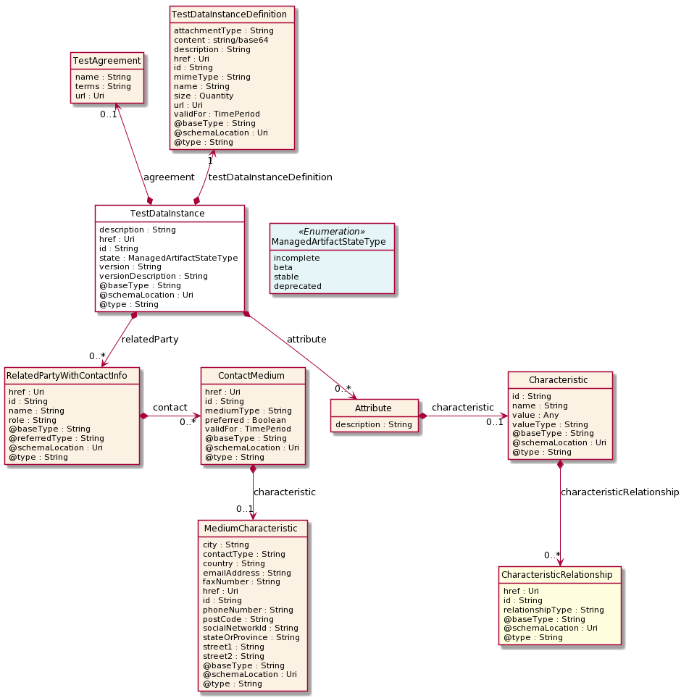

Field descriptions
TestDataInstance fields
description | A string. The description for the artifact.
version | A string. The artifact version.
versionDescription | A string. The artifact version description.
href | An uri (Uri). Hyperlink reference.
id | A string. unique identifier.
href | An uri (Uri). Hyperlink reference.
id | A string. unique identifier.
@baseType | A string. When sub-classing, this defines the super-class.
@schemaLocation | An uri (Uri). A URI to a JSON-Schema file that defines additional attributes and relationships.
@type | A string. When sub-classing, this defines the sub-class Extensible name.
testDataInstanceDefinition | A test data instance definition (TestDataInstanceDefinition). Test data instance definition.
agreement | A test agreement (TestAgreement).
attribute | A list of attributes (Attribute [*]).
relatedParty | A list of related party with contact infos (RelatedPartyWithContactInfo [*]). Related party specialization that includes contact information.
state | A managed artifact state type (ManagedArtifactStateType). Possible values for the state of a managed artifact: 'incomplete', 'beta', 'stable', 'deprecated'.
Attribute sub-resource

characteristic | A characteristic (Characteristic). Describes a given characteristic of an object or entity through a name/value pair.
description | A string. The attribute description.
Characteristic sub-resource
Describes a given characteristic of an object or entity through a name/value pair.
@baseType | A string. When sub-classing, this defines the super-class.
@schemaLocation | An uri (Uri). A URI to a JSON-Schema file that defines additional attributes and relationships.
@type | A string. When sub-classing, this defines the sub-class Extensible name.
characteristicRelationship | A list of characteristic relationships (CharacteristicRelationship [*]). Another Characteristic that is related to the current Characteristic;.
id | A string. Unique identifier of the characteristic.
name | A string. Name of the characteristic.
value | An any (Any). The value of the characteristic.
valueType | A string. Data type of the value of the characteristic.
CharacteristicRelationship sub-resource
Another Characteristic that is related to the current Characteristic;.
href | An uri (Uri). Hyperlink reference.
id | A string. Unique identifier of the characteristic.
@baseType | A string. When sub-classing, this defines the super-class.
@schemaLocation | An uri (Uri). A URI to a JSON-Schema file that defines additional attributes and relationships.
@type | A string. When sub-classing, this defines the sub-class Extensible name.
relationshipType | A string. The type of relationship.
ContactMedium sub-resource
Indicates the contact medium that could be used to contact the party.
href | An uri (Uri). Hyperlink reference.
id | A string. unique identifier.
@baseType | A string. When sub-classing, this defines the super-class.
@schemaLocation | An uri (Uri). A URI to a JSON-Schema file that defines additional attributes and relationships.
@type | A string. When sub-classing, this defines the sub-class Extensible name.
characteristic | A medium characteristic (MediumCharacteristic). Any additional characteristic(s) of this contact medium.
mediumType | A string. Type of the contact medium, such as: email address, telephone number, postal address.
preferred | A boolean. If true, indicates that is the preferred contact medium.
validFor | A time period. The time period that the contact medium is valid for.
MediumCharacteristic sub-resource
Describes the contact medium characteristics that could be used to contact a party (an individual or an organization).
href | An uri (Uri). Hyperlink reference.
id | A string. unique identifier.
@baseType | A string. When sub-classing, this defines the super-class.
@schemaLocation | An uri (Uri). A URI to a JSON-Schema file that defines additional attributes and relationships.
@type | A string. When sub-classing, this defines the sub-class Extensible name.
city | A string. The city.
contactType | A string. The type of contact, for example: phone number such as mobile, fixed home, fixed office. postal address such as shipping installation….
country | A string. The country.
emailAddress | A string. Full email address in standard format.
faxNumber | A string. The fax number of the contact.
phoneNumber | A string. The primary phone number of the contact.
postCode | A string. Postcode.
socialNetworkId | A string. Identifier as a member of a social network.
stateOrProvince | A string. State or province.
street1 | A string. Describes the street.
street2 | A string. Complementary street description.

Quantity sub-resource
An amount in a given unit.
amount | A float. Numeric value in a given unit.
units | A string. Unit.
RelatedPartyWithContactInfo sub-resource
Related party specialization that includes contact information.
@referredType | A string. The actual type of the target instance when needed for disambiguation.
role | A string. Role played by the related party.
name | A string. Name of the related entity.
href | An uri (Uri). Hyperlink reference.
id | A string. unique identifier.
@baseType | A string. When sub-classing, this defines the super-class.
@schemaLocation | An uri (Uri). A URI to a JSON-Schema file that defines additional attributes and relationships.
@type | A string. When sub-classing, this defines the sub-class Extensible name.
contact | A list of contact mediums (ContactMedium [*]). Indicates the contact medium that could be used to contact the party.
TestAgreement sub-resource

name | A string. The agreement name.
terms | A string. The terms of the agreement.
url | An uri (Uri). The agreement URL.
TestDataInstanceDefinition sub-resource
Test data instance definition.
attachmentType | A string. Attachment type such as video, picture.
content | A base 6 4 (Base64). The actual contents of the attachment object, if embedded, encoded as base64.
description | A string. A narrative text describing the content of the attachment.
href | An uri (Uri). Hyperlink reference.
id | A string. unique identifier.
mimeType | A string. Attachment mime type such as extension file for video, picture and document.
name | A string. The name of the attachment.
url | An uri (Uri). Uniform Resource Locator, is a web page address (a subset of URI).
@baseType | A string. When sub-classing, this defines the super-class.
@schemaLocation | An uri (Uri). A URI to a JSON-Schema file that defines additional attributes and relationships.
@type | A string. When sub-classing, this defines the sub-class Extensible name.
size | A quantity (Quantity). The size of the attachment.
validFor | A time period. The period of time for which the attachment is valid.
Json representation sample
We provide below the json representation of an example of a 'TestDataInstance' resource object
{
"id": "2db74193-e5fb-462a-98e0-6b1ed970dfc7",
"href": "https://mycsp:8080/tmf-api/testData/v4/testDataInstance/2db74193-e5fb-462a-98e0-6b1ed970dfc7",
"description": "Input parameters for test case execution",
"version": "1.2.3",
"relatedParty": [
{
"name": "testUser",
"role": "Owner",
"@referredType": "Individual",
"contact": [
{
"mediumType": "email",
"characteristic": {
"emailAddress": "testUser@abc.com"
}
}
]
}
],
"state": "stable",
"testDataInstanceDefinition": {
"attachmentType": "json",
"content": "<base64-encoded test data instance>",
"mimeType": "base64"
}
}

Test Data Schema resource
A managed test data schema resource.
Resource model
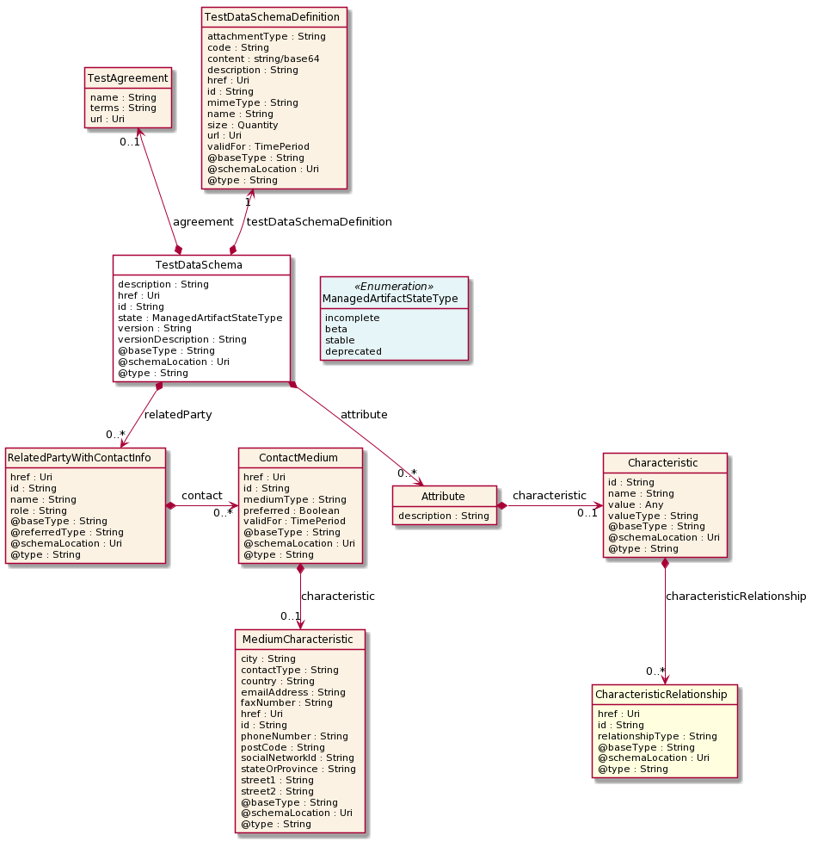

Field descriptions
TestDataSchema fields
description | A string. The description for the artifact.
version | A string. The artifact version.
versionDescription | A string. The artifact version description.
href | An uri (Uri). Hyperlink reference.
id | A string. unique identifier.
href | An uri (Uri). Hyperlink reference.
id | A string. unique identifier.
@baseType | A string. When sub-classing, this defines the super-class.
@schemaLocation | An uri (Uri). A URI to a JSON-Schema file that defines additional attributes and relationships.
@type | A string. When sub-classing, this defines the sub-class Extensible name.
testDataSchemaDefinition | A test data schema definition (TestDataSchemaDefinition). Test data schema definition.
agreement | A test agreement (TestAgreement).
attribute | A list of attributes (Attribute [*]).
relatedParty | A list of related party with contact infos (RelatedPartyWithContactInfo [*]). Related party specialization that includes contact information.
state | A managed artifact state type (ManagedArtifactStateType). Possible values for the state of a managed artifact: 'incomplete', 'beta', 'stable', 'deprecated'.
Attribute sub-resource

characteristic | A characteristic (Characteristic). Describes a given characteristic of an object or entity through a name/value pair.
description | A string. The attribute description.
Characteristic sub-resource
Describes a given characteristic of an object or entity through a name/value pair.
@baseType | A string. When sub-classing, this defines the super-class.
@schemaLocation | An uri (Uri). A URI to a JSON-Schema file that defines additional attributes and relationships.
@type | A string. When sub-classing, this defines the sub-class Extensible name.
characteristicRelationship | A list of characteristic relationships (CharacteristicRelationship [*]). Another Characteristic that is related to the current Characteristic;.
id | A string. Unique identifier of the characteristic.
name | A string. Name of the characteristic.
value | An any (Any). The value of the characteristic.
valueType | A string. Data type of the value of the characteristic.
CharacteristicRelationship sub-resource
Another Characteristic that is related to the current Characteristic;.
href | An uri (Uri). Hyperlink reference.
id | A string. Unique identifier of the characteristic.
@baseType | A string. When sub-classing, this defines the super-class.
@schemaLocation | An uri (Uri). A URI to a JSON-Schema file that defines additional attributes and relationships.
@type | A string. When sub-classing, this defines the sub-class Extensible name.
relationshipType | A string. The type of relationship.
ContactMedium sub-resource
Indicates the contact medium that could be used to contact the party.
href | An uri (Uri). Hyperlink reference.
id | A string. unique identifier.
@baseType | A string. When sub-classing, this defines the super-class.
@schemaLocation | An uri (Uri). A URI to a JSON-Schema file that defines additional attributes and relationships.
@type | A string. When sub-classing, this defines the sub-class Extensible name.
characteristic | A medium characteristic (MediumCharacteristic). Any additional characteristic(s) of this contact medium.
mediumType | A string. Type of the contact medium, such as: email address, telephone number, postal address.
preferred | A boolean. If true, indicates that is the preferred contact medium.
validFor | A time period. The time period that the contact medium is valid for.
MediumCharacteristic sub-resource
Describes the contact medium characteristics that could be used to contact a party (an individual or an organization).
href | An uri (Uri). Hyperlink reference.
id | A string. unique identifier.
@baseType | A string. When sub-classing, this defines the super-class.
@schemaLocation | An uri (Uri). A URI to a JSON-Schema file that defines additional attributes and relationships.
@type | A string. When sub-classing, this defines the sub-class Extensible name.
city | A string. The city.
contactType | A string. The type of contact, for example: phone number such as mobile, fixed home, fixed office. postal address such as shipping installation….
country | A string. The country.
emailAddress | A string. Full email address in standard format.
faxNumber | A string. The fax number of the contact.
phoneNumber | A string. The primary phone number of the contact.
postCode | A string. Postcode.
socialNetworkId | A string. Identifier as a member of a social network.
stateOrProvince | A string. State or province.
street1 | A string. Describes the street.
street2 | A string. Complementary street description.

Quantity sub-resource
An amount in a given unit.
amount | A float. Numeric value in a given unit.
units | A string. Unit.
RelatedPartyWithContactInfo sub-resource
Related party specialization that includes contact information.
@referredType | A string. The actual type of the target instance when needed for disambiguation.
role | A string. Role played by the related party.
name | A string. Name of the related entity.
href | An uri (Uri). Hyperlink reference.
id | A string. unique identifier.
@baseType | A string. When sub-classing, this defines the super-class.
@schemaLocation | An uri (Uri). A URI to a JSON-Schema file that defines additional attributes and relationships.
@type | A string. When sub-classing, this defines the sub-class Extensible name.
contact | A list of contact mediums (ContactMedium [*]). Indicates the contact medium that could be used to contact the party.
TestAgreement sub-resource

name | A string. The agreement name.
terms | A string. The terms of the agreement.
url | An uri (Uri). The agreement URL.
TestDataSchemaDefinition sub-resource
Test data schema definition.
attachmentType | A string. Attachment type such as video, picture.
content | A base 6 4 (Base64). The actual contents of the attachment object, if embedded, encoded as base64.
description | A string. A narrative text describing the content of the attachment.
href | An uri (Uri). Hyperlink reference.
id | A string. unique identifier.
mimeType | A string. Attachment mime type such as extension file for video, picture and document.
name | A string. The name of the attachment.
url | An uri (Uri). Uniform Resource Locator, is a web page address (a subset of URI).
@baseType | A string. When sub-classing, this defines the super-class.
@schemaLocation | An uri (Uri). A URI to a JSON-Schema file that defines additional attributes and relationships.
@type | A string. When sub-classing, this defines the sub-class Extensible name.
code | A string. The test data schema code.
size | A quantity (Quantity). The size of the attachment.
validFor | A time period. The period of time for which the attachment is valid.
Json representation sample
We provide below the json representation of an example of a 'TestDataSchema' resource object
{
"id": "f7a4914b-e2b0-43db-92ec-5457688a9cde",
"href": "https://mycsp:8080/tmf-api/testData/v4/testDataSchema/f7a4914b-e2b0-43db-92ec-5457688a9cde",
"description": "Sample test data schema",
"version": "1.2.3",
"relatedParty": [
{
"name": "testUser",
"role": "Owner",
"@referredType": "Individual",
"contact": [
{
"mediumType": "email",
"characteristic": {
"emailAddress": "testUser@abc.com"
}
}
]
}
],
"state": "stable",
"testDataSchemaDefinition": {
"attachmentType": "json",
"content": "<base64-encoded test data schema>",
"mimeType": "base64"
}
}

Notification Resource Models

10 notifications are defined for this API
Notifications related to TestDataInstance:
- TestDataInstanceCreateEvent
- TestDataInstanceChangeEvent
- TestDataInstanceDeleteEvent
- TestDataInstanceAttributeValueChangeEvent
- TestDataInstanceStateChangeEvent
Notifications related to TestDataSchema:
- TestDataSchemaCreateEvent
- TestDataSchemaChangeEvent
- TestDataSchemaDeleteEvent
- TestDataSchemaAttributeValueChangeEvent
- TestDataSchemaStateChangeEvent
The notification structure for all notifications in this API follow the pattern depicted by the figure below.
A notification event resource (depicted by "SpecificEvent" placeholder) is a sub class of a generic Event structure containing at least an id of the event occurrence (eventId), an event timestamp (eventTime), and the name of the resource (eventType).
This notification structure owns an event payload structure ("SpecificEventPayload" placeholder) linked to the resource concerned by the notification using the resource name as access field ("resourceName" placeholder).
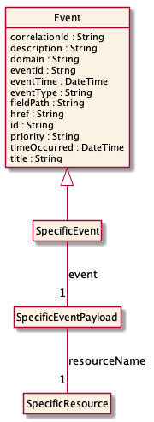

Test Data Instance Create Event
Notification TestDataInstanceCreateEvent case for resource TestDataInstance
Json representation sample
We provide below the json representation of an example of a 'TestDataInstanceCreateEvent' notification event object
{
"eventId":"00001",
"eventTime":"2015-11-16T16:42:25-04:00",
"eventType":"TestDataInstanceCreateEvent",
"event": {
"testDataInstance" :
{-- SEE TestDataInstance RESOURCE SAMPLE --}
}
}

Test Data Instance Change Event
Notification TestDataInstanceChangeEvent case for resource TestDataInstance
Json representation sample
We provide below the json representation of an example of a 'TestDataInstanceChangeEvent' notification event object
{
"eventId":"00001",
"eventTime":"2015-11-16T16:42:25-04:00",
"eventType":"TestDataInstanceChangeEvent",
"event": {
"testDataInstance" :
{-- SEE TestDataInstance RESOURCE SAMPLE --}
}
}

Test Data Instance Delete Event
Notification TestDataInstanceDeleteEvent case for resource TestDataInstance
Json representation sample
We provide below the json representation of an example of a 'TestDataInstanceDeleteEvent' notification event object
{
"eventId":"00001",
"eventTime":"2015-11-16T16:42:25-04:00",
"eventType":"TestDataInstanceDeleteEvent",
"event": {
"testDataInstance" :
{-- SEE TestDataInstance RESOURCE SAMPLE --}
}
}

Test Data Instance Attribute Value Change Event
Notification TestDataInstanceAttributeValueChangeEvent case for resource TestDataInstance
Json representation sample
We provide below the json representation of an example of a 'TestDataInstanceAttributeValueChangeEvent' notification event object
{
"eventId":"00001",
"eventTime":"2015-11-16T16:42:25-04:00",
"eventType":"TestDataInstanceAttributeValueChangeEvent",
"event": {
"testDataInstance" :
{-- SEE TestDataInstance RESOURCE SAMPLE --}
}
}

Test Data Instance State Change Event
Notification TestDataInstanceStateChangeEvent case for resource TestDataInstance
Json representation sample
We provide below the json representation of an example of a 'TestDataInstanceStateChangeEvent' notification event object
{
"eventId":"00001",
"eventTime":"2015-11-16T16:42:25-04:00",
"eventType":"TestDataInstanceStateChangeEvent",
"event": {
"testDataInstance" :
{-- SEE TestDataInstance RESOURCE SAMPLE --}
}
}

Test Data Schema Create Event
Notification TestDataSchemaCreateEvent case for resource TestDataSchema
Json representation sample
We provide below the json representation of an example of a 'TestDataSchemaCreateEvent' notification event object
{
"eventId":"00001",
"eventTime":"2015-11-16T16:42:25-04:00",
"eventType":"TestDataSchemaCreateEvent",
"event": {
"testDataSchema" :
{-- SEE TestDataSchema RESOURCE SAMPLE --}
}
}

Test Data Schema Change Event
Notification TestDataSchemaChangeEvent case for resource TestDataSchema
Json representation sample
We provide below the json representation of an example of a 'TestDataSchemaChangeEvent' notification event object
{
"eventId":"00001",
"eventTime":"2015-11-16T16:42:25-04:00",
"eventType":"TestDataSchemaChangeEvent",
"event": {
"testDataSchema" :
{-- SEE TestDataSchema RESOURCE SAMPLE --}
}
}

Test Data Schema Delete Event
Notification TestDataSchemaDeleteEvent case for resource TestDataSchema
Json representation sample
We provide below the json representation of an example of a 'TestDataSchemaDeleteEvent' notification event object
{
"eventId":"00001",
"eventTime":"2015-11-16T16:42:25-04:00",
"eventType":"TestDataSchemaDeleteEvent",
"event": {
"testDataSchema" :
{-- SEE TestDataSchema RESOURCE SAMPLE --}
}
}

Test Data Schema Attribute Value Change Event
Notification TestDataSchemaAttributeValueChangeEvent case for resource TestDataSchema
Json representation sample
We provide below the json representation of an example of a 'TestDataSchemaAttributeValueChangeEvent' notification event object
{
"eventId":"00001",
"eventTime":"2015-11-16T16:42:25-04:00",
"eventType":"TestDataSchemaAttributeValueChangeEvent",
"event": {
"testDataSchema" :
{-- SEE TestDataSchema RESOURCE SAMPLE --}
}
}

Test Data Schema State Change Event
Notification TestDataSchemaStateChangeEvent case for resource TestDataSchema
Json representation sample
We provide below the json representation of an example of a 'TestDataSchemaStateChangeEvent' notification event object
{
"eventId":"00001",
"eventTime":"2015-11-16T16:42:25-04:00",
"eventType":"TestDataSchemaStateChangeEvent",
"event": {
"testDataSchema" :
{-- SEE TestDataSchema RESOURCE SAMPLE --}
}
}

API OPERATIONS
Remember the following Uniform Contract:
Operation on Entities | Uniform API Operation | Description
Query Entities | GET Resource | GET must be used to retrieve a representation of a resource.
Create Entity | POST Resource | POST must be used to create a new resource
Partial Update of an Entity | PATCH Resource | PATCH must be used to partially update a resource
Remove an Entity | DELETE Resource | DELETE must be used to remove a resource

Filtering and attribute selection rules are described in the TMF REST Design Guidelines.
Notifications are also described in a subsequent section.

Operations on Test Data Instance

List test data instances
GET /testDataInstance?fields=...&{filtering}
Description
This operation list test data instance entities.
Attribute selection is enabled for all first level attributes.
Filtering may be available depending on the compliance level supported by an implementation.

Usage Samples
Here's an example of a request for retrieving a list of test data instances.
Request
GET /tmf-api/testData/v4/testDataInstance
Accept: application/json
Response
200
[
{
"id": "2db74193-e5fb-462a-98e0-6b1ed970dfc7",
"href": "https://mycsp:8080/tmf-api/testData/v4/testDataInstance/2db74193-e5fb-462a-98e0-6b1ed970dfc7",
"description": "Input parameters for test case execution",
"version": "1.2.3",
"relatedParty": [
{
"name": "testUser",
"role": "Owner",
"@referredType": "Individual",
"contact": [
{
"mediumType": "email",
"characteristic": {
"emailAddress": "testUser@abc.com"
}
}
]
}
],
"state": "stable",
"testDataInstanceDefinition": {
"content": "<base64-encoded test data instance> - please see Example 1 in Appendix 1",
"mimeType": "base64",
"url": "http://myservice.com/artifact/1234"
}
}
]

Retrieve test data instance
GET /testDataInstance/{id}?fields=...&{filtering}
Description
This operation retrieves a test data instance entity.
Attribute selection is enabled for all first level attributes.
Filtering on sub-resources may be available depending on the compliance level supported by an implementation.

Usage Samples
Here's an example of a request for retrieving a specific test data instance.
Request
GET /tmf-api/testData/v4/testDataInstance/2db74193-e5fb-462a-98e0-6b1ed970dfc7
Accept: application/json
Response
200
{
"id": "2db74193-e5fb-462a-98e0-6b1ed970dfc7",
"href": "https://mycsp:8080/tmf-api/testData/v4/testDataInstance/2db74193-e5fb-462a-98e0-6b1ed970dfc7",
"description": "Input parameters for test case execution",
"version": "1.2.3",
"relatedParty": [
{
"name": "testUser",
"role": "Owner",
"@referredType": "Individual",
"contact": [
{
"mediumType": "email",
"characteristic": {
"emailAddress": "testUser@abc.com"
}
}
]
}
],
"state": "stable",
"testDataInstanceDefinition": {
"content": "<base64-encoded test data instance> - please see Example 1 in Appendix 1",
"mimeType": "base64",
"url": "http://myservice.com/artifact/1234"
}
}

Create test data instance
POST /testDataInstance
Description
This operation creates a test data instance entity.
Mandatory and Non Mandatory Attributes
The following tables provide the list of mandatory and non mandatory attributes when creating a TestDataInstance, including any possible rule conditions and applicable default values. Notice that it is up to an implementer to add additional mandatory attributes.
Mandatory Attributes | Rule
description
version
termsOfService
contact
license
testDataInstanceDefinition

Non Mandatory Attributes | Rule
versionDescription
@baseType
@schemaLocation
@type
agreement
attribute
relatedParty
state

Usage Samples
Here's an example of a request for creating a test data instance.
Request
POST /tmf-api/testData/v4/testDataInstance
Content-Type: application/json
{
"description": "Input parameters for test case execution",
"version": "1.2.3",
"relatedParty": [
{
"name": "testUser",
"@referredType": "Individual",
"role": "Owner",
"contact": [
{
"mediumType": "email",
"characteristic": {
"emailAddress": "testUser@abc.com"
}
}
]
}
],
"state": "stable",
"testDataInstanceDefinition": {
"attachmentType": "json",
"content": "<base64-encoded test data instance> - please see Example 1 in Appendix 1",
"mimeType": "base64"
}
}
Response
201
{
"id": "2db74193-e5fb-462a-98e0-6b1ed970dfc7",
"href": "https://mycsp:8080/tmf-api/testData/v4/testDataInstance/2db74193-e5fb-462a-98e0-6b1ed970dfc7",
"description": "Input parameters for test case execution",
"version": "1.2.3",
"relatedParty": [
{
"name": "testUser",
"role": "Owner",
"@referredType": "Individual",
"contact": [
{
"mediumType": "email",
"characteristic": {
"emailAddress": "testUser@abc.com"
}
}
]
}
],
"state": "stable",
"testDataInstanceDefinition": {
"content": "<base64-encoded test data instance> - please see Example 1 in Appendix 1",
"mimeType": "base64",
"url": "http://myservice.com/artifact/1234"
}
}

Patch test data instance
PATCH /testDataInstance/{id}
Description
This operation allows partial updates of a test data instance entity. Support of json/merge (https://tools.ietf.org/html/rfc7386) is mandatory, support of json/patch (http://tools.ietf.org/html/rfc5789) is optional.
Note: If the update operation yields to the creation of sub-resources or relationships, the same rules concerning mandatory sub-resource attributes and default value settings in the POST operation applies to the PATCH operation. Hence these tables are not repeated here.
Patchable and Non Patchable Attributes
The tables below provide the list of patchable and non patchable attributes, including constraint rules on their usage.
Patchable Attributes | Rule
description
versionDescription
@baseType
@schemaLocation
@type
testDataInstanceDefinition
agreement
attribute
relatedParty
state

Non Patchable Attributes | Rule
id
href
version

Usage Samples
Here's an example of a request for patching a TestDataInstance resource.
Request
PATCH /tmf-api/testData/v4/testDataInstance/2db74193-e5fb-462a-98e0-6b1ed970dfc7
Content-Type: application/merge-patch+json
{
"name": "new name"
}
Response
200
{
"id": "2db74193-e5fb-462a-98e0-6b1ed970dfc7",
"href": "https://mycsp:8080/tmf-api/testData/v4/testDataInstance/2db74193-e5fb-462a-98e0-6b1ed970dfc7",
"description": "Input parameters for test case execution",
"version": "1.2.3",
"relatedParty": [
{
"name": "testUser",
"role": "Owner",
"@referredType": "Individual",
"contact": [
{
"mediumType": "email",
"characteristic": {
"emailAddress": "testUser@abc.com"
}
}
]
}
],
"state": "stable",
"testDataInstanceDefinition": {
"attachmentType": "json",
"content": "<base64-encoded test data instance>",
"mimeType": "base64"
},
"name": "new name"
}

Delete test data instance
DELETE /testDataInstance/{id}
Description
This operation deletes a test data instance entity.

Usage Samples
Here's an example of a request for deleting a test data instance.
Request
DELETE /tmf-api/testData/v4/testDataInstance/2db74193-e5fb-462a-98e0-6b1ed970dfc7
Response
204

Operations on Test Data Schema

List test data schemas
GET /testDataSchema?fields=...&{filtering}
Description
This operation list test data schema entities.
Attribute selection is enabled for all first level attributes.
Filtering may be available depending on the compliance level supported by an implementation.

Usage Samples
Here's an example of a request for retrieving a list of test data schemas.
Request
GET /tmf-api/testData/v4/testDataSchema
Accept: application/json
Response
200
[
{
"id": "f7a4914b-e2b0-43db-92ec-5457688a9cde",
"href": "https://mycsp:8080/tmf-api/testData/v4/testDataSchema/f7a4914b-e2b0-43db-92ec-5457688a9cde",
"description": "Sample test data schema",
"version": "1.2.3",
"relatedParty": [
{
"name": "testUser",
"role": "Owner",
"@referredType": "Individual",
"contact": [
{
"mediumType": "email",
"characteristic": {
"emailAddress": "testUser@abc.com"
}
}
]
}
],
"state": "stable",
"testDataSchemaDefinition": {
"content": "<base64-encoded test data schema>",
"mimeType": "base64",
"url": "http://myservice.com/testDataSchema/1234"
}
}
]

Retrieve test data schema
GET /testDataSchema/{id}?fields=...&{filtering}
Description
This operation retrieves a test data schema entity.
Attribute selection is enabled for all first level attributes.
Filtering on sub-resources may be available depending on the compliance level supported by an implementation.

Usage Samples
Here's an example of a request for retrieving a specific test data schema.
Request
GET /tmf-api/testData/v4/testDataSchema/f7a4914b-e2b0-43db-92ec-5457688a9cde
Accept: application/json
Response
200
{
"id": "f7a4914b-e2b0-43db-92ec-5457688a9cde",
"href": "https://mycsp:8080/tmf-api/testData/v4/testDataSchema/f7a4914b-e2b0-43db-92ec-5457688a9cde",
"description": "Sample test data schema",
"version": "1.2.3",
"relatedParty": [
{
"name": "testUser",
"role": "Owner",
"@referredType": "Individual",
"contact": [
{
"mediumType": "email",
"characteristic": {
"emailAddress": "testUser@abc.com"
}
}
]
}
],
"state": "stable",
"testDataSchemaDefinition": {
"content": "<base64-encoded test data schema>",
"mimeType": "base64",
"url": "http://myservice.com/testDataSchema/1234"
}
}

Create test data schema
POST /testDataSchema
Description
This operation creates a test data schema entity.
Mandatory and Non Mandatory Attributes
The following tables provide the list of mandatory and non mandatory attributes when creating a TestDataSchema, including any possible rule conditions and applicable default values. Notice that it is up to an implementer to add additional mandatory attributes.
Mandatory Attributes | Rule
description
version
termsOfService
contact
license
testDataSchemaDefinition

Non Mandatory Attributes | Rule
versionDescription
@baseType
@schemaLocation
@type
agreement
attribute
relatedParty
state

Usage Samples
Here's an example of a request for creating a test data schema.
Request
POST /tmf-api/testData/v4/testDataSchema
Content-Type: application/json
{
"description": "Sample test data schema",
"version": "1.2.3",
"relatedParty": [
{
"name": "testUser",
"@referredType": "Individual",
"role": "Owner",
"contact": [
{
"mediumType": "email",
"characteristic": {
"emailAddress": "testUser@abc.com"
}
}
]
}
],
"state": "stable",
"testDataSchemaDefinition": {
"attachmentType": "json",
"content": "<base64-encoded test case>",
"mimeType": "base64"
}
}
Response
201
{
"id": "f7a4914b-e2b0-43db-92ec-5457688a9cde",
"href": "https://mycsp:8080/tmf-api/testData/v4/testDataSchema/f7a4914b-e2b0-43db-92ec-5457688a9cde",
"description": "Sample test data schema",
"version": "1.2.3",
"relatedParty": [
{
"name": "testUser",
"role": "Owner",
"@referredType": "Individual",
"contact": [
{
"mediumType": "email",
"characteristic": {
"emailAddress": "testUser@abc.com"
}
}
]
}
],
"state": "stable",
"testDataSchemaDefinition": {
"content": "<base64-encoded test data schema>",
"mimeType": "base64",
"url": "http://myservice.com/testDataSchema/1234"
}
}

Patch test data schema
PATCH /testDataSchema/{id}
Description
This operation allows partial updates of a test data schema entity. Support of json/merge (https://tools.ietf.org/html/rfc7386) is mandatory, support of json/patch (http://tools.ietf.org/html/rfc5789) is optional.
Note: If the update operation yields to the creation of sub-resources or relationships, the same rules concerning mandatory sub-resource attributes and default value settings in the POST operation applies to the PATCH operation. Hence these tables are not repeated here.
Patchable and Non Patchable Attributes
The tables below provide the list of patchable and non patchable attributes, including constraint rules on their usage.
Patchable Attributes | Rule
description
versionDescription
@baseType
@schemaLocation
@type
testDataSchemaDefinition
agreement
attribute
relatedParty
state

Non Patchable Attributes | Rule
id
href
version

Usage Samples
Here's an example of a request for patching a TestDataSchema resource.
Request
PATCH /tmf-api/testData/v4/testDataSchema/f7a4914b-e2b0-43db-92ec-5457688a9cde
Content-Type: application/merge-patch+json
{
"name": "new name"
}
Response
200
{
"id": "f7a4914b-e2b0-43db-92ec-5457688a9cde",
"href": "https://mycsp:8080/tmf-api/testData/v4/testDataSchema/f7a4914b-e2b0-43db-92ec-5457688a9cde",
"description": "Sample test data schema",
"version": "1.2.3",
"relatedParty": [
{
"name": "testUser",
"role": "Owner",
"@referredType": "Individual",
"contact": [
{
"mediumType": "email",
"characteristic": {
"emailAddress": "testUser@abc.com"
}
}
]
}
],
"state": "stable",
"testDataSchemaDefinition": {
"attachmentType": "json",
"content": "<base64-encoded test data schema>",
"mimeType": "base64"
},
"name": "new name"
}

Delete test data schema
DELETE /testDataSchema/{id}
Description
This operation deletes a test data schema entity.

Usage Samples
Here's an example of a request for deleting a test data schema.
Request
DELETE /tmf-api/testData/v4/testDataSchema/f7a4914b-e2b0-43db-92ec-5457688a9cde
Response
204

API NOTIFICATIONS
For every single of operation on the entities use the following templates and provide sample REST notification POST calls.
It is assumed that the Pub/Sub uses the Register and UnRegister mechanisms described in the REST Guidelines reproduced below.

Register listener
POST /hub
Description
Sets the communication endpoint address the service instance must use to deliver information about its health state, execution state, failures and metrics. Subsequent POST calls will be rejected by the service if it does not support multiple listeners. In this case DELETE /api/hub/{id} must be called before an endpoint can be created again.
Behavior
Returns HTTP/1.1 status code 204 if the request was successful.
Returns HTTP/1.1 status code 409 if request is not successful.
Usage Samples
Here's an example of a request for registering a listener.

Request
POST /api/hub
Accept: application/json

{"callback": "http://in.listener.com"}
Response
201
Content-Type: application/json
Location: /api/hub/42

{"id":"42","callback":"http://in.listener.com","query":null}

Unregister listener
DELETE /hub/{id}
Description
Clears the communication endpoint address that was set by creating the Hub.
Behavior
Returns HTTP/1.1 status code 204 if the request was successful.
Returns HTTP/1.1 status code 404 if the resource is not found.
Usage Samples
Here's an example of a request for un-registering a listener.
Request
DELETE /api/hub/42
Accept: application/json
Response
204

Publish Event to listener
POST /client/listener
Description
Clears the communication endpoint address that was set by creating the Hub.
Provides to a registered listener the description of the event that was raised. The /client/listener url is the callback url passed when registering the listener.
Behavior
Returns HTTP/1.1 status code 201 if the service is able to set the configuration.
Usage Samples
Here's an example of a notification received by the listener. In this example “EVENT TYPE” should be replaced by one of the notification types supported by this API (see Notification resources Models section) and EVENT BODY refers to the data structure of the given notification type.
Request
POST /client/listener
Accept: application/json

{
"event": {
EVENT BODY
},
"eventType": "EVENT_TYPE"
}
Response
201

For detailed examples on the general TM Forum notification mechanism, see the TMF REST Design Guidelines.

Appendix 1

Examples of base64-encoded Attachment content for ONAP VTP

Example 1. ONAP VTP test data instance representation example
Encoded value
ewogICAgImFyZzEiOiAic2FtcGxlIHZhbHVlIgp9Cg==
Original /decoded JSON object
{
"arg1": "sample value"
}

Acknowledgements

Version History
Version Number | Date | Release led by: | Description
4.0.0 | 29-Jul-2020 | Pierre Gauthier  TM Forum  pgauthier@tmforum.org  Edward Pershwitz  ITEA Technologies  edward.pershwitz@iteatechnologies.com | First Release of the Document.

Release History
Release Status | Date | Release led by: | Description
Pre-production | 29-Jul-2020 | Pierre Gauthier  Edward Pershwitz | First Release of the Document.
Production | 23-Sep-2020 | Adrienne Walcott | Updated to reflect TM Forum Approved Status

Contributors to Document

Kanagaraj Manickam | Huawei Technologies Co., Ltd

