TM Forum Specification

Service Ordering Management API User Guide

TMF641
Team Approved Date: 07-Dec-2020

Release Status: Production | Approval Status: TM Forum Approved
Version 4.1.0 | IPR Mode: RAND

NOTICE
Copyright © TM Forum 2021. All Rights Reserved.

This document and translations of it may be copied and furnished to others, and derivative works that comment on or otherwise explain it or assist in its implementation may be prepared, copied, published, and distributed, in whole or in part, without restriction of any kind, provided that the above copyright notice and this section are included on all such copies and derivative works. However, this document itself may not be modified in any way, including by removing the copyright notice or references to TM FORUM, except as needed for the purpose of developing any document or deliverable produced by a TM FORUM Collaboration Project Team (in which case the rules applicable to copyrights, as set forth in the TM FORUM IPR Policy, must be followed) or as required to translate it into languages other than English.
The limited permissions granted above are perpetual and will not be revoked by TM FORUM or its successors or assigns.
This document and the information contained herein is provided on an "AS IS" basis and TM FORUM DISCLAIMS ALL WARRANTIES, EXPRESS OR IMPLIED, INCLUDING BUT NOT LIMITED TO ANY WARRANTY THAT THE USE OF THE INFORMATION HEREIN WILL NOT INFRINGE ANY OWNERSHIP RIGHTS OR ANY IMPLIED WARRANTIES OF MERCHANTABILITY OR FITNESS FOR A PARTICULAR PURPOSE.
TM FORUM invites any TM FORUM Member or any other party that believes it has patent claims that would necessarily be infringed by implementations of this TM Forum Standards Final Deliverable, to notify the TM FORUM Team Administrator and provide an indication of its willingness to grant patent licenses to such patent claims in a manner consistent with the IPR Mode of the TM FORUM Collaboration Project Team that produced this deliverable.

The TM FORUM invites any party to contact the TM FORUM Team Administrator if it is aware of a claim of ownership of any patent claims that would necessarily be infringed by implementations of this TM FORUM Standards Final Deliverable by a patent holder that is not willing to provide a license to such patent claims in a manner consistent with the IPR Mode of the TM FORUM Collaboration Project Team that produced this TM FORUM Standards Final Deliverable. TM FORUM may include such claims on its website but disclaims any obligation to do so.

TM FORUM takes no position regarding the validity or scope of any intellectual property or other rights that might be claimed to pertain to the implementation or use of the technology described in this TM FORUM Standards Final Deliverable or the extent to which any license under such rights might or might not be available; neither does it represent that it has made any effort to identify any such rights. Information on TM FORUM's procedures with respect to rights in any document or deliverable produced by a TM FORUM Collaboration Project Team can be found on the TM FORUM website. Copies of claims of rights made available for publication and any assurances of licenses to be made available, or the result of an attempt made to obtain a general license or permission for the use of such proprietary rights by implementers or users of this TM FORUM Standards Final Deliverable, can be obtained from the TM FORUM Team Administrator. TM FORUM makes no representation that any information or list of intellectual property rights will at any time be complete, or that any claims in such list are, in fact, Essential Claims.

Direct inquiries to the TM Forum office:
181 New Road, Suite 304
Parsippany, NJ 07054 USA
Tel No. +1 973 944 5100
Fax No. +1 973 998 7916
TM Forum Web Page: www.tmforum.org

Table of Contents
NOTICE ………………………………………………………………………………………………………………………………………………………………….2
Table of Contents…………………………………………………………………………………………………………………………………………………..4
List of Tables…………………………………………………………………………………………………………………………………………………….6
Introduction……………………………………………………………………………………………………………………………………………………………7
SAMPLE USE CASES…………………………………………………………………………………………………………………………………………………8
Support of polymorphism and extension …………………………………………………………………………………………………………………9
RESOURCE MODEL…………………………………………………………………………………………………………………………………………………10
Managed Entity and Task Resource Models 10
Service Order resource 10
Cancel Service Order resource 28
Lifecycle of Service 34
Notification Resource Models 36
Service Order Create Event 37
Service Order Attribute Value Change Event 38
Service Order State Change Event 38
Service Order Delete Event 38
Service Order Information Required Event 39
Service Order Milestone Event 39
Service Order Jeopardy Event 40
Cancel Service Order Create Event 40
Cancel Service Order State Change Event 40
Cancel Service Order Information Required Event 41
API OPERATIONS…………………………………………………………………………………………………………………………………………………….42
Operations on Service Order 42
List service orders 42
Retrieve service order 43
Create service order 47
Patch service order 50
Delete service order 56
Operations on Cancel Service Order 56
List cancel service orders 56
Retrieve cancel service order 57
Create cancel service order 58
API NOTIFICATIONS…………………………………………………………………………………………………………………………………………………61
Register listener 61
Unregister listener 63
Publish Event to listener 63
Acknowledgements…………………………………………………………………………………………………………………………………………………65
Document History 65
Version History 65
Release History 66
Contributors to Document 66

List of Tables
N/A

Introduction
The following document is the specification of the REST API for Service Order Management. It includes the model definition as well as all available operations. Possible actions are creating, updating and retrieving Service Orders (including filtering). The specification covers also a task-based resource to request Service Order Cancellation.
The following Assumptions were considered in the development of this document:
- The Order Management system has access to a catalog system
- A service order will describe a list of service order items.
- A service order item references an action on an existing or future service.
- By service we designed Customer-Facing Service (CFS) as well as Resource Facing Service (RFS).
From a component perspective, a service order should be available
- from a Service Orchestration Component (and it could mix CFS and RFS)
- from an Infrastructure Control & Management component (and it would have only RFS)
Service ordering API performs the following operations
…on Service Order:
- Retrieval of a service order or a collection of service orders depending on filter criteria
- Partial update of a service order (including updating rules)
- Creation of a service order (including default values and creation rules)
- Deletion of service order (for administration purposes)
- Notification of events on service order
  - service order creation
  - service order deletion
  - service order state change
  - service order value change used to notify that any data in an order has just changed
  - service order information required used to notify that some data in the order need to be filled / are missing
…on CancelServiceOrder:
- Retrieval of a service order cancellation request or a collection of service order cancellation requests depending on filter criteria
- Creation of a service order cancel request
- Notification of events on service order
  - cancel service Order creation
  - cancel service Order state change
  - order information required used to notify that some data in the cancel service order need to be filled / are missing

SAMPLE USE CASES

We illustrate in this document a multi-items service order covering use-cases:
- Item 1: Creation of a very simplified CPE illustrating an object characteristic
- Item 2: Modification of an existing service to change a characteristic value and a supporting resource.
- Item 3: Creation of a service with feature
- Item 4 : Modification of a service order item to switch to inactive an existing service
The document also provide an example to a cancel service order request/

Support of polymorphism and extension
Support of polymorphic collections and types and schema based extension is provided by means of a list of generic meta-attributes that we describe below. Polymorphism in collections occurs when entities inherit from base entities, for instance a TypeAServiceOrder or TypeBServiceOrder inheriting properties from the base ServiceOrder entity.
Generic support of polymorphism and pattern extensions is described in the TMF API Design Guidelines v4.0 (TMF630) document.
The @type attribute provides a way to represent the actual class type of an entity. For example, within a list of ServiceOrder instances some may be instances of TypeAServiceOrder where other could be instances of TypeBServiceOrder . The @type gives this information. All resources and sub-resources of this API have a @type attributes that can be provided when this is useful.
The @referredType can be used within reference entities (like for instance an RelatedParty object) to explicitly denote the actual entity type of the referred class. Notice that in reference entities the @type, when used, denotes the class type of the reference itself, such as RelatedParty, and not the class type of the referred object. However, since reference classes are rarely sub-classed, @type is generally not useful in reference objects.
The @schemaLocation property can be used in resources to allow specifying user-defined properties of an Entity or to specify the expected characteristics of an entity.
The @baseType attribute gives a way to provide explicitly the base of class of a given resource that has been extended.

RESOURCE MODEL

Managed Entity and Task Resource Models

Service Order resource
Resource model
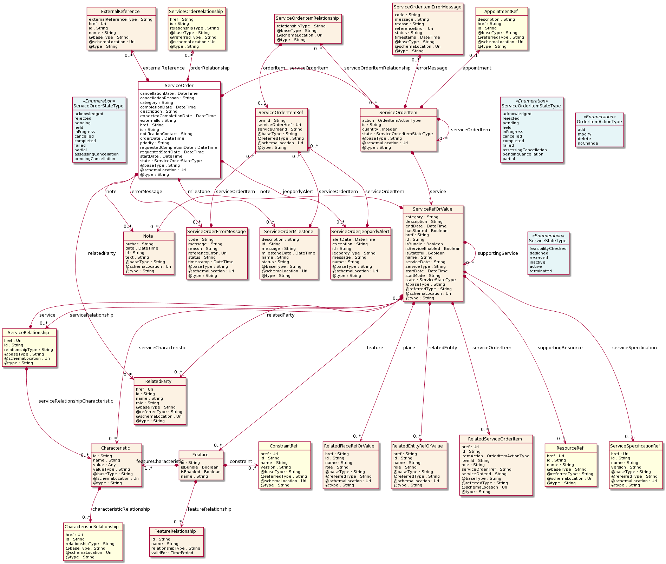
Field descriptions
ServiceOrder fields
href | A string. Hyperlink to access the order.
id | A string. ID created on repository side.
@baseType | A string. When sub-classing, this defines the super-class.
@schemaLocation | An uri (Uri). A URI to a JSON-Schema file that defines additional attributes and relationships.
@type | A string. When sub-classing, this defines the sub-class Extensible name.
cancellationDate | A date time (DateTime). Date when the order is cancelled. This is used when order is cancelled.
cancellationReason | A string. Reason why the order is cancelled. This is used when order is cancelled.
category | A string. Used to categorize the order, useful for the OM system, such as: Broadband, TVOption.
completionDate | A date time (DateTime). Effective delivery date amended by the provider.
description | A string. A free-text description of the service order.
errorMessage | A list of service order error messages (ServiceOrderErrorMessage [*]). the error(s) cause an order status change.
expectedCompletionDate | A date time (DateTime). Expected delivery date amended by the provider.
externalId | A string. ID given by the consumer to facilitate searches.
externalReference | A list of external references (ExternalReference [*]). External reference of the individual or reference in other system.
href | A string. Hyperlink to access the order.
id | A string. ID created on repository side.
jeopardyAlert | A list of service order jeopardy alerts (ServiceOrderJeopardyAlert [*]). A list of jeopardy alerts related to this order.
milestone | A list of service order milestones (ServiceOrderMilestone [*]). A list of milestones related to this order.
note | A list of notes (Note [*]). Extra-information about the order, e.g., useful to add extra delivery information that could be useful for a human process.
notificationContact | A string. Contact attached to the order to send back information regarding this order.
orderDate | A date time (DateTime).
orderRelationship | A list of service order relationships (ServiceOrderRelationship [*]). A list of service orders related to this order (e.g., prerequisite, dependent on).
priority | A string. Can be used by consumers to prioritize orders in a Service Order Management system.
relatedParty | A list of related parties (RelatedParty [*]). A list of parties which are involved in this order and the role they are playing.
requestedCompletionDate | A date time (DateTime). Requested delivery date from the requestor’s perspective.
requestedStartDate | A date time (DateTime). Order start date wished by the requestor.
serviceOrderItem | A list of service order items (ServiceOrderItem [*]). A list of service order items to be processed by this order.
startDate | A date time (DateTime). Date when the order was started for processing.
state | A service order state type (ServiceOrderStateType). State of the order: described in the state-machine diagram.
Characteristic sub-resource
Describes a given characteristic of an object or entity through a name/value pair.
@baseType | A string. When sub-classing, this defines the super-class.
@schemaLocation | An uri (Uri). A URI to a JSON-Schema file that defines additional attributes and relationships.
@type | A string. When sub-classing, this defines the sub-class Extensible name.
characteristicRelationship | A list of characteristic relationships (CharacteristicRelationship [*]). Another Characteristic that is related to the current Characteristic;.
id | A string. Unique identifier of the characteristic.
name | A string. Name of the characteristic.
value | An any (Any). The value of the characteristic.
valueType | A string. Data type of the value of the characteristic.
CharacteristicRelationship sub-resource
Another Characteristic that is related to the current Characteristic;.
href | An uri (Uri). Hyperlink reference.
id | A string. Unique identifier of the characteristic.
@baseType | A string. When sub-classing, this defines the super-class.
@schemaLocation | An uri (Uri). A URI to a JSON-Schema file that defines additional attributes and relationships.
@type | A string. When sub-classing, this defines the sub-class Extensible name.
relationshipType | A string. The type of relationship.
ExternalReference sub-resource
External reference of the individual or reference in other system.
href | An uri (Uri). Hyperlink reference.
id | A string. unique identifier.
@baseType | A string. When sub-classing, this defines the super-class.
@schemaLocation | An uri (Uri). A URI to a JSON-Schema file that defines additional attributes and relationships.
@type | A string. When sub-classing, this defines the sub-class Extensible name.
externalReferenceType | A string. Type of the external reference.
name | A string. External reference name.
Feature sub-resource
Configuration feature.
constraint | A list of constraint references (ConstraintRef [*]). This is a list of feature constraints.
featureCharacteristic | A list of characteristics (Characteristic [1..*]). This is a list of Characteristics for a particular feature.
featureRelationship | A list of feature relationships (FeatureRelationship [*]). Configuration feature.
id | A string. Unique identifier of the feature.
isBundle | A boolean. True if this is a feature group. Default is false.
isEnabled | A boolean. True if this feature is enabled. Default is true.
name | A string. This is the name for the feature.
FeatureRelationship sub-resource
Configuration feature.
id | A string. Unique identifier of the target feature.
name | A string. This is the name of the target feature.
relationshipType | A string. This is the type of the feature relationship.
validFor | A time period. The period for which this feature relationship is valid.
Note sub-resource
Extra information about a given entity.
@baseType | A string. When sub-classing, this defines the super-class.
@schemaLocation | An uri (Uri). A URI to a JSON-Schema file that defines additional attributes and relationships.
@type | A string. When sub-classing, this defines the sub-class Extensible name.
author | A string. Author of the note.
date | A date time (DateTime). Date of the note.
id | A string. Identifier of the note within its containing entity.
text | A string. Text of the note.
RelatedEntityRefOrValue sub-resource
A reference to an entity, where the type of the entity is not known in advance. A related entity defines an entity described by reference or by value linked to a specific entity. The polymorphic attributes @type, @schemaLocation & @referredType are related to the Entity and not the RelatedEntityRefOrValue class itself.
@referredType | A string. The actual type of the target instance when needed for disambiguation.
name | A string. Name of the related entity.
href | A string. Reference of the related entity.
id | A string. Unique identifier of a related entity.
@baseType | A string. When sub-classing, this defines the super-class.
@schemaLocation | An uri (Uri). A URI to a JSON-Schema file that defines additional attributes and relationships.
@type | A string. When sub-classing, this defines the sub-class Extensible name.
role | A string.
RelatedParty sub-resource
Related Party reference. A related party defines party or party role linked to a specific entity.
@referredType | A string. The actual type of the target instance when needed for disambiguation.
name | A string. Name of the related entity.
href | An uri (Uri). Hyperlink reference.
id | A string. unique identifier.
@baseType | A string. When sub-classing, this defines the super-class.
@schemaLocation | An uri (Uri). A URI to a JSON-Schema file that defines additional attributes and relationships.
@type | A string. When sub-classing, this defines the sub-class Extensible name.
role | A string. Role played by the related party.
RelatedPlaceRefOrValue sub-resource
Related Entity reference. A related place defines a place described by reference or by value linked to a specific entity. The polymorphic attributes @type, @schemaLocation & @referredType are related to the place entity and not the RelatedPlaceRefOrValue class itself.
@referredType | A string. The actual type of the target instance when needed for disambiguation.
name | A string. A user-friendly name for the place, such as [Paris Store], [London Store], [Main Home].
href | A string. Unique reference of the place.
id | A string. Unique identifier of the place.
@baseType | A string. When sub-classing, this defines the super-class.
@schemaLocation | An uri (Uri). A URI to a JSON-Schema file that defines additional attributes and relationships.
@type | A string. When sub-classing, this defines the sub-class Extensible name.
role | A string.
RelatedServiceOrderItem sub-resource
RelatedServiceOrderItem (a ServiceOrder item) .The service order item which triggered service creation/change/termination.
href | An uri (Uri). Hyperlink reference.
id | A string. unique identifier.
@baseType | A string. When sub-classing, this defines the super-class.
@schemaLocation | An uri (Uri). A URI to a JSON-Schema file that defines additional attributes and relationships.
@type | A string. When sub-classing, this defines the sub-class Extensible name.
@referredType | A string. The actual type of the target instance when needed for disambiguation.
itemAction | An order item action type (OrderItemActionType). Action of the order item for this service.
itemId | A string. Identifier of the order item where the service was managed.
role | A string. role of the service order item for this service.
serviceOrderHref | A string. Reference of the related entity.
serviceOrderId | A string. Unique identifier of a related entity.
ServiceOrderErrorMessage sub-resource
A ServiceOrderErrorMessage represents an error that causes a status change in a service order.
code | A string. error code.
message | A string. More details and corrective actions related to the error.
reason | A string. Explanation of the reason for the error.
referenceError | An uri (Uri). URI of documentation describing the error.
status | A string. error code extension like sys-ABC-2001.
@baseType | A string. When sub-classing, this defines the super-class.
@schemaLocation | An uri (Uri). A URI to a JSON-Schema file that defines additional attributes and relationships.
@type | A string. When sub-classing, this defines the sub-class Extensible name.
serviceOrderItem | A list of service order item references (ServiceOrderItemRef [*]). A list of order item references corresponded to this error.
timestamp | A date time (DateTime). Date when the error happened.
ServiceOrderItem sub-resource

@baseType | A string. When sub-classing, this defines the super-class.
@schemaLocation | An uri (Uri). A URI to a JSON-Schema file that defines additional attributes and relationships.
@type | A string. When sub-classing, this defines the sub-class Extensible name.
action | An order item action type (OrderItemActionType). The action to be carried out on the Service. Can be add, modify, delete, noChange.
appointment | An appointment reference (AppointmentRef). An appointment that was set up with a related party for this order item.
errorMessage | A list of service order item error messages (ServiceOrderItemErrorMessage [*]). the error(s) cause an order item status change.
id | A string. Identifier of the individual line item.
quantity | An integer. Quantity ordered.
service | A service ref or value (ServiceRefOrValue). The Service to be acted on by the order item.
serviceOrderItem | A list of service order items (ServiceOrderItem [*]). A list of order items embedded to this order item.
serviceOrderItemRelationship | A list of service order item relationships (ServiceOrderItemRelationship [*]). A list of order items related to this order item.
state | A service order item state type (ServiceOrderItemStateType). State of the order item: described in the state machine diagram. This is the requested state.
ServiceOrderItemErrorMessage sub-resource
AServiceOrderItemErrorMessage represents an error that causes a status change in a service order item.
code | A string. error code.
message | A string. More details and corrective actions related to the error.
reason | A string. Explanation of the reason for the error.
referenceError | An uri (Uri). URI of documentation describing the error.
status | A string. error code extension like sys-ABC-2001.
@baseType | A string. When sub-classing, this defines the super-class.
@schemaLocation | An uri (Uri). A URI to a JSON-Schema file that defines additional attributes and relationships.
@type | A string. When sub-classing, this defines the sub-class Extensible name.
timestamp | A date time (DateTime). Date when the error happened.
ServiceOrderItemRelationship sub-resource
Linked service order item to the one containing this attribute.
@baseType | A string. When sub-classing, this defines the super-class.
@schemaLocation | An uri (Uri). A URI to a JSON-Schema file that defines additional attributes and relationships.
@type | A string. When sub-classing, this defines the sub-class Extensible name.
orderItem | A service order item reference (ServiceOrderItemRef). A service order item in relationship with this order item.
relationshipType | A string. The type of related order item, can be: dependency if the order item needs to be not started until another order item is complete.
ServiceOrderJeopardyAlert sub-resource
A ServiceOrderJeopardyAlert represents a predicted exception during a service order processing that would bring risk to complete successfully the order.
alertDate | A date time (DateTime). A date time( DateTime). The date that the alert issued.
exception | A string. The exception associated with this jeopardy alert.
id | A string. identifier of the JeopardyAlert.
jeopardyType | A string. A string represents the type of jeopardy/risk like Normal, Hazard, Critical, ...
message | A string. A string represents the message of the alert.
name | A string. A string used to give a name to the jeopardy alert.
@baseType | A string. When sub-classing, this defines the super-class.
@schemaLocation | An uri (Uri). A URI to a JSON-Schema file that defines additional attributes and relationships.
@type | A string. When sub-classing, this defines the sub-class Extensible name.
serviceOrderItem | A list of service order item references (ServiceOrderItemRef [*]). A list of order item references corresponded to this alert.
ServiceOrderMilestone sub-resource
ServiceOrderMilestone represents an action or event marking a significant change or stage in processing of a service order.
description | A string. free-text description of the Milestone.
id | A string. identifier of the Milestone.
message | A string. A string represents the message of the milestone.
milestoneDate | A date time (DateTime). A date time( DateTime). The date that the milestone happens.
name | A string. A string used to give a name to the milestone.
status | A string. The milestone status.
@baseType | A string. When sub-classing, this defines the super-class.
@schemaLocation | An uri (Uri). A URI to a JSON-Schema file that defines additional attributes and relationships.
@type | A string. When sub-classing, this defines the sub-class Extensible name.
serviceOrderItem | A list of service order item references (ServiceOrderItemRef [*]). A list of order item references corresponded to this milestone.
ServiceOrderRelationship sub-resource
Linked service order to the one containing this attribute.
href | A string. A hyperlink to the related order.
id | A string. The id of the related order.
@baseType | A string. When sub-classing, this defines the super-class.
@schemaLocation | An uri (Uri). A URI to a JSON-Schema file that defines additional attributes and relationships.
@type | A string. When sub-classing, this defines the sub-class Extensible name.
@referredType | A string. The entity type of the related order.
relationshipType | A string. The type of related order, such as: [dependency] if the order needs to be [not started] until another order item is complete (a service order in this case) or [cross-ref] to keep track of the source order (a productOrder).
ServiceRefOrValue sub-resource
A Service to be created defined by value or existing defined by reference. The polymorphic attributes @type, @schemaLocation & @referredType are related to the Service entity and not the RelatedServiceRefOrValue class itself.
@referredType | A string. The actual type of the target instance when needed for disambiguation.
name | A string. Name of the service.
href | A string. Reference of the service.
id | A string. Unique identifier of the service.
@baseType | A string. When sub-classing, this defines the super-class.
@schemaLocation | An uri (Uri). A URI to a JSON-Schema file that defines additional attributes and relationships.
@type | A string. When sub-classing, this defines the sub-class Extensible name.
category | A string. Is it a customer facing or resource facing service.
description | A string. Free-text description of the service.
endDate | A date time (DateTime). Date when the service ends.
hasStarted | A boolean. If TRUE, this Service has already been started.
isBundle | A boolean. If true, the service is a ServiceBundle which regroup a service hierachy. If false, the service is an 'atomic' service (hierachy leaf).
isServiceEnabled | A boolean. If FALSE and hasStarted is FALSE, this particular Service has NOT been enabled for use - if FALSE and hasStarted is TRUE then the service has failed.
isStateful | A boolean. If TRUE, this Service can be changed without affecting any other services.
serviceDate | A string. Date when the service was created (whatever its status).
serviceType | A string. Business type of the service.
startDate | A date time (DateTime). Date when the service starts.
startMode | A string. This attribute is an enumerated integer that indicates how the Service is started, such as: 0: Unknown; 1: Automatically by the managed environment; 2: Automatically by the owning device; 3: Manually by the Provider of the Service; 4: Manually by a Customer of the Provider; 5: Any of the above.
feature | A list of features (Feature [*]). A list of features associated with this service.
note | A list of notes (Note [*]). A list of notes made on this service.
place | A list of related place ref or values (RelatedPlaceRefOrValue [*]). A list of places (Place [*]). Used to define a place useful for the service (for example a geographical place where the service is installed).
relatedEntity | A list of related entity ref or values (RelatedEntityRefOrValue [*]). A list of related entity in relationship with this service.
relatedParty | A list of related parties (RelatedParty [*]). A list of related party references (RelatedParty [*]). A related party defines party or party role linked to a specific entity.
serviceCharacteristic | A list of characteristics (Characteristic [*]). A list of characteristics that characterize this service (ServiceCharacteristic [*]).
serviceOrderItem | A list of related service order items (RelatedServiceOrderItem [*]). A list of service order items related to this service.
serviceRelationship | A list of service relationships (ServiceRelationship [*]). A list of service relationships (ServiceRelationship [*]). Describes links with other service(s) in the inventory.
serviceSpecification | A service specification reference (ServiceSpecificationRef). The specification from which this service was instantiated.
state | A service state type (ServiceStateType). The life cycle state of the service, such as designed, reserved, active, etc...
supportingResource | A list of resource references (ResourceRef [*]). A list of supporting resources (SupportingResource [*]).Note: only Service of type RFS can be associated with Resources.
supportingService | A list of service ref or values (ServiceRefOrValue [*]). A list of supporting services (SupportingService [*]). A collection of services that support this service (bundling, link CFS to RFS).
ServiceRelationship sub-resource

href | An uri (Uri). Hyperlink reference.
id | A string. unique identifier.
@baseType | A string. When sub-classing, this defines the super-class.
@schemaLocation | An uri (Uri). A URI to a JSON-Schema file that defines additional attributes and relationships.
@type | A string. When sub-classing, this defines the sub-class Extensible name.
relationshipType | A string.
service | A service ref or value (ServiceRefOrValue). A Service to be created defined by value or existing defined by reference. The polymorphic attributes @type, @schemaLocation & @referredType are related to the Service entity and not the RelatedServiceRefOrValue class itself.
serviceRelationshipCharacteristic | A list of characteristics (Characteristic [*]). Describes a given characteristic of an object or entity through a name/value pair.
AppointmentRef relationship
Refers an appointment, such as a Customer presentation or internal meeting or site visit.
href | A string. The reference of the appointment.
id | A string. The identifier of the referred appointment.
@baseType | A string. When sub-classing, this defines the super-class.
@schemaLocation | An uri (Uri). A URI to a JSON-Schema file that defines additional attributes and relationships.
@type | A string. When sub-classing, this defines the sub-class Extensible name.
@referredType | A string. The actual type of the target instance when needed for disambiguation.
description | A string. An explanatory text regarding the appointment made with a party.
ConstraintRef relationship
Constraint reference. The Constraint resource represents a policy/rule applied to an entity or entity spec.
@referredType | A string. The actual type of the target instance when needed for disambiguation.
name | A string. Name of the related entity.
href | An uri (Uri). Hyperlink reference.
id | A string. unique identifier.
@baseType | A string. When sub-classing, this defines the super-class.
@schemaLocation | An uri (Uri). A URI to a JSON-Schema file that defines additional attributes and relationships.
@type | A string. When sub-classing, this defines the sub-class Extensible name.
version | A string. constraint version.

ResourceRef relationship

@referredType | A string. The actual type of the target instance when needed for disambiguation.
name | A string. Name of the related entity.
href | An uri (Uri). Hyperlink reference.
id | A string. unique identifier.
@baseType | A string. When sub-classing, this defines the super-class.
@schemaLocation | An uri (Uri). A URI to a JSON-Schema file that defines additional attributes and relationships.
@type | A string. When sub-classing, this defines the sub-class Extensible name.
ServiceOrderItemRef relationship

@baseType | A string. When sub-classing, this defines the super-class.
@schemaLocation | An uri (Uri). A URI to a JSON-Schema file that defines additional attributes and relationships.
@type | A string. When sub-classing, this defines the sub-class Extensible name.
@referredType | A string. The actual type of the target instance when needed for disambiguation.
itemId | A string. Identifier of the line item.
serviceOrderHref | An uri (Uri). Link to the order to which this item belongs to.
serviceOrderId | A string. Identifier of the order that this item belongs to.
ServiceSpecificationRef relationship
Service specification reference: ServiceSpecification(s) required to realize a ProductSpecification.
@referredType | A string. The actual type of the target instance when needed for disambiguation.
name | A string. Name of the related entity.
href | An uri (Uri). Hyperlink reference.
id | A string. unique identifier.
@baseType | A string. When sub-classing, this defines the super-class.
@schemaLocation | An uri (Uri). A URI to a JSON-Schema file that defines additional attributes and relationships.
@type | A string. When sub-classing, this defines the sub-class Extensible name.
version | A string. Service specification version.
Json representation sample
We provide below the json representation of an example of a 'ServiceOrder' resource object.
{
"id": "42",
"href": "http://serverlocation:port/serviceOrdering/v4/serviceOrder/42",
"externalId": "BSS747",
"priority": "1",
"description": "Service order description",
"category": "TMF resource illustration",
"state": "InProgress",
"orderDate": "2020-08-27T09:37:40.508Z",
"completionDate": "",
"requestedStartDate": "2020-08-31T09:37:40.508Z",
"requestedCompletionDate": "2020-08-31T09:37:40.508Z",
"expectedCompletionDate": "2020-08-31T09:37:40.508Z",
"startDate": "2020-08-31T09:37:40.508Z",
"@type": "ServiceOrder",
"note": [
{
"date": "2020-08-27T09:37:40.508Z",
"id": "1",
"author": "Harvey Poupon",
"text": "Some text"
}
],
"relatedParty": [
{
"id": "456",
"href": "http://serverlocation:port/partyManagement/v4/party/456",
"role": "requester",
"name": "Jean Pontus",
"@referredType": "Individual"
}
],
"jeopardyAlert": [
{
"id": "144",
"alertDate": "2020-08-27T23:17:45.450Z",
"exception": "Order Item Completion is in Jeopardy",
"jeopardyType": "Raised",
"message": "Order Item Completion is in Jeopardy",
"name": "Order Item Completion",
"serviceOrderItem": [
{
"itemId": "1",
"serviceOrderHref": "http://serverlocation:port/serviceOrdering/v4/serviceOrder/42",
"serviceOrderId": "42"
}
],
"@type": "ServiceOrderJeopardyAlert"
}
],
"milestone": [
{
"id": "143",
"description": "Port Allocation",
"message": "Port Allocation",
"milestoneDate": "2020-08-27T23:17:45.450Z",
"name": "Port Allocation",
"status": "Completed",
"serviceOrderItem": [
{
"itemId": "2",
"serviceOrderHref": "http://serverlocation:port/serviceOrdering/v4/serviceOrder/42",
"serviceOrderId": "42"
}
],
"@type": "ServiceOrderMilestone"
}
],
"serviceOrderItem": [
{
"id": "1",
"action": "add",
"state": "InProgress",
"service": {
"@type": "Service",
"state": "active",
"serviceType": "CFS",
"serviceCharacteristic": [
{
"id": "452-gh6",
"name": "vCPE",
"valueType": "object",
"value": {
"@type": "vCPE",
"@schemaLocation": "http://nbi/api/v4/serviceSpecification/ONAPvCPE_Spec/specificationInputSchema",
"vCPE_IP": "193.218.236.21",
"MaxTxRate": 300,
"TransmitPower": "11 dBm",
"maxTream": "OFF"
}
}
],
"serviceSpecification": {
"@type": "ONAPServiceSpecificationRef",
"@schemaLocation": "http://my.schema/ONAPServiceSpecificationRef.json",
"id": "ONAPvCPE_Spec",
"href": "http://../serviceSpecification/ONAPvCPE_Spec",
"name": "vCPE",
"version": "1",
"invariantUUID": "456-852-357",
"toscaModelURL": "http//..."
}
},
"errorMessage": [
{
"code": "500",
"message": "Resource Fallout",
"reason": "IP address not available",
"referenceError": "http://serverlocation:port/serviceOrdering/v4/errorMessage/500",
"status": "ERROR-003",
"timestamp": "2020-08-27T23:17:45.450Z",
"@type": "ServiceOrderItemErrorMessage"
}
],
"@type": "ServiceOrderItem"
},
{
"id": "2",
"action": "modify",
"state": "InProgress",
"service": {
"id": "456",
"@type": "Service",
"href": "http://serverlocation:port/serviceInventoryManagement/v4/service/456",
"state": "active",
"serviceType": "CFS",
"serviceCharacteristic": [
{
"id": "452-gh6",
"valueType": "string",
"name": "InputPort",
"value": "456/7"
}
],
"supportingResource": [
{
"id": "3456_DFG5-H690",
"href": "http://...",
"@referredType": "CloudResource"
}
]
},
"@type": "ServiceOrderItem"
},
{
"id": "3",
"action": "add",
"state": "acknowledged",
"service": {
"state": "active",
"serviceType": "CFS",
"@type": "Service",
"serviceRelationship": [
{
"relationshipType": "reliesOn",
"service": {
"href": "https://.../serviceManagement/v4/service/45",
"id": "45"
}
}
],
"serviceSpecification": {
"id": "48",
"href": "http//..../48",
"name": "genericDataService48",
"version": "2"
},
"feature": [
{
"id": "Feat1",
"isEnabled": true,
"name": "DataDownload",
"@type": "Feature",
"featureCharacteritic": [
{
"name": "VolumeCapped",
"id": "444",
"value": true,
"valueType": "boolean"
}
]
}
]
},
"@type": "ServiceOrderItem"
},
{
"id": "4",
"action": "modify",
"state": "acknowledged",
"service": {
"id": "12",
"href": "http://serverlocation:port/serviceInventoryManagement/v4/service/12",
"state": "inactive"
},
"@type": "ServiceOrderItem"
}
]
}

Cancel Service Order resource
Request for cancellation an existing Service order.
Resource model
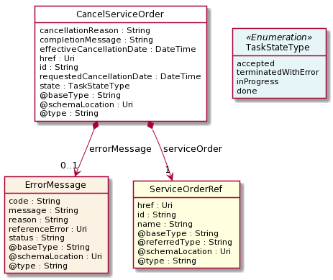
Lifecycle
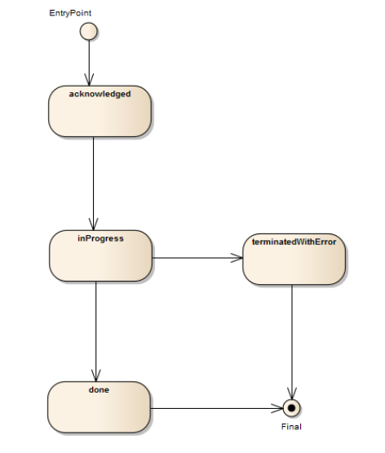
Field descriptions
CancelServiceOrder fields
cancellationReason | A string. Reason why the order is cancelled.
effectiveCancellationDate | A date time (DateTime). Date when the order is cancelled.
href | An uri (Uri). Hyperlink reference.
id | A string. unique identifier.
requestedCancellationDate | A date time (DateTime). Date when the submitter wants the order to be cancelled.
href | An uri (Uri). Hyperlink reference.
id | A string. unique identifier.
@baseType | A string. When sub-classing, this defines the super-class.
@schemaLocation | An uri (Uri). A URI to a JSON-Schema file that defines additional attributes and relationships.
@type | A string. When sub-classing, this defines the sub-class Extensible name.
completionMessage | A string. an optional message describing the completion of the task if it is done as expected or it is denied for a reason (like order in a state of PoNR).
errorMessage | An error message (ErrorMessage). the error(s) cause the termination of cancelServiceOrder (in TerminatedWithError state).
serviceOrder | A service order reference (ServiceOrderRef). Useful to understand the which was the Service order through which the service was instantiated in the service inventory.
state | A task state type (TaskStateType). Tracks the lifecycle status of the cancellation request, such as Acknowledged, Rejected, InProgress, Pending and so on.
ErrorMessage sub-resource
represents an Error.
@baseType | A string. When sub-classing, this defines the super-class.
@schemaLocation | An uri (Uri). A URI to a JSON-Schema file that defines additional attributes and relationships.
@type | A string. When sub-classing, this defines the sub-class Extensible name.
code | A string. error code.
message | A string. More details and corrective actions related to the error.
reason | A string. Explanation of the reason for the error.
referenceError | An uri (Uri). URI of documentation describing the error.
status | A string. error code extension like sys-ABC-2001.
ServiceOrderRef relationship
Service Order reference. Useful to understand the which was the Service order through which the service was instantiated in the service inventory.
@referredType | A string. The actual type of the target instance when needed for disambiguation.
name | A string. Name of the related service order.
href | An uri (Uri). Hyperlink reference.
id | A string. unique identifier.
@baseType | A string. When sub-classing, this defines the super-class.
@schemaLocation | An uri (Uri). A URI to a JSON-Schema file that defines additional attributes and relationships.
@type | A string. When sub-classing, this defines the sub-class Extensible name.
Json representation sample
We provide below the json representation of an example of a 'CancelServiceOrder' resource object.
{
"id": "789-fsds5-kjp",
"href": "https://host:port/serviceOrdering/v4/cancelServiceOrder/789-fsds5-kjp",
"cancellationReason": "Duplicate service order",
"effectiveCancellationDate": "2020-08-27T12:58:35.489Z",
"requestedCancellationDate": "2020-08-27T12:56:21.931Z",
"serviceOrder": {
"id": "45f-98f-ss45",
"href": "https://host:port/serviceOrdering/v4/serviceOrder/45f-98f-ss45",
"@referredType": "ServiceOrder"
},
"state": "done",
"@type": "CancelServiceOrder"
}

A Service Order is a type of order which can be used to describe a group of operations on service – one service order item per service. An action at the level of the service order item describe the operation to be done on a service (add, changer, terminate for example). The service order is triggered from the BSS system in charge of the product order management to the SOM (Service order Management) system that will manage the service fulfillment.
Here is the state machine diagram for a Service order. Each order state is described in the following table.
Note: Consistence rules are defined between order state & order item state.
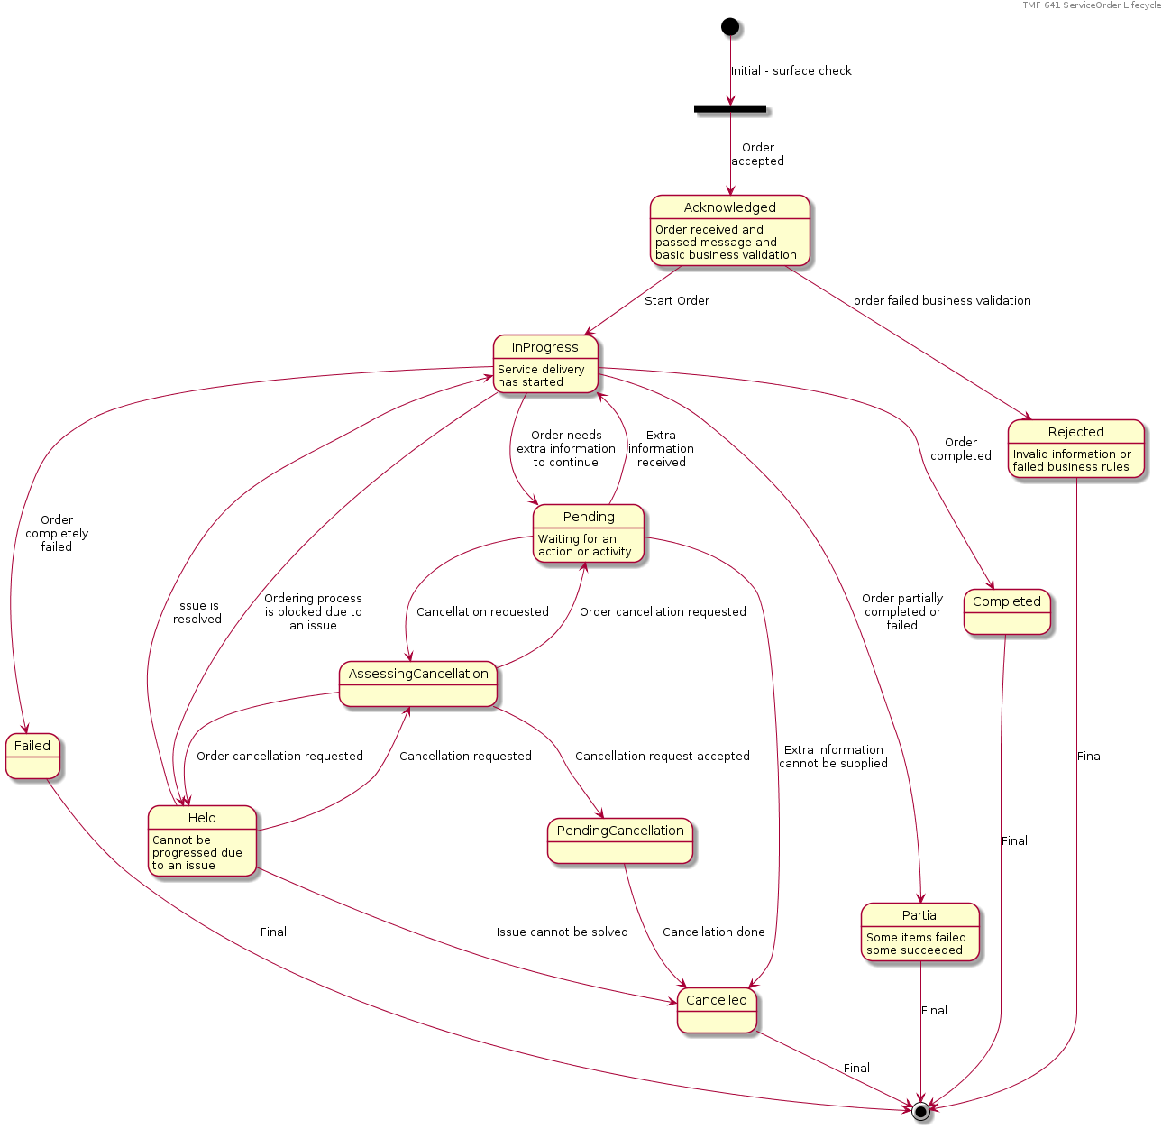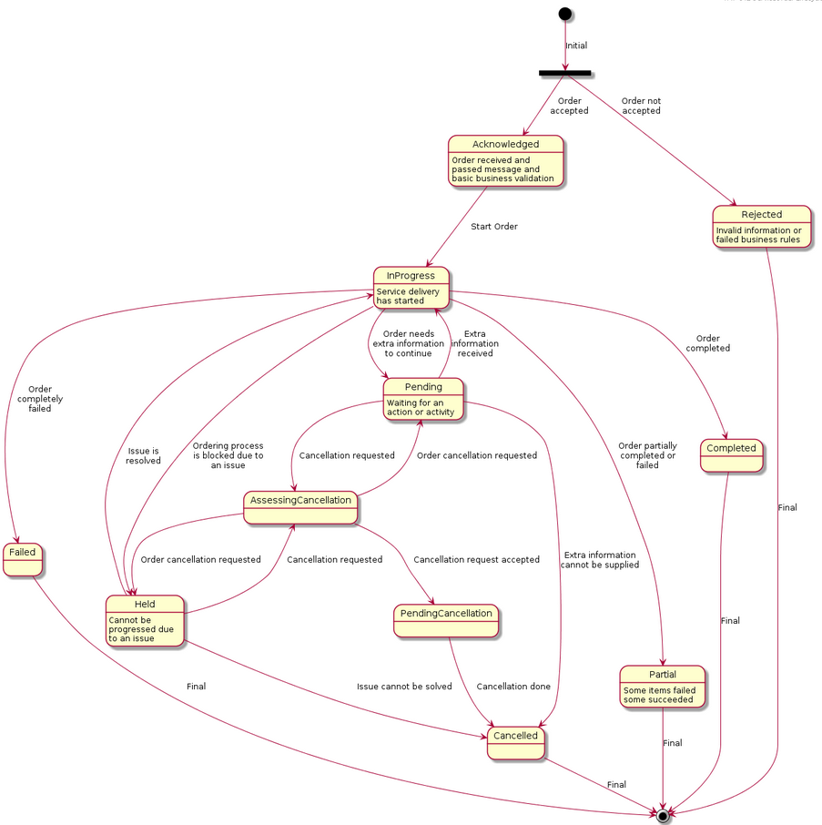

ServiceOrder & ServiceOrderItem State definition:
The following table provides service order state and service order item state description:
State | Definition
Acknowledged | The Acknowledged state is when an order/item has been received and has passed surface message validation.
Rejected | The Rejected state is where:  - Invalid information is provided through the order request (not checked synchronously – like check that a service id provided exist in the inventory and relation service order item action is valid)  - The order request fails to meet business rules for ordering  Same rules applied for order item.  If an order item is rejected the complete service order is rejected.
Pending | The Pending state is used when an order/item is currently in a waiting stage for an action/activity to be completed before the order/item can progress further, pending order amend or cancel assessment. In situations where Access Seeker action is required, an “information required” notification will be issued on transition into this state.  A pending stage can lead into auto cancellation of an order/item, if no action is taken.
InProgress | The in Progress state is where an order Item has passed the Order check successfully and service delivery has started.  For the order at least one order item is inProgress
Held | The Held state is used when an order/item cannot be progressed due to an issue. Service provided has temporarily delayed completing an order/item to resolve an infrastructure shortfall to facilitate supply of order. Upon resolution of the issue, the order/item will continue to progress.
AssessingCancellation | Following a cancel request, the SP is assessing if cancel can be done for the order/item (or if the Service Order has reached PONR). If cancellation request is not accepted after assessment the order will return in Held or Pending or InProgress state.
PendingCancellation | Once a cancel order has been accepted by SP, it could in some UC take time to effectively cancel the order/item. During this time when accepted cancellation is effectively processed we use Pending Cancellation.
Cancelled | The Cancelled state is where an In-Flight Order/item has been successfully cancelled.
Completed | The Completed state is where an item has complete provision, and the service is now active.  For an order if all order items are completed
Failed | Order item as not a successful delivery completion. The service is not delivered, and the order item failed.  All Order items have failed which results in the entire Order has Failed.
Partial | Some Order items have failed, and some have succeeded so the entire Order is in a Partial state. This provides support for partial Failure of an Order (or a service order item with ‘embedded’ service order item)

Lifecycle of Service
Here is the state machine diagram for a Service:

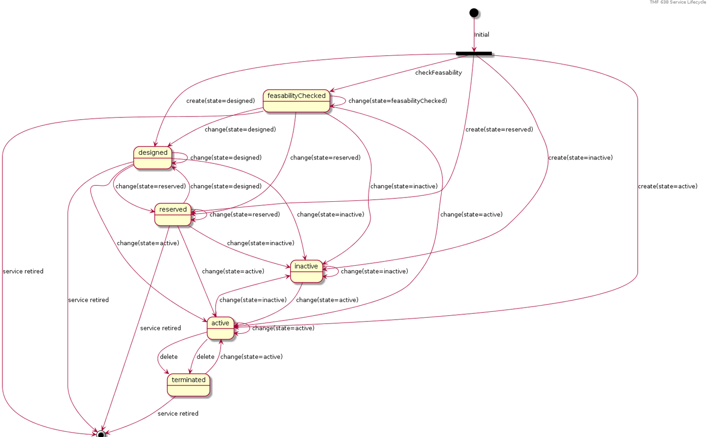
The following table provided service state explanation:
A service is in state… | when the Service Component Activation Interface shall support the following operations
feasabilityChecked | The service component OS is requested to determine whether the necessary resources are available and sufficient for the installation of a given service.  It should be noted that this is just an initial feasibility check and no RFS is created.
designed | The Service Component OS is requested to design the service. This could be used to allocate resources, but nothing is supposed to be reserved.
reserved | The Service Component OS is requested to reserve a resource, or a set of resources, required for a service. This situation allows for the requesting OS to determine whether the underlying resources are available and reserve them in order to support a service (an RFS).  As a result of the reservation request, a service is instantiated & reserved.
inactive | The service is deactivated - The Resource Facing service is deactivated and thus is no longer available for service. It remains allocated to the CFS that is managed by the high level service activation OS
active | The service component OS is requested to activate a given resource facing service such that the component is fully available and active as part of the CFS.  When this request is complete, all RFS component shall be in active state
terminated | The service is ‘logically deleted’. The resource facing service is deleted and thus allocated from the CFS. All associated resources are freed and made available for service to other users.

Note: when action ‘no change’ is used we did not expect any state change.
CancelOrder State definition:
State | Definition
Accepted | The accepted state is where a CancelOrder request has been received and has passed message and basic business validations. Everything should be updatable in this state
InProgress | The InProgress state is when the CancelOrder is currently in the hands of server side to assess cancellation request.
TerminatedWithError | The CancelOrder could not be correctly completed by Service Order component. It did not mean that the cancel request is denied – it means that the assessment was not done
Done | CancelOrder assessment has been done. The Order has been cancelled or keep it as is if cancel request denied (for example, the order is in point Of No Return (PoNR).

Notification Resource Models
10 notifications are defined for this API
Notifications related to ServiceOrder:
- ServiceOrderCreateEvent
- ServiceOrderAttributeValueChangeEvent
- ServiceOrderStateChangeEvent
- ServiceOrderDeleteEvent
- ServiceOrderInformationRequiredEvent
- ServiceOrderMilestoneEvent
- ServiceOrderJeopardyEvent
Notifications related to CancelServiceOrder:
- CancelServiceOrderCreateEvent
- CancelServiceOrderStateChangeEvent
- CancelServiceOrderInformationRequiredEvent
The notification structure for all notifications in this API follow the pattern depicted by the figure below.
A notification event resource (depicted by "SpecificEvent" placeholder) is a sub class of a generic Event structure containing at least an id of the event occurrence (eventId), an event timestamp (eventTime), and the name of the resource (eventType).
This notification structure owns an event payload structure ("SpecificEventPayload" placeholder) linked to the resource concerned by the notification using the resource name as access field ("resourceName" placeholder).
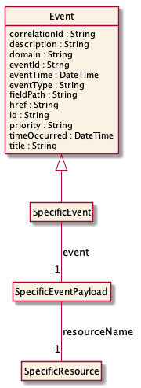

Service Order Create Event
Notification ServiceOrderCreateEvent case for resource ServiceOrder
Json representation sample
We provide below the json representation of an example of a 'ServiceOrderCreateEvent' notification event object.
{
"eventId":"00001",
"eventTime":"2015-11-16T16:42:25-04:00",
"eventType":"ServiceOrderCreateEvent",
"event": {
"serviceOrder" :
{-- SEE ServiceOrder RESOURCE SAMPLE --}
}
}

Service Order Attribute Value Change Event
Notification ServiceOrderAttributeValueChangeEvent case for resource ServiceOrder
Json representation sample
We provide below the json representation of an example of a 'ServiceOrderAttributeValueChangeEvent' notification event object.
{
"eventId":"00001",
"eventTime":"2015-11-16T16:42:25-04:00",
"eventType":"ServiceOrderAttributeValueChangeEvent",
"event": {
"serviceOrder" :
{-- SEE ServiceOrder RESOURCE SAMPLE --}
}
}

Service Order State Change Event
Notification ServiceOrderStateChangeEvent case for resource ServiceOrder
Json representation sample
We provide below the json representation of an example of a 'ServiceOrderStateChangeEvent' notification event object.
{
"eventId":"00001",
"eventTime":"2015-11-16T16:42:25-04:00",
"eventType":"ServiceOrderStateChangeEvent",
"event": {
"serviceOrder" :
{-- SEE ServiceOrder RESOURCE SAMPLE --}
}
}

Service Order Delete Event
Notification ServiceOrderDeleteEvent case for resource ServiceOrder
Json representation sample
We provide below the json representation of an example of a 'ServiceOrderDeleteEvent' notification event object.
{
"eventId":"00001",
"eventTime":"2015-11-16T16:42:25-04:00",
"eventType":"ServiceOrderDeleteEvent",
"event": {
"serviceOrder" :
{-- SEE ServiceOrder RESOURCE SAMPLE --}
}
}

Service Order Information Required Event
Notification ServiceOrderInformationRequiredEvent case for resource ServiceOrder
Json representation sample
We provide below the json representation of an example of a 'ServiceOrderInformationRequiredEvent' notification event object.
{
"eventId":"00001",
"eventTime":"2015-11-16T16:42:25-04:00",
"eventType":"ServiceOrderInformationRequiredEvent",
"event": {
"serviceOrder" :
{-- SEE ServiceOrder RESOURCE SAMPLE --}
}
}

Service Order Milestone Event
Notification ServiceOrderMilestoneEvent case for resource ServiceOrder
Json representation sample
We provide below the json representation of an example of a 'ServiceOrderMilestoneEvent' notification event object.
{
"eventId":"00001",
"eventTime":"2015-11-16T16:42:25-04:00",
"eventType":"ServiceOrderMilestoneEvent",
"event": {
"serviceOrder" :
{-- SEE ServiceOrder RESOURCE SAMPLE --}
}
}

Service Order Jeopardy Event
Notification ServiceOrderJeopardyEvent case for resource ServiceOrder
Json representation sample
We provide below the json representation of an example of a 'ServiceOrderJeopardyEvent' notification event object.
{
"eventId":"00001",
"eventTime":"2015-11-16T16:42:25-04:00",
"eventType":"ServiceOrderJeopardyEvent",
"event": {
"serviceOrder" :
{-- SEE ServiceOrder RESOURCE SAMPLE --}
}
}

Cancel Service Order Create Event
Notification CancelServiceOrderCreateEvent case for resource CancelServiceOrder
Json representation sample
We provide below the json representation of an example of a 'CancelServiceOrderCreateEvent' notification event object.
{
"eventId":"00001",
"eventTime":"2015-11-16T16:42:25-04:00",
"eventType":"CancelServiceOrderCreateEvent",
"event": {
"cancelServiceOrder" :
{-- SEE CancelServiceOrder RESOURCE SAMPLE --}
}
}

Cancel Service Order State Change Event
Notification CancelServiceOrderStateChangeEvent case for resource CancelServiceOrder
Json representation sample
We provide below the json representation of an example of a 'CancelServiceOrderStateChangeEvent' notification event object.
{
"eventId":"00001",
"eventTime":"2015-11-16T16:42:25-04:00",
"eventType":"CancelServiceOrderStateChangeEvent",
"event": {
"cancelServiceOrder" :
{-- SEE CancelServiceOrder RESOURCE SAMPLE --}
}
}

Cancel Service Order Information Required Event
Notification CancelServiceOrderInformationRequiredEvent case for resource CancelServiceOrder
Json representation sample
We provide below the json representation of an example of a 'CancelServiceOrderInformationRequiredEvent' notification event object.
{
"eventId":"00001",
"eventTime":"2015-11-16T16:42:25-04:00",
"eventType":"CancelServiceOrderInformationRequiredEvent",
"event": {
"cancelServiceOrder" :
{-- SEE CancelServiceOrder RESOURCE SAMPLE --}
}
}

API OPERATIONS
Remember the following Uniform Contract:
Operation on Entities | Uniform API Operation | Description
Query Entities | GET Resource | GET must be used to retrieve a representation of a resource.
Create Entity | POST Resource | POST must be used to create a new resource
Partial Update of an Entity | PATCH Resource | PATCH must be used to partially update a resource
Remove an Entity | DELETE Resource | DELETE must be used to remove a resource
Execute an Action on an Entity | POST on TASK Resource | POST must be used to execute Task Resources
Other Request Methods | POST on TASK Resource | GET and POST must not be used to tunnel other request methods.

Filtering and attribute selection rules are described in the TMF REST Design Guidelines.
Notifications are also described in a subsequent section.

Operations on Service Order

List service orders
GET /serviceOrder?fields=...&{filtering}
Description
This operation list service order entities.
Attribute selection is enabled for all first level attributes.
Filtering may be available depending on the compliance level supported by an implementation.
Usage Samples
Here's an example of a request for retrieving all the service orders for a given customer that were completed before a specified date.
Request
GET /tmf-api/serviceOrdering/v4/serviceOrder?fields=id,href,expectedCompletionDate&state=completed&category=TMFresourceillustration&completionDate.gt=2020-08-27T09:37:40.508Z
Accept: application/json
Response
200
[
{
"id": "6987",
"href": ".../serviceOrdering/v4/serviceOrder/6987",
"expectedCompletionDate": "2020-12-14T14:52:21.823Z"
},
{
"id": "7412",
"href": ".../serviceOrdering/v4/serviceOrder/7412",
"expectedCompletionDate": "2020-12-14T14:21:31.325Z"
},
{
"id": "3214",
"href": ".../serviceOrdering/v4/serviceOrder/3214",
"expectedCompletionDate": "2020-12-28T18:08:31.325Z"
},
{
"id": "6547",
"href": ".../serviceOrdering/v4/serviceOrder/6547",
"expectedCompletionDate": "2020-12-28T10:48:28.325Z"
}
]

Retrieve service order
GET /serviceOrder/{id}?fields=...&{filtering}
Description
This operation retrieves a service order entity.
Attribute selection is enabled for all first level attributes.
Filtering on sub-resources may be available depending on the compliance level supported by an implementation.

Usage Samples
Here is a sample of a request for retrieving a ServiceOrder resource based on its id.
Request
GET /tmf-api/serviceOrdering/v4/serviceOrder/43
Accept: application/json
Response
200
{
"id": "43",
"href": "http://serverlocation:port/serviceOrdering/v4/serviceOrder/43",
"externalId": "BSS747",
"priority": "1",
"description": "Service order description",
"category": "TMF resource illustration",
"state": "acknowledged",
"orderDate": "2020-08-27T09:37:40.508Z",
"completionDate": "",
"requestedStartDate": "2020-08-31T09:37:40.508Z",
"requestedCompletionDate": "2020-08-31T09:37:40.508Z",
"expectedCompletionDate": "2020-08-31T09:37:40.508Z",
"startDate": "2020-08-31T09:37:40.508Z",
"@type": "ServiceOrder",
"note": [
{
"date": "2020-08-27T09:37:40.508Z",
"id": "1",
"author": "Harvey Poupon",
"text": "Some text"
}
],
"relatedParty": [
{
"id": "456",
"href": "http://serverlocation:port/partyManagement/v4/party/456",
"role": "requester",
"name": "Jean Pontus",
"@referredType": "Individual"
}
],
"serviceOrderItem": [
{
"id": "1",
"action": "add",
"state": "acknowledged",
"service": {
"@type": "Service",
"state": "active",
"serviceType": "CFS",
"serviceCharacteristic": [
{
"id": "452-gh6",
"name": "vCPE",
"valueType": "object",
"value": {
"@type": "JSONSpecification",
"@schemaLocation": "http://my.schemas/vCPE.schema.json",
"vCPE_IP": "193.218.236.21",
"MaxTxRate": 300,
"TransmitPower": "11 dBm",
"maxTream": "OFF"
}
}
],
"serviceSpecification": {
"@type": "ONAPServiceSpecification",
"@baseType": "ServiceSpecificationRef",
"@schemaLocation": "http://my.schema/ONAPServiceSpecification.json",
"id": "12",
"href": "http://.../serviceSpecification/12",
"name": "vCPE",
"version": "1",
"invariantUUID": "456-852-357",
"toscaModelURL": "http//...",
"targetServiceSchema": {
"@type": "onapJsonScheam",
"@schemaLocation": "http://nbi/api/v4/serviceSpecification/456-852-357/specificationInputSchema"
}
}
},
"@type": "ServiceOrderItem"
},
{
"id": "2",
"action": "modify",
"state": "acknowledged",
"service": {
"id": "456",
"@type": "Service",
"href": "http://serverlocation:port/serviceInventoryManagement/v4/service/456",
"state": "active",
"serviceType": "CFS",
"serviceCharacteristic": [
{
"id": "452-gh6",
"name": "InputPort",
"valueType": "string",
"value": "456/7"
}
],
"supportingResource": [
{
"id": "3456_DFG5-H690",
"href": "http://serverlocation:port/resourceInventoryManagement/v4/resource/3456_DFG5-H690",
"@referredType": "CloudResource"
}
]
},
"@type": "ServiceOrderItem"
},
{
"id": "3",
"action": "add",
"state": "acknowledged",
"service": {
"state": "active",
"serviceType": "CFS",
"@type": "Service",
"serviceRelationship": [
{
"relationshipType": "reliesOn",
"service": {
"href": "https://serverlocation:port/serviceManagement/v4/service/45",
"id": "45"
}
}
],
"serviceSpecification": {
"id": "48",
"href": "http//serverlocation:port/serviceCatalogManagement/v4/serviceSpecification/48",
"name": "genericDataService48",
"version": "2"
},
"feature": [
{
"id": "Feat1",
"isEnabled": true,
"name": "DataDownload",
"@type": "Feature",
"featureCharacteristic": [
{
"name": "VolumeCapped",
"value": true,
"id": "444",
"valueType": "boolean"
}
]
}
]
},
"@type": "ServiceOrderItem"
},
{
"id": "4",
"action": "modify",
"state": "acknowledged",
"service": {
"id": "12",
"href": "http://serverlocation:port/serviceInventoryManagement/v4/service/12",
"state": "inactive"
},
"@type": "ServiceOrderItem"
}
]
}

Create service order
POST /serviceOrder
Description
This operation creates a service order entity.
Mandatory and Non Mandatory Attributes
The following tables provide the list of mandatory and non mandatory attributes when creating a ServiceOrder, including any possible rule conditions and applicable default values. Notice that it is up to an implementer to add additional mandatory attributes.
Mandatory Attributes | Rule
serviceOrderItem

Non Mandatory Attributes | Rule
@baseType
@schemaLocation
@type
cancellationDate
cancellationReason
category
completionDate
description
errorMessage
expectedCompletionDate
externalId
externalReference
jeopardyAlert
milestone
note
notificationContact
orderDate
orderRelationship
priority
relatedParty
requestedCompletionDate
requestedStartDate
startDate
state

Additional Rules
The following table provides additional rules indicating mandatory fields in sub-resources or relationships when creating a ServiceOrder resource.
Context | Mandatory Sub-Attributes
serviceOrderItem | id, action, service
relatedParty | id, @type
note | text
orderRelationship | id, relationshipType
serviceOrderItem.service.supportingResource | id
serviceOrderItem.service.serviceCharacteristic | name, value
serviceOrderItem.serviceOrderItemRelationship | relationshipType
serviceOrderItem.serviceOrderItemRelationship.orderItem | itemId, serviceOrderId
serviceOrderItem.appointment | id
externalReference | name
serviceOrderItem.service.place | role, @type
serviceOrderItem.service.relatedEntity | role, @type

The following pre-conditions apply for this operation.
Pre-conditions
When creating a service order (post) an order must not have the state, cancellationDate, cancellationReason, completionDate, orderDate fields valued
When creating a service order (post) an order item must not have the state field valued
In relatedParty, the role is mandatory if the id identified a party - optional if it is a party role.

Usage Samples
Here is a sample of a request for creating a ServiceOrder resource. We use the ‘fields’ parameter to restrict the numbers of attributes returned in the response.
Request
POST /tmf-api/serviceOrdering/v4/serviceOrder
Content-Type: application/json
{
"externalId": "BSS748",
"priority": "1",
"description": "Service order description",
"category": "TMF resource illustration",
"requestedStartDate": "2020-08-27T09:37:40.508Z",
"requestedCompletionDate": "2020-08-27T09:37:40.508Z",
"@type": "ServiceOrder",
"serviceOrderItem": [
{
"id": "1",
"action": "add",
"@type": "ServiceOrderItem",
"service": {
"serviceState": "active",
"type": "CFS",
"serviceCharacteristic": [
{
"name": "vCPE",
"valueType": "object",
"value": {
"@type": "JSONSpecification",
"@schemaLocation": "http://nbi/api/v4/serviceSpecification/ONAPvCPE_Spec/specificationInputSchema",
"vCPE_IP": "193.218.236.21",
"MaxTxRate": 300,
"TransmitPower": "11 dBm",
"maxTream": "OFF"
}
}
],
"serviceSpecification": {
"id": "ONAPvCPE_Spec",
"href": "http://...:serviceSpecification/ONAPvCPE_Spec",
"name": "vCPE",
"version": "1",
"@type": "vCPE"
}
}
}
]
}
Response
201
{
"id": "5351",
"href": "https://host:port/serviceOrder/v4/serviceOrder/5351"
}

Patch service order
PATCH /serviceOrder/{id}
Description
This operation allows partial updates of a service order entity. Support of json/merge (https://tools.ietf.org/html/rfc7386) is mandatory, support of json/patch (http://tools.ietf.org/html/rfc5789) is optional.
Note: If the update operation yields to the creation of sub-resources or relationships, the same rules concerning mandatory sub-resource attributes and default value settings in the POST operation applies to the PATCH operation. Hence these tables are not repeated here.
Patchable and Non Patchable Attributes
The tables below provide the list of patchable and non patchable attributes, including constraint rules on their usage.
Patchable Attributes | Rule
description
expectedCompletionDate
externalId
externalReference
note
notificationContact
orderRelationship
priority
relatedParty
requestedCompletionDate
requestedStartDate
serviceOrderItem
state

Non Patchable Attributes | Rule
id
href
orderDate
jeopardyAlert
errorMessage
milestone
@baseType
@schemaLocation
@type
cancellationDate
cancellationReason
category
completionDate
startDate

Additional Rules
The following pre-conditions apply for this operation.
Pre-conditions
When creating a service order (post) an order must not have the state, cancellationDate, cancellationReason, completionDate, orderDate fields valued
When creating a service order (post) an order item must not have the state field valued
In relatedParty, the role is mandatory if the id identified a party - optional if it is a party role.

Usage Samples
Here's an example of a request for patching a ServiceOrder resource (created via previous POST) with change on following attributes: description, requestedStartDate, requestedCompletionDate, vCPE IP (characteristic) value.
Request
PATCH /tmf-api/serviceOrdering/v4/serviceOrder/42
Content-Type: application/merge-patch+json
{
"description": "Service order new description updated v2",
"requestedStartDate": "2020-08-27T09:37:40.508Z",
"requestedCompletionDate": "2020-08-27T09:37:40.508Z",
"orderItem": [
{
"id": "1",
"action": "add",
"state": "acknowledged",
"service": {
"@type": "Service",
"state": "active",
"serviceType": "CFS",
"serviceCharacteristic": [
{
"id": "452-gh6",
"name": "vCPE",
"valueType": "object",
"value": {
"@type": "vCPE",
"@schemaLocation": "http://nbi/api/v4/serviceSpecification/ONAPvCPE_Spec/specificationInputSchema",
"vCPE_IP": "193.218.236.26",
"MaxTxRate": 300,
"TransmitPower": "11 dBm",
"maxTream": "OFF"
}
}
],
"serviceSpecification": {
"@type": "ONAPServiceSpecificationRef",
"@schemaLocation": "http://my.schema/ONAPServiceSpecificationRef.json",
"id": "ONAPvCPE_Spec",
"href": "http://../serviceSpecification/ONAPvCPE_Spec",
"name": "vCPE",
"version": "1",
"invariantUUID": "456-852-357",
"toscaModelURL": "http//..."
}
},
"@type": "ServiceOrderItem"
}
]
}
Response
200
{
"id": "5351",
"href": "http://serverlocation:port/serviceOrdering/v4/serviceOrder/5351",
"externalId": "BSS747",
"priority": "1",
"category": "TMF resource illustration",
"state": "acknowledged",
"orderDate": "2020-08-27T09:37:40.508Z",
"completionDate": "",
"description": "Service order new description updated v2",
"requestedStartDate": "2020-08-27T09:37:40.508Z",
"requestedCompletionDate": "2020-08-27T09:37:40.508Z",
"expectedCompletionDate": "2020-12-14T09:37:40.508Z",
"startDate": "2020-08-27T09:37:40.508Z",
"@type": "ServiceOrder",
"note": [
{
"date": "2020-08-27T09:37:40.508Z",
"author": "Harvey Poupon",
"text": "Some text"
}
],
"relatedParty": [
{
"id": "456",
"href": "http://serverlocation:port/partyManagement/v4/party/456",
"role": "requester",
"name": "Jean Pontus",
"@referredType": "Individual"
}
],
"orderItem": [
{
"id": "1",
"action": "add",
"state": "acknowledged",
"service": {
"@type": "Service",
"state": "active",
"serviceType": "CFS",
"serviceCharacteristic": [
{
"id": "452-gh6",
"name": "vCPE",
"valueType": "object",
"value": {
"@type": "vCPE",
"@schemaLocation": "http://nbi/api/v4/serviceSpecification/ONAPvCPE_Spec/specificationInputSchema",
"vCPE_IP": "193.218.236.26",
"MaxTxRate": 300,
"TransmitPower": "11 dBm",
"maxTream": "OFF"
}
}
],
"serviceSpecification": {
"@type": "ONAPServiceSpecificationRef",
"@schemaLocation": "http://my.schema/ONAPServiceSpecificationRef.json",
"id": "ONAPvCPE_Spec",
"href": "http://../serviceSpecification/ONAPvCPE_Spec",
"name": "vCPE",
"version": "1",
"invariantUUID": "456-852-357",
"toscaModelURL": "http//..."
}
},
"@type": "ServiceOrderItem"
}
]
}

Here is an example of a request for patching a ServiceOrder resource (created via previous POST) with change on following attributes: description, requestedStartDate, requestedCompletionDate, vCPE IP (characteristic) value.
Request
PATCH /tmf-api/serviceOrdering/v4/serviceOrder/42
Content-Type: application/json-patch+json
[
{
"op": "replace",
"path": "requestedStartDate",
"value": "2020-08-31T09:37:40.508Z"
},
{
"op": "replace",
"path": "description",
"value": "Service order new description updated v2"
},
{
"op": "replace",
"path": "requestedCompletionDate",
"value": "2020-08-31T09:37:40.508Z"
},
{
"op": "replace",
"path": "orderItem/1/service/serviceCharacteristic/value/",
"value": {
"@type": "JSONSpecification",
"@schemaLocation": "http://nbi/api/v4/serviceSpecification/ONAPvCPE_Spec/specificationInputSchema",
"vCPE_IP": "193.218.236.26",
"MaxTxRate": 300,
"TransmitPower": "11 dBm",
"maxTream": "OFF"
}
}
]
Response
200
{
"id": "5351",
"href": "http://serverlocation:port/serviceOrdering/v4/serviceOrder/5351",
"externalId": "BSS747",
"priority": "1",
"category": "TMF resource illustration",
"state": "acknowledged",
"orderDate": "2020-08-27T09:37:40.508Z",
"completionDate": "",
"description": "Service order new description updated v2",
"requestedStartDate": "2020-08-27T09:37:40.508Z",
"requestedCompletionDate": "2020-08-27T09:37:40.508Z",
"expectedCompletionDate": "2020-12-14T09:37:40.508Z",
"startDate": "2020-08-27T09:37:40.508Z",
"@type": "ServiceOrder",
"note": [
{
"date": "2020-08-27T09:37:40.508Z",
"author": "Harvey Poupon",
"text": "Some text"
}
],
"relatedParty": [
{
"id": "456",
"href": "http://serverlocation:port/partyManagement/v4/party/456",
"role": "requester",
"name": "Jean Pontus",
"@referredType": "Individual"
}
],
"orderItem": [
{
"id": "1",
"action": "add",
"state": "acknowledged",
"service": {
"@type": "Service",
"state": "active",
"serviceType": "CFS",
"serviceCharacteristic": [
{
"id": "452-gh6",
"name": "vCPE",
"valueType": "object",
"value": {
"@type": "vCPE",
"@schemaLocation": "http://nbi/api/v4/serviceSpecification/ONAPvCPE_Spec/specificationInputSchema",
"vCPE_IP": "193.218.236.26",
"MaxTxRate": 300,
"TransmitPower": "11 dBm",
"maxTream": "OFF"
}
}
],
"serviceSpecification": {
"@type": "ONAPServiceSpecificationRef",
"@schemaLocation": "http://my.schema/ONAPServiceSpecificationRef.json",
"id": "ONAPvCPE_Spec",
"href": "http://../serviceSpecification/ONAPvCPE_Spec",
"name": "vCPE",
"version": "1",
"invariantUUID": "456-852-357",
"toscaModelURL": "http//..."
}
},
"@type": "ServiceOrderItem"
}
]
}

Delete service order
DELETE /serviceOrder/{id}
Description
This operation deletes a service order entity.

Usage Samples
Here's an example of a request for deleting a Service order.
Request
DELETE /tmf-api/serviceOrdering/v4/serviceOrder/47
Response
204

Operations on Cancel Service Order

List cancel service orders
GET /cancelServiceOrder?fields=...&{filtering}
Description
This operation list cancel service order entities.
Attribute selection is enabled for all first level attributes.
Filtering may be available depending on the compliance level supported by an implementation.

Usage Samples
Here is an example of a request for retrieving a list of Service order cancel request(s). The given criteria is the cancel request state (done).
Request
GET /tmf-api/serviceOrdering/v4/cancelServiceOrder?fields=id,ServiceOrder.id,ServiceOrder.href&state=done
Accept: application/json
Response
200
[
{
"id": "6987",
"serviceOrder": {
"id": "45f-98f-ss45",
"href": "https://host:port/serviceOrdering/v4/serviceOrder/45f-98f-ss45"
}
},
{
"id": "7412",
"serviceOrder": {
"id": "45f-789-sdre",
"href": "https://host:port/serviceOrdering/v4/serviceOrder/45f-789-sdre"
}
},
{
"id": "3214",
"serviceOrder": {
"id": "45f-as4-os3f",
"href": "https://host:port/serviceOrdering/v4/serviceOrder/45f-as4-os3f"
}
}
]

Retrieve cancel service order
GET /cancelServiceOrder/{id}?fields=...&{filtering}
Description
This operation retrieves a cancel service order entity.
Attribute selection is enabled for all first level attributes.
Filtering on sub-resources may be available depending on the compliance level supported by an implementation.
Usage Samples
Here is an example of a cancel Service order request retrieval. The given criteria is the Service order request cancel id 789-fsds5-kjp.
Request
GET /tmf-api/serviceOrdering/v4/cancelServiceOrder/789-fsds5-kjp
Accept: application/json
Response
200
{
"id": "789-fsds5-kjp",
"href": "https://host:port/serviceOrdering/v4/cancelserviceOrder/789-fsds5-kjp",
"cancellationReason": "Duplicate service order",
"effectiveCancellationDate": "2020-08-27T09:37:40.508Z",
"requestedCancellationDate": "2020-08-27T09:37:40.508Z",
"serviceOrder": {
"id": "45f-98f-ss45",
"href": "https://host:port/serviceOrdering/v4/serviceOrder/45f-98f-ss45",
"@referredType": "ServiceOrder"
},
"state": "done",
"@type": "CancelServiceOrder"
}

Create cancel service order
POST /cancelServiceOrder
Description
This operation creates a cancel service order entity.
Mandatory and Non Mandatory Attributes
The following tables provide the list of mandatory and non mandatory attributes when creating a CancelServiceOrder, including any possible rule conditions and applicable default values. Notice that it is up to an implementer to add additional mandatory attributes.
Mandatory Attributes | Rule
ServiceOrder

Non Mandatory Attributes | Rule
cancellationReason
effectiveCancellationDate
requestedCancellationDate
@baseType
@schemaLocation
@type
completionMessage
errorMessage
serviceOrder
state

Additional Rules
The following table provides additional rules indicating mandatory fields in sub-resources or relationships when creating a CancelServiceOrder resource.
Context | Mandatory Sub-Attributes
ServiceOrder | id

The following pre-conditions apply for this operation.
Pre-conditions
service order id must exist
When creating a cancel service order (post) the id, href, effectiveCancellationDate, completionMessage, errorMessage and state fields must not be valued in the request

Usage Samples
Here is an example of a request for cancel a Service order - the resulting Service order cancellation request is 789-fsds5-kjp.
Request
POST /tmf-api/serviceOrdering/v4/cancelServiceOrder
Content-Type: application/json
{
"cancellationReason": "Duplicate service order",
"requestedCancellationDate": "2020-08-27T09:37:40.508Z",
"serviceOrder": {
"id": "45f-98f-ss45",
"@referredType": "ServiceOrder"
},
"@type": "CancelServiceOrder"
}
Response
201
{
"id": "789-fsds5-kjp",
"href": "https://host:port/serviceOrdering/v4/cancelserviceOrder/789-fsds5-kjp",
"cancellationReason": "Duplicate service order",
"effectiveCancellationDate": "2020-08-27T09:37:41.331Z",
"requestedCancellationDate": "2020-08-27T09:37:40.508Z",
"serviceOrder": {
"id": "45f-98f-ss45",
"href": "https://host:port/serviceOrdering/v4/serviceOrder/45f-98f-ss45",
"@referredType": "ServiceOrder"
},
"state": "done",
"@type": "CancelServiceOrder"
}

API NOTIFICATIONS
For every single of operation on the entities use the following templates and provide sample REST notification POST calls.
It is assumed that the Pub/Sub uses the Register and UnRegister mechanisms described in the REST Guidelines reproduced below.
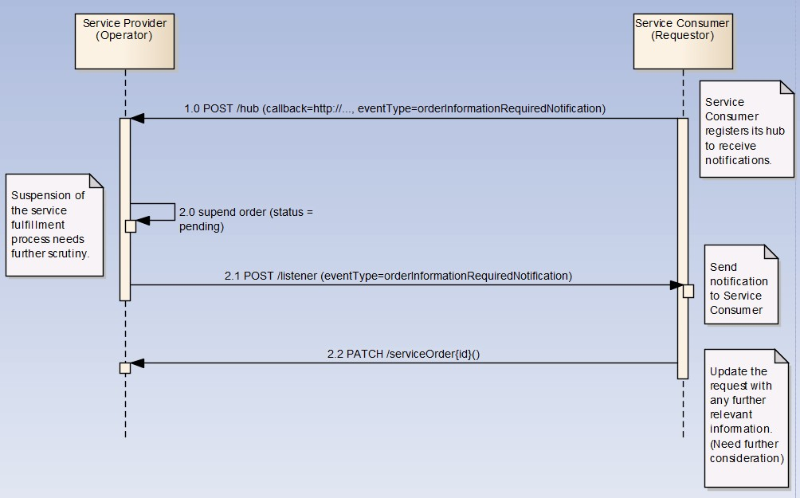

Register listener
POST /hub
Description
Sets the communication endpoint address the service instance must use to deliver information about its health state, execution state, failures and metrics. Subsequent POST calls will be rejected by the service if it does not support multiple listeners. In this case DELETE /api/hub/{id} must be called before an endpoint can be created again.
Behavior
Returns HTTP/1.1 status code 204 if the request was successful.
Returns HTTP/1.1 status code 409 if request is not successful.
Usage Samples
Here is an example of a request for registering a listener.

Request
POST /api/hub
Accept: application/json

{"callback": "http://in.listener.com"}
Response
201
Content-Type: application/json
Location: /api/hub/42

{"id":"42","callback":"http://in.listener.com","query":null}

Unregister listener
DELETE /hub/{id}
Description
Clears the communication endpoint address that was set by creating the Hub..
Behavior
Returns HTTP/1.1 status code 204 if the request was successful.
Returns HTTP/1.1 status code 404 if the resource is not found.
Usage Samples
Here's an example of a request for un-registering a listener.
Request
DELETE /api/hub/42
Accept: application/json
Response
204

Publish Event to listener
POST /client/listener
Description
Clears the communication endpoint address that was set by creating the Hub.
Provides to a registered listener the description of the event that was raised. The /client/listener url is the callback url passed when registering the listener.
Behavior
Returns HTTP/1.1 status code 201 if the service is able to set the configuration.

Usage Samples
Here is an example of a notification received by the listener. In this example “EVENT TYPE” should be replaced by one of the notification types supported by this API (see Notification resources Models section) and EVENT BODY refers to the data structure of the given notification type.
Request
POST /client/listener
Accept: application/json

{
"event": {
EVENT BODY
},
"eventType": "EVENT_TYPE"
}
Response
201

For detailed examples on the general TM Forum notification mechanism, see the TMF REST Design Guidelines (TMF630).

Acknowledgements

Document History

Version History
Version Number | Date | Release led by: | Description
1.0 |  | Pierre Gauthier  Andrew Forth  August-Wilhelm Jagau | First Release of the Document.
2.0 | 24-Oct-2016 | Pierre Gauthier  Ludovic Robert  Nicoleta Stoica  Jean-Luc Tymen | Alignment with Guidelines 3.0
3.0 | Dec 2018 | Pierre Gauthier  Ludovic Robert  Mariano Belaunde
4.0.0 | 28-May-2020 | Pierre Gauthier  Ludovic Robert
4.0.1 | 20-Jul-2020 | Adrienne Walcott | Updated to reflect TM Forum Approved Status
4.1.0 | 07-Dec-2020 | Kamal Maghsoudlou | Added support for order milestone, jeopardy alert, error messages

Release History
Release Status | Date | Release led by: | Description
Pre-production | 28-May-2020 | Pierre Gauthier  Ludovic Robert | Added support for order milestone, jeopardy alert, error messages
Production | 20-Jul-2020 | Adrienne Walcott | Updated to reflect TM Forum Approved Status
Pre-production | 07-Dec-2020 | Kamal Maghsoudlou | Added support for order milestone, jeopardy alert, error messages
Production | 26-Mar-2021 | Adrienne Walcott | Updated to reflect TM Forum Approved Status

Contributors to Document
Abdul Majid Hussain | Telstra | abdul.majidhussain@team.telstra.com
Andrew Forth | Amdocs | aforth@amdocs.com
August-Wilhelm Jagau | Ericsson | August-wilhelm.jagau@ericsson.com
Jean-Luc Tymen | Orange | jeanluc.tymen@orange.com
Kamal Maghsoudlou | Ericsson | Kamal.maghsoudlou@ericsson.com
Ludovic Robert | Orange | ludovic.robert@orange.com
Mariano Belaunde | Orange | mariano.belaunde@orange.com
Nicoleta Stoica | Vodafone | nicoleta.stoica@vodafone.com
Pierre Gauthier | TM Forum | pgauthier@tmforum.org

